NAME………………………………………………...….CLASS……..…ADMN NO…………

DATE……………………………………………………………SIGN………………………….

232/2 PHYSICS
PAPER 2
TIME: 2 HOURS
M.E.C.S CLUSTER EXAMINATION
FORM FOUR END OF TERM 1, APRIL 2023
INSTRUCTIONS TO CANDIDATES

- This paper consists of two sections A and B.
- Answer all the questions in sections A and B in the spaces provided.
- Non programmable silent electronic calculators may be used.
- This paper consists of 12 printed pages.
- Candidates should check the questions to ascertain that all the pages are printed as indicated and that no question is missing.

FOR EXAMINER’S USE ONLY.

SECTION | QUESTION | MAXIMUM SCORE | CANDIDATE’S SCORE
A | 1-13 | 25
B | 14 | 10
 | 15 | 12
 | 16 | 11
 | 17 | 12
 | 18 | 10
TOTAL |  | 80

SECTION A (25MARKS)
1. A ray of light is incident on a plane mirror as shown in the figure below.
If the mirror is rotated anticlockwise through angle of 8º what will be the angle of rotation of the reflected ray? (1mark)

…………………………………………………………………………………………………………………

…………………………………………………………………………………………………………………
2. State two uses of a charged gold leaf electroscope (2marks)

…………………………………………………………………………………………………………………

………………………………………………………………………………………………………………….
3. The table below shows part of the electromagnetic spectrum in order of decreasing wavelength.

A | B | Infrared  Radiation | Visible  Light | C | D

a)Name the radiation C (1mk)

…………………………………………………………………………………………………………………..

b)Give one use of the wave D in medicine (1mark)

…………………………………………………………………………………………………………………..
4. A current of 0.5A flows in a circuit. Calculate the amount of charge that crosses a point in the circuit in 4 minutes. (2marks)

…………………………………………………………………………………………………………………

…………………………………………………………………………………………………………………

………………………………………………………………………………………………………………....

5. Give two properties of magnetic field lines around a bar magnet. (2marks)

…………………………………………………………………………………………………………………

………………………………………………………………………………………………………………....

6. The diagram below shows a displacement- position graph for a slinky spring as it is continually vibrated at one end.

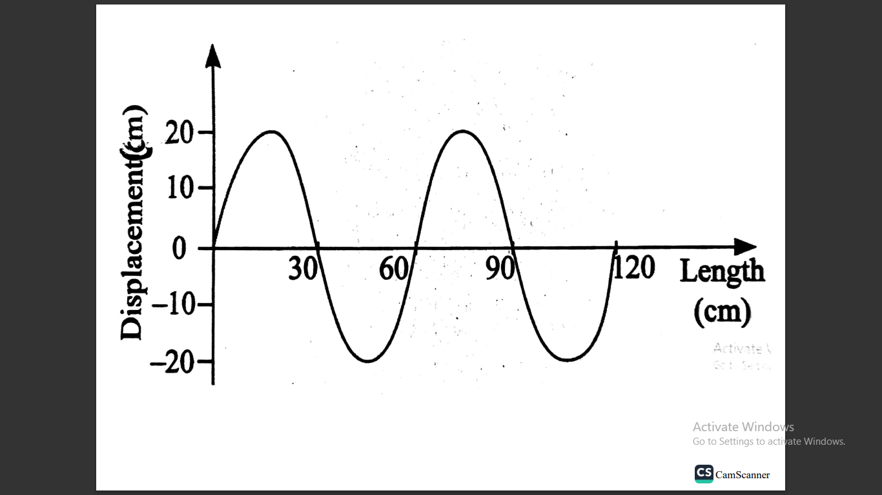

What is the
i) Amplitude of the displacement? (1mark)

…………………………………………………………………………………………………………………
ii) Wavelength of the waves (1mark)

…………………………………………………………………………………………………………………
7. The critical angle for a ray travelling from glass to air is 42 º. Determine the refractive index of the glass. (2marks)

…………………………………………………………………………………………………………………

…………………………………………………………………………………………………………………

…………………………………………………………………………………………………………………
8. The diagram below shows a current – carrying wire wound on a U-shaped soft iron.

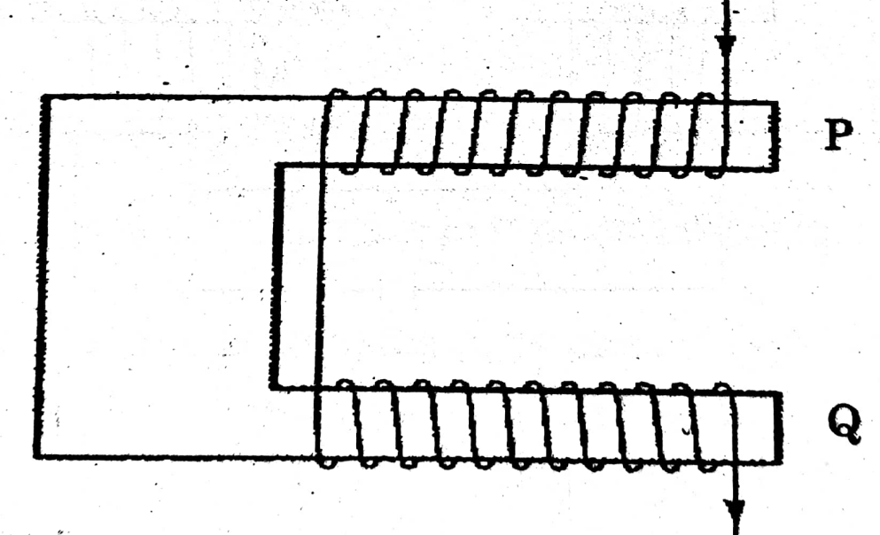
Draw the magnetic field patterns at P and Q (2marks)

9. An electrical heater rated 240V, 3000W is to be connected to a 240V mains supply through a 10 A fuse. Determine whether the fuse is suitable or not. (3marks)

…………………………………………………………………………………………………………………

…………………………………………………………………………………………………………………

…………………………………………………………………………………………………………………
10. State one cause of power loss in long distance transmission wire and how this loss can be minimized. (1mark)
………………………………………………………………………………………………………………

………………………………………………………………………………………………………………….

…………………………………………………………………………………………………………………..

11. Explain why walls of the studio are padded with woolen materials. (1mark)

…………………………………………………………………………………………………………………..

12. An object is placed 8cm from a concave mirror whose radius of curvature is 20cm. Determine the position of the image. (3marks)

…………………………………………………………………………………………………………………

…………………………………………………………………………………………………………………

…………………………………………………………………………………………………………………
13. The figure below shows a pair of parallel plates of a capacitor connected to battery. The upper plate is displaced slight to the left.
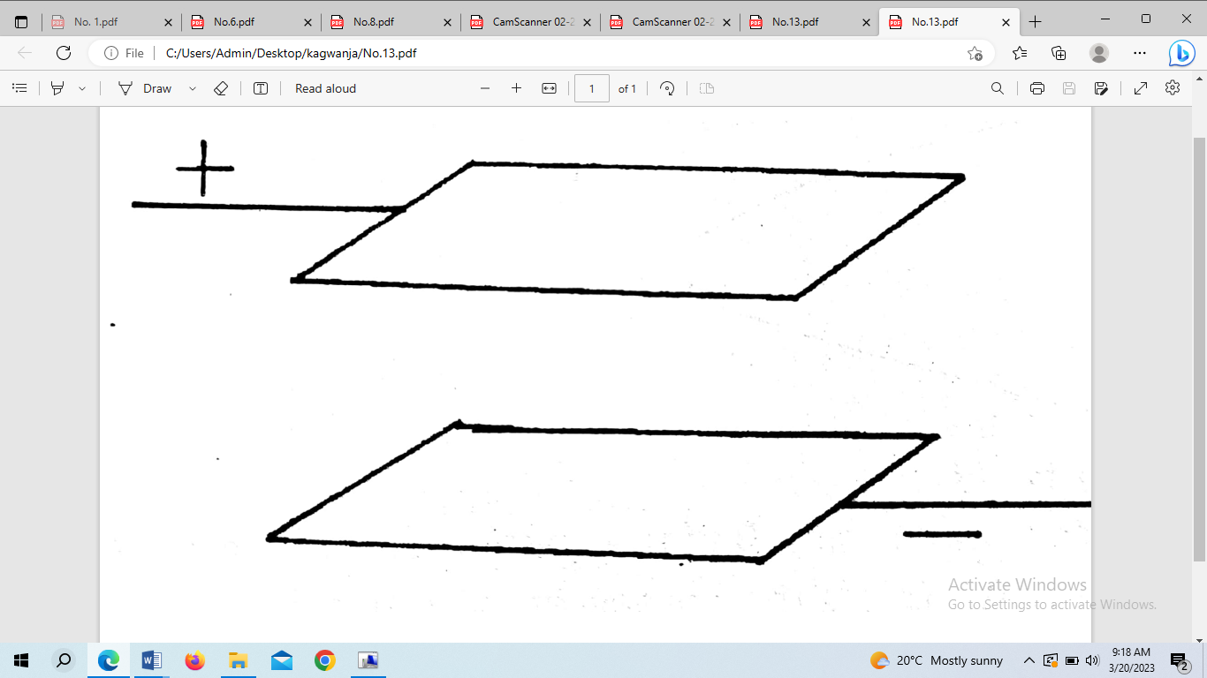
State with a reason the effect of this movement on the capacitance. (2marks)

…………………………………………………………………………………………………………………

…………………………………………………………………………………………………………………

…………………………………………………………………………………………………………………

SECTION B (55 MARKS )

14a) Define the term critical angle. (1mark)

…………………………………………………………………………………………………………………

…………………………………………………………………………………………………………………
…………………………………………………………………………………………………………………..
b)The figure below shows an object O at the bottom of a beaker full of a liquid. An observer above the beaker sees its image at point X inside a liquid

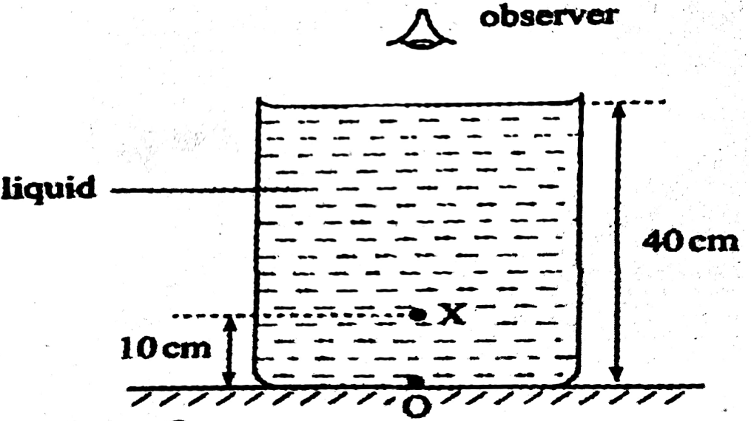
Determine the refractive index of the liquid (3marks)

…………………………………………………………………………………………………………………

…………………………………………………………………………………………………………………

c) The diagram below shows a ray of light travelling from water to glass. Given that the refractive index of water and glass are 1.33 and 1.5 respectively. Find the angle of refraction r in the glass (3marks)

35º
θ
Water
Glass

…………………………………………………………………………………………………………………

…………………………………………………………………………………………………………………

………………………………………………………………………………………………………………....

d) The diagram below shows a simple network of capacitor.

4µF
6µF
2µF
X
Y

If the potential difference between X and Y is 6V, calculate the total charge stored by the capacitors. (3marks)

..............................................................................................................................................................................

..............................................................................................................................................................................

..............................................................................................................................................................................

15a) Define the term principal focus of a convex lens (1mark)

…………………………………………………………………………………………………………………

………………………………………………………………………………………………………………….

b) State two characteristics of image formed by the diverging lens. (2marks)

…………………………………………………………………………………………………………………

…………………………………………………………………………………………………………………

c) An object of height 10cm is placed 25cm from a converging lens of focal length 15cm.
i) On the grid provided draw a ray diagram to locate the position of the image. (3marks)

ii) From the graph determine the;
a) Image height (2marks)

…………………………………………………………………………………………………………………

………………………………………………………………………………………………………………….
b) Image distance (2marks)

…………………………………………………………………………………………………………………

…………………………………………………………………………………………………………………

c) Magnification (2marks)

…………………………………………………………………………………………………………………

…………………………………………………………………………………………………………………

…………………………………………………………………………………………………………………

16a) what is meant by electromotive force E.m.f of a cell (1mark)

…………………………………………………………………………………………………………………

…………………………………………………………………………………………………………………

b) Name one factor that affect resistance of a metallic conductor. (1mark)

………………………………………………………………………………………………………………...
c) In an experiment to determine E.m.f ,E and the internal resistance r of a cell, a student obtained the values of voltage V and current I . He then plotted the graph of voltage V against current below.

i) Sketch the circuit that could be used to obtained the plotted results. (2marks)

ii) Given that V=E – Ir determine
I) E.m.f, E of the battery (2marks)

………………………………………………………………………………………………………………..................................................................................................................................................................................................................................................................................................................................................................
………………………………………………………………………………………………………………
II) Internal resistance r of the battery (2marks)

..............................................................................................................................................................................

..............................................................................................................................................................................

.............................................................................................................................................................................

d) What causes electrical resistance in conductors (1mark)

…………………………………………………………………………………………………………………

………………………………………………………………………………………………………………….

e) The combined resistance of the resistors in the circuit below is 8Ω.

Find the value of R (2marks)

…………………………………………………………………………………………………………………

…………………………………………………………………………………………………………………

…………………………………………………………………………………………………………………

17a)State the Lenz’s law of electromagnetic induction (1mark)

…………………………………………………………………………………………………………………

…………………………………………………………………………………………………………………

b) In the figure below show the direction of the induced current in the circuit (1mk)

c) Give two factors that determine the magnitude of emf induced in a coil. (2marks)

…………………………………………………………………………………………………………………

………………………………………………………………………………………………………………...

d) A transformer has 1200 turns in the primary circuit and 120 turns in the secondary circuit has its primary circuit connected to a 400V a.c source.

i) Name the type of the transformer. (1mark)
………………………………………………………………………………………………………………......
ii) Determine the secondary voltage (2marks)

..............................................................................................................................................................................

..............................................................................................................................................................................

..............................................................................................................................................................................
iii) Determine the efficiency of the transformer given that the current in the primary coil is 0.10A and in the secondary coil is 0.80A (3marks)

…………………………………………………………………………………………………………………

…………………………………………………………………………………………………………………

…………………………………………………………………………………………………………………

iv) One of the primary ways in which power is lost in a transformer is through eddy currents. State how eddy currents can be minimized (1mark)

………………………………………………………………………………………………………………......

v) State one property of soft iron that makes it suitable for use as a transformer core. (1mark)

………………………………………………………………………………………………………………….
18a)Give two conditions neccessary for the formation of stationary waves (2marks)

…………………………………………………………………………………………………………………

…………………………………………………………………………………………………………………

b)The figure below shows progressive wave crossing from a deep to shallow region.

Deep Shallow

i)On the diagram show how the waves proceed in the shallow region. (1mk)

ii)State the property of the waves illustrated in the diagram you have drawn above in b(i) (1mark)

…………………………………………………………………………………………………………………..

iii) Calculate the wavelength of a radio wave of frequency 100 kHz (Take C=3.0 x10⁸ m/s). (2marks)

…………………………………………………………………………………………………………………

…………………………………………………………………………………………………………………

c)The diagram below shows light rays from two coherent sources S₁ and S₂ falling on the screen. Dark and bright fridges are observed between M and N.

Explain how

I) Bright fridges are formed (1mark)

…………………………………………………………………………………………………………………..
II) Dark fridges are formed (1mark)

…………………………………………………………………………………………………………………..
ii)State and explain what is observed when light of a higher frequency is used (2marks)

…………………………………………………………………………………………………………………

…………………………………………………………………………………………………………………

…………………………………………………………………………………………………………………

THIS IS THE LAST PRINTED PAGE

