NAME:. . . . . . . . . . . . . . . . . . . . . . . . . . . ADM NO: - . . . . . . CLASS:. . . . . . .
232/2
PHYSICS MARKING SCHEME
PAPER 2
TIME: 2 HOURS
M.E.C.S CLUSTER EXAMINATION
FORM FOUR END OF TERM 1, APRIL 2023
INSTRUCTIONS TO CANDIDATES

- This paper consists of two sections A and B.
- Answer all the questions in sections A and B in the spaces provided.
- Non programmable silent electronic calculators may be used.
- This paper consists of 10 printed pages.
- Candidates should check the questions to ascertain that all the pages are printed as indicated and that no question is missing.

FOR EXAMINER’S USE ONLY.

SECTION | QUESTION | MAXIMUM SCORE | CANDIDATE’S SCORE
A | 1-13 | 25
B | 14 | 10
 | 15 | 12
 | 16 | 11
 | 17 | 12
 | 18 | 10
TOTAL |  | 80

SECTION A (25MARKS)
1. A ray of light is incident on a plane mirror as shown in the figure below.
If the mirror is rotated anticlockwise through angle of 8º ,determine the angle through which reflected ray is rotated? (1mk)
Angle of rotation of the reflected ray=angle of rotation X 2
= 8X2 =16 º

2. State two uses of a charged gold leaf electroscope (2mks)
To identify type of charge
To identify conductors and insulators.

3. The table below shows part of the electromagnetic spectrum in order of decreasing wavelength.

A | B | Infrared  Radiation | Visible  light | C | D

a)Name the radiation C (1mk)
U.V Radiation

b)Give one use of the wave D in medicine (1mk)
Radiography
Cancer therapy

4. A current of 0.5A flows in a circuit..Calculate the amount of charge that crosses a point in the circuit in 4 minutes. (2mks)
Q=It
=0.5X4X60=120C

5. Give two properties of magnetic field lines around a bar magnet. (2mks)
Originate from N-pole and end at the S-pole
The field lines do not intersect.

6. The diagram below shows a displacement- position graph for a slinky spring as it is continually vibrated at one end.

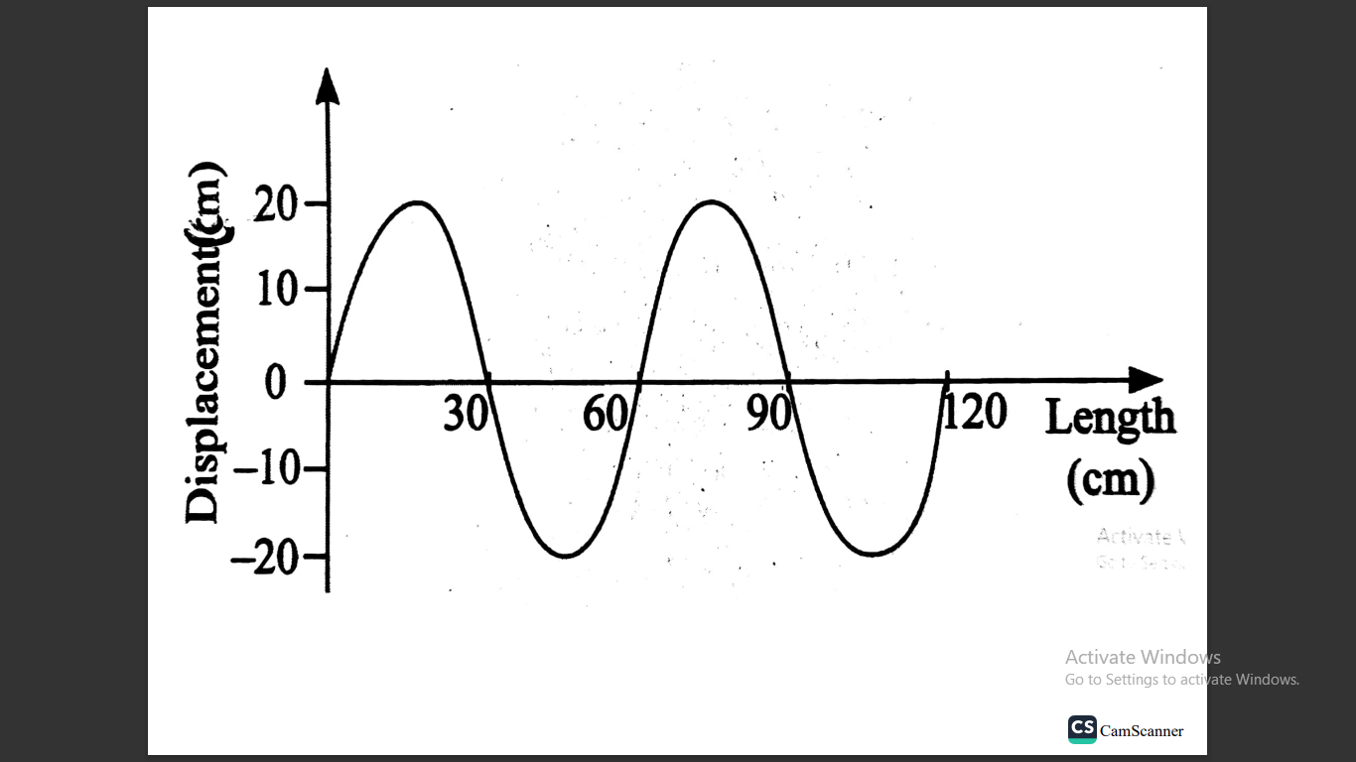
What is the
i) Amplitude of the displacement?(1mk)
20cm

ii) Wavelength of the waves (1mk)
60cm

7. The critical angle for a ray travelling from glass to air is 42 º. Determine the refractive index of the glass. (2mks)

n=1/sin C n=1/sin42 =1.494

8. The diagram below shows a current – carrying wire wound on a U-shaped soft iron.

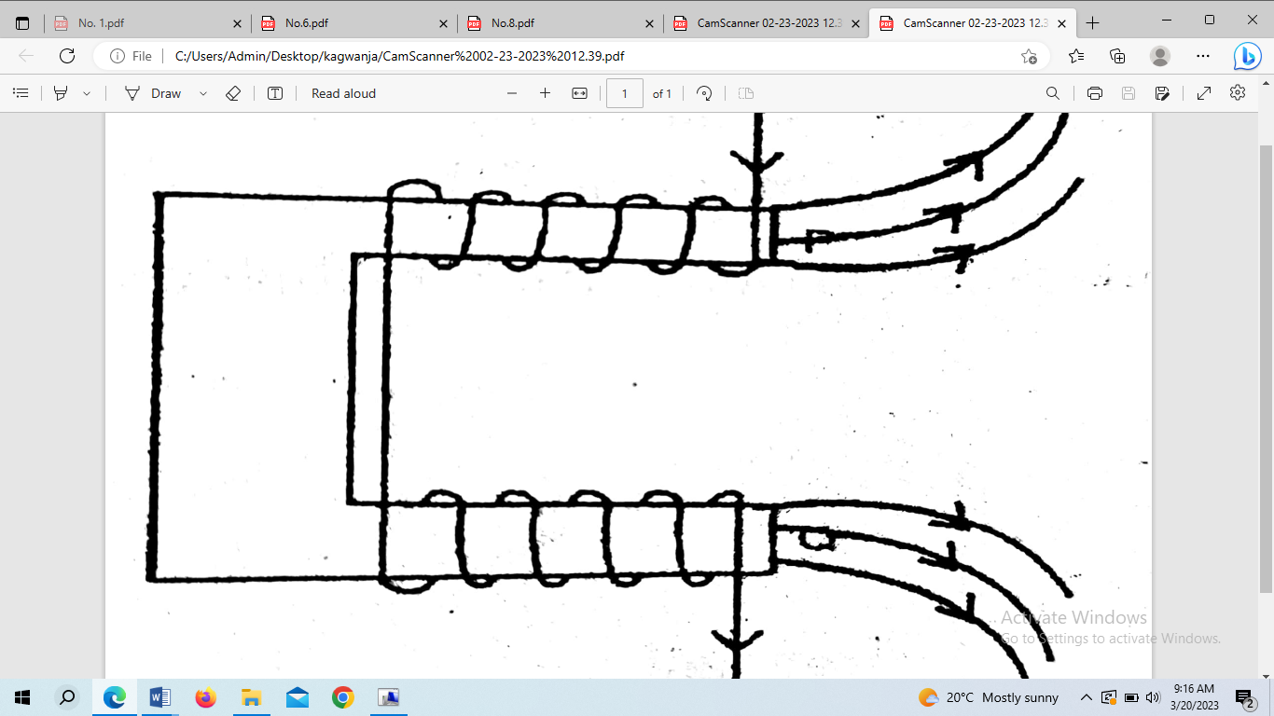
Draw the magnetic field pattern at P and Q (2mks)

9. An electrical heater rated 240V, 3000W is to be connected to a 240V mains supply through a 10 A fuse. Determine whether the fuse is suitable or not.(3mks)

1=P/V =3000/240 =12.5A fuse not suitable since 12.5 > 10A

10. State one cause of power loss in long distance transmission wire and how this loss can be minimized. (1mk)
High resistance in cables – use thicker cables to reduce resistance
High current I in the cables- stepping up the voltage before transmission.

11. Explain why walls of the studio are padded with wollen materials. (1mk)
To absorb incident sound waves preventing the formation of echo.

12. An object is placed 8cm from a concave mirror whose radius of curvature is 20cm. Determine the position of the image. (3mks)

1/f=1/U+1/V 1/V=1/10-1/8
1/10=1/8+1/V 1/V=-2/80 V=-40cm

13. The figure below shows a pair of parallel plates of a capacitor connected to battery. The upper plate is displaced slight to the left.
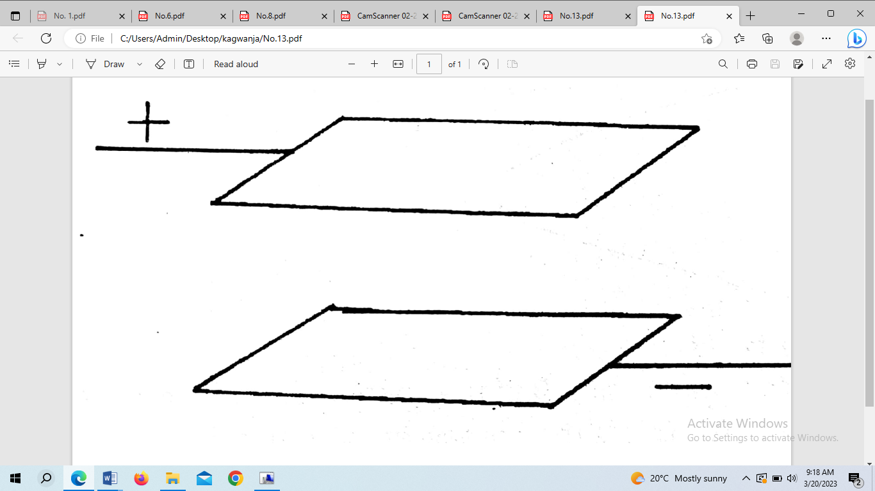
State with a reason the effect of this movement on the capacitance. (2mks)
Area of overlap decreases hence causing decrease in capacitance

SECTION B 55 MARKS

14a) Define the term critical angle. (1mk)
The angle of incidence in the optically denser medium for which the angle of refraction in the less dense medium is 90 º

b)The figure below shows an object O at the bottom of a beaker full of a liquid. An observer above the beaker sees its image at point X inside a liquid

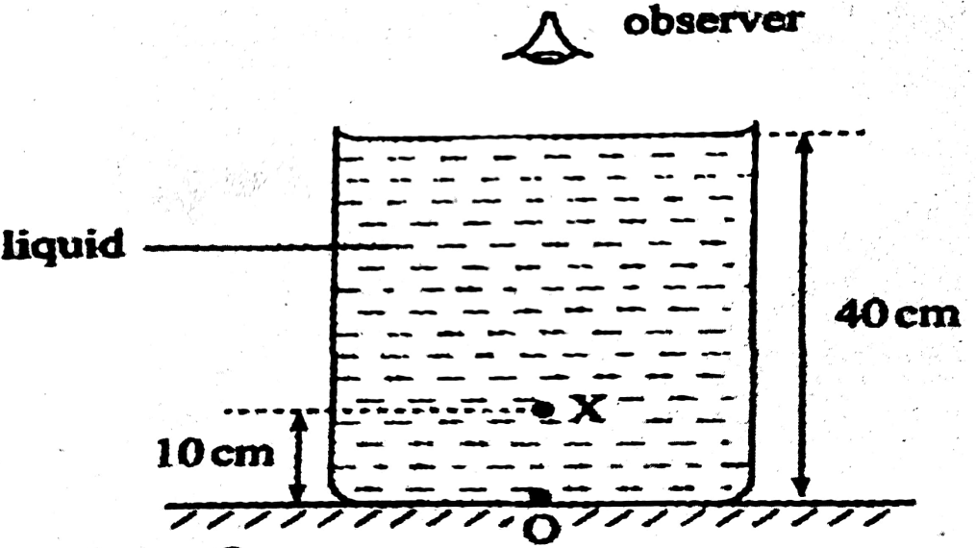
Determine the refractive index of the liquid (3mks)

n=real depth /apparent depth =40/(40-10) =1.333

c) The diagram below shows a ray of light travelling from water to glass. Given that the refractive index of water and glass are 1.33 and 1.5 respectively. Find the angle of refraction r in the glass (3mks)
35º
θ
Water
Glass

_{a}n_{w} sin Ꝋ₁ =_{a}n_{g} Sin Ꝋ ₂ Sin r = 1.33 sin 55/1.5
1.33 Sin 55 = 1.5 Sin r Sin r=0.7263
r=46.58⁰

d) The diagram below shows a simple network of capacitor.

4µF
6µF
2µF
X
Y

If the potential difference between X and Y is 6V, calculate the total charge stored by the capacitors. (3mks)
C_{T}= $\frac{4x6}{4+6}$ +2 =2.4 + 2 =4.4µF
Q=CV
=4.4 X10⁻⁶X 6
=26.4 µC

15a) Define the term principal focus of a convex lens (1mk)
Point on the principal axis where rays parallel and close to the principal axis converge after refraction by the lens.
b) State two characteristics of image formed by the diverging lens. (2mks)
Virtual -upright/erect
Diminished
c) An object of height 10cm is placed 25cm from a converging lens of focal length 15cm.
i) On the grid provided draw a ray diagram to locate the position of the image. (3mks)

ii) From the graph determine the ;
a) Image height 2mks)
h_{i}=3cm x 5 =15cm

b) Image distance 2mks)
V=7.5cm x 5 =37.5cm

c) Magnification 2mks)
M =V/U OR M=H_{I}/H_{O}
=37.5/25 =15/10
=1.5 =1.5

16a)What is meant by electromotive force emf of a cell 1mk)

This is the total voltage across the terminals of a cell in an open circuit.

b)Name one factor that affect resistance of a metallic conductor (1mk)
length ,thickness of the conductor,temperature.

c) In an experiment to determine emf E and the internal resistance r of a cell,a student obtained the values of voltage V and current I . He then plotted the graph of voltage V against current below.

i) Sketch the circuit that could be used to obtained the plotted results.2mks)

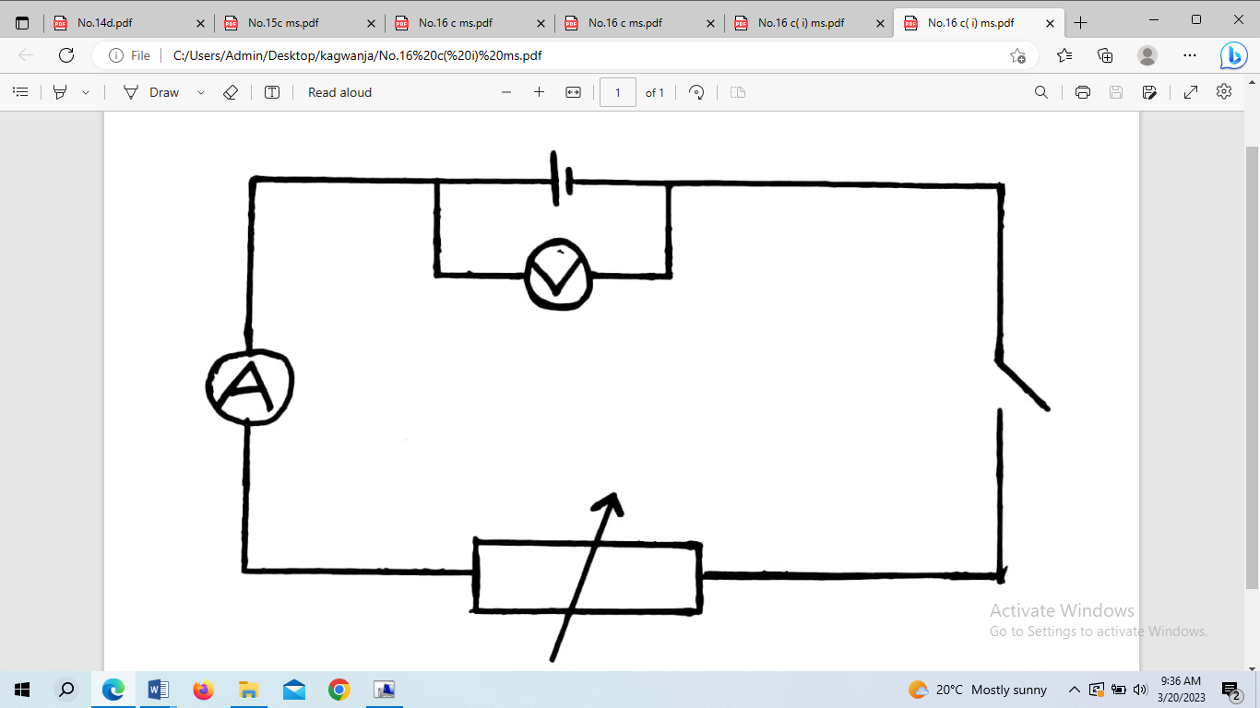

ii)Given that V=E – Ir determine

I) Emf E of the battery 2mks)
- Extrapolate
-Emf E =1.5V
II) Internal resitance r of the battery 2mks)
-r = slope =(0.75-1.125)/(1.0-0.5)
=-0.375/0.5
=-0.75
r=0.75Ω

d)What causes electrical resistance in conductors (1mk)

The collisions between the charge/electrons flowing and atoms or impurities in the conductor.

e) The combined resistance of the resistors in the circuit below is 8Ω.

Find the value of R 2mks)

R_{E} =$\frac{R1R2}{R1+R2}$ 8=$\frac{12X R}{12+R}$ 96+8R=12R 4R=96 R =24Ω

17a)State the Lenz’s law of electromagnetic induction (1mk)

The direction of induced emf is such that the current which it causes to flow produces a magnetic effect that opposes the change producing it.

b) In the figure below show the direction of the induced current in the circuit (1mk)
c)Give two factors that determine the magnitude of emf induced in a coil. (2mks)
Rate of change of magnetic flux
Number of turns in the coil

d)A transformer has 1200 turns in the primary circuit and 120 turns in the secondary circuit has its primary circuit connected to a 400V a.c source.

i) Name the type of the transformer used. (1mk)
Step down transformer

ii) Determine the secondary voltage (2mks)
V_{S}/V_{P} =N_{S}/N_{P} V_{S}=400 X 120/1200
V_{S}=40V

iii) Determine the efficiency of the transformer given that the current in the primary coil is 0.10A and in the secondary coil is 0.80A (3mks)
Efficiency=$\frac{power output}{power input}$ x100%
=$\frac{40 x0.8}{400x 0.1}$ x 100%
=$\frac{32}{40}$ x100% =80%

iv)One of the primary ways in which power is lost in a transformer is through eddy currents. State how eddy currents can be minimized (1mk)
Core is made of laminated sheets

v)State one property of soft iron that makes it suitable for use as a transformer core. (1mk)
Iron is easily magnetized and demagnetized

18a)Give two conditions neccessary for the formation of stationary waves (2mks)
Same speed
Same frequency
Same amplitude (NB:Deny nearly equal Amplitude)

b)The figure below shows progressive wave crossing from a deep to shallow region.

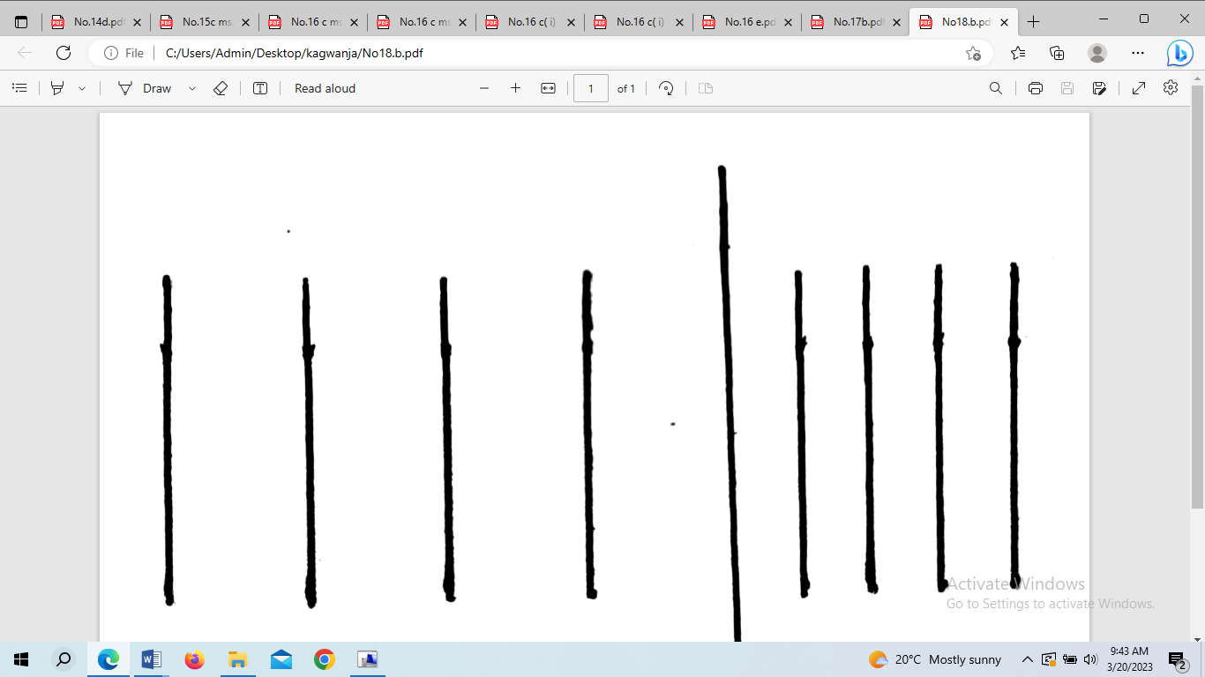
Deep Shallow
i)On the diagram show how the waves proceed in the shallow region. (1mk)

ii)State the property of the waves illustrated in the diagram you have drawn above in b(i) (1mk)
Refraction
iii)Calculate the wavelength of a radiowave of frequency 100kHz(Take C=3.0 x10⁸ m/s). (2mks)

C=λf λ=C/f
=3.0 x 10⁸/100x 10³
=3000m

c)The diagram below shows light rays from two coherent sources S₁ and S₂ falling on the screen. Dark and bright fridges are observed between M and N.

Explain how

I) Bright fridges are formed (1mk)

They are formed as a result of constructive interference of the two waves from the two sources

II) Dark fridges are formed (1mk)

They are formed as a result of destructive interference of the waves from the two sources.

ii)State and explain what is observed when light of a higher frequency is used (2mks)

The bright and dark fridges become more closely spaced.This is because increase in frequency causes decrease in wavelength, hence it takes shorter intervals of distance for the path difference.

THIS IS THE LAST PRINTED PAGE

