NAME………………………………………………...….CLASS……..…ADMN NO…………

DATE……………………………………………………………SIGN………………………….

232/1
PHYSICS
FORM FOUR
APRIL-2023
TIME: 2HRS

MECS JOINT EXAMINATION
Kenya Certificate of Secondary Education 2023

PHYSICS PAPER ONE

INSTRUCTIONS TO CANDIDATES
- Write your name and admission number in the spaces provided above.
- Sign and write the date of examination in the spaces provided above
- This paper consists of TWO sections A and B.
- Answer ALL the questions in section A and B in the spaces provided.
- All working MUST be clearly shown.
- Non programmable silent calculators may be used.
- This paper has 12 pages. It is the responsibility of the candidate to ascertain that all the pages are printed as indicated and that no questions are missing.
- Candidates should answer the questions in English.
Constant: g=10N/kg or 10m/s²

For Examiners Use Only

Section | Question | Maximum Score | Candidate’s Score
A | 1 – 13 | 25
B | 14 | 10
 | 15 | 12
 | 16 | 11
 | 17 | 11
 | 18 | 11
 | TOTAL SCORE | 80

SECTION A: (25 MARKS)
- 1 The figure below shows part of a vernier callipers when the jaws are closed without an object in between the jaws.
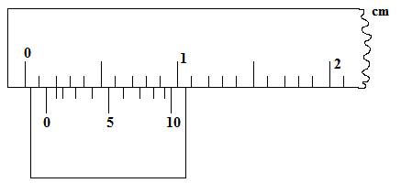
- State the zero error of the vernier callipers. (1mark)

……………………………………………………………………………………………………………………………………………………………………………………………………………………………….

b) A student used the same vernier calipers to measure the diameter of a test tube of actual diameter 2.15cm. What was the reading shown by the vernier callipers? (1mark)
……………………………………………………………………………………………………………………………………………………………………………………………………………………………….

2 State a reason why a burn from steam at 1000C is more severe than a burn from boiling water at the same temperature (1 mark)

………………………………………………………………………………………………………………………………………………………………………………………………………………………………..

3. Apart from temperature difference between the ends of a material, state any other two factors that determines rate of heat flow in a material (2marks)
……………………………………………………………………………………………………………………………………………………………………………………………………………………………………………………………………………………………………………………………………………….

4. A point in the rim of a wheel has a linear velocity of 5.6 m/s. if the rim has a radius of 40cm determine the angular velocity of the point (2marks)
………………………………………………………………………………………………………………………………………………………………………………………………………………………………………………………………………………………………………………………………………………………………………………………………………………………………………………………………………………………………………………………………………………………………………………..

5. A wooden block of mass 2kg is placed on a horizontal surface. A horizontal force of 12N is exerted on it makes it to accelerate at 5ms⁻². Find the coefficient of friction between the surfaces. (3marks)
………………………………………………………………………………………………………………………………………………………………………………………………………………………………………………………………………………………………………………………………………………..

6. .Explain briefly how the temperature in a green house is kept higher than outside. (2 marks)

……………………………………………………………………………………………………………………………………………………………………………………………………………………………………………………………………………………………………………………………………………….
……………………………………………………………………………………………………………….

- The figure below shows two inflated balloons hanging vertically on light threads.
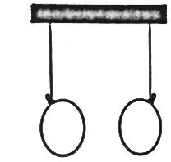
State and explain the observation that will be made when a stream of air is blown in the space between the balloons. (2 marks)
………………………………………………………………………………………………………………………………………………………………………………………………………………………………………………………………………………………………………………………………………………

8. Explain why a hole in a ship near the bottom is more dangerous than the one near the top (1mark) ……………………………………………………………………………………………………………………………………………………………………………………………………………………………………………………………………………………………………………………………………………….

9.The diagram bellow shows a uniform meter rule pivoted at its center and balanced by the forces shown. (3marks)
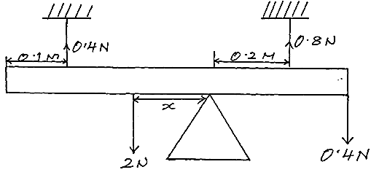
Determine the value of x.

………………………………………………………………………………………………………………………………………………………………………………………………………………………………………………………………………………………………………………………………………………
…………………………………………………………………………………………………………….......

10.The figure shows a capillary tube dipped in water.
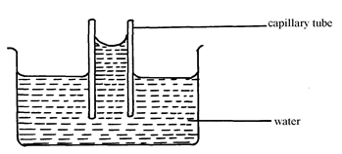
Water
Capillary tube
State two differences that will be observed when water is replaced with mercury in the set up above. (2 marks)
……………………………………………………………………………………………………………………………………………………………………………………………………………………………………………………………………………………………………………………………………………….

11. Give the transducer used to convert mechanical energy to electrical energy. (1 mark)

………………………………………………………………………………………………………………
12. A body is uniformly accelerated from rest to a final velocity of 100m/s in 10seconds. Calculate the distance covered. (2marks)

………………………………………………………………………………………………………………………………………………………………………………………………………………………………………………………………………………………………………………………………………………

13. The figure below shows beaker containing a block of ice.
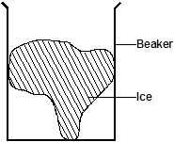

State and explain the change in stability when the ice melts. (2marks)

………………………………………………………………………………………………………………………………………………………………………………………………………………………………

SECTION B (55 MARKS)
14. a) Define the term heat capacity. (1 mark)
………………………………………………………………………………………………………………………………………………………………………………………………………………………………..

b) A metal block of mass 2.0kg is heated electrically. The voltmeter read 12 volts and ammeter 4.0A. The temperature of the metal block increased from 25⁰C to 75⁰C in 10 minutes. Assuming no heat is lost to the surrounding. Determine:
i) Heat supplied by the heater. (2marks)
………………………………………………………………………………………………………………………………………………………………………………………………………………………………………………………………………………………………………………………………………………..

ii) Heat gained by the metal cylinder (1mark) ………………………………………………………………………………………………………………………………………………………………………………………………………………………………..

iii) Specific heat capacity of the metal block. (2marks)

………………………………………………………………………………………………………………………………………………………………………………………………………………………………………………………………………………………………………………………………………………

c) Explain why food cooks faster in a pressure cooker than in an open sufuria (2marks)

………………………………………………………………………………………………………………………………………………………………………………………………………………………………

d)The figure below shows two identical containers A and B containing hot water and ice block.
Ice block wrapped in wire gauze
Hot Water
Floating ice block
B
A

State with reason which water cools faster assuming that the wire gauge absorbs negligible heat. (2marks)
………………………………………………………………………………………………………………………………………………………………………………………………………………………………………………………………………………………………………………………………………………

- a) State Newton’s second law of motion in terms of in momentum. (1mark)

……………………………………………………………………………………………………………………………………………………………………………………………………………………………….

- (i) A bullet of mass 20.0 g is fired with a velocity of 300m/s into a wooden block of mass 4.98 kg suspended from a long in extensible string. The bullet sticks into the wood and the two moves together.
Find the velocity of the block and bullet immediately after collision took place. (2marks)
………………………………………………………………………………………………………………………………………………………………………………………………………………………………………………………………………………………………………………………………………………………………………………………………………………………………………………………………..

(ii) Calculate the height to which both swings upwards. (2marks)
………………………………………………………………………………………………………………………………………………………………………………………………………………………………………………………………………………………………………………………………………………..

c) Figure shows a hydraulic press system using a lever of negligible mass on the side of a small piston pivoted at point P. A force of 200N is applied at R.
P
100 cm
50 cm
Liquid
Area= 180cm²
A Bale
200 N
A =50 cm²
R

Calculate ;
- The force F exerted by small piston on the liquid. (2marks)
………………………………………………………………………………………………………………………………………………………………………………………………………………………………………………………………………………………………………………………………………………………………………………………………………………………………………………………………

- The weight of the Bale supported by the large piston (2marks)
……………………………………………………………………………………………………………………………………………………………………………………………………………………………………………………………………………………………………………………………………………………………………………………………………………………………………………………………….

- Efficiency of the system. (3marks)
………………………………………………………………………………………………………………………………………………………………………………………………………………………………………………………………………………………………………………………………………………………………………………………………………………………………………………………………………………………………………………………………………………………………………………………………………………………………………………………………………………………………………………………………………………………………………………………………………………..

- (a) State Archimedes principle (1mark)
……………………………………………………………………………………………………………………………………………………………………………………………………………………..................

(b) A cylinder of length 5.0 cm and uniform cross section area 50.00 cm² is suspended from a spring balance and totally immersed in water. If the density of the material of the cylinder is 1.25g/cm³ and density of water 1g/cm³, determine:
    - The up thrust on the cylinder (2marks)
………………………………………………………………………………………………………………………………………………………………………………………………………………………………………………………………………………………………………………………………………………………………………………………………………………………………………………………………

    - Weight of the cylinder (2marks)
……………………………………………………………………………………………………………………………………………………………………………………………………………………………………………………………………………………………………………………………………………….

    - The reading on the spring balance (2marks)
……………………………………………………………………………………………………………………………………………………………………………………………………………………………………………………………………………………………………………………………………………….

(b)(i) State the reason why lead shots are fixed at the bottom of hydrometer. (1 mark)
Length (cm)
0 1.0 2.0 3.0 4.0 5.0
0.1

………………………………………………………………………………………………………………………………………………………………………………………………………………………………

(ii) A hydrometer of mass 30.0 g floats in water of density 1.0g/cm³.If the bulb of the hydrometer had a volume of 2.8x10⁻⁵ m³ and stem has a cross – section area of 1.0 cm², what length of the stem would be submerged in the water. (3marks)
………………………………………………………………………………………………………………………………………………………………………………………………………………………………………………………………………………………………………………………………………………………………………………………………………………………………………………………………………………………………………………………………………………………………………………..

17. a) Define the term angular velocity. (1mark)

………………………………………………………………………………………………………………………………………………………………………………………………………………………………
b) The graph below was obtained from an experiment to investigate the variation of the centripetal force, F with the radius, r of the circle on which a body rotates was performed.

0
0.1
0.2
0.3
0.4
0.5
0.1
0.4
0.3
0.5
0.2
0.6
r (m)
F (N)

From the graph, determine the angular velocity, Ꞷ of the body given that m = 100g and
F = mꞶ²r + c where c is a constant. (3 marks)
……………………………………………………………………………………………………………………………………………………………………………………………………………………………………………………………………………………………………………………………………………....

- A stone of mass 40g is tied to the end of a string 50cm long and whirled in a vertical circle at 2 revolutions per second. Calculate the maximum tension in the string. (3marks)

……………………………………………………………………………………………………………………………………………………………………………………………………………………………………………………………………………………………………………………………………………………………………………………………………………………………………………………………….
- A stone is thrown horizontally with a velocity of 45m/s from the top of a vertical tower 50m high. Determine:
- The time taken by the bullet to reach the ground (2marks)
……………………………………………………………………………………………………………………………………………………………………………………………………………………………………………………………………………………………………………………………………………….

- The maximum horizontal distance covered by the bullet (2marks)
………………………………………………………………………………………………………………………………………………………………………………………………………………………………………………………………………………………………………………………………………………
18. a) Define the absolute zero of the Kelvin temperature scale. (1 mark)

………………………………………………………………………………………………………………………………………………………………………………………………………………………………

(b) The diagram below shows an experiment to investigate the relationship between volume and temperature of a fixed mass of gas at constant pressure
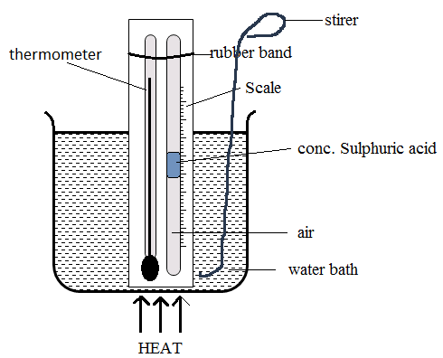
- While stating any measurements to be made, explain how the set up would be used to verify Charles law. (3marks) ……………………………………………………………………………………………………………………………………………………………………………………………………………………………………………………………………………………………………………………………………………………………………………………………………………………………………………………………………………………………………………………………………………………………………………......

(iii)On the grid shown in the figure below sketch a graph of volume (cm³) against temperature (⁰C) for the experiment above. Clearly mark with the letter T the absolute zero temperature. (1 mark) 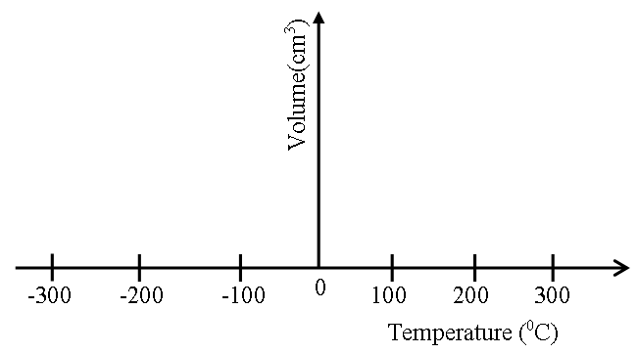

c) A mass of air of volume 750cm³ is heated at constant pressure from 10⁰ C to 100⁰ C. determine the final volume of the air. (2marks)

………………………………………………………………………………………………………………………………………………………………………………………………………………………………………………………………………………………………………………………………………………………………………………………………………………………………………………………………..

d) The figure below shows a graph of weights of persons entering a lift against the extension of four similar springs supporting a lift. From the graph determine,

- The spring constant of the springs (3marks)
………………………………………………………………………………………………………………………………………………………………………………………………………………………………………………………………………………………………………………………………………………………………………………………………………………………………………………………………..
- The spring constant of a single spring (1mrk)
………………………………………………………………………………………………………………………………………………………………………………………………………………………………………………………………………………………………………………………………………………………………………………………………………………………………………………………………..

THIS IS THE LAST PRINTED PAGE.

