NAME………………………………………………...….CLASS……..…ADMN NO…………

DATE……………………………………………………………SIGN………………………….

232/1
PHYSICS
FORM FOUR
APRIL-2023
TIME: 2HRS

MECS JOINT EXAMINATION
Kenya Certificate of Secondary Education 2023

PHYSICS PAPER ONE

INSTRUCTIONS TO CANDIDATES
- Write your name and admission number in the spaces provided above.
- Sign and write the date of examination in the spaces provided above
- This paper consists of TWO sections A and B.
- Answer ALL the questions in section A and B in the spaces provided.
- All working MUST be clearly shown.
- Non programmable silent calculators may be used.
- This paper has 11 pages. It is the responsibility of the candidate to ascertain that all the pages are printed as indicated and that no questions are missing.
- Candidates should answer the questions in English.
Constant: g=10N/kg or 10m/s²

For Examiners Use Only

Section | Question | Maximum Score | Candidate’s Score
A | 1 – 13 | 25
B | 14 | 10
 | 15 | 12
 | 16 | 11
 | 17 | 11
 | 18 | 11
 | TOTAL SCORE | 80

SECTION A: (25 MARKS)
- 1 The figure below shows part of a vernier callipers when the jaws are closed without an object in between the jaws.
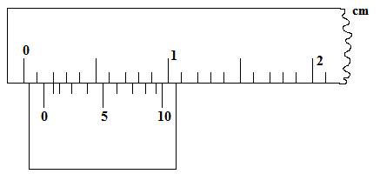
- State the zero error of the vernier callipers. (1mark)

0.11cm

b) A student used the same vernier calipers to measure the diameter of a test tube of actual diameter 2.15cm. What was the reading shown by the vernier callipers? (1mark)
2.26cm

2 State a reason why a burn from steam at 1000C is more severe than a burn from boiling water at the same temperature (1 mark)

Steam has more energy because it contains latent heat of vaporization which the boiling water doesn’t have

3. Apart from temperature difference between the ends of a material, state any other two factors that determines rate of heat flow in a material (2marks)

Cross section area
Length of the conductor

4. A point in the rim of a wheel has a linear velocity of 5.6 m/s. if the rim has a radius of 40cm determine the angular velocity of the point (2marks)

Ꞷ=v/r=5.6/0.4 =14rads/s

5. A wooden block of mass 2kg is placed on a horizontal surface. A horizontal force of 12N is exerted on it makes it to accelerate at 5ms⁻². Find the coefficient of friction between the surfaces. (3marks)

F=ma 2=μR
= 2x5 = 10N μ = 2/20=0.1

12-10 = 2N

6. .Explain briefly how the temperature in a green house is kept higher than outside. (2 marks)

Roofing materials allows radiations to penetrate into the greenhouse1
After absorption, radiation of lower energy is emitted back. 1

- The figure below shows two inflated balloons hanging vertically on light threads.
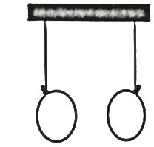
State and explain the observation that will be made when a stream of air is blown in the space between the balloons. (2 marks)
The balls moves towards each other. High velocity of air lowers the pressure between the balloons making the greater pressure outside the balloons to push them towards each other.
8. Explain why a hole in a ship near the bottom is more dangerous than the one near the top (1mark)
Pressure at the bottom of the ship is greater than pressure near the top, more water will enter into the ship at the bottom then at the top. 1

9.The diagram bellow shows a uniform meter rule pivoted at its center and balanced by the forces shown. (3marks)
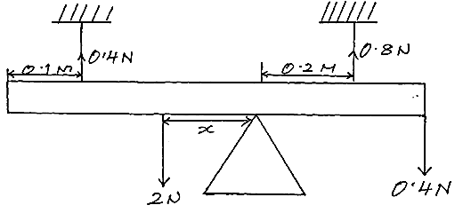
Determine the value of x.
. sum of clockwise moment = sum of Anticlockwise moment
2x + (0.8X0.2) = (0.4x0.4) + (0.4X0.5)
2x + 0.16 = 0.16 +0.2
2x + 0.16 =0.36
2x = 0.2
X = 0.1m

10.The figure shows a capillary tube dipped in water.
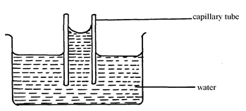
Water
Capillary tube
State two differences that will be observed when water is replaced with mercury in the set up above. (2 marks)
Mercury level inside the capillary tube is below the level outside ₁
Has a convex meniscus ₁

11. Give the transducer used to convert mechanical energy to electrical energy. (1 mark)
Generator

12. A body is uniformly accelerated from rest to a final velocity of 100m/s in 10seconds. Calculate the distance covered. (2marks)
a=v-u/t =100-0/10 = 10m/s² alternatively s=average velocity x t
s=ut +1/2at² s=100/2 x10
= 0 + 1/2x10 x10² =500m =50x10 =500m

13. The figure below shows beaker containing a block of ice.
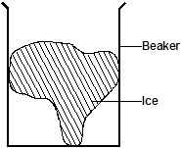

State and explain the change in stability when the ice melts. (2marks)
- stability increases,
- position of cog lowers

SECTION B (55 MARKS)
14. a) Define the term heat capacity. (1 mark)
Amount of heat energy required to change the temperature of a given amount of a substance by 1K/1⁰C
b) A metal block of mass 2.0kg is heated electrically. The voltmeter read 12 volts and ammeter 4.0A. The temperature of the metal block increased from 25⁰C to 75⁰C in 10 minutes. Assuming no heat is lost to the surrounding. Determine:
i) Heat supplied by the heater. (2marks)
Q=IVt
= 4x12x10x60
= 28,800J
ii) Heat gained by the metal cylinder (1mark)
28,800J

iii) Specific heat capacity of the metal block. (2marks)
Q= mcϴ
28,800=2xCx50
C = 28,800/100
=288 J/Kg/K

c) Explain why food cooks faster in a pressure cooker than in an open sufuria (2marks)

Pressure inside the pressure cooker is higher which raises the boiling point of water and therefore the food cooks at a higher temperature than the one in an open sufuria.

d)The figure below shows two identical containers A and B containing hot water and ice block.
Ice block wrapped in wire gauze
Hot Water
Floating ice block
B
A

State with reason which water cools faster assuming that the wire gauge absorbs negligible heat. (2marks)
A 1
In A,there is creation of convection currents that facilitates cooling which is not present at B since the cold water cannot rise. 1

- a) State Newton’s second law of motion in terms of in momentum. (1mark)
The rate of change of momentum is directly proportional to the external resultant force and takes place in the direction of force.

- (i) A bullet of mass 20.0 g is fired with a velocity of 300m/s into a wooden block of mass 4.98 kg suspended from a long in extensible string. The bullet sticks into the wood and the two moves together.
Find the velocity of the block and bullet immediately after collision took place. (2marks)
m₂u₂ + m₁u₁ = (m₁+m₂) v
20/1000 x 300 + 5 x 0 = (5) v
6 = 5.v
V = 1.2 m/s

(ii) Calculate the height to which both swings upwards. (2marks)
½ x 5 x 1.2² = 5 x 10 x h
h =3.6/50
= 0.072m

c)Figure shows a hydraulic press system using a lever of negligible mass on the side of a small piston pivoted at point P. A force of 200N is applied at R.
P
100 cm
50 cm
Liquid
Area= 180cm²
A Bale
200 N
A =50 cm²
R

Calculate ;
- The force F exerted by small piston on the liquid. (2marks)
Am = cm
200x1.5 = F x 0.5
F= 200x1.5/0.5
= 600N
- The weight of the Bale supported by the large piston (2marks)

F₂=F!xA₂/A₁
=600x180/50
=2,160N

- Efficiency of the system. (3marks)
VR₁= 1.5/0.5=3 VR₂=180/50 =3.6 VR_{t} = 3x3.6 =10.8
MA =L/E= 2,160/200 = 10.8
Efficiency =MA/VR x 100 = 10.8/10.8x100 =100%
- (a) State Archimedes principle (1mark)
When a body is partially or fully immersed in a fluid it experiences an upthrust force equal to the weight of fluid displaced.

(b) A cylinder of length 5.0 cm and uniform cross section area 50.00 cm² is suspended from a spring balance and totally immersed in water. If the density of the material of the cylinder is 1.25g/cm³ and density of water is 1g/cm³determine:
    - The up thrust on the cylinder (2marks)
U =ρgV
= 1000x10x(5x50) x10⁻⁶
=2.5N
    - Weight of the cylinder (2marks)
W = mg
= ρVg
= 1250x(5x50x10⁻⁶)x10
= 3.125N
    - The reading on the spring balance (2marks)
Apparent weight = W-U
= 3.125-2.5
=0.625N

(b)(i) State the reason why lead shots are fixed at the bottom of hydrometer. (1 mark)
Length (cm)
0 1.0 2.0 3.0 4.0 5.0
0.1

To keep the hydrometer floating upright ₁

(ii) A hydrometer of mass 30.0 g floats in water of density 1.0g/cm³.If the bulb of the hydrometer had a volume of 2.8x10⁻⁵ m³ and stem has a cross – section area of 1.0 cm², what length of the stem would be submerged in the water. (3marks)
Weight of water displaced = 30x10/1000 = 0.3 N
V=U/ρg = 0.3/10,000 =3x10⁻⁵ m³
Volume of stem=0.00003-0.000028=0.000002m³
L=V/A =0.000002/1x10⁻⁴ = 0.02m = 2cm

17. a) Define the term angular velocity. (1mark)

Rate of change of angular displacement.

b) The graph below was obtained from an experiment to investigate the variation of the centripetal force, F with the radius, r of the circle on which a body rotates was performed.

0
0.1
0.2
0.3
0.4
0.5
0.1
0.4
0.3
0.5
0.2
0.6
r (m)
F (N)

From the graph, determine the angular velocity, Ꞷ of the body given that m = 100g and
F = mꞶ²r + c where c is a constant. (3 marks)

M= 0.4-0.2/0.325-0.15 m=mꞶ²
= 0.2/0.175 1.143= 0.1 Ꞷ²
= 1.143 (range 0.9-1.2) Ꞷ = √11.43 = 3.381rads⁻¹

- A stone of mass 40g is tied to the end of a string 50cm long and whirled in a vertical circle at 2 revolutions per second. Calculate the maximum tension in the string. (3marks)

T =mg + mꞶ²r
= 0.04x10 + 0.04 x (2x2Л)² x 0.5
=0.4 + 3.158
= 3.558N

- A stone is thrown horizontally with a velocity of 45m/s from the top of a vertical tower 50m high. Determine:
- The time taken by the bullet to reach the ground (2marks)
S =ut + $\frac{1}{2}$ gt²
50= 0 + $\frac{1}{2}$ x10 x t²
5t² = 50
t = 3.16 s

- The maximum horizontal distance covered by the bullet (2marks)
R=ut
=45x3.16
=142.2m

18. a) Define the absolute zero of the Kelvin temperature scale. (1 mark)

The temperature at which the volume pressure/K.E of a gas is assumed to be zero.1

(b) The diagram below shows an experiment to investigate the relationship between volume and temperature of a fixed mass of gas at constant pressure
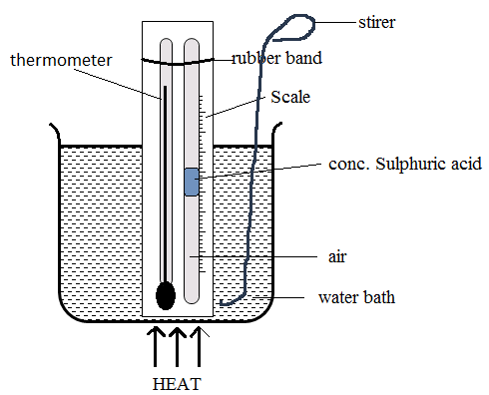
- While stating any measurements to be made, explain how the set up would be used to verify Charles law. (3marks)
- Corresponding values of temperature and volume are recorded
- A graph of volume against temperature is then plotted
- A straight line graph is obtained.

(iii)On the grid shown in the figure below sketch a graph of volume (cm³) against temperature (⁰C) for the experiment above. Clearly mark with the letter T the absolute zero temperature. (1 mark) 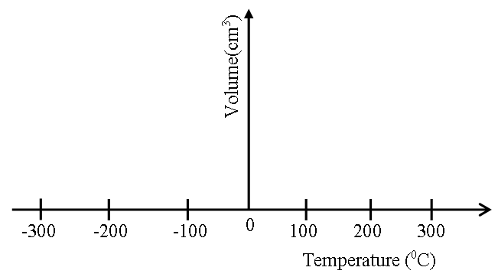

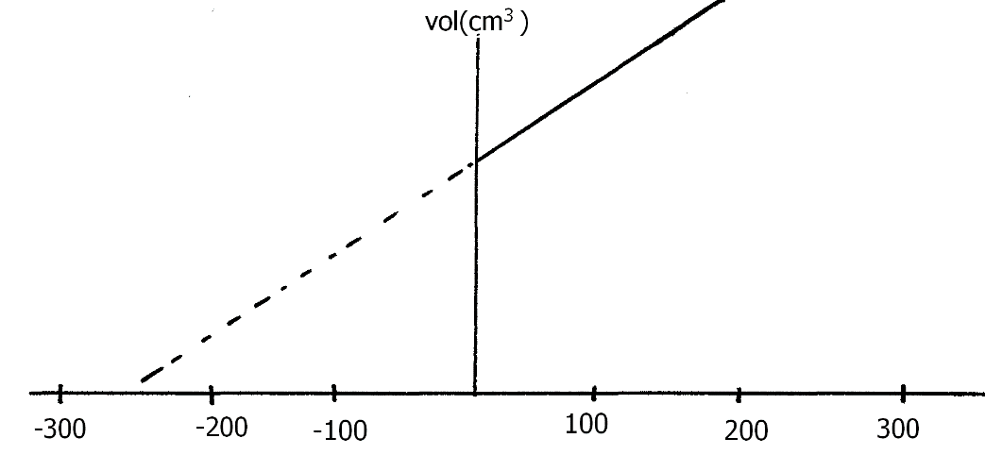

c) A mass of air of volume 750cm³ is heated at constant pressure from 10⁰ C to 100⁰ C. determine the final volume of the air. (2marks)

V₁/T₁=V₂/T₂
750/283=V2/373
V₂= 988.52 cm ³

d) The figure below shows a graph of weights of persons entering a lift against the extension of four similar springs supporting a lift. From the graph determine,

- The spring constant of the springs (3marks)
M=4000-2000/0.2-0.1 =2000/0.1= 20,000N/m

- The spring constant of a single spring (1mrk)
20,000/4 =5,000N/m

THIS IS THE LAST PRINTED PAGE.

