**SUNRISE ONE**

**PHYSICS P3 MS**

**PRE-MOCK 2023**

**QUESTION 1**

**PART A**

(i) Table 1

|  |  |  |  |  |  |  |  |
| --- | --- | --- | --- | --- | --- | --- | --- |
| Angle. iº | 10 | 15 | 20 | 25 | 30 | 35 | 40 |
| y(cm) | 4.5 | 4.3 | 4.1 | 3.9 | 3.7 | 3.5 | 3.4 |

(Check trend)

6 marks – max 6 correct.

1 mark – Each correct

(J) Graph (5 marks)

* 1. yo = 4.9cm 🗸¹ (y – intercept of student)
  2. b = 6.1cm ± 0.1 🗸¹

🗸¹

= 1.245 🗸¹

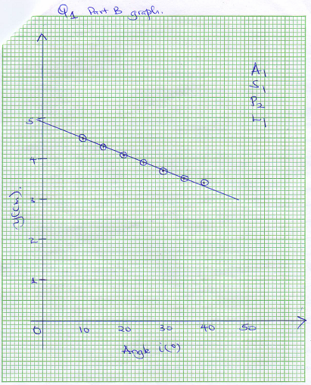

**PART B**

1. h = 15cm ± 1cm 🗸1(must be to 1.d.p)
2. d = 2cm ± 1cm 🗸 [Use students value] (must be to 1.d.p)
3. t = h – d

= 15 – 2(must be to 1.d.p)

= 13cm 🗸[Use students substitution of c and d]

1. M = 61.2 ± 10g🗸 [Use students value]
2. D = 2.53cm ± 0.1cm 🗸(must be to 2.d.p)
3. 🗸
4. M = 12ρπR²



🗸 Correct substitution

= 1.014gcmˉ³ 🗸

**QUESTION 2**

i) **V1 = 0.35 V** + **0.10V**  *at least 1d.p* (1mark)

ii) (1mark)

***Correct substitution ½ mk***

***Correct evaluation to 4 s.f or exact ½ mk***

***If missing unit deny ½mk***

***If wrong units Penalize ½mk***

d) i) **V2 = 0.70 V**+ **0.10V**  *at least 1d.p* (1mark)

ii) (1mark)

***Correct substitution ½ mk***

***Correct evaluation to 4s.f or exact ½ mk***

***If missing unit deny ½mk***

***If wrong units Penalize ½mk***

e)(1mark)

***Principle of averaging shown ½ mk***

***Correct evaluation to 4s.f or exact ½ mk***

***If missing unit deny ½mk***

***If wrong units Penalize ½mk***

f) (2marks)

***Application of the formula***  or  ***1mk***

***Correct evaluation of C to 4s.f or exact 1mk***

***If missing unit deny 1mk***

***If wrong units Penalize 1mk***

h)

|  |  |  |  |  |  |  |
| --- | --- | --- | --- | --- | --- | --- |
| **Current, I (A)** | **0.04** | **0.08** | **0.12** | **0.16** | **0.20** | **0.24** |
| **Voltage, V(V)** | *2.9* | *2.8* | *2.7* | *2.6* | *2.5* | *2.4* |
|  | ***Each 1mk*** *to a max of 4 correct values* ***+ 0.3V*** *at least 1d.p*  *NB: Voltage, V should* ***NOT*** *go beyond* ***3.0V*** | | | | | |

(4marks)

j) (5marks)

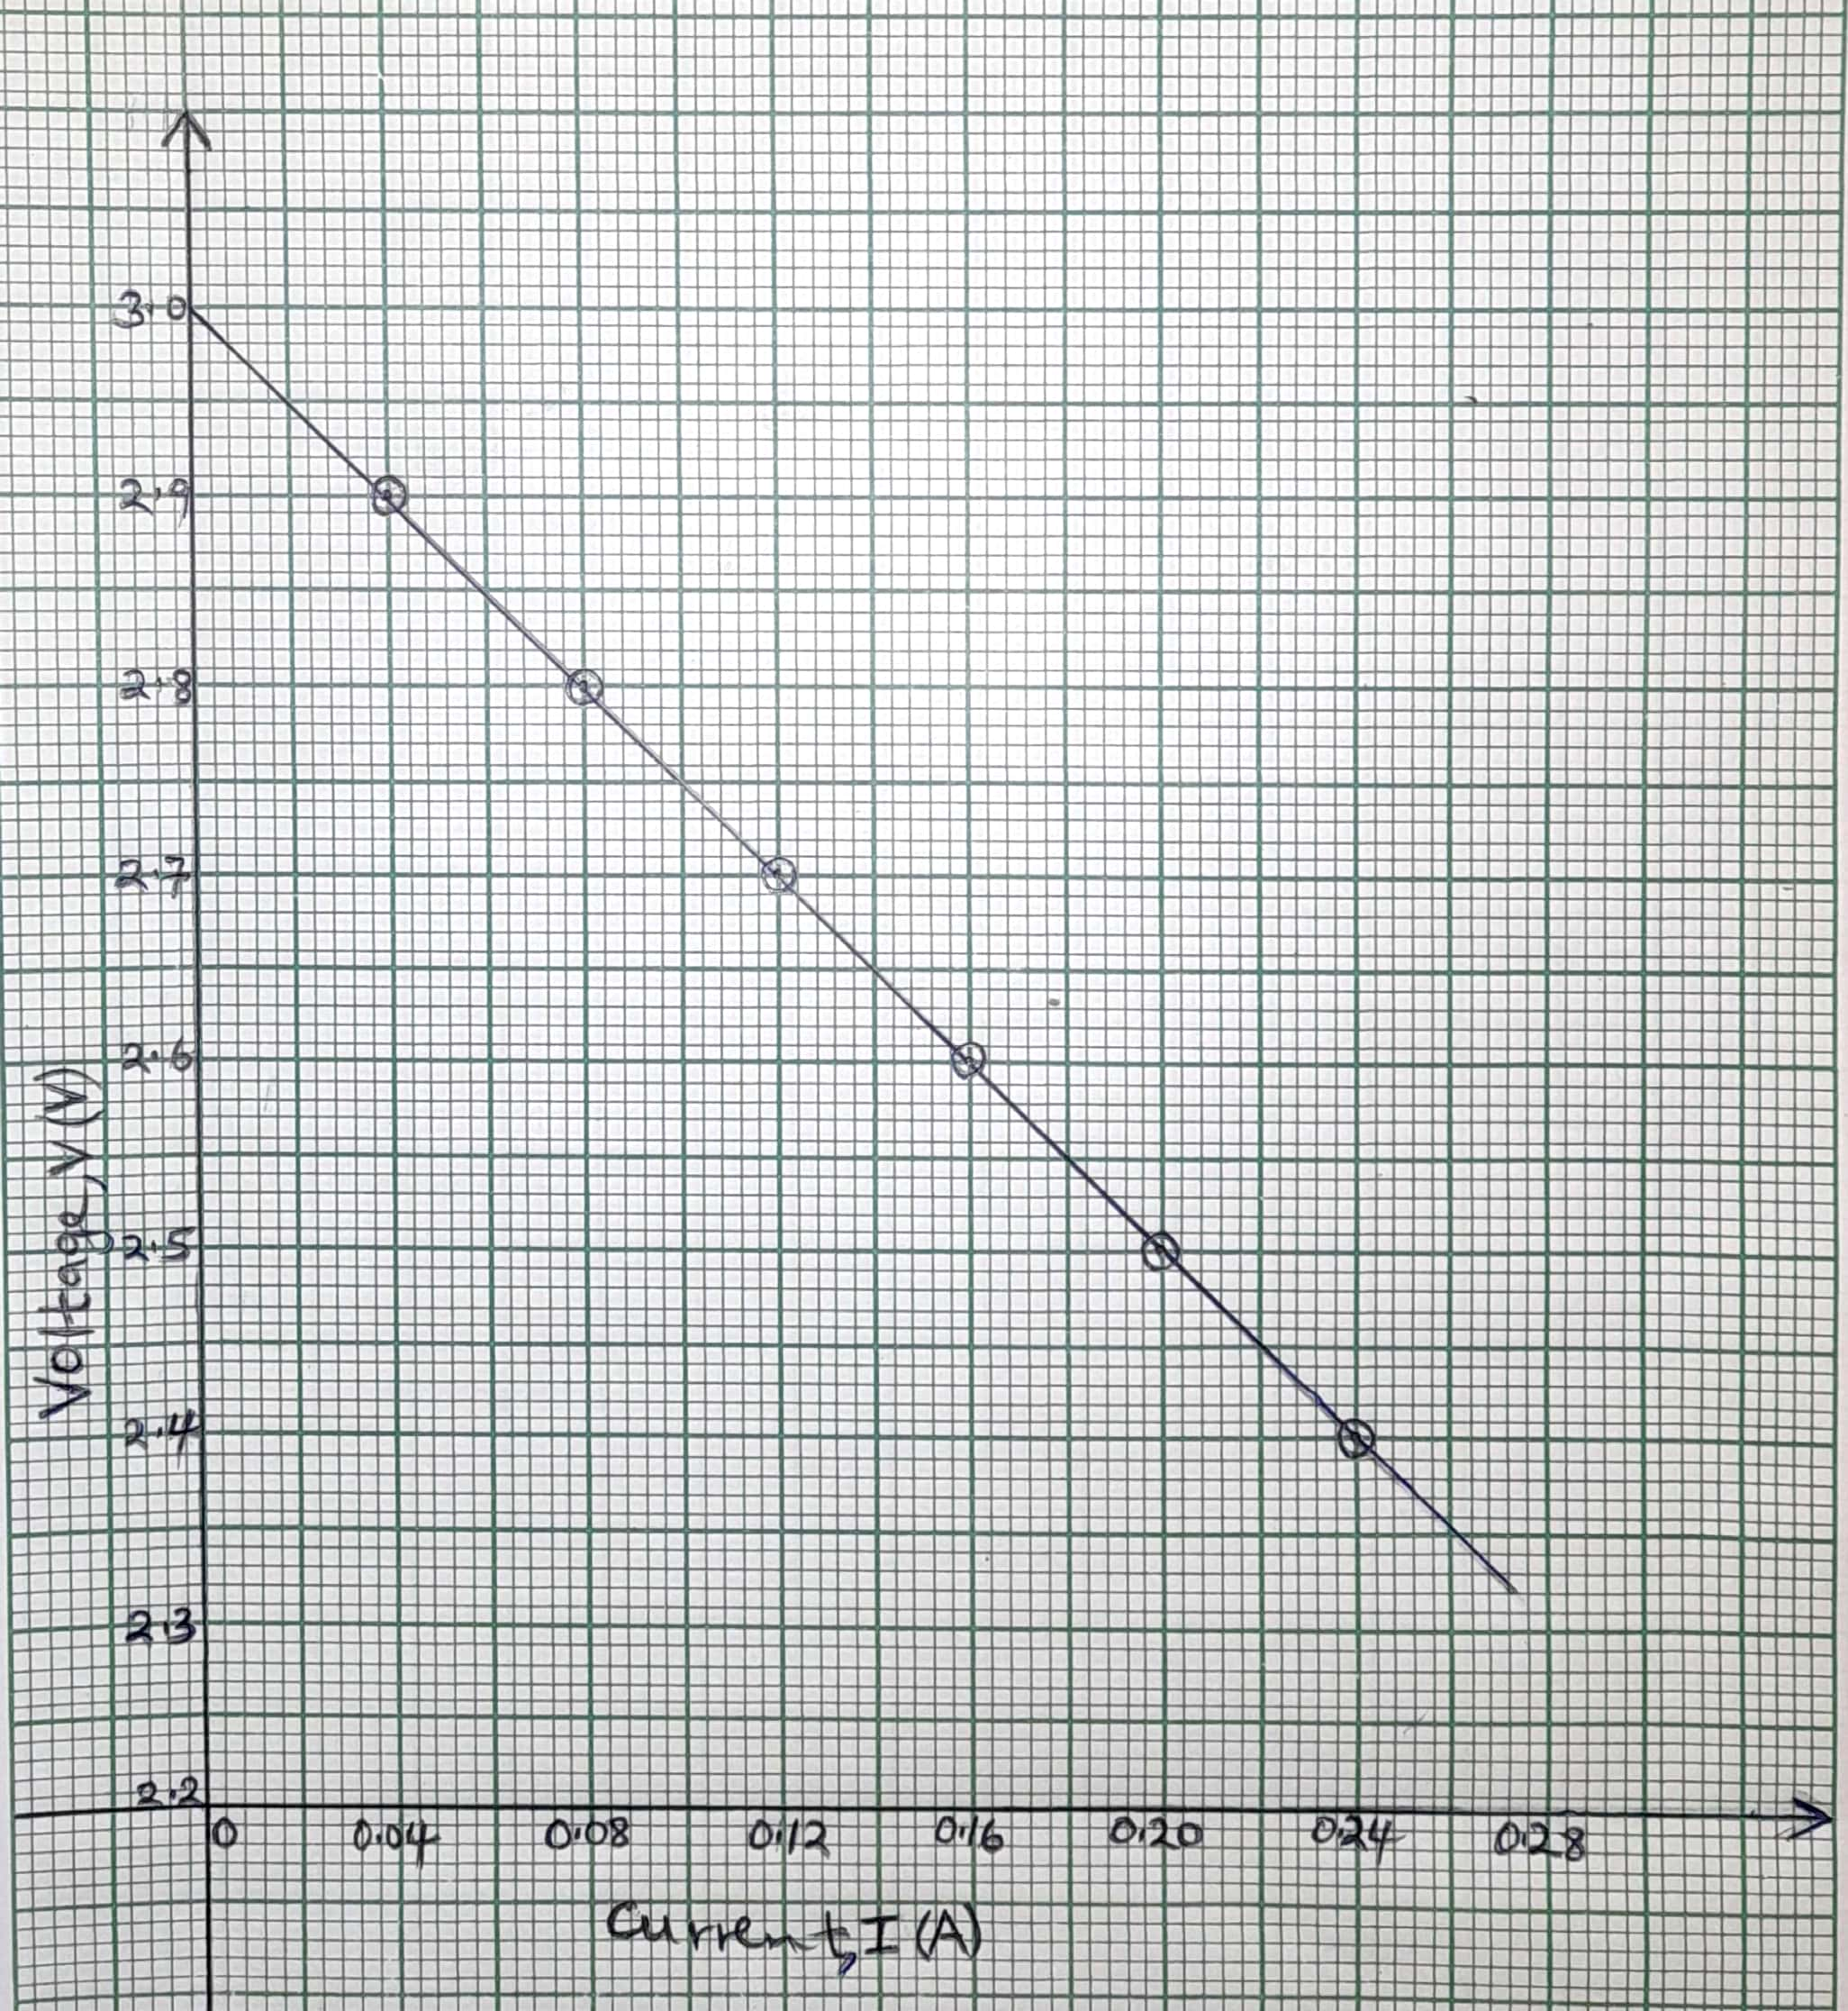

k) (2marks)

***Change in y ½mk***

***Change in x ½mk***

***Correct evaluation to 4s.f or exact 1mk***

***If missing unit deny ½mk***

***If wrong units Penalize ½mk***

l) **E** = ***y – intercept***. (1mark)

***To be read from the graph, so graph should be extrapolated***.

***If missing unit deny ½ mk***

***fully if graph not extrapolated***

**r** = ***Slope*** (1mark)

***Ignore sign***

***If missing unit deny ½mk***