SUNRISE ONE

232/2 PHYSICS PAPER 2

PRE-MOCK 2023 MARKING SCHEME

1. A - microwave

B - for vision

2.

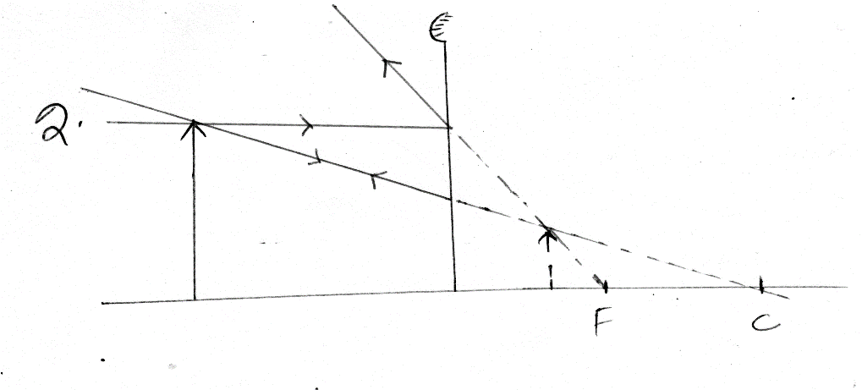

3. (a)

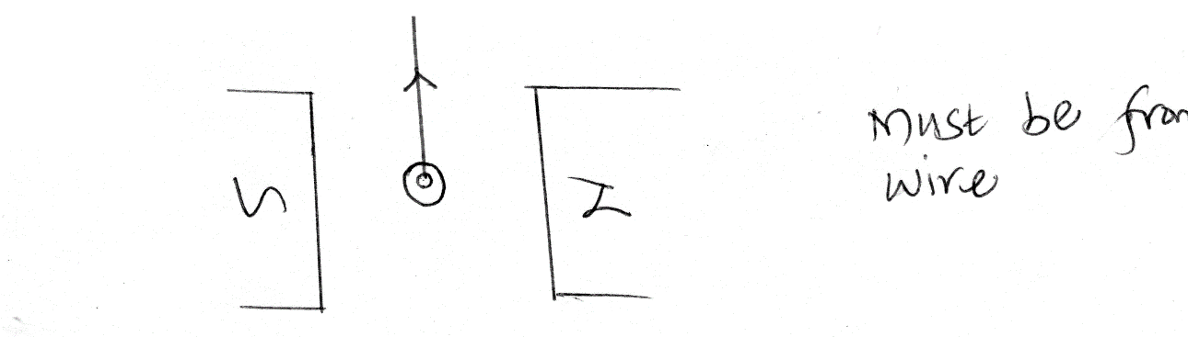

(b) moves on the opposite side.

4 (i) safeguard appliances from excessive current

(ii) P=VI

60=240 I

I=0.25A

5. Ns/Np=Vs/Vp

5/10=Vs/12

Vs=6V

6. 3m+2m=5m

7. the ratio of sine of angle of incidence to sine of angle of refaction is the same for a pair of media.

8. Pd reduces,resistance reduces.

9. a) f =V/ λ V1/λ1=V2λ2

2/1=V2/0.4

V2=0.8m/s

b) used in transformer cores

used in electric motors

10. 90-35=55o

11.

**N S**

12. d=1/2st

1/2x1600x2.4=1920m

13. negative charges

**Section B**

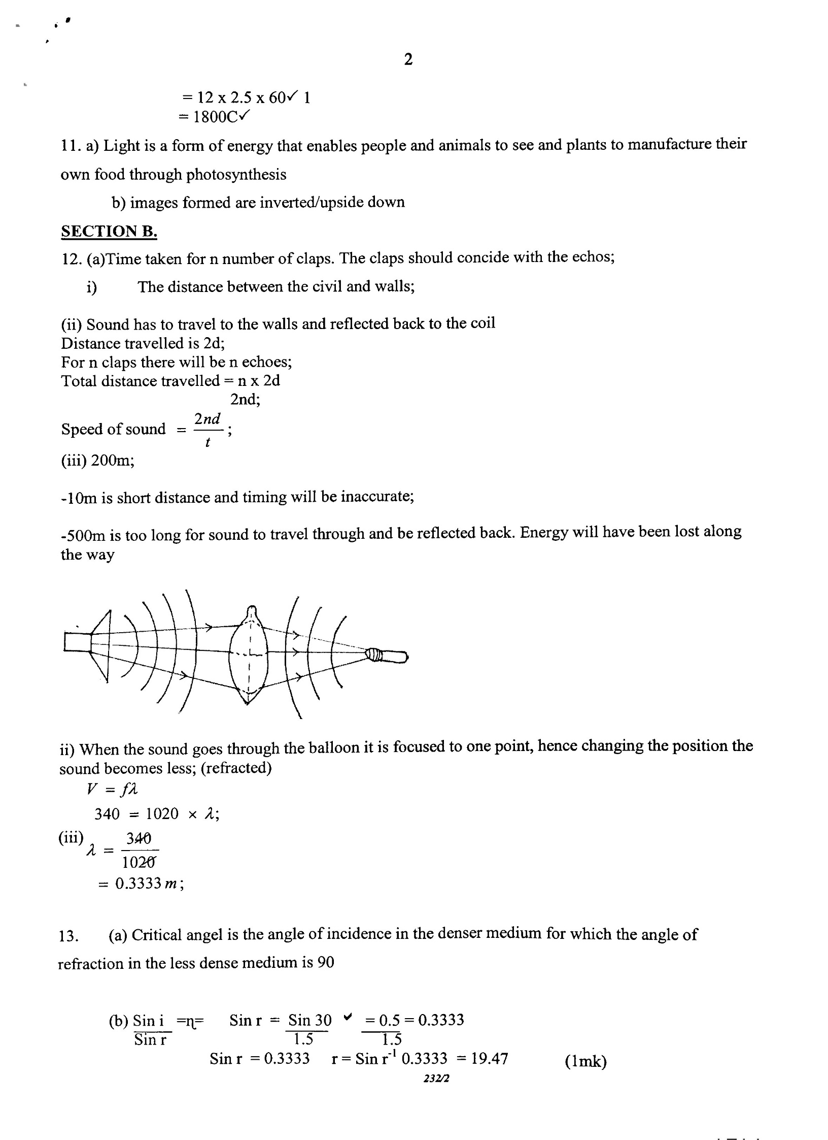

13. (a) Angle of incidence in optically dense medium for which the angle

of refraction in optically less dense medium is 90º. 🗸¹ (1mk)

1. 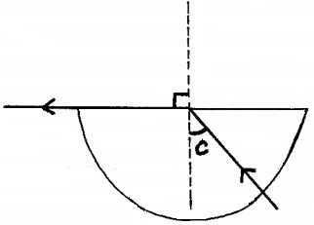(i)

Labeling 🗸¹ (1mk)

(ii)  🗸¹

🗸¹

 🗸¹ (3mks)

1. Move the cardboard with crosswire along the metre rule until a sharp image

of the cross-wires is formed alongside the object cross-wires. 🗸¹

Measure the distance between the lens and the cardboard, 🗸¹ this is equal

to the focal length, f, of the lens.

Repeat the procedure 🗸¹ and find the average value of f. 🗸¹ (4mks)

14. (a) (i) They never cross each other.

(ii) They are close to each other where the field is strong and far apart

where it is weak.

1. They are directed towards the direction in which a free positive

charge would move if placed at the particular point in the field.

1. Start at 90º from the positive charge and end on the negative charge

at 90º. Any 2 (2mks)

(b) (i) Parallel; Co = C1 + C2 = (4 + 2)µF = 6µF 🗸¹





 🗸¹

 🗸¹ (3marks)

(ii) Q = CV = 2 x 10µC

= 20µC 🗸¹ (1mk)

1. Electrical resistance decreases 🗸¹ when thickness of a conductor increases. (1mk)

15. (a) (i) A: Split ring (commutator). 🗸¹

B: Carbon brushes. 🗸¹ (2mks)

1. A (Split ring/commutator).

To reverse the direction of current in the coil after every half turn which

allows continuous rotation of the coil. 🗸¹ (1mk)

B (Carbon brushes).

To provide electrical connection to the coil. 🗸¹ (1mk)

(iii) Concentrates magnetic field towards the coil. 🗸¹ (1mk)

(iv) When current flows through it, it experiences a force, 🗸¹ and

motion 🗸¹ is produced (rotation). (2mks)

(b) (i) Amplitude = 3cm 🗸¹ from the graph. (1mk)

(ii) Time for 1 complete oscillation = 2.0 seconds 🗸¹ (1mk)

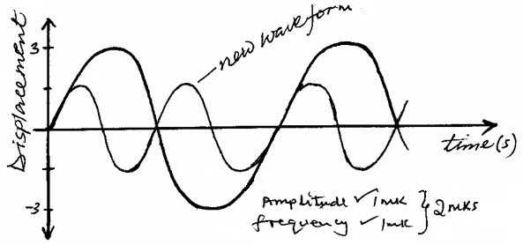 (iii)

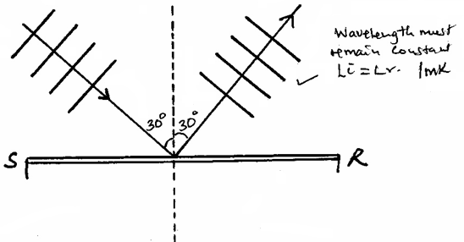

(c)

16. (a) (i) RP=(R1R2)/(R1+R2)

RS=(R1+R2)

(3X6)/(3+6)+8

10Ω

(ii) V=IR

I = 4/3

= 1.333A

(iii) 10-4 =6V

(c) (i) pd across a cell when it is supplying current

(ii) E = IR+Ir

E = (2X0.6)+2r E=1.8V,r = 0.3Ω

E = (1.5+0.9)+1.5r

