Name:……………………………………… Adm No. ……………Class….…….…

School: ………………….... ……………….. Date: ...........................................

231/3
BIOLOGY
Practical
Paper 3
September, 2021
Time: 1 ¾ Hrs

SUNRISE EXAMINATION
Kenya Certificate of Secondary Education (K.C.S.E)
231/3
Biology
Paper 3
September, 2021

INSTRUCTIONS TO CANDIDATES

- Answer all the questions.
- Spend the first 15 minutes of the 1 ¾ hours allowed for this paper reading the whole paper carefully before commencing your work.
- Answers MUST be written in the spaces provided in the QUESTION PAPER ONLY.
FOR EXAMINERS USE ONLY
QUESTION | Max Score | Candidate Score
1 | 14
2 | 12
3 | 14
TOTAL SCORE | 40

- You are provided with olive oil, liquids labeled L₁ and L₂, and an Irish potato. Label test tubes A and B. Place 2cm³ of water into each test tube. Add 8 drops of olive oil into each test tube. To test tube A, add 8 drops of liquid L. Shake both test tubes. Allow to stand for 2 minutes.

- (i) Record your observations (2 marks)
Test Tube A
………………………………………………………………………………………………………………………………………………………………………………………………………………………………
Test Tube B
………………………………………………………………………………………………………………………………………………………………………………………………………………………………
(ii) Name the process that has taken place in test tube A (1 mark)
………………………………………………………………………………………………………………
(iii) State the significance of the process named in (a) above (1 mark)
………………………………………………………………………………………………………………
(v) Name the digestive juice in humans that has the same effect on oil as
liquid L₁ (1 mark)
………………………………………………………………………………………………………………
(v) Name the region of the alimentary canal into which the juice is secreted (1 mark)
………………………………………………………………………………………………………………

- Label two test tubes C and D place 2cm³ of liquid L2 into each test tube. Add a drop of iodine solution into each test tube. Record your observations. (1 mark)
………………………………………………………………………………………………………………………………………………………………………………………………………………………………

- Suggest the identity of L₂ (1 mark)
…………………………………………………………………………………………………………
- Cut a cube whose sides are 1cm³ from the Irish potato. Crush the cube to obtain a paste. Place the paste into a test tube labeled C. add 2cm3 of amylase solution. Leave the set up for at least 30 minutes.
Record your observations (2 marks)
C
………………………………………………………………………………………………………
D
………………………………………………………………………………………………………
- Account for the result in (b)(iii) above (2 marks)
………………………………………………………………………………………………………………………………………………………………………………………………………………
- Cut another cube whose sides are 1cm from the Irish potato. Crush the cube. Place the crushed paste into a test tube. Carry out food test with reagents provided. Record your procedure and results.
Procedure: (1 mark)
………………………………………………………………………………………………………………………………………………………………………………………………………………
Results: (1 mark)
………………………………………………………………………………………………………………………………………………………………………………………………………………
- You are provided with specimen K. Use it to answer the questions that follow
- Cut the specimen K longitudinally. Draw one of the sections (4marks)

- With a reason state the agent of pollination (1mark)
…………………………………………………………………………………………………………………………………………………………………………………………………………………………………………………………………………………………….………………………………………………..
- The photographs labelled Q, R,and S are sections of some plant parts.
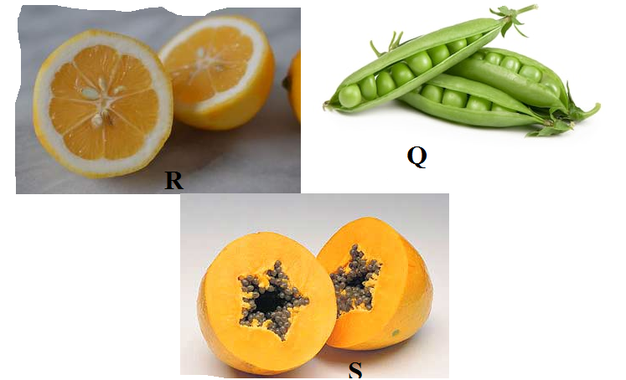

(i ) Name the type of placentation in the specimens shown in photographs Q, R and S (3 marks)
Q………………………………………………………………………………………………….
R………………………………………………………………………………………………….
S………………………………………………………………………………………………….
(ii) Giving a reason in each case, name the mode of dispersal of the specimen in photograph Q and S (4mark)
Q Mode……………………………………………………………………...……………………………..
Reason ………………………………………………………………………………………………………………………………………………………………………………………………………………………………………………………………………………..……………………………………………………………..
S
Mode………………………………..……………………………………………………………………..
Reason
………………………………………………………………………………………………………………………………………………………………………………………………………………………………………………………………………………………………………………………………………………

- Study photographs shown below then answer the questions.

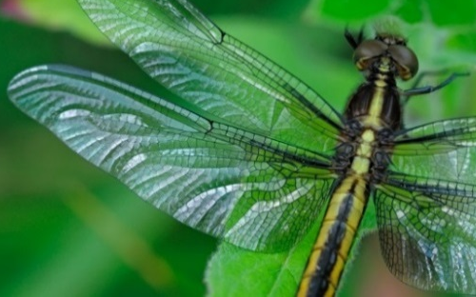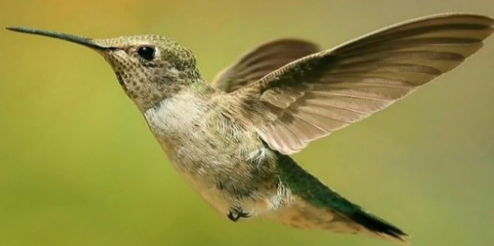
R1
R
Q1
Q
S1
S
A
B
C
M
A1
B1
C1

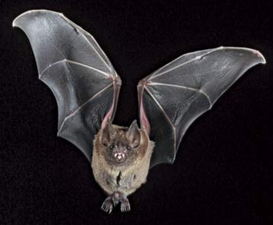

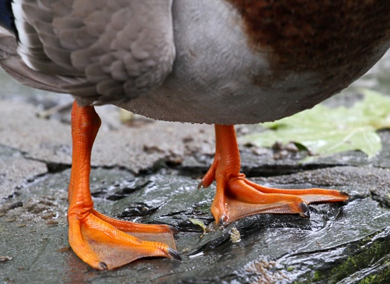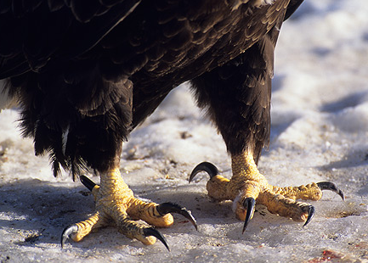

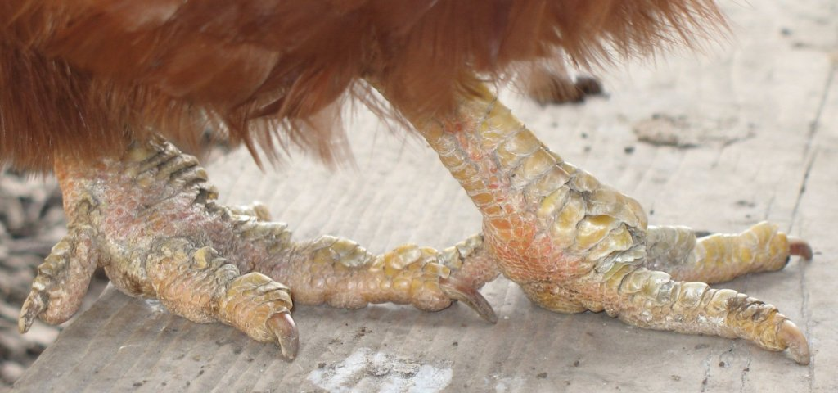
(a) State the type of evolution represented by structures Q1, R1 and S1. (1mk)

……………………………………………………………………………………………………

b) Explain the type of evolution identified in (a) above. (1mk)

……………………………………………………………………………………………………

(c) Give the evolution term used to describe structures;

(i) Q1, R1 and S1. (1mk)

(ii)A1, B1 and C1. (1mk)

d). what type of evolution is illustrated by the limbs (A1, B1 and C1)? (1mk)
………………………………………………………………………………………………………

e). (i) Name classes for organisms labeled Q, R and S.
Q……………………………………………………………...……………………… (1mk)

R………………………………………………………………………...…………… (1mk)

S…………………………………………………………………………………...… (1mk)
(ii) Give two reasons for placing S in the class above (2mks)
………………………………………………………………………………………………………………………………………………………………………………………………………………………………………………………………………………………………………………………………………………………………………………………………………………………………………………………………
f) (i) Suggest the diet of animals B and R.
B…………………………………………..………………………………………… (1mk)

R………………………………………………….……………………………….... (1mk)

(ii) How is beak of animal B adapted to its function? (2mks)

………………………………………………………………………………………………..

…………………………………………………………………………………………………

