BIOLOGY PAPER 3
(Practical)
SUNRISE EXAM
MARKING SCHEME

- (a)
- Test Tube A
- Oil is broken into small or tiny droplets / oil is emulsified;
- Oil is suspended / spread throughout the liquid / cloudy suspension;
(Any 1, 1 mark)
Test Tube B
- Oil floats on water / no mixing / two separate layers / two immiscible layers;

- Emulsification;
- To increase surface area for enzyme / activity / of lipases;
- Bile;
- Duodenum;
Nb: (v) is tied to (iv)

(b)
- Blue black color / colouration;
- Starch solution;
- C - Blue black colour disappears / fades / solution turns brown / yellow;
D – Blue black colour remains;

- Enzyme amylase breaks down / hydroses / converts / digests starch into sugars reducing sugars / maltose; those do not give blue black colour with iodine;

c) Procedure
To a little of the paste in a test tube, add benedicts solution and heat;

Results
Colour changes to yellow / orange / brown precipitate;
- You are provided with specimen K. Use it to answer the questions that follow
- Cut the specimen K longitudinally. Draw one of the sections 4 marks

- With a reason state the agent of pollination 2 Marks
Insect
Bright coloured petals to attract insects
Scented and produce nectar that attract insects that feed on nectar
Pollen grains are relatively large, heavy and rough so as to stick onto the body of the insect
- The photographs labelled Q, R and S are sections of some plant parts.
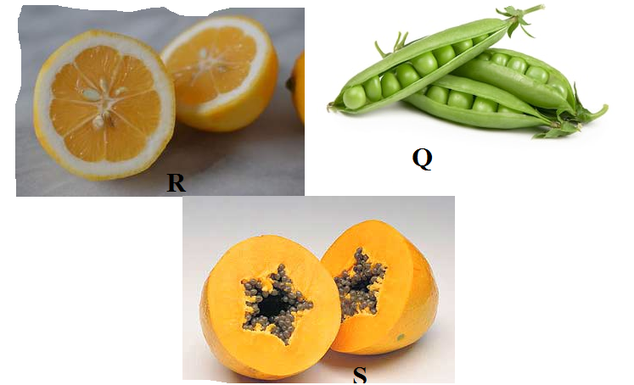

(i)Name the type of placentation in the specimens shown in photographs Q, R and S (3 marks)
Q Marginal placentation
R Axile/ central placentation
S Parietal placentation
(ii)Giving a reason in each case, name the mode of dispersal of the specimen in photograph Q and S (4mark)
Q Mode
Self-dispersal
Reason
Fruits are found inside a pod. The pods contains lines of weakness
S
Mode
Animal
Reason
Succulent and brightly coloured.
- (a) convergent evolution
(b) Different structures with different embryonic origins are modified to perform similar functions
(c) (i) analogous structures
(ii) Homologous structures
d). divergent evolution/ adaptive radiation
e). Q…..…Insecta; R……Aves; S……Mammalia
(f) (i) B………flesh; R……nectar from flowers
(ii) Strong, curved and sharp; to rip flesh from bones.

