SUNRISE ONE TERM 1 EXAMINATION 2023
Kenya Certificate of Secondary Education
FORM FOUR
Form 4 BIOLOGY Term 1

Name ……………………………………………… Adm No: ………….. Index No:…………………..
Class:…………………….. Candidate’s Signiture………..Date………………………….
LEARNER’S TARGET ……………………….
231/3
BIOLOGY
PAPER 3
(PRACTICAL)
APRIL 2023
TIME: 1¾ HOURS.

INSTRUCTIONS TO CANDIDATES
- Answer all the questions.
- You are required to spend the first 15 minutes of the 1¾ hours allowed for the paper reading the whole paper carefully before commencing your work.
- Answers must be written in the spaces provided in the question paper.
- Additional pages must not be inserted.
- This paper consists of 4 printed pages. Candidates should check to ensure that all pages are printed as indicated and no questions are missing

FOR EXAMINER’S USE ONLY
Questions | Maximum score | Candidate's score
Question 1 | 16
Question 2 | 13
Question 3 | 11
Total score | 40

- You are provided five with potato cylinders each measuring 5cm long, liquid S₁ and S₂, Hydrogen Peroxide, dilute Hydrochloric Acid, and test tubes labeled A,B and C.
- i) Place one cylinder in a beaker containing liquid labeled S₁ and another in the liquid labeled S₂. Allow to stand for 30 minutes, then remove the cylinders, wipe them dry using blotting paper. Measure each cylinder in centimeters and record their length and texture in the table given below. (4 marks)

CYLINDER | LENGTH IN CM | TEXTURE
LIQUID S₁
LIQUID S₂

ii) Account for the results obtained in a (i) above (4marks)
………………………………………………………………………………………………………………………………………………………………………………………………………………………………………………………………………………………………………………………………………………………………………………………………………………………………………………………………………………………………………………………………………………………………………………
- Using a scalpel cut one of the cylinders into 5 parts each one centimeter long. Put the pieces into test tube A. Crush the other two using mortar and pestle into a paste. Divide the paste into two equal lots.
Put one lot into test tube B and the other into test tube C.
To each of the test tubes A and B add 2cm³ of hydrogen peroxide and to test tube C add 1 cm³ of dilute Hydrochloric Acid, then 2cm³ of hydrogen peroxide. Record your observation below. (3marks)
Test tube A
………………………………………………………………………………………………………………………………………………..……………………..………………………………………………………
Test tube B
………………………………………………………………………………………………………………………………………………..……………………..………………………………………………………
Test tube C
………………………………………………………………………………………………………………………………………………..……………………..………………………………………………………
(ii) Write a word equation for the reaction that occurs in the test tubes (1mark)
………………………………………………………………………………………………………………………………………………..……………………..………………………………………………………
………………………………………………………………………………………………………………

(iii) Account for the rate of reaction in test tube A, B and C. (4 marks)
A
………………………………………………………………………………………………………………
………………………………………………………………………………………………………………B
………………………………………………………………………………………………………………………………………………..……………………..………………………………………………………
………………………………………………………………………………………………………………C
………………………………………………………………………………………………………………………………………………..……………………..………………………………………………………
………………………………………………………………………………………………………………
- Below are sections of a dicotyledonous plant organs labeled X and Y.
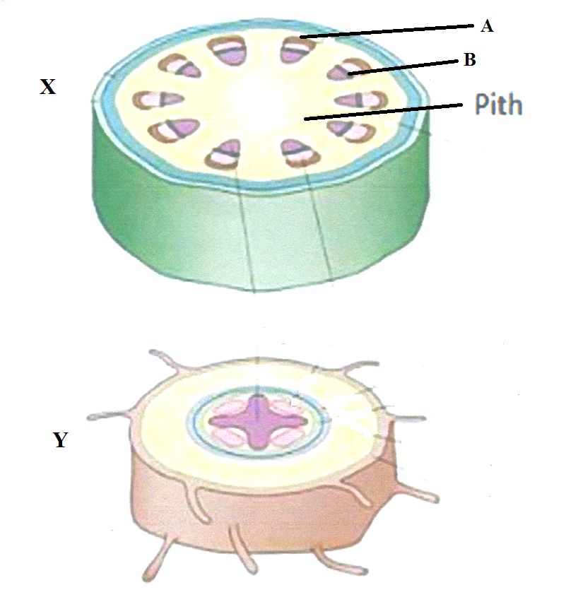

(a) Give three observable differences between the sections. (3 marks)
……………………………………………………………………………………………………………………………………………………………………………………………………………………………………………………………………………………………………………………………………………………………………………………………………………………………………………………………………………………………………………………………………………………………………………………………
(b) On the diagram, label any three parts of section Y. (3 marks)

(c) Identify and state the functions of the parts labeled A and B. (4 marks)
A ………………………………………………………………………………………………………………
Function……………………………………………………………………………………………………………………………………………………………………………………………………………………………………………………………………………………………………………………………………………
B ………………………………………………………………………………………………………………
Function……………………………………………………………………………………………………………………………………………………………………………………………………………………………………………………………………………………………………………………………………………
(d) How would section X compare with that of a monocotyledonous plant? (3 marks)
………………………………………………………………………………………………………………………………………………………………………………………………………………………………………………………………………………………………………………………………………………………………………………………………………………………………………………………………………………………………………………………………………………………………………………………………………………………………………………………………………………………………………………

- Study the photographs below and answer the questions that follow.
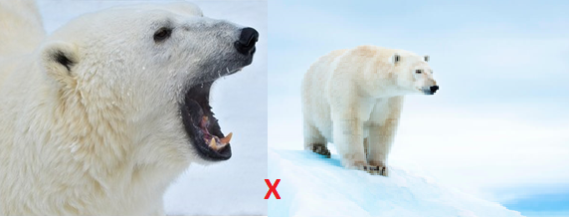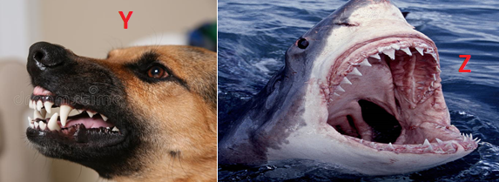
- Give two visible survival adaptive features for the organism in photograph X. (2 marks)
…………………………………………………………………………………………………………..
…………………………………………………………………………………………………………..
- Identify the dentitions exhibited in photograph Y and Z (2 marks)
Y ……………………………………………………………………………………………………….
Z ……………………………………………………………………………………………………….

- Study the photographs below showing a certain type of tooth and teeth arrangement in man.
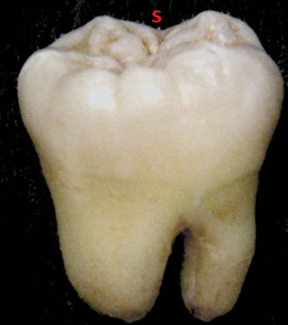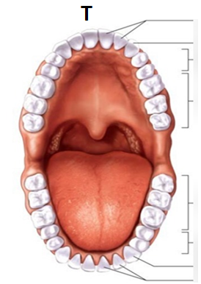
S

- Label any three parts of the tooth in photograph S. (3 marks)
- Give two adaptations of the tooth to its function. (2 marks)
…………………………………………………………………………………………………………
…………………………………………………………………………………………………………
- Write the dental formula for the teeth arrangement in photograph T. (1 mark)

