SUNRISE 1 EXAMINATION TERM 1
FORM FOUR
BIOLOGY
PAPER 3
MARKING SCHEME
- a) i)

Cylinder | Length in cm | texture
Liquid s₁ | 5.1-5.2 | (very hard /stiff/firm
Liquid s₂ | 4.9-4.8 | Soft /flabby/flexible

ii) S₁ has lower concerntration /lower osmotic pressure /hypotonic /more dilute than the cell sap of potato cells; water enters the potato cell by osmosis making the cells turgid /increasing the size of cells;
S₂ has higher concentration / higher osmotic pressure /hypertonic than cell sap of potato cells;water is lost from the cell by osmosis making them flaccid /decreasing the size of cels.l (4marks)
b i) Test tube A ; less foam /bubbles /froth formed /slow effervescence /fizzing /frothing;
Test tube B: more foam /bubbles /froth firmed //rapid effervescence /fizzing /frothing;
Test tube C: little /small bubbles formed; 3marks
ii) Hydrogen catalase water +oxygen
Peroxide 1mark
iii) Test tube A
The potato pieces provide a smaller surface area for enzyme action
Test tube B
The crushed potato cylinder provides a larger surface area for enzyme action
Test tube C
Dilute hydrochloric Acid alters /lowers the ph making it less favourable /suitable for enzyme catalase activity
(6marks)
- a)
X | Y
Xylem in a ring | Xylem star shaped
No root hair | Presence of root hair

b).

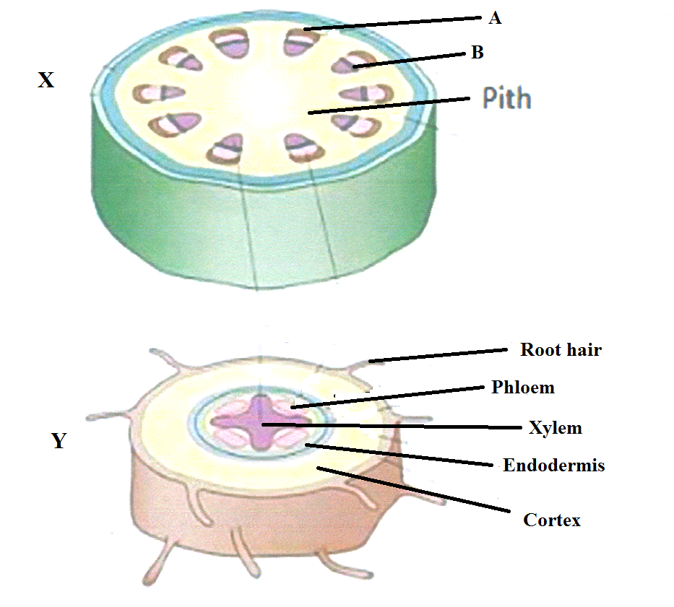
c). A Sclerenchyma;- Provide strength and support;
B Cambium; –Give rise to new Xylem and new Phloem;
d). In monocots, the vascular bundle is scattered in the ground tissue; No pith; No cambium;
- Study the photographs below and answer the questions that follow.
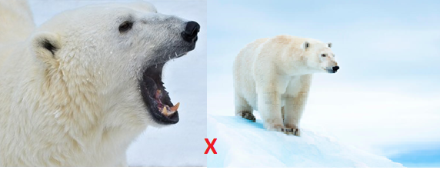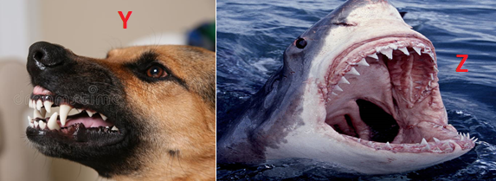
- Give two visible survival adaptive features for the organism in photograph X (2mks)
- Presence of ( large/long/curved) sharp/sharp pointed canine for piercing ;
- Camouflage/blend well with environment concealing/hiding themselves from their predators/prey ;
- Presence of fur to insulate against the low temperature
- Identify the dentitions exhibited in photograph Y and Z (2mks)
Y Heterodont
Z Homodont
- Study the photographs below showing a certain type of tooth and teeth arrangement in man.
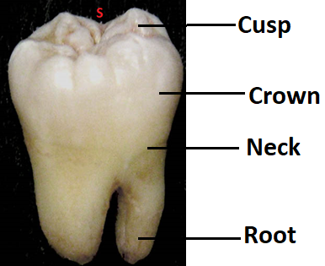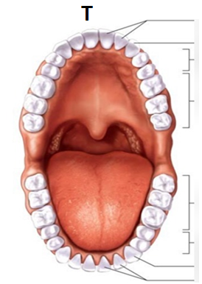
- Label any three parts of the tooth in photograph S (3mks)
- Give two observable adaptations of the tooth to its function (2mks)
- Broad surface to increase surface area for chewing
- Cusps /ridges to increase surface area for chewing
- Write the dental formula for the teeth arrangement in photograph T (1mk)
2 1 2 3
i — c - pm — m -
2 1 2 3
Reject
- If Commas and capital letters are used in the dental formula
- If Divisional line is missing in the dental formula

