Kenya Certificate of Secondary Education
WISDOM PRE-MOCK CLUSTER EXAMS
231/3 – BIOLOGY – Paper 3
(Practical)
SEPTEMBER 2021 - 1 ¾ hours
Name………………………………………Adm No……
Class…………… Date……………………………
Instructions to Candidates
- Write your name, Admission number and your other details in the spaces provided above.
- Spend the first 15 minutes of the time allocated to read through the question paper before commencing your work
- Answer all the questions in the spaces provided.
- Additional pages must not be inserted
- For Examiner's Use Only
Question | Maximum Score | Candidate’s Score
1 | 14
2 | 14
3 | 12
Total Score | 40

- You are provided with the following reagents and materials.
Specimen R
Benedict’s solution
Sodium hydroxide solution
Copper sulphate solution
Source of heat
3 test tubes in a rack
Droppers
Scalpel/Razor blade
Pestle and mortar
Filter paper
Study the specimen R provided.
(a) Identify the type of fruit (1mk)
Pome
(b) With reasons, identify the method of dispersal for the specimen.
Method of dispersal (1mk)
Animal
Reasons (2mks)
- Brightly coloured
- Pleasant scent
- Succulent /juicy
- Sweet tasting
(c) By use of the scalpel provided, peel off the outer cover of the specimen R to reveal the inner juicy part. Extract a small portion of the juicy part, place in a mortar and mash it using a pestle.
Use the filter paper provided to filter the extract from the specimen R.
Divide the extract from specimen R into two portions each 2cm³ and use them as follows;
Portion one
Use the reagents provided to test for the food substances present in portion 1. Use the table below as a guide. (6mks)

Food substance | Procedure | Observation | Conclusion
Reducing sugars | - Put 1ml of portion 1 into a test tube  - Add 1ml of Benedict’s solution  - Boil
Proteins | - Put 1ml of portion 1 into a test tube  - Add 1ml of Sodium hydroxide solution  - Add Copper Sulphate solution dropwise
Portion two
(d) (i) To 1cm³ of DCPIP in a test tube, add 0.1% solution of Ascorbic acid drop by drop until the colour of DCPIP disappears. Shake the test tube after addition of each drop. Record the number of droplets used. (1mk)
………………………………………………………………………………………………………………
ii) To another 1cm³ of DCPIP in a test tube add the portion two drop by drop, shaking the test tube after addition of each drop until the colour of DCPIP disappears. Record the number of drops used (1mk)
………………………………………………………………………………………………………………
iii) From the results obtained in (e) (i) above, calculate the percentage of Ascorbic acid in the juice obtained from specimen R. Show your working (2mks)

………………………………………………………………………………………………………………
………………………………………………………………………………………………………………
………………………………………………………………………………………………………………

- Study the photographs below and answer the questions that follow.
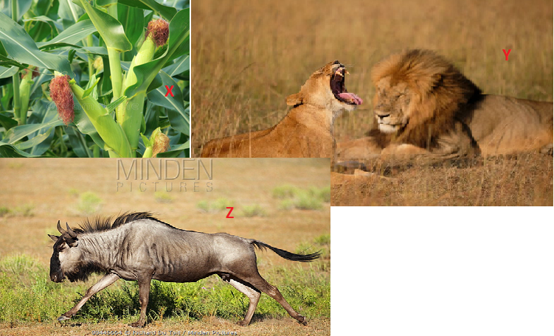
- (i) By use of a flow chart, show the possible energy flow in the ecosystem above (1mk)
(ii) State two ways in which energy is lost from one trophic level to the next one (2mks)
Heat energy in;
- Breathe of animals
- Urine
- Faeces
- With observable reasons, identify the classes of specimen X and Z
Specimen X
Class Monocotyledonae
Reasons
- Parallel venation in leaves
- Presence of leaf sheath
Specimen Z
Class Mammalia
Reason
- Presence of mammary glands
- Presence of fur
- Describe two adaptations of organism labeled Y to its habitat (2mks)
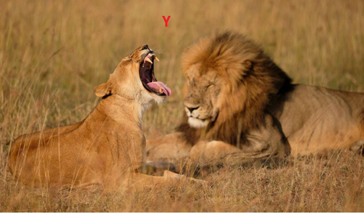
- {Large /long/curved}Sharp /pointed canine to pierce/kill prey
- Camouflaged/blend well in environment to conceal/hide from prey
- Study the photograph below and answer the questions that follow.
- Which part of the plant is represented by the cross-section shown above (1mk)
- Root
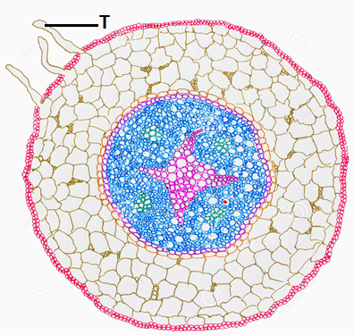
- Give two observable reasons for your answer in (d)(i) above (2mks)
- Presence of root hairs
- Xylem forms a star shape
- Phloem is found between the two rays of the star
- Give one adaptation of the part labeled T to its function (1mk)
- Long to provide a large surface area for absorption of water and mineral salts
- Has numerous mitochondria to supply energy for active transport
- Has thin cell wall for rapid movement of materials
- Has large cell vacuole to store absorbed water and mineral salts
- Has cell vacuole containing high solute concentration to maintain high osmotic pressure to absorb water
- Study the photographs below and answer the questions that follow.
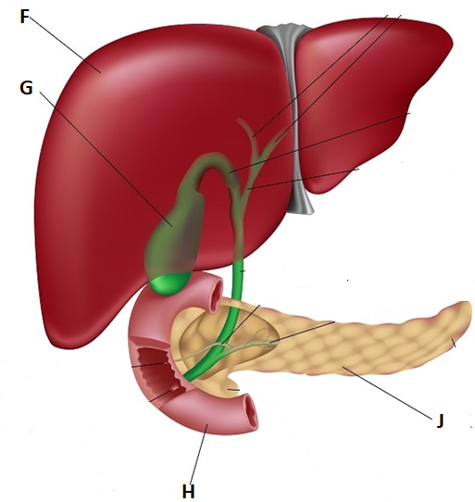
- Identify the following parts (2mks)
F Liver
G Gall bladder
- (i) Identify the secretions stored in part labeled G (1mk)
- Bile /bile salts
(ii) Give two functions of the secretions you have identified in (b)(i) above (2mks)
- Emulsification /break fats into tiny droplets
- Provide alkaline medium for working of digestive enzymes
- Neutralize the acidic chime from the stomach
- (i) Give two major roles of the part labeled J (2mks)
- Secretion of hormones/secretin
- Secretion of digestive juices
(ii) State the hormone secreted by the part labeled H (1mk)
- Cholecystokinin

- Study the photograph below and answer the questions that follow.
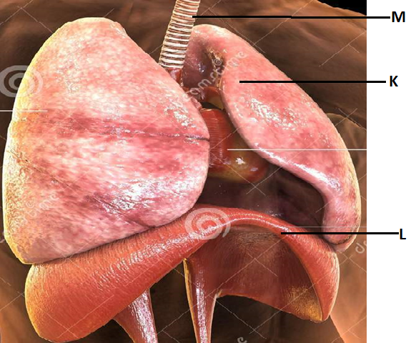
- (i) Identify the following parts (2mks)
K Lung/left lung
L Diaphragm
(ii) Give two adaptations of the part labeled M (2mks)
- Has rings of cartilage to prevent the collapse of trachea during exhalation/- enable the tubes to be stretched e.g. during coughing.
- Hollow to allow passage of air
- Has mucus secreting cells that trap and filter micro-organisms and dust particles preventing them from entering the lungs.
- Is lined with cilia which move /waft mucus upwards into the pharynx
- Endothelium is moist to moisten the inhaled air
This is the last printed page

