NAME _______________________________________________________ ADM NO ______________
DATE ________________________________ SIGNATURE __________________
INDEX NUMBER: ________________________________________________________________

231/2
BIOLOGY
Paper 2
TIME: 2 HOURS
September/October
WISDOM PRE-MOCK EXAMINATIONS 2021
Kenya Certificate of Secondary Education
231/2
BIOLOGY
PAPER 2
TIME: 2HRS
Instructions to Candidates
(a) This paper consists of two sections; A and B.
(b) Answer all the questions in section A in the spaces provided after each question.
(c) In section B answer question 6 (compulsory) and either question 7 or 8 in the spaces
provided after question 8.
(d) Candidates should answer the questions in English
For Examiner’s Use Only
SECTION | QUESTIONS | MAXIMUM SCORE | CANDIDATE  SCORE
A | 1
 | 2
 | 3
 | 4
 | 5
B | 6
 | 7
 | 8
TOTAL SCORE

- Study the table below and answer the questions that follow. Organisms A and B are of the same size.

FOOD SUBSTRATE | Organism A | Organism B
 | Amount of energy produced in KJ/MOL | Amount of energy produced in KJ/MOL
Carbohydrates | 2898 | 211
Fats | 6478 | 375
Proteins | 3750 | 222
- Name the process that is responsible for the energy production in organism A. (1mark)
……………………………………………………………………………………………………………………………………………………………………………………………………………………………………………………………………………………………..
- Account for the energy production in organisms A and B. (2 marks)
………………………………………………………………………………………………………………………………………………………………………………………………………………………………………………………………………………………………………………………………………………………………………………………………………………………………………………………………………………………………………………………………………………………………………………………………………………………………………………
- State two reasons why fats are not the main food substrate in organism A. (2 marks)
………………………………………………………………………………………………………………………………………………………………………………………………………………………………………………………………………………………………………………………………………………………………………………………………
- Explain how age affects energy production in organism A. (2 marks)
………………………………………………………………………………………………………………………………………………………………………………………………………………………………………………………………………………………………………………………………………………………………………………………………

- State one economic importance of the process that occurs in organism B. (1 mark)
………………………………………………………………………………………………………………………………………………………………………………………………………………………………………………………………………………………………………………………………………………………………………………………………
2. An investigation was performed by a group of students as shown in the set up below.
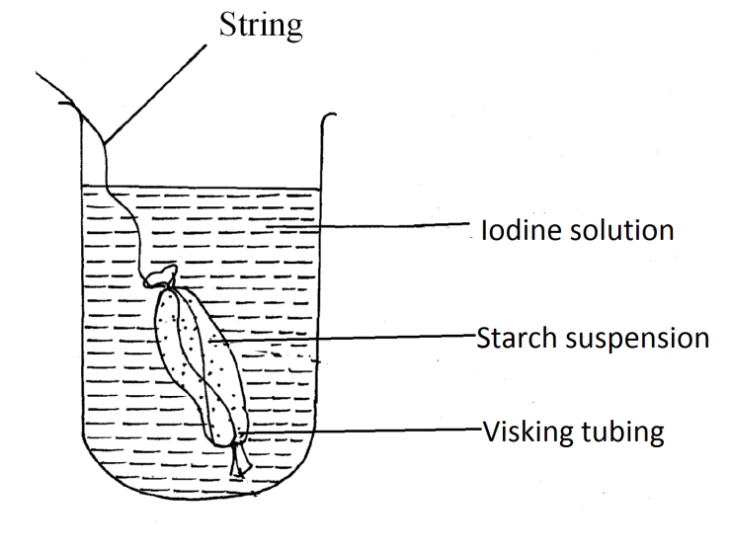
After 30 minutes, the starch suspension had turned blue-black while iodine solution retained its colour.
(a) Name the physiological process that was being investigated in the experiment. (1 mark)
…………………………………………………………………………………………………………………………………………………………………………………………………………........
(b) Account for the results observed after 30 minutes. (3 marks)
………………………………………………………………………………………………………………………………………………………………………………………………………………………………………………………………………………………………………………………………………………………………………………………………………………………………………………………………………………………………………………………………………………………………………………………………………………………………………………

(c) Explain what would happen to a red blood cell when placed in distilled water and left to
stand for the same duration as for the experiment above. (3 marks)
……………………………………………………………………………………………………………………………………………………………………………………………………………………………………………………………………………………………………………………………………………………………………………………………………………………………… (d) Define cell physiology. (mark)
………………………………………………………………………………………………………………………………………………………………………………………………………………3 .In an investigation, equal amounts of water was placed in three test tubes A, B and C. Water plant of equal length were dropped in each test tube. The test tubes were then placed in identical conditions of light and carbon iv oxide at different temperatures for five minutes. After five minutes, the bubbles produced in each test tube were counted for two minutes .The results were recorded in the table below.
Test tube | Temperature (℃) | Number of bubbles
A | 25 | 30
B | 36 | 42
C | 57 | 12

- (i) Name one requirement for this process that is not mentioned in the
investigation. (1mark)
………………………………………………………………………………
- Name the gas produced in the investigation (1mark)
……………………………………………………………………………………. ……………………………………………………………………………………..
- Account for the results in the test tube B and C (2 marks)
……………………………………………………………………………………… ………………………………………………………………………………………

(b) State two ways in which the human intestinal villus is adapted to its function. (4 marks)
………………………………………………………………………………………………………………………………………………………………………………………………………………………………………………………………………………………………………………………………………………………………………………………………………………………………
4. Sickle cell anaemia is a hereditary disease due to a recessive gene which changes normal
haemoglobin (Hb – A) to abnormal haemoglobin (Hb – S). The red blood cells of people
with sickle cell anaemia are sickle shaped.
- What are the possible phenotypes of the offspring of a man who is heterozygous and a woman who is also heterozygous? Show your working. (5 marks)
…………………………………………………………………………………………………………………………………………………………………………………………………………………………………………………………………………………………………………………………………………………………………………………………………………………………………………………………………………………………………………………………………………………………………………………………………………………………………………………………………………………………………………………………………………………………………………………………………………………………………………………………………………………………………………………………………………………………………………………………………………………………………..
- Sickle cell trait is more prevalent in tropical countries than in temperate countries. Give an explanation for this observation. (2 marks)
………………………………………………………………………………………………………………………………………………………………………………………………………………………………………………………………………………………………………………………………………………………………………….
- Define non-disjunction (1 mark)
……………………………………………………………………………………………………………………………………………………………………………………………………………………………………………………………………………..

5. The diagram below shows structures of the bat wing and human arm.
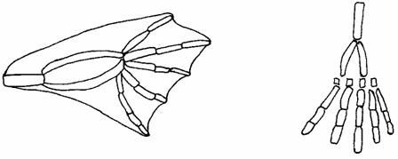
Wing membrane

(a)These structures are thought to have same ancestral origin. State one structural similarity
and one adaptational difference between the two.

- Structural similarity. (1 mark)
……………………………………………………………………………………………………………………………………………………………………………………………………………………………………………………………….
- Adaptation difference. (2 marks)
………………………………………………………………………………………………………………………………………………………………………………………………………………………………………………………………………………………………………………………………………………………………………………………………………………………………………..

(b) Give two other examples of structures in nature that show the type of evolution as in
(a) above. (2 marks)
………………………………………………………………………………………………………………………………………………………………………………………………………………………………………………………………………………………………………………………………………………………………………………………………………………………………………………………………………………………………

(c) Distinguish between the terms ‘chemical evolution’ and ‘organic evolution’. (2 marks)
…………………………………………………………………………………………………………………………………………………………………………………………………………………………………………………………………………………………………………………………………………………………………………………………………………………………………………………………………………………………………………………………………………………………………………………………………………………………………………….
(d) What is the study of fossils called? (1 mark)
…………………………………………………………………………………………………………………………………………………………………………………………………………………………………………………………………………………………………………………….
6. The table below shows how quantities of sweat and urine vary with external temperatures
External temperature (⁰c) | Urine cm³/h | Sweat cm³/h
0  5  10  15  20  25  30  35 | 100  90  80  70  60  50  40  30 | 5  6  10  20  30  60  120  200

(a) Using the same axes, draw a graph of quantity of urine and sweat against the external
temperature. (7 marks)

(b) (i) State the quantity of urine and sweat produced when external temperature was 12.5⁰c. (2 marks)
.................................................................................................................................................................................................................................................................................................................................................................................................................................................................................
(ii) State the physical process through which the body was cooled by sweating as temperature was rising. (1 mark)
............................................................................................................................................................................................................................................................................................................................................................................................................................................................................................................................................................................................................................................
(iii) Account for the quantity of urine produced as the temperature increased. (4 marks)
.........................................................................................................................................................................................................................................................................................................................................................................................................................................................................................................................................................................................................................................................................................................................................................................................................................................................................................................................................................................................................................................................................................................................................................................................................................................................................................................................................................................................................................................................
(c) State three nitrogenous wastes that could be eliminated in urine or sweat in human beings. (3 marks)
................................................................................................................................................................................................................................................................................................................................................................................................................................................................................................................................................................................................................................................
(d) State three behavioral mechanisms that poikilotherms use to regulate their body temperature under hot conditions. (3 marks)
...................................................................................................................................................................................................................................................................................................................................................................................................................................................................................
7. Describe how mammalian heart is adapted to its functions. (20 marks)
8. Giving examples, describe the following relationships among living organisms. (20 marks)
(i) Parasitism
(ii) predator-prey
(iii) Symbiosis
..........................................................................................................................................................................................................................................................................................................................................................................................................................................................................................................................................................................................................................................................................................................................................................................................................................................................................................................................................................................................................................................................................................................................................................................................................................................................................................................................................................................................................................................................................................................................................................................................................................................................................................................................................................................................................................................................................................................................................................................................................................................................................................................................................................................................................................................................................................................................................................................................................................................................................................................................................................................................................................................................................................................................................................................................................................................................................................................................................................................................................................................................................................................................................................................................................................................................................................................................................................................................................................................................................................................................................................................................................................................................................................................................................................................................................................................................................................................................................................................................................................................................................................................................................................................................................................................................................................................................................................................................................................................................................................................................................................................................................................................................................................................................................................................................................................................................................................................................................................................................................................................................................................................................................................................................................................................................................................................................................................................................................................................................................................................................................................................................................................................................................................................................................................................................................................................................................................................................................................................................................................................................................................................................................................................................................................................................................................................................................................................................................................................................................................................................................................................................................................................................................................................................................................................................................................................................................................................................................................................................................................................................................................................................................................................................................................................................................................................................................................................................................................................................................................................................................................................................................................................................................................................................................................................................................................................................................................................................................................................................................................................................................................................................................................................................................................................................................................................................................................................................................................................................................................................................................................................................................................................................................................................................................................................................................................................................................................................................................................................................................................................................................................................................................................................................................................................................................................................................................................................................................................................................................................................................................................................................................................................................................................................................................................................................................................................................................................................................................................................................................................................................................................................................................................................................................................................................................................................................................................................................................................................................................................................................................................................................................................................................................................................................................................................................................................................................................................................................................................................................................................................................................................................................................................................................................................................................................................................................................................................................................................................................................................................................................................................................................................................................................................................................................................................................................................................................................................................................................................................................................................................................................................................................................................................................................................................................................................................................................................................................................................................................................................................................................................................................................................................................................................................................................................................................................................................................................................................................................................................................................................................................................................................................................................................................................................................................................................................................................................................................................................................................................................................................................................................................................................................................................................................................................................................................................

