WISDOM PRE-MOCK TERM 1 2021
MARKING SCHEME BIOLOGY PAPER 2 JOINT EXAM
1 a) Name the process that is responsible for the energy production in organism A. (1mark)
Aerobic respiration;
b) Account for the energy production in organisms A and B. (2 marks)
In organism A, aerobic respiration takes place leading to complete oxidation of food substrate; thus higher energy production while in B, there is anaerobic respiration leading to partial/incomplete oxidation of the food substrates; hence lower energy production.
c) State two reasons why fats are not the main food substrate in organism A. (2 marks)
-Fats require a lot of oxygen to be oxidised; -Fats are insoluble thus takes time to be transported to the respiratory sites (Cytoplasm and Mitochondria);
d) Explain how age affects energy production in organism A. (2 marks)
Young organisms have actively dividing cells; thus high respiration rate resulting in high energy production;
e) State one economic importance of the process that occurs in organism B.(1 mark)
-Production of biogas;
-Manufacture of alcoholic drinks;
-Manufacture of dairy products such as cheese;
-Manufacture of organic acids such as oxalic acids;
-Used in sewage treatment plants;

2. An investigation was performed by a group of students as shown in the set up below.
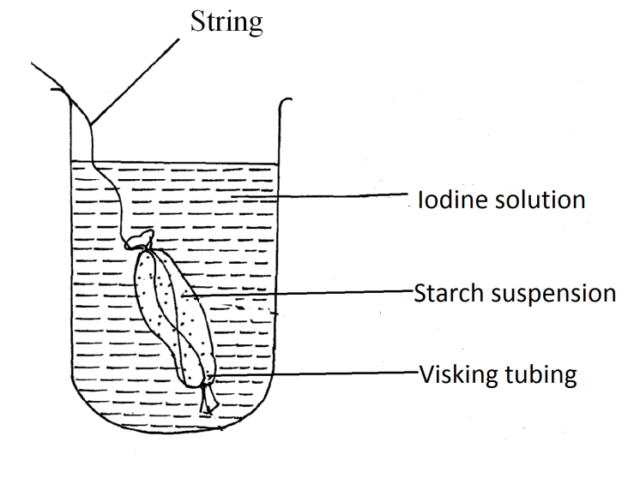
After 30 minutes, the starch suspension had turned blue-black while iodine solution retained its colour.
(a) Name the physiological process that was being investigated in the experiment. (1 mark)
Diffusion;
(b) Account for the results observed after 30 minutes. (3 marks)
Visking tubing is semi-permeable; allowing the small sized Iodine molecules to pass through; but preventing the large sized starch molecules from crossing;
(c) Explain what would happen to a red blood cell when placed in distilled water and left to stand for the same duration as for the experiment above. (3 marks)
The cell is hypertonic to the solution / distilled water; hence water molecules moved into the cell by osmosis; making the cell to swell and eventually burst/haemolysis;
(d) Define cell physiology. (1 mark)
It is the study of the functions of cell structures;
3.(a) (i) chlorophyll
(ii) oxygen
(iii) test tube B is at optimum temperature for enzyme activity ;hence high rate of photosynthesis/more bubbles. In test tube C most enzymes have been denatured by high temperature; hence low rate of photosynthesis/fewer bubbles.

(b) -The villus epithelium is thin; for faster diffusion of dissolved food substances;
-The epithelium has goblet cells; which produce mucus to lubricate food
-Has microvilli; which further increase surface area for absorption;
-has lacteal; for absorption of fatty acids and glycerol/transportation of lipids
-highly vascuralised;for transportation of absorbed food;

4 HbAHb S $×$ HbAHbS ;
HbS
HbA
HbS
HbA

;

HbAHbA HbAHbS HbAHbS HbSHbS

NORMAL ; SICKLE CELL TRAIT ; SICKLE CELL ANAEMIA;

(b) In tropical countries malaria incidence is high; those who are heterozygous recover faster to malaria; this is called heterozygous advantage /survival advantage.
(c) Define non-disjunction (1 mark)
Failure of chromosomes to separate during gamete formation/meiosis

5 . The diagrams below shows structures of arms of two organism.
(a) These structures are thought to have same ancestral origin. State one structural similarity and one adaptation AL difference between the two.
(i) Structural similarity. (1mk)
Both show the pentadactyl limb structure;

(ii) Adaptation difference. (2mks)
a. Human arm has five digits separated into four fingers and an opposable thump for grasping;
- The bat wing has five digits which are long and spread apart to support a large membranous wing for flight;
(b) Give two other examples of structures in nature that show the type of evolution as in (a) above. (2mks)
Different shapes and sizes of beaks in birds;
Different feet structure in birds;
(c) Distinguish between the terms 'chemical evolution' and 'organic evolution'. (2mks)
Chemical evolution explains the origin of life as having occurred when simple chemical compounds reacted to form the simplest life forms; organic evolution is the progressive development of complex organisms from simple pre-existing life forms over a long period of time;
(d) What is the study of fossils called? (1mk) Palaeontology;

- The table below shows how quantities of sweat and urine vary with external temperatures
(a) Using the same axes, draw a graph of quantity of urine and sweat against the external temperature. (7mks)
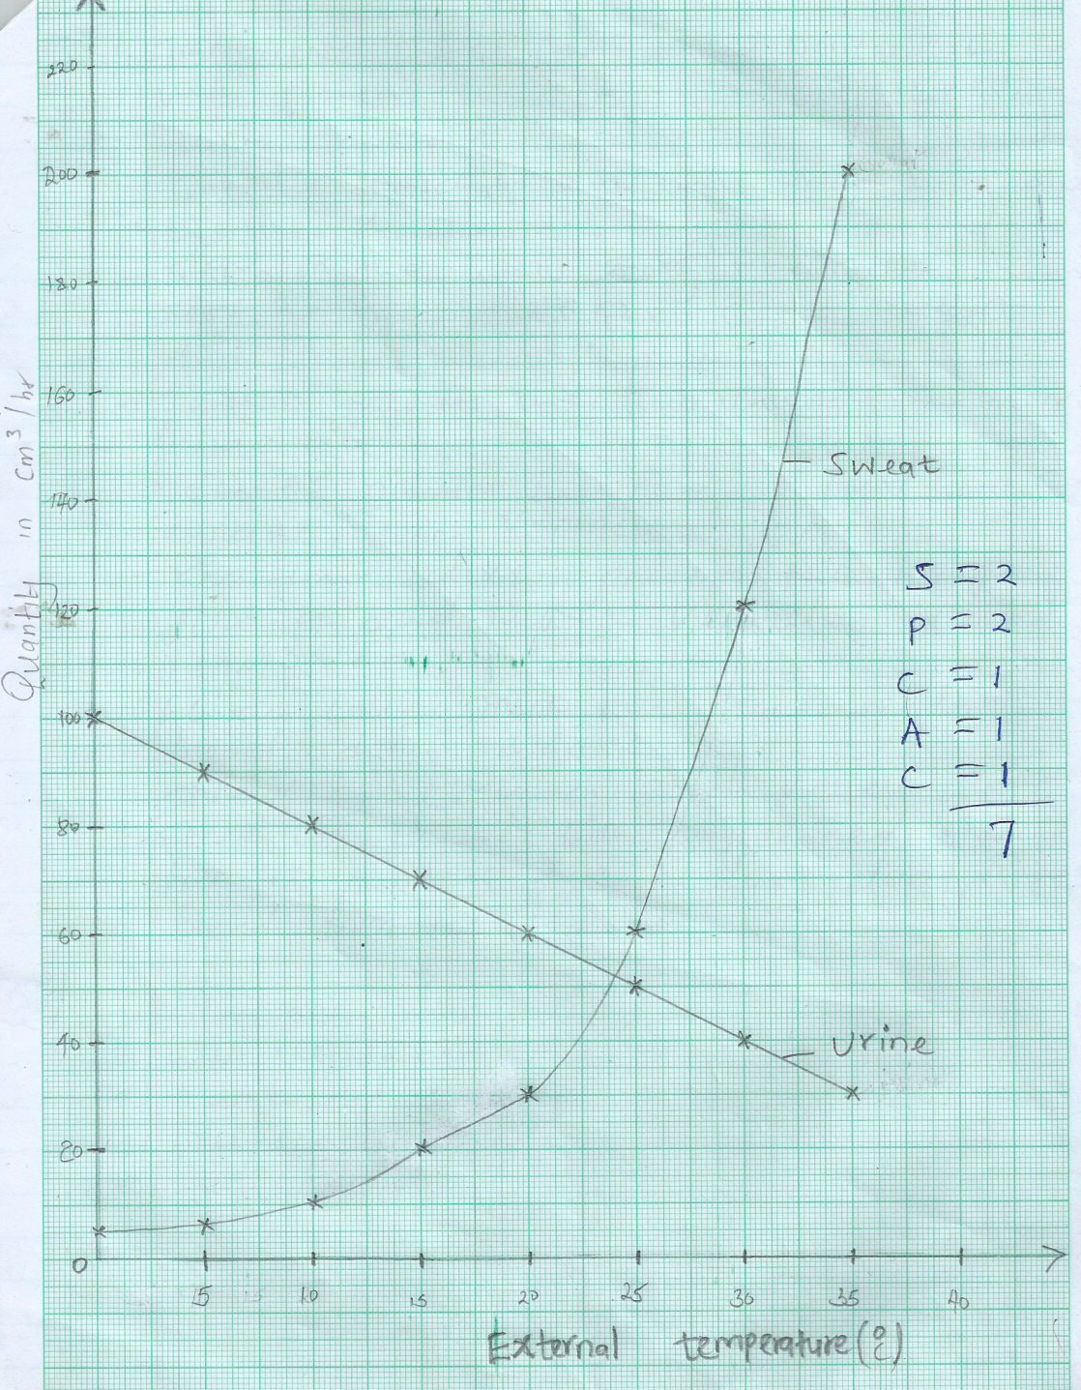

(b)
(i) State the quantity of urine and sweat produced when external temperature was 12.5⁰c. (2mks)
.Urine 74 cm³/h ± 1
Sweat 14 cm³/h ± 1
(ii) State the physical process through which the body was cooled by sweating as temperature was rising. (1mk)
Evaporation
(iii) Account for the quantity of urine produced as the temperature increased. (4mks)
An increase in temperature decreases the amount of urine produced. this is due to increased sweating which increases osmotic pressure of blood, hence more water is reabsorbed back into the blood stream at the kidney tabules.
(c) State three nitrogenous wastes that could be eliminated in urine or sweat in human beings. (3mks)
Urea
Uric acid
Ammonia
(d) State three behavioral mechanism that poikilotherms use to regulate their body temperature under hot conditions. (3mks)
Aestivation
Burrowing
Staying under shaded places.

- Describe how mammalian heart is adapted to its functions. (20 mks)
The heart has vagus and sympathetic nerves to control the rate of heartbeat
The heart has cardiac muscles which are myogenic and do not fatigue for continuous pumping of blood.
The heart has atrioventricular valves to prevent backflow of blood into the auricles
The heart has a solid muscular septum to separate right and left sides of the heart to prevent mixing of oxygen poor and oxygen rich bloods
The heart has semi lunar valves at the bases of the origin of the major arteries to prevent backflow of blood into the ventricles.
The heart has valve tendons which are inelastic to prevent the atria-ventricular valves from turning inside out due to the changes in the pressure in the ventricles.
The heart has coronary artery to supply nutrients to the heart tissues and the coronary vein to remove metabolic wastes from the heart tissues.
- The heart has a double pericardium membrane for protection/The pericardium membrane secretes pericardial fluid to lubricate the heart reducing the friction on its walls as it pumps. pericardium which prevents its walls from overstreaching duing diastole
The heart has thicker left ventricle to generate the high pressure required to pump blood to distant parts of the body
The heart has the Sino Atrial Node at the base of the right atrium to generate the primary impulse and transmit it towards the atrioventricular node.
8
Prey-predator relationship.
A predator is an animal that kill/kills another animal(prey) for food.eg a dog and a hare. Prey device survival mechanism in their habitats in order not to be killed/eaten to survive and reproduce/propagate their lineage. They run faster/strong hind muscles, camouflage with environment, mimic predators or some emit some chemicals /smell that turn off predators. Other like porcupine use quails/spines to fight predators. Some have good sense of smell to detect predators. On the other hand predators also evolve /device means to survive. For instance run faster, camouflage with environment,mimic preys, sharp eyesight, strong sense of smell, produce venom/poison which kill/paralyse prey, strong jaws/long/sharp canines/long sharp talons.

Symbiosis
Its an association/ relationship between two different organisms of different species where the two mutually benefit from each other. Eg bacteria in the rumen/gut of herbivores which help the herbivores digest cellulose as they are sheltered by the herbivores. The bacteria found in the human digestive system/gut are also sheltered by humans as they aid in synthesis of vitamin K/B12/ . the nitrogen fixing bacteria/rhizobium on the root nodules of leguminous plants benefit from the shelter offered by plant as the facilitate conversion of free atmospheric nitrogen into forms that can be readily absorbed by plant/nitrates.
Parasitism
Its a kind of relationship/ association where one member/organism the parasite benefits while the other (host) is harmed/loses. Eg a tick(parasite)sucking blood/nutrients from cow(host), making the cow anaemic,/skin destroyed/malnourished/transmission of diseases. Parasites can be external(ectoparasites)or internal(endoparasites) for instance liverfluke suck blood from host and can cause death/bodily harm on internal organs of the host including blocking blood vessels.

