NAME………………………..…ADM NO.………CLASS……DATE……..

231/1
BIOLOGY
PAPER 1
TIME: 2 HOURS
TERM ONE 2023

MECS CLUSTER JOINT EXAMINATION
End of Term 1 Exam
Form Four

INSTRUCTIONS TO STUDENTS
- Write your name and admission number in the spaces provided above
- Answer all the questions in the spaces provided.
- This paper consists of 10 printed pages
- Students should check the question paper to ascertain that all the pages are printed and that no questions are missing

FOR EXAMINER’S USE ONLY
QUESTIONS | MAXIMUM SCORE | CANDIDATE’S SCORE
1-28 | 80

- (a)State two functions of a microscope. (2mks)
…………………………………………………………………………………………………..
…………………………………………………………………………………………………..
(b) Define the term field of view as used in microscopy (1mk)
…………………………………………………………………………………………………..
…………………………………………………………………………………………………..
2. Study the diagram below showing a portion of an onion epidermis that had been irrigated with a certain solution X.
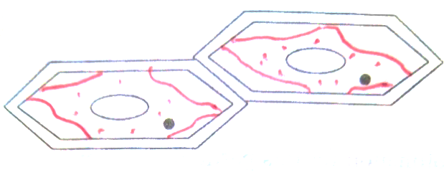
(a) In one word describe the condition of the cells (1mk)
…………………………………………………………………………………………………
(b)Describe the process that leads to the condition named above. (3mks)
…………………………………………………………………………………………………
…………………………………………………………………………………………………
…………………………………………………………………………………………………
…………………………………………………………………………………………………
3.The following reaction may proceed in forward or backward direction
Glucose + fructose sucrose + water.
(a)What term is used to refer to the backward reaction. (1mk)
…………………………………………………………………………………………………
(b)In which part of alimentary canal does the backward reaction occur? (1mk)
…………………………………………………………………………………………………
(c)Name the enzyme that catalyzes the backward reaction. (1mk)
…………………………………………………………………………………………………

4. A certain metabolic pathway takes the following sequence.
J K L M N
At the start of the experiment an inhibitor was added to the reactants. After the experiment it was found out that there was the same concentration of J, near absence of K, L, M and N. When L was added to the inhibitor set M and N were detected.
(a)At what stage of the reaction sequence did the inhibitor have its effect? (1mk)
……………………………………………………………….…………………………………
(b)Explain how the inhibitor affected the reaction. (1mk)
……………………………………………………………….…………………………………
…………………………………………………………………………………………………
(c)What is the identity of substance L? (1mk)
…………………………………………………………………….……………………………
5. After fertilization of an ovule, which parts develops into: -
a) Testa (1mk)
………………………………………………….………………………………………………
b) Endosperm (1mk)
…………………………………………………….……………………………………………
6. (i) Name the process through which a plant takes up some mineral ions against a concentration gradient. (1mk)
……………………………………………………………….…………………………………
ii) State two factors that may affect the process named in (i) above. (2mks)
……………………………………………………………….…………………………………
…………………………………………………………………………………………………

7. Study the flow chart below which represents a physiological process in mammals

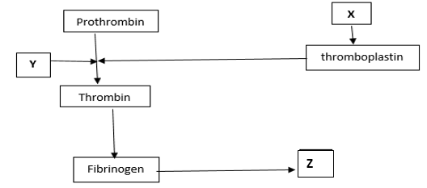
ai) Name blood components represented by X. (1mk)
……………………………………………………………….…………………………………
ii) What is the significance of product represented by Z. (2mks)
……………………………………………………………….…………………………………
………………………………………………………………………………………………… b) Under what condition is thrombokinase released by the platelets? (1mk)
……………………………………………………………….…………………………………
…………………………………………………………………………………………………
…………………………………………………………………………………………………..
8. (a) Name the nitrogenous waste product excreted by a fresh water fish (1mk)
……………………………………………………………….…………………………………
(b) Explain why a person discharges urine more frequently when environmental temperatures are low than when they are high (2mks)
……………………………………………………………….…………………………………
…………………………………………………………………………………………………
……………………………………………………………….…………………………………
9. Why is it important to use dry mass in ecological studies and not wet mass (2mks)
……………………………………………………………….………………………………….…………………………………………………………………………………………………..……………………………………………………………….………………………………….
10. Identify the agent of dispersal of the following (2mks)
(i)Fruits which split open along sutures when dry, hauling their seeds away from the parent plant
……………………………………………………………….………………………………….
…………………………………………………………………………………………………..
(ii)Light seeds with hairy extensions
……………………………………………………………….………………………………….
…………………………………………………………………………………………………..
11.a) Name the TWO components of a lipid molecule (2mks)
…………………………………………………………………………………………………..
…………………………………………………………………………………………………..
b) State TWO disadvantages of using fats as respiratory substrates (2mks)
…………………………………………………………………………………………………..
…………………………………………………………………………………………………..
12.a) Name the pigment that protects humans from the negative effect of Ultraviolet lights (1mk)
…………………………………………………………………………………………………..
b) Explain how sunlight contributes to stronger bones and teeth in human beings (2mks)
…………………………………………………………………………………………………
…………………………………………………………………………………………………
…………………………………………………………………………………………………
13.Name the main target organ of the following hormones: (2mks)
Aldosterone……………………………………………………………………………………..
Insulin ………………………………………………………………………………………….\
14.Give THREE features that make modern man to be more adaptable to the environment (3mks)
…………………………………………………………………………………………………..
…………………………………………………………………………………………………..
……………………………………………………………………..………………….………...
15.State TWO contributions of Carolus Linnaeus (1708 – 1778) to taxonomy (2mks)
…………………………………………………………………………………………………
…………………………………………………………………………………………………..
16.A mother had a still birth and the expelled foetus showed clear signs of anemia and jaundice
a) Give the name of this disorder (1mk)
……………………………………………………………………………………..……………
b) Describe how the disorder arose (3mks)
……………………………………………………………………………………..………..…
…………………………………………………………………………………………………
…………………………………………………………………………………………………
………………………………………………………………………………………………
17.The process of gamete formation is represented below
XX
XX

XX
X
X
P
Q

a) State a reason why the process above represents gamete formation in female mammals (1mk)

…………………………………………………………………………………………………..
b) Name the chromosomal mutation represented above
………………………………………………………………………………...………………...
c) Identify the genetic disorder that arise when the following gametes are fertilized
P (1mk)
…………………………………………………………………………………………………..

Q (1mk)
…………………………………………………………………………………………………..
18.A sample of air was passed through pyrogallic acid and its volume reduced from 8 cm³ to 7 cm³. When it was later passed through lime water, the volume reduced to 6.8cm³.
a) What was the role of pyrogallic acid in this experiment? (1mk)

…………………………………………………………………………………………………

b) Determine the percentage of Carbon (IV) oxide in the sample of air (2mks)

…………………………………………………………………………………………………..
…………………………………………………………………………………………………..
…………………………………………………………………………………………………..
…………………………………………………………………………………………………..
c)Is this sample of air exhaled air or inhaled air? (1mk)
………………………………………………………………………………...………………
19.A zebra is observed to be grazing at a grassland, suddenly a lion appears and the zebra takes off. List two characteristics of living things exhibited by the zebra (2 mks)
...………………………………………………………………………………………………
…………………………………………………………………………………………………

20. The diagram below represents an organism. Study it and answer the questions that follow.
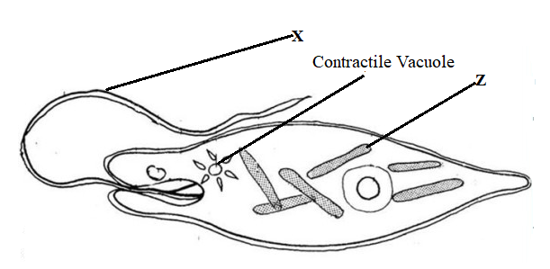

- Identify the kingdom to which the organism belongs (1 mk)
………………………………………………………………………………………………….. b) Name the structure labeled X (1 mk)
…………………………………………………………………………………………………..c) Identify the type of nutrition carried out by the organism and give a reason (2 mks)
Type of:
Nutrition.......................................................................................................................................
Reason…………………………………………………………………………………………..
21.A wild beast in Maasai Mara National Park was found to be infested with a lot of ticks. State the trophic level occupied by the following organisms: (2mks)
(a)(i)Wild beast…………………………………………………………………………………
(ii)Ticks…………………………………………………………………………………………
(b) Construct a food chain from the above information (1mk)
…………………………………………………………………………………………………
…………………………………………………………………………………………………
22.(a) Name one hormone involved in insect metamorphosis. (1mk)
…………………………………………………………………………………………………
(b)State the importance of metamorphosis to the life of insects. (2mks)
…………..………………………………………………………………………………………
…………………………………………………………………………………………………..
…………………………………………………………………………………………………..
23.(a) State two differences between the primary growth and secondary growth in woody plants. (2mks)
…………………………………………………………………………………………………
…………………………………………………………………………………………………
…………………………………………………………………………………………………
…………………………………………………………………………………………………
…………………………………………………………………………………………………
(b)Name two tissues responsible for secondary growth in flowering plants. (2mks)
…………………………………………………………………………………………………
…………………………………………………………………………………………………
24. a) What is respiratory quotient? (1mk)
......................................................................................................................................................
…………………………………………………………………………………………………
b) Explain why it is difficult to measure respiratory quotient in plants. (2mks)
......................................................................................................................................................
…………………………………………………………………………………………………
......................................................................................................................................................
…………………………………………………………………………………………………
25.Name one class of phylum Arthropoda with cephalothorax (1mk)
…………………………………………………………………………………………………
…………………………………………………………………………………………………
26. A section of nucleic strand contains the following sequence.
A — C — G — A — G — A — T — A— C
a) i) Write the complimentary DNA stand. (lmk)
......................................................................................................................................................
ii) Write the mRNA strand of the strand in (a) above. (lmk)
......................................................................................................................................................
b) Name the site for protein synthesis in a cell. (lmk)
......................................................................................................................................................
27. (a) What are analogous structures? (1mk)
…………………………………………………………………………………………………..
…………………………………………………………………………………………………..
(b) Give two examples of analogous structures in animals (2mks)
…………………………………………………………………………………………………..
…………………………………………………………………………………………………..
…………………………………………………………………………………………………..
28. Name any two sites where gaseous exchange takes place in a leaf of a terrestrial plant (2mks)
…………………………………………………………………………………………………..
………………...………………………………………...………………………………………
………………………………...………………………………………………………………

