THE EARTH AND THE SOLAR SYSTEM.

1. (a) State two effects of the rotation of the earth (2mks)
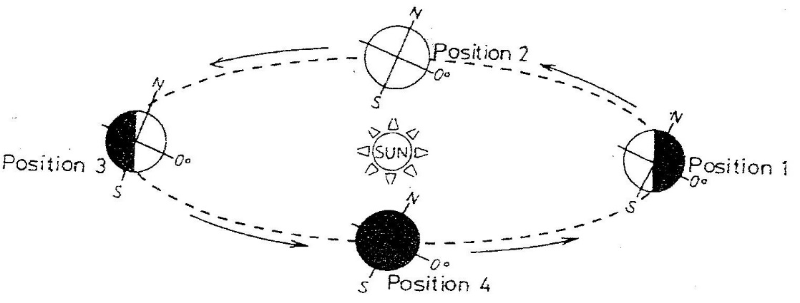
- Study the diagram below and answer the questions that follow

(i) Which movement of the earth is represented by the diagram? (1mk)
(ii) Give two effects of the movement represented by the diagram (2mks)
2. The diagram below represents the structure of the earth. Use it to answer question
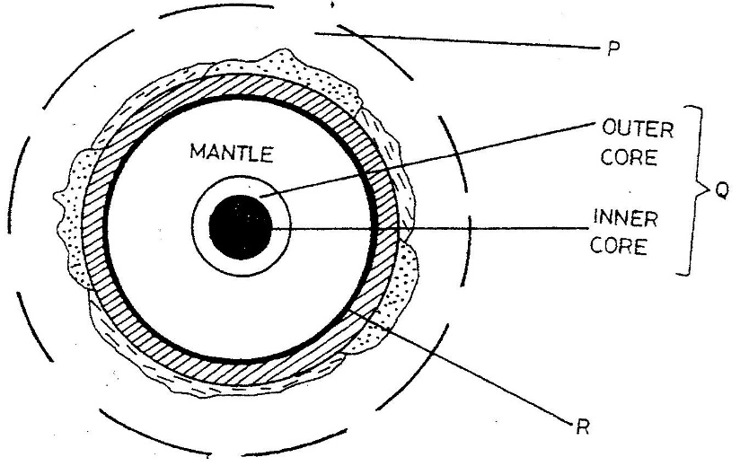

- Name
(i) The parts marked P and Q (2mks)
(ii) The discontinuity marked R (1mk)

(b) State three characteristics of the mantle (3mks)
3. The diagram below shows the composition of the solar system
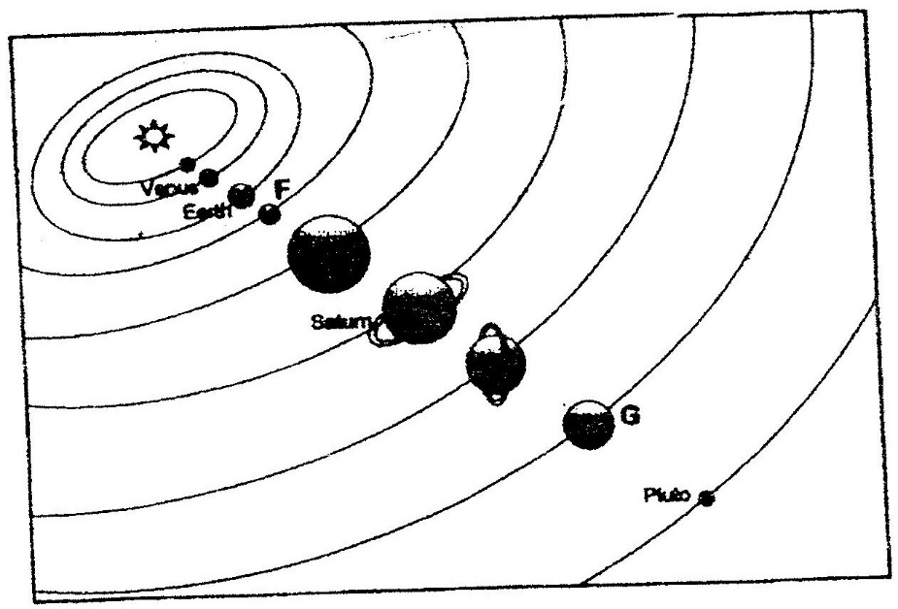

(a) Name the planets marked F and G (2mks)
(b) State three effects of the rotation of the earth on its axis (3mks)
4. a) What is the solar system?
b) Use the diagram below to answer the questions that follow.
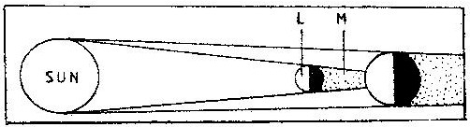

i) What type of eclipse is represented by the diagram?
ii) Name the features marked L and M
5. (a) (i) Give the two dates in a year during which the number of hours of
darkness is equal in both the north and south poles.
(ii) Why do the lengths of days and nights vary from one part of the earth to another?
(b) The diagram below shows the revolution of the earth around the sun. Use it to answer the questions that follow
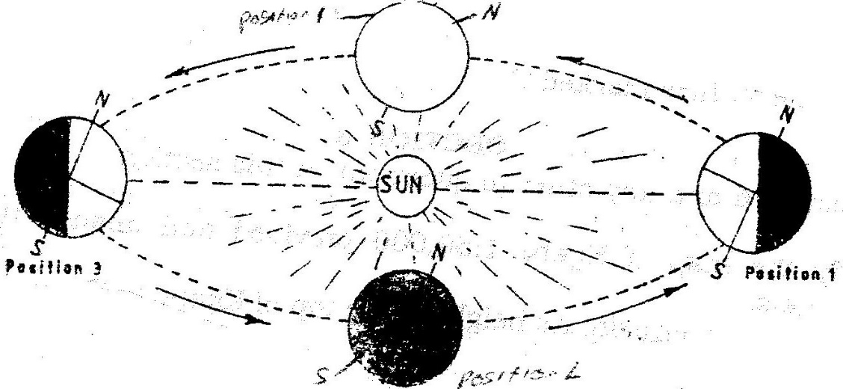

(i) If the earth takes 366 days to make a complete revolution during a leap year, how long will it take to move from position 1 to position 4?
(ii) What season is experienced in the southern hemisphere when the earth is in Position 1?
6. Define the following,
i. Solar system
ii. Galaxy
iii. Star
iv. Asteroids (6mks)
7. Differentiate between the following
(a) Latitude and longitude
(b) Dateline and international dateline
(c) Meteors and Meteorite. (6mks)
8. State three differences between solar eclipse and lunar eclipse. (2mks)
9. State four factors that support life on planet earth. (4mks)
10. (a) List four effects of earth rotation. (4mks)
(b) At Nairobi on longitude 37°E local time is 1 p.m. What time would it be at Sarissa on longitude 41 °E? (4mks)
11. (a) Define equinox. (2mks)
(b) State characteristics of summer solstice. (4mks)
12. The earth is inclined to the ecliptic plane at an angle of..... and the axis is also inclined at an angle ..... to perpendicular line. (4mks)
13. Fill in the table from (a) - (f) (10mks)

Property s/Layer | Major constituent | Thickness | Density | Temperature
Outer crust | (a) | iii. 16-24 kms | (b)
Inner crust | ii. Magnesium | S (c) | 2.8-30 gms/cc
Asthensophere | i. Iron | 2900 kms | (d) | 5000 C
Centrosphere | ii. Nickle | (e) |  | (f)

14. State three weaknesses of the passing star theory. (6mks)
15. Differentiate between hydrosphere and atmosphere. (4mks)
16. Planet ... 1... is seventh planet from the sun and is greenish in colour. Planet ...2... takes shortest time to revolve round the sun about 88 earth day. Planet ...3... and ...4... are referred to as twin planets. Planet ...5... takes about 11.86 earth years to revolve round the sun. All the planets have satellite orbiting round them except planet ...6... and ...7... (7mks)
17. Explain reasons for flattening and bulging of earth. (4mks)
18. State characteristics of winter solstice (4mks)
19. Differentiate between summer solstice and winter solstice. (4mks)
20. (a) What is an eclipse? (2mks)
21. Apart from planets name other heavenly bodies.
22. What is a longitude? (2mks)
23. State the effects of the elliptical shape of the earth's orbit. (6mks)
24. If the local time in Nairobi on longitude 37°E time is 10 p.m. What will the time be at Buchanan Liberia on longitude 10°W.? (4mks)
(a) What is the effect of International Date Line on crossing the line? (4mks)
(b) What is the angle of inclination of the earth axis from its orbit? (2mks)
(c) Give four proofs that the earth is spherical in shape. (8mks)

