FISHING
1 (a) State three measures that have been taken to conserve fisheries in Kenya.
3 mks
(b) Give four reasons why Norway is a great fishing nation. 4 mks
(c) Two traditional/ subsistence methods of fishing. 2 mks
(d) Three measures the government of Kenya is undertaking to encourage fish culture. 3 mks
2. Use the map of North America to answer question (a).
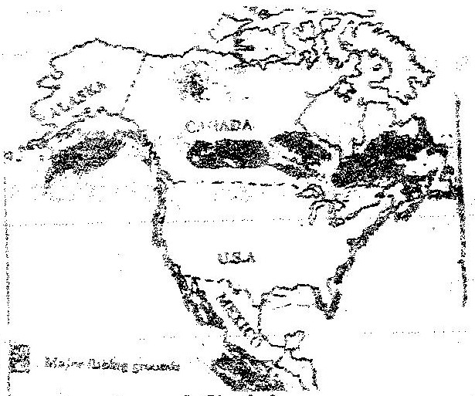

(a) Name two methods of fishing used in the shaded areas. 2 mks
(b) Name two types of fish caught along the West Coast of Canada. 2 mks
(c) Explain how the following factors favour fishing in the shaded areas,
(i) Indented coastline
(ii) Ocean currents 4 mks
(d) Give three methods used to preserve fish. 3 mks
(e) Explain three problems experienced by fishermen while fishing in Lake Victoria. 3 mks
3. The map below shows some major fishing grounds in the world. Use it to
Answer the questions below.
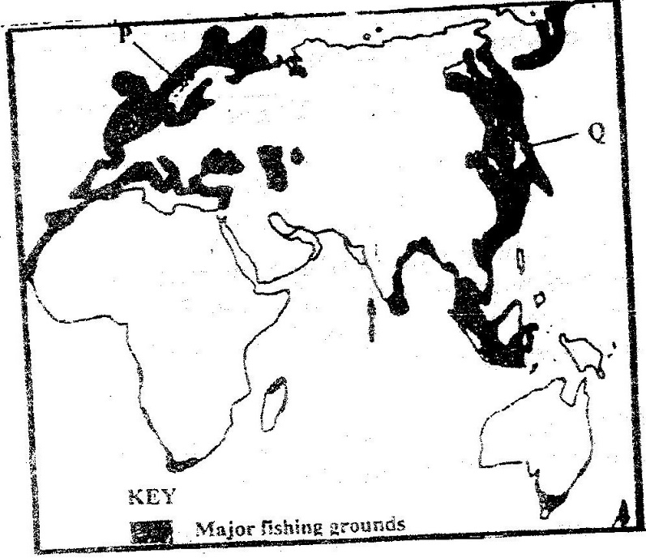

(a) Name the countries marked P and Q. 2 mks
(b) Explain four conditions that favour fishing in the shaded coastal waters.
8 mks
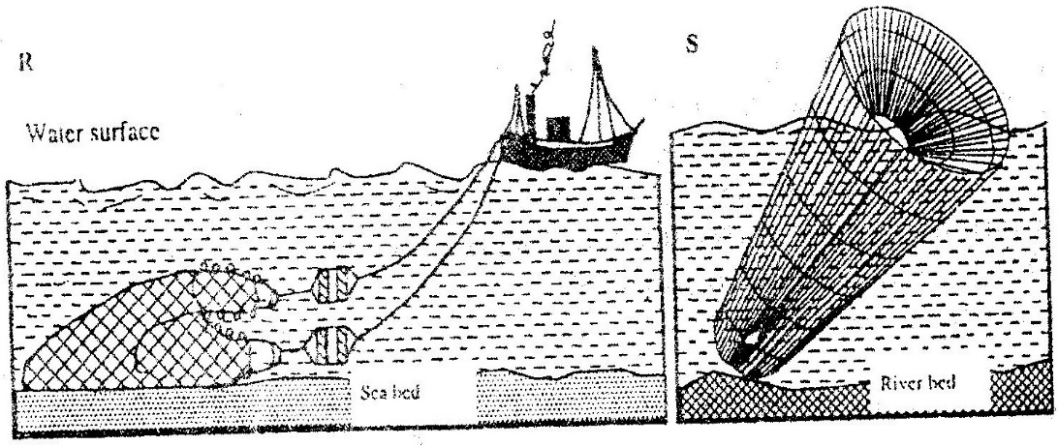
4. (a) The diagrams below represents some fishing methods.

(i) Name R and S. 2 mks
(ii) Describe how the above methods are used in fishing. 4 mks
5. (a) Differentiate between fishing and fisheries. 4 mks
(b) Identify the physical and human factors influencing fishing. 5mks
6. (a) Draw an outline map of the world and locate the major fishing grounds.
2 mks
(b) Account for the location of fishing grounds located in 6(a). 4 mks
7. (a) Discuss the main types of fishing. 3 mks
(b) List the traditional methods of fishing. 3 mks
(c) Describe how the following methods of fishing are carried out:
(i) Drifting
(ii) Trawling 4 mks
8. (a) (i) Apart from Lake Victoria, name other fresh water fisheries in
Uganda and Tanzania. 4 mks
(ii) Explain the factors favouring fishing on Lake Victoria. 6 mks
(b) Explain why marine fisheries are underdeveloped in East Africa. 5 mks
9. (a) State the significance of fishing to the economy of Kenya. 5 mks
(b) (i) Describe the problems facing fishing in Kenya. 5 mks
(ii) Identify the solutions in b(i) above. 5 mks
10. Draw a table showing the similarities and differences between fishing in Kenya and Japan. 6 mks
11. (a) Define:
(i) Management of fisheries.
(ii) Conservation of fisheries. 4 mks
(b) State the measures which can be undertaken to manage and conserve fisheries. 4 mks

