EXTERNAL LAND FORMING PROCESSES – MASS MOVEMENT.
1. a) State two conditions which may influence the occurrence of landslides
b) Using the diagram (in question paper), name
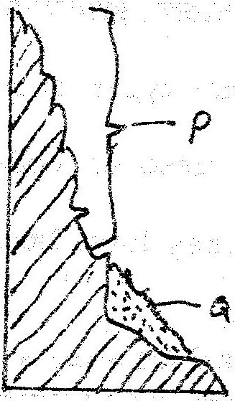

(i) The type of mass movement shown
(ii) The features marked P and Q (2mks)
2. Explain five ways in which soil creep occurs. (10mks)
3. Describes the effects of soil creep. (6mks)
4. Define the following:
a) Mass wasting.
b) Mass movement. (2mks)
5. Name and explain three process of slow mass movement. (4mks)
6. Explain the factors that are responsible for rapid mass wasting.
7. List the evidences of soil creep. (4mks)

