Term 2 - 2022
PHYSICS (232/1)
FORM FOUR (4)
Time: 2 Hours

Marking Scheme

INSTRUCTION TO THE TEACHER:
This marking scheme may not be the final draft. The author acknowledges that there could be other perspectives of facts and so the teacher concerned is highly encouraged to adapt it accordingly.

SECTION A (25 MARKS)
- Figure 1, shows a Vernier caliper of zero error 0.02 cm being used for measuring the diameter of a cylindrical container of height 10 cm. The scale reading of the Vernier is as shown alongside.

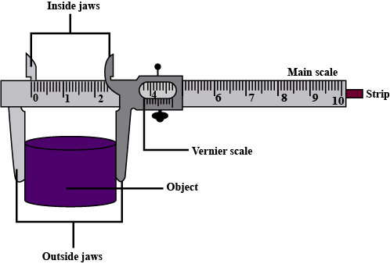

Figure 1
4

cm
0 5 10

- Determine the diameter of the container (2 marks)
$reading=3.7+0.02=3.72cm ;$
$actual diameter=3.72-0.02=3.70cm ;$
- Estimate the volume of a liquid which can completely fill the container (2 marks)
$volume=πr^{2}h$
$3.142×\frac{3.70}{2}×\frac{3.70}{2}×10 ;=107.5{cm}^{3}$ ; correct substitution and correct answer with units
- State one factor that affects the turning effect of a force on a body. (1 mark)
- Magnitude of the force
- Perpendicular distance between pivot and line of action of force
1-mark max. (mark only the first response of the learner)
- Figure 2 shows some air trapped by mercury in a glass tube. The tube is inverted in a dish containing mercury.
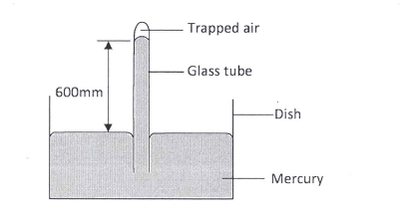

Figure 2
Given that the atmospheric pressure is 760 mmHg and the height of mercury column in the tube is 600 mm, determine the pressure of the air trapped in the tube in mmHg. (2 marks)

$atm.pressure=liquid pressure+air pressure$ formula/sub
$760=600+air pressure$ ;
Therefore, air pressure = $760-600=160mmHg$ ; correct answer with units

- Figure 3 shows drops of mercury and water on a glass surface, Explain the difference in the shapes of the drops. (2marks)

Mercury water
Glass surface

Figure 3
Cohesive force among mercury molecules is stronger than adhesive force between mercury and glass molecules; in water, adhesive force between water and glass molecules is stronger than cohesive force between water molecules;
- A ball is thrown from the top of a cliff 20m high with a horizontal velocity of 10ms⁻¹. Calculate the distance from the foot of the cliff to where the ball strikes the ground. (3 marks)
$h=\frac{1}{2}gt^{2}≡20=\frac{1}{2}×10×t^{2}→t=2 seconds$ ; award for time
$R=ut→R=10×2;=20m;$ formula/sub and the correct answer with units

- Explain one advantage of mercury over alcohol as a thermometric liquid. (1mark)
Higher boiling point so it can measure higher temperature than alcohol;

- A body of mass M is allowed to slide down an inclined plane. State two factors that affect its final velocity at the bottom of the inclined plane. (2marks)
- Angle of inclination of the plane
- Vertical Height of the inclined plane
- Length of the plane
- Frictional force between the plane and the body
Maximum of two marks but consider only the first two responses of the learner

- A stopwatch reads 08:10:84 and 09:10: 90 before and after an experiment respectively. Determine the duration of the event in SI units. (2marks)
$final time=\left(9×60\right)+10.90=550.90s$ award for either final/initial time
Initial time = $\left(8×60\right)+10.84=490.84s$ ;
Time taken = 60.06 seconds ; correct answer with units
- Explain the meaning of thermodynamics as a branch of physics. (1 mark)
The study of heat and its transformation to and from other forms of energy;

- State the Hooke’s Law. (1mark)
For an elastic material, extension is directly proportional to the stretching force provided elastic limit is not exceeded;

- Figure 4 shows identical spiral springs supporting a load of 90N. Each spring has a spring constant k = 200N/m
Figure 4
Determine the total extension of the system (take the weight of the cross bars and springs to be negligible) (2 marks)
$K_{1}=3×200=600{Nm}^{-1}$; so extension is: $\frac{F}{K}=\frac{90}{600}=0.15m$
$K_{2}=2×200=400Nm^{-1}-$so extension is: $\frac{F}{K}=\frac{90}{400}=0.225m$
award for either combined spring constant
$total extension=0.15+0.225=0.375m$ ; correct answer with units

- Figure 5 shows a rectangular loop with a thin thread loosely tied and dipped into a soap solution.
Draw on the space provided what is observed when point A is punctured. (1mark)

Figure 5
A
B
thread

- Two horizontal strings are attached to a block, resting on a frictionless surface, as shown in figure 6.

F
100 N
support
Figure 6
A force of 100N pulls on one string. The block does not move. Find the value of the force, F on the other string. (1 mark)

$0=100N+(-F)$ therefore, F= 100N;

- A wooden bench feels neither warm nor cold when touched by your bare hands. Explain this observation. (2 marks)

Wood is a poor conductor of heat; it does not therefore take away heat from the hand hence no change in body temperature;

SECTION B (55 MARKS)

- (a) State the principle of conservation of linear momentum. (1 mark)

- For a system of colliding bodies, the total momentum before collision equals to the total momentum after collision.

(b) Distinguish between elastic and inelastic collision. (1 mark)
Elastic | Inelastic
KE & momentum conserved  Bodies move apart | Only momentum is conserved  Bodies stick together and moves as one

(c) A striker kicks a ball of mass 200g initially at rest with a force of 78N.Given that the foot
was in contact with the ball for 0.30s; determine the takeoff velocity of the ball. (3 marks)
M = 0.2kg
M = 0ms⁻¹
F = 78N
t = 0.3S
Ft = M (v – u)
7 8 x 0.3 = 0.2 (v – 0)
V = $\frac{78 x 0.3}{0.2}$
= 117ms⁻¹
(d) A high jumper usually lands on thick soft mattress. Explain how the mattress helps in
reducing the force of impact. (2 marks)

- It increases the time of impact thereby reducing the impulsive force.

(e) A ball is thrown horizontally from the top of a vertical tower of height 75m and strikes the ground at a point 80m from the bottom of the tower. Determine the:
(i) Time taken by the ball to hit the ground. (Acceleration due to gravity=10m/s²) (3 marks)

h = 75m
R = 80m
t = ?
h = $\frac{1}{2}gt^{2}$
75 = $\frac{1}{2}x 10 x t^{2}$

5$t^{2}$ = 75
$$t^{2}=15$$
t = 3.873s
(ii) Initial horizontal velocity of the ball. (2 marks)
R = Ux X t
80 = Ux X 3.873
Ux = $\frac{80}{3.873}$

= 20.66 ms⁻¹

- State two factors that affect the boiling point of a liquid (2 marks)

- Impurities;
- Pressure;

- 100g of a liquid at a temperature of 10⁰ C is poured into a well lagged calorimeter. An electric heater rated 50W is used to heat the liquid. The graph in figure 7 shows the variation of the temperature of the liquid with time.
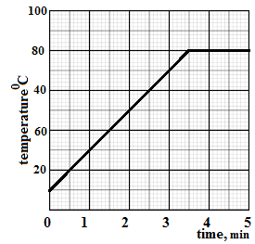
Figure 7
- From the graph, determine the boiling point of the liquid (1 mark)
80⁰C ;
- Determine the heat given out the by the heater between the times t = 0.5 minutes and t = 5.0 minutes (3 marks)

$time=\left(5-1.5\right)×60=210seconds$ ;

$heat\left(energy\right)=power×time=50×210;=10500J$ ;

- From the graph determine the temperature change between the times t = 0.5 minutes and t = 5.0 minutes, hence determine the specific heat capacity of the liquid (3 marks)

Change in temperature = $80-20=60$ºC ;
Heat energy absorbed = $mc∆θ →10500=0.1×c×60$ ;formula or substitution
$c=\frac{10500}{0.1×60}=1750$J/kg K ; correct answer with units

- 1.8 g of vapor was collected from above the liquid between the times t= 3.5 minutes and t= 4.5 minutes. Determine the specific latent heat of vaporization of the liquid (4 marks)

Heat energy supplied by the heater = heat energy spent to vaporize the liquid ;

$mL_{v}=50×1×60$ ; ; correct substitutions for both energy supplied and absorbed

$L_{v}=\frac{3000}{0.1}=30,000$J/kg ; correct answer with correct units

- State the law of floatation (1 mark)

A floating body displaces its own weight of fluid in which it floats;

- Figure 8 below shows a simple hydrometer
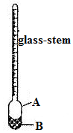
A bulb ;

B lead-shots ;
Figure 8
- Identify the parts labelled A and B (2 marks)

See above for labelling

- State the purpose of the part labelled B (1 mark)

It enables the hydrometer float upright ;

- How would the hydrometer be made more sensitive? (1 mark)

Using a narrower glass-stem ;

- Describe how the hydrometer is calibrated to measure relative density (3 marks)

Float the hydrometer in a liquid of known relative density and mark level of the liquid on the stem;
Float the hydrometer again in another liquid of known relative density and mark its level on the stem;
Divide the length between the marks into equal divisions and label it accordingly ;

- Figure 9 shows a cork floating on water and held to the bottom of the beaker by a thin thread.
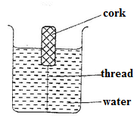
- Name the forces acting on the cork (3 marks)
- Tension ;
- Up-thrust ;
- Weight ;

Figure 9
- Describe how each of the forces mentioned in (i) above changes when water is added until the container is completely filled (3 marks)
- Tension increases ;
- Up-thrust increases ;
- weight remains constant ;

- Figure 10 shows a graph of pressure against volume for a fixed mass of a gas at constant temperature.

$$\frac{1}{v}$$
p
Pressure, p
Volume, v
Figure 10
In the space provided, sketch a graph of pressure, p against $\frac{1}{v}$ (1 mark)

- Explain the pressure law using the kinetic theory of matter (3 marks)

When a gas is heated, its molecules gain kinetic energy and move about faster; since volume is constant, the molecules will bombard the wall of the container with greater momenta. The total rate of change of momentum (force) will therefore increase; the resulting force per unit area (pressure) will therefore increase;

- 20cm³ of a gas exerts a pressure of 760mmHg at 25⁰C. Determine the temperature of the gas when the pressure increases to 900mmHg and the volume decreases to 15 cm³. (3 marks)

$\frac{p_{1}v_{1}}{T_{1}}=\frac{P_{2}v_{2}}{T_{2}}$ ; formula

$\frac{760×20}{298}=\frac{900×15}{T} ;≡T=$264.7k; Correct substitution and answer with units

- Define the term velocity ratio of a machine (1 mark)
The ratio of effort distance to load distance;

- The figure 11, below shows part of the hydraulic lift system. State any property of the liquid under which the hydraulic system works (1 mark)
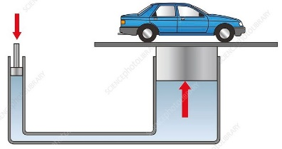
- Incompressible
- High boiling point and low freezing point
- Non-corrosive
Award one mark for any correct response
Figure 11
- The hydraulic lift machine above has velocity ratio 45 and it overcomes a load of 4500 N when an effort of 135 N is applied. Determine:
- The mechanical advantage of the machine (2 marks)
$M.A=\frac{LOAD}{EFFORT}=\frac{4500}{135};=33.33;$ correct substitution and correct answer

- Efficiency of the machine (3 marks)
$∩=\frac{M.A}{V.R}×100 ;$ formula
$≡∩=\frac{33.33}{45}×100$ ; substitution
$→∩=74.07\%$ ; correct evaluation in %
- The percentage of work that goes to waste (1 mark)
$100-74.07=25.93\%$ ;

This is the last printed page

