**SUNRISE MATHEMATICS PP2 MARKING SCHEME**

|  |  |  |  |
| --- | --- | --- | --- |
|  | C:\Users\user\Pictures\2017-05-15\011.jpg |  |  |
|  | C:\Users\user\Pictures\2017-05-15\010.jpg |  |  |
|  | **Ans**    = |  |  |
|  |  |  |  |
|  |  | **M1**  **M1**  A1 |  |
|  |  |  |  |
|  | C:\Users\user\Pictures\2017-05-16\007.jpg |  |  |
|  |  |  |  |
|  | Actual area cm2  Maximum area cm2  Minimum area 2  Absolute error = $\frac{1}{2}(max-min)$ $$= \frac{1}{2}(11.8275-11.1375)$$ $$=0.69$$ Relative error = $\frac{Absolute error}{Actual}$ $$=\frac{0.69}{11.48}$$ $$=0.060104529$$ $$or 0.06010$$ | M1  M1  A1 |  |
|  |  |  |  |
|  |  |  |  |
|  | A=P(1+)  =180,000(1+)12  =256,636.96  I=A-P  =256,636.96-180,000  =Sh. 76,636.96 | M1  A1  B1 |  |
|  |  |  |  |
|  | p=an + bn2 -a+b = -3 a=9-4 = 5  -3=-a +b a+2b= 9  18=2a+4b 3b=6 b= 2 p=5n +2n2 p= 5+2 =7 |  |  |
|  | C:\Users\user\Pictures\2017-05-15\013.jpg |  |  |
|  |  |  |  |
|  | 3log104+log10125 – 3 log102  Log1043+ log10125 – log 1023  Log10 64 x125  8  Log101000 = 3 log 10 10  = 3 |  |  |
|  |  |  |  |
|  | 2    P= 2i – 4j + 5k $\sqrt{({2)}^{2}+{(-4)}^{2}+5^{2}}$ $\sqrt{4+16+25}$    = 6.7082 units |  |  |
|  |  |  |  |
|  | 25a+17.5b  a+b  125 = 25  100 = ?  100 x 25  125  = 20 |  |  |
|  |  |  |  |
|  | 9+2+3+4+5+5+7+8+1  9  44 = 4.89  9  9 4.11 16.89  2 -2.89 8.352  3 -1.89 3.5721  4 -0.89 0.7921  5 0.11 0.0121  5 0.11 0.0121  7 2.11 4.4521  8 3.11 9.6721  1 -3.89 15.1321  58.8866  Variance = $\frac{58.8866}{9}$ $\sqrt{6.542956}$  Standard dev = 2.5579 |  |  |
|  |  |  |  |
|  | 2 sin(x-300) =  2 2  Sin (x-30)0 = -0.866  (x-300) = 2400, 300  x-300 = 240  x= 2700  x-300= 300  x= 3300 |  |  |
|  | **SECTION II** |  |  |
|  | a)   1. <HBD   Tan-1(4/10) = 21.800   1. <ACE     Tan-1(4/10) = 21.800   1. AGE   Tan-1(4/10) = 21.800   1. < MON |  |  |
|  | C:\Users\user\Pictures\2017-05-15\016.jpg |  |  |
|  |  |  |  |
|  | (a) Tan 60o= AC  5cm  AC=8.6605cm  (b) A= ½ x 5x8.6605  A=21.65125  60/360xπr2  (c)60/360x 3.142x25  =13.091cm2  (d) Area of shaded part,  Δ COA=ΔOBA, sector OCD=OCB  21.65x2=43.3025cm2  13.091x 2=26.182cm2  ∴Area of shaded part  43.3025-26.182  =17.11225cm2 | M1  A1  M1  A1  M1  A1  M1  M1  M1  A1  10 |  |
|  | |  |  |  |  |  |  |  |  |  | | --- | --- | --- | --- | --- | --- | --- | --- | --- | | x | -2 | -1 | 0 | 1 | 2 | 3 | 4 | 5 | | x3 | -8 | -1 | 0 | 1 | 8 | 27 | 64 | 125 | | -5x2 | -20 | -5 | 0 | -5 | -20 | -45 | -80 | 125 | | 2x | -4 | -2 | 0 | 2 | 4 | 6 | 8 | 10 | | 7 | 7 | 7 | 7 | 7 | 7 | 7 | 7 | 7 | | y | -5 | -1 | 7 | 5 | -1 | -5 | 11 | 17 |   b)  C:\Users\USER\Pictures\Capture 1.PNG  c) x=-0.9  x= 1.9  x= 4.1  d) x3-5x2+x+4 = 0  x3-5x2+2x+7= y  x3-5x2+x+4 = 0  x+3 = y  x= -0.7  x= 1.2  x=4.5 |  |  |
|  |  |  |  |
|  | C:\Users\USER\Pictures\Capture 3.PNG         1. 1- ()   1 -  = |  |  |
|  |  |  |  |
|  |  |  |  |
|  |  |  |  |
|  | 1. .   No of rows = 468  Of benches   1. .   No of rows = 468  Of benches   1. 468 - 468 = 1   5x + 6 5x + 9 | M1 A1  M1 A1  M1  M1  M1  M1  A1 |  |

a)

|  |  |  |  |  |  |  |  |  |  |  |  |  |  |
| --- | --- | --- | --- | --- | --- | --- | --- | --- | --- | --- | --- | --- | --- |
| x | 0 | 300 | 600 | 900 | 1200 | 1500 | 1800 | 2100 | 2400 | 3700 | 3000 | 3300 | 3600 |
| Sin2x | 0 | 0866 | 0866 | 0 | -0.866 | -0.866 | 0 | +0.866 | 0.866 | 0 | -0.866 | -0.866 | 0 |
| 3cosx-2 | 1 | 0.598 | -0.5 | -2 | -3.5 | -4.598 | -5 | -4.598 | -3.5 | -2 | -0.5 | -0.5 | 1 |

b)

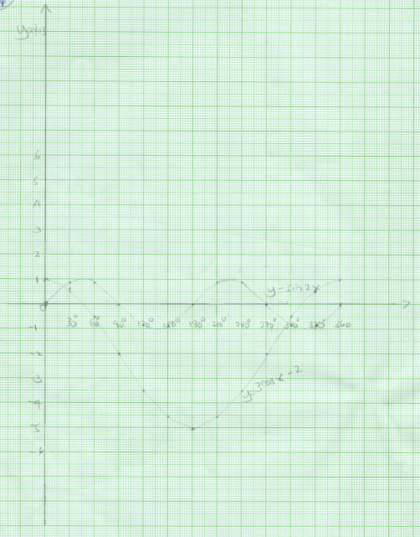

c) x = 220

x = 2970