MECS JOINT EXAMINATION
TERM 1 APRIL 2023
MATHEMATICS

Form 4
Paper 2

MARKING SCHEME

SECTION I
 | WORKING | MARKS | GUIDELINES
 | $$Let \log_{3} x= y$$  $$y^{2}- ½ y =\frac{3}{2}$$  $$2y^{2} – y – 3 =0$$  $$(2y – 3) ( y + 1) = 0$$  $$y =\frac{3}{2} or y -1$$  $$\log_{3} x =\frac{3}{2}or \log_{3} x = -1$$  $$x = 3^{\frac{3}{2}} or x =3^{-1}$$  $$x = 5.196 \left(or 3\sqrt{3} \right)or x =\frac{1}{3}$$ | M1  M1  M1  A1
 |  | 4
 | $$OT=\sqrt{{25}^{2}-{24}^{2}}=7 cm$$  $$<TOP=\sin^{-1}\left(\frac{24}{25}\right)=73.74°$$  $$Area of shaded region$$  $$=\frac{1}{2}bh-\frac{θ}{360}πr^{2}$$  $$=\frac{1}{2}×7×24-\frac{73.74}{360}×\frac{22}{7}×7^{2}$$  $$=84-31.54$$  $$=52.46 {cm}^{2}$$ | B1  M1  A1
 |  | 3
 | $$b^{2}=4ac$$  $${\left(\frac{-3}{2}\right)}^{2}=4×w×\frac{1}{16}$$  $$\frac{9}{4}=\frac{w}{4}$$  $$w=9$$ | M1  A1
 |  | 2
 | $$\frac{4( \sqrt{ 5} - \sqrt{2} )- 3( \sqrt{5} + \sqrt{2})}{( \sqrt{5} + \sqrt{2}) (\sqrt{5} - \sqrt{2})}$$  $$\frac{4 \sqrt{ 5} - 4\sqrt{2} - 3\sqrt{5}-3 \sqrt{2})}{5-2}$$  $$\frac{ \sqrt{ 5} - 7\sqrt{2}}{3}$$ | M1  M1  A1
 |  | 3
 | $$c=k+cn$$  $$45000= k + 100x$$  $$40000=k + 60x$$  $$5000=40x$$  $$x=125$$  $$k=32500$$  $$c=32500+125n$$  $$63000=32500+125n$$  $$125n=30500$$  $$n=244$$ | M1  A1  B1
 |  | 3
 | y x 0 1 2 3 4 5 6  0 0 1 2 3 4 5 6  1 1 0 1 2 3 4 5  2 2 1 0 1 2 3 4  3 3 2 1 0 1 2 3  4 4 3 2 1 0 1 2  5 5 4 3 2 1 0 1  6 6 5 4 3 2 1 0  $$|x-y|$$  P$|x-y|≥3$ $= \frac{20}{49}$ | B1  B1  B1 | Table  $$|x-y|$$
 |  | 3
 | $$-9x-x^{2}+6x=0$$  ${-x}^{2}-3x =0$  $x^{2}+3x=0$  $x\left(x+3\right)$=0  $x=0 or x=-3$ | M1  M1  A1 | determinant = 0  both values
 |  | 3
 | - Centre 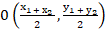  = 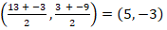  - Equation of circle  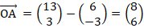  Equation | B1  M1  M1  A1 | for coordinates of centre
 |  | 3
 | $$A.S.F= \frac{750}{120}= \frac{25}{4}$$  $$L.S.F= \sqrt{\frac{25}{4}}=\frac{5}{2}$$  $$V.S.F= {\left(\frac{5}{2}\right)}^{3}= \frac{125}{8}$$  $$Volume of larger = \frac{125}{8}×\frac{400}{1000}=6.25 litres$$ | M1  M1  A1
 |  | 3
 | $$P=38000$$  $$A=24×2000=48000$$  $$48000=38000{\left(1+\frac{r}{100}\right)}^{24}$$  $$1.263={\left(1+\frac{r}{100}\right)}^{24}$$  $$1+\frac{r}{100}=1.009781$$  $$\frac{r}{100}=0.009781$$  $$r=0.9781\%$$ | M1  M1  A1
 |  | 3
 | $$cost price per kg=\frac{350×84+140×105}{350+140}$$  $$=shs.90$$  $$Selling price per kg=120×\frac{90}{100}$$  $$=shs.108$$ | M1  M1  A1
 |  | 3
 | $$\log{v=n log p+\log{a}}$$  $$\log{a}=-1.8$$  $$a=0.01585$$  $$n=\frac{-1.8-0}{0-3}=0.6$$ | B1  B1  B1
 |  | 3
 | $$amplitude=2$$  $$period=\frac{360}{\frac{1}{2}}=720°$$  $$phase angle=30°$$ | B1  B1  B1
 |  | 3
 | $OC=\frac{3}{2}OB-\frac{1}{2}OA$  $=\frac{3}{2}\left(\begin{aligned}-1 \\ -2 \\ 3\end{aligned}\right)-\frac{1}{2}\left(\begin{aligned}4 \\ 8 \\ -2\end{aligned}\right)$  =$\left(\begin{aligned}-3.5 \\ -7 \\ 5.5\end{aligned}\right)$  $$\left|OC\right| =\sqrt{({-3.5)}^{2}+ (-{7)}^{2}+ {5.5}^{2}}=\sqrt{91.5}$$  $=9.565=9.57 units$(2dp) | M1  A1  B1
 |  | 3
 | - $P.A.Y.E=5000 – (3944)$  $=Ksh 1056$  - $Gross tax = 1056 + 1056=Ksh 2112$  SLABS:  $$9680 × \frac{10}{100} = 968$$  $= 1144$  $$x×\frac{15}{100}=1144$$  $x=\frac{1144}{0.15}=7626.67$  $Monthly income =9680 + 7,626.67=ksh.17,306.7$ | M1  M1  M1  A1
 |  | 4
 | $<OAC=<OCA=70°$ and $<OAB=10°$  $$<CAB=70+10$$  $$=80°$$ | B1  M1  A1
 |  | 3

SECTION II
 | $$a)i. AB=-a+b$$  $$ii.CB=\frac{1}{3}a-3b$$  $$b) CM=k\left(\frac{1}{3}a-3b\right)$$  $$AM=h(-a+b)$$  $$AM=-a+3b+k\left(\frac{1}{3}a-3b\right)$$  $$AM=\left(-1+\frac{1}{3}k\right)a+(3-3k)b$$  $$∴-ha+hb=\left(-1+\frac{1}{3}k\right)a+(3-3k)b$$  Comparing the coefficients  $$-1+\frac{1}{3}k=h$$  $$3-3k=h$$  $$Hence-1+\frac{1}{3}k=3-3k$$  $$k=\frac{3}{4}and h=\frac{3}{4}$$  c) $OM=-a+3b+\frac{3}{4}\left(\frac{1}{3}a-3b\right)=\frac{1}{4}a+\frac{3}{4}b$  $$MN=\frac{3}{4}a-\frac{3}{4}b-\frac{1}{2}a+\frac{3}{2}b=\frac{1}{4}a+\frac{3}{4}b$$  $$∴OM=MN hence OM is parallel MN and M is a common point$$  $$hence O , M and N are collinear$$ | B1  B1  B1  M1  M1  M1  A1  B1  B1  B1
 |  | 10
 | $$Class$$ $$f$$ $$Mid point(x)$$ $$x-A=d$$ $$fd$$ $$d^{2}$$ $$fd^{2}$$  $$40-44$$ $$3$$ $$42$$ $$-15$$ $$-45$$ 225 $$675$$  $$45-49$$ $$30$$ $$47$$ $$-10$$ $$-300$$ 100 $$3000$$  $$50-54$$ $$29$$ $$52$$ $$-5$$ $$-145$$ 25 $$725$$  $$55-59$$ $$33$$ $$57$$ $$0$$ $$0$$ 0 $$0$$  $$60-64$$ $$13$$ $$62$$ $$5$$ $$65$$ 25 $$325$$  $$65-69$$ $$1$$ $$67$$ $$10$$ $$10$$ 100 $$100$$  $$70-74$$ $$1$$ $$72$$ $$15$$ $$15$$ 225 $$225$$  $$110$$ $$-400$$ $$5050$$  $$Mean= \frac{-400}{110}+ 57$$  $$=53.364$$  - $s= \sqrt{\frac{5050}{110}- {\left(\frac{-400}{110}\right)}^{2}}$  $$= \sqrt{32.69}$$  $$= 5.718$$  - 50th student  $$=49.5+\frac{17}{29}×5$$  $$=49.5+2.9310$$  $$=52.43$$ | B1  B1  B1  B1  M1  A1  M1  A1  M1  A1
 |  | 10
 | - $T_{3}=a+2d$  $$T_{9}=a+8d$$  $$T_{25}=a+24d$$  $$\frac{a+24d}{a+8d}=\frac{a+8d}{a+2d}$$  $$a^{2}+16ad+64d^{2}=a^{2}+24ad+2ad+48d^{2}$$  $$16ad+64d^{2}=26ad+48d^{2}$$  $$16d^{2}=10ad$$  $$16d-10a=0-------------(i)$$  $$a+6d+2\left(a+5d\right)=78$$  $$a+6d+2a+10d=78$$  $$3a+16d=78-------------(ii)$$  $$3a+16d=78$$  $$16d-10a=0$$  $$13a=78$$  $a=6$, $d=3.75$  - $a=6+7.5=13.5$  $r=\frac{36}{13.5}=2\frac{2}{3}$  $$s_{n}=\frac{a(r^{n}-1)}{r-1}$$  $$s_{5}=\frac{13.5{\left(2\frac{2}{3}\right)}^{5}-1)}{2\frac{2}{3}-1}$$  $$s_{5}=1084.17$$ | B2  M1  M1  M1  M1  A1  M1  M1  A1
 |  | 10
 | - (i)  $$Distance=\frac{θ}{360}2πR cosα$$  $$θ=29+31={60}^{o}$$  $$=\frac{60}{360}×2×\frac{22}{7}×6370\cos{60}$$  $$=3336\frac{2}{3} km or 3336.67 km$$  $$ii)$$  $$time difference=4×60=240 minutes=4hrs$$  $$Local time= 1200h+4hrs$$  $$=1600hr or 4:00pm$$  $$b)$$  $$distance=\frac{θ}{360}2πR$$  $$\frac{θ}{360}×2×\frac{22}{7}×6370=8000$$  $$\frac{1001}{9}θ=8000$$  $$θ=71.93°$$  $$71.92-60=11.93°$$  $$B(11.93°S,45°E)$$ | B1  M1  A1  M1  M1  A1  M1  A1  B1  B1
 |  | 10
 | X 0° 30° 60° 90° 120° 150° 180° 210° 240° 270° 300° 330° 360°  -cos x -1 -- 0.87 -0.5 0 0.5 0.87 1 0.87 0.5 0 -0.5 -0.87 -1  Sin ( x - 30°) -0.5 0 0.5 0.87 1 0.87 0.5 0 -0.5 -0.87 -1 -0.87 -0.5  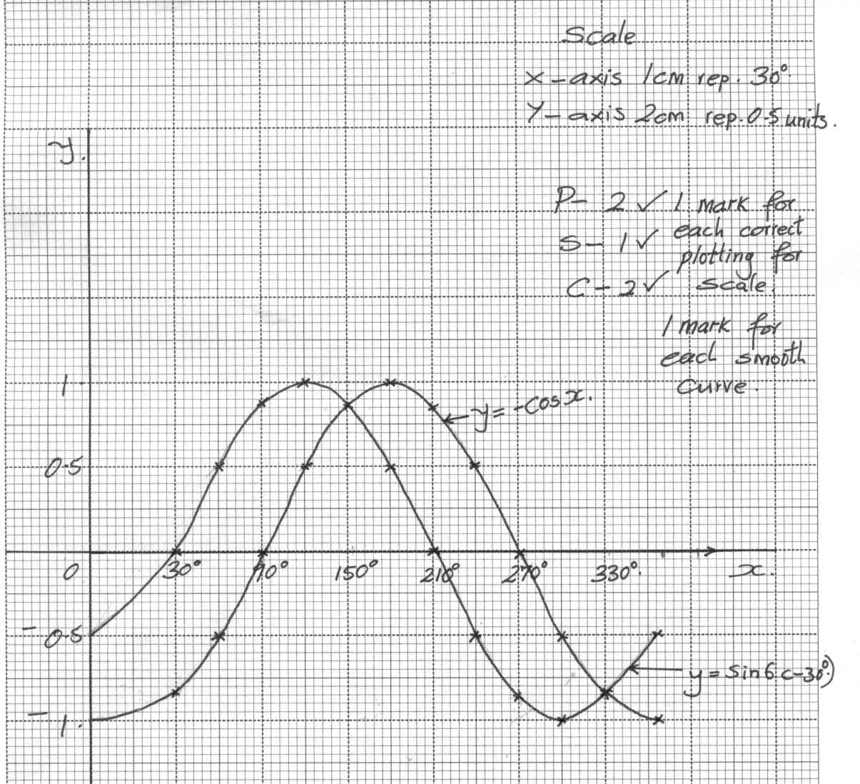  $$a) i. x=150°, 330°$$  $$ii.x=120°, 240°$$ | B2  M1  S1  P2  C2  B1 B1  B1
 |  | 10
 | - $P \left(Only one hits\right)=\left(\frac{2}{5} × \frac{3}{4} × \frac{4}{7}\right)+\left(\frac{1}{4} × \frac{3}{5} × \frac{4}{7}\right)+\left(\frac{3}{7} × \frac{3}{4} × \frac{3}{5}\right)$  $$=\frac{6}{35} + \frac{3}{35} + \frac{27}{140} = \frac{9}{20}$$  $$\left(b\right)P \left(All hits\right)=\frac{2}{5} × \frac{1}{4} × \frac{3}{7} = \frac{3}{70}$$  $$(c) P (None hits) = \frac{3}{5} × \frac{3}{4} × \frac{4}{7}= \frac{9}{35}$$  $$\left(d\right)P \left(Two hits\right)= \left(\frac{2}{5} × \frac{1}{4} ×\frac{4}{7}\right) + \left(\frac{1}{4}× \frac{3}{7}× \frac{3}{5}\right) +\left(\frac{2}{5} × \frac{3}{7} ×\frac{3}{4}\right)$$  $$= \frac{8}{140} + \frac{9}{140} + \frac{18}{140} = \frac{1}{4}$$  $$\left(e\right)P\left(atleast one hit target\right)=1 – P (None hits the target$$  $$= 1 - \frac{9}{35} = \frac{26}{35}$$ | M1  A1  M1A1  M1A1  M1  A1  M1A1
 |  | 10
 | - $Length of line Qs = \sqrt{{16}^{2}+{12}^{2}}=\sqrt{400}$  $$=20 cm$$  - $Height of the pyramid=\sqrt{{13}^{2}-{10}^{2}}=\sqrt{69}$  $$=8.3 cm (1 d.p)$$  - $Cos = 10/13 = 0.7692$  $$= 39.72$$  $$h=\sqrt{{13}^{2}-6^{2}}= 11.53 cm$$  $Cos = \frac{8}{11.53} = 0.6938$  $=47.06°$  $= 2 ×\sin^{-1} (8/11.53$)  $$= 2 × 43.93$$  $$= 87.87°$$ | M1  A1  M1  A1  M1  A1  M1  A1  M1  A1
 |  | 10
 | 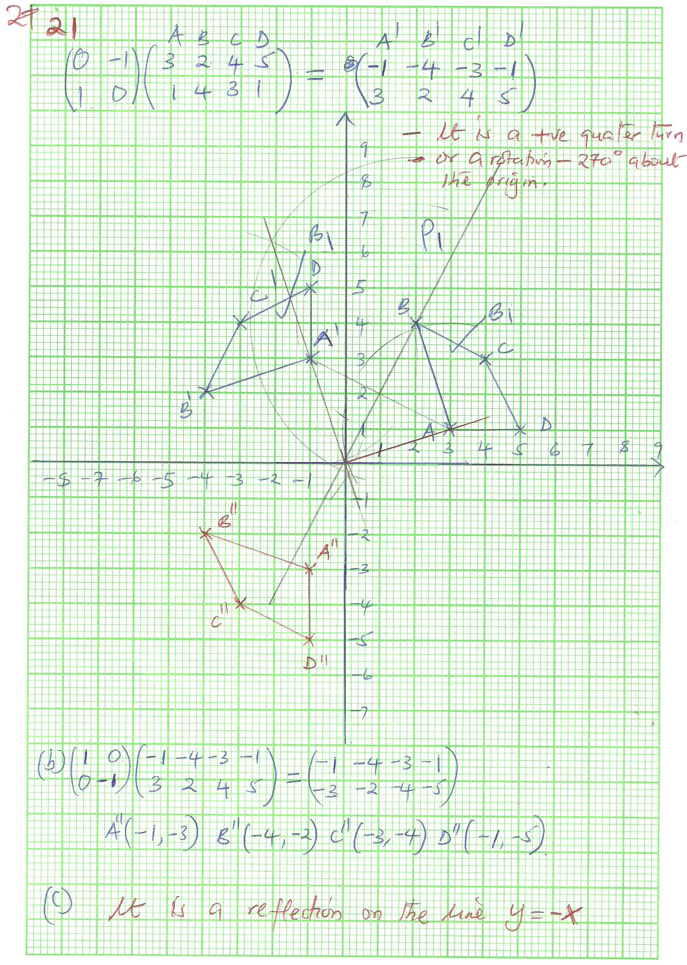  $$\left(\begin{matrix}1 & 0 \\ 0 & -1\end{matrix}\right)\left(\begin{matrix}0 & -1 \\ 1 & 1\end{matrix}\right)=\left(\begin{matrix}0 & -1 \\ -1 & 0\end{matrix}\right)$$  $$det=0-1=-1$$  $$-1\left(\begin{matrix}0 & -1 \\ -1 & 0\end{matrix}\right)=\left(\begin{matrix}0 & 1 \\ 1 & 0\end{matrix}\right)$$ | B1  B1  B1  B1  M1  A1  B1  M1  A1  B1 | Coordinates  ABCD  A'B'C'D'  Describe transformation  A''B''C''D''  Describing transformation
 |  | 10

