Name: _________________________________________________Class: __________________

Date: _________________________________________________ Adm No: _____________

121/2

MATHEMATICS

PAPER 2

April 2023

TIME: 2 HOURS 30 MINUTES

MECS JOINT EXAMINATION

FORM FOUR

TERM 1 2023

**INSTRUCTIONS TO CANDIDATES:**

* Write your **name**, **admission numbe**r and write **date** of examination in the spaces provided
* The paper contains **two** sections. Section I and Section II.
* Answer **ALL** the questions in section I and any **five** questions in section II.
* Answers and working **must** be written on the question paper in the spaces provided below each question.
* Show all steps in your calculations below each question.
* Marks may be given for correct working even if the answer is wrong.
* Non programmable silent electronic calculators and KNEC mathematical table may be used, except where stated otherwise.

**FOR EXAMINERS USE ONLY**

**SECTION I**

|  |  |  |  |  |  |  |  |  |  |  |  |  |  |  |  |  |  |
| --- | --- | --- | --- | --- | --- | --- | --- | --- | --- | --- | --- | --- | --- | --- | --- | --- | --- |
| **Question** | 1 | 2 | 3 | 4 | 5 | 6 | 7 | 8 | 9 | 10 | 11 | 12 | 13 | 14 | 15 | 16 | **TOTAL** |
| **Marks** |  |  |  |  |  |  |  |  |  |  |  |  |  |  |  |  |  |

**SECTION II**

**GRAND TOTAL**

|  |  |  |  |  |  |  |  |  |  |
| --- | --- | --- | --- | --- | --- | --- | --- | --- | --- |
| **Question** | 17 | 18 | 19 | 20 | 21 | 22 | 23 | 24 | **TOTAL** |
| **Marks** |  |  |  |  |  |  |  |  |  |

**Section I (50 Marks)**

**Answer ALL questions in this section in the spaces provided**

1. Solve for x

${\left(\log_{3}{x}\right)}^{2}-\frac{1}{2}\log_{3}{x=}$ $\frac{3}{2}$ $\left[4marks\right]$

1. In the figure below PT is a tangent to the circle from an external point P. $PT=24 cm$ and $OP= 25 cm$.

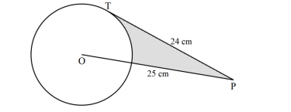

Calculate the area of the shaded region correct to 2 decimal places $\left[4marks\right]$

1. Find the value of $w$ in the expression $wx^{2}-\frac{3}{2}x+\frac{1}{16}$ is a perfect square , given that $w$ is a constant $\left[2marks\right]$

1. Simplify

 (3 marks)

1. The cost C of hiring a conference facility for one day consists of two parts, one which is fixed and the other varies as the number of participants $n$ attending the conference. If Kshs 45000 is charged for hiring the facility for 100 participants and Kshs 40000 for 60 participants, Find the number of participants if 63000 is used to hire the facility $\left[3marks\right]$
2. Juma a form 2 student was told to pick two number x and y from a set of digits 0, 1, 2, 3, 4, 5 and 6. Find the probability that $\left|x-y\right|$ is atleast 3. $\left[3marks\right]$
3. Given that the matrix $\left(\begin{aligned}3x x \\ x-6 -3\end{aligned}\right)$ maps a triangle A $\left(0,0\right)$, B $\left(2, 1\right)$ and c $\left(3, 5\right)$ on to a straight line. Find the possible values of $x.$ $\left[3marks\right]$
4. The points with co-ordinates A(13,3) and B(-3,-9) are the end of diameter of a circle centre O. Determine ;
5. The coordinates of O $\left[1mark\right]$

1. The equation of the circle expressing it in the form

$x^{2}+y^{2}+ax +by +c=0$ $\left[3marks\right]$

1. Two containers have base areas of 750cm2 and 120cm2 respectively. Calculate the volume of the larger container in litres given that the volume of the smaller container is 400cm3.

(3 marks)

1. The cash price of a laptop is 4800. Wambui bought it on hire purchase by making a deposit of kshs. 10000 followed by 24 monthly instalments of kshs 2000 each. Calculate the monthly rate at which compund interest was charged $\left[3marks\right]$
2. A merchant blends 350kg of KAKUZI tea costing shs. 84 per kg with 140 kg of KETEPA tea costing sh.105 per kg. calculate the price at which he must sell 1kg of the mixture to attain 20 % profit. $\left[3marks\right]$
3. The graph below is part of the straight line graph obtained from the initial equation $V=aP^{n}$

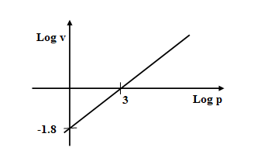

Write down the equation of a straight line in the form of $y=mx+c$ hence use the graph to find the of $a$ and $n$ $\left[3marks\right]$

1. State the amplitude, period and phase angle of $y=2\sin\left(\frac{1}{2}x+{30}^{0}\right)$

(i) Amplitude (1 mark)

(ii) Period (1 mark)

(iii) Phase angle (1 mark)

1. Given the position vectors $\vec{OA}=4i +8j-2k$ and $\vec{OB}=3k-i-2j.$ Point C divides vector AB in the ratio of 3:-1. Find the magnitude of $\vec{OC}$. Give your answer to 2dp

$\left[3marks\right]$

1. The table below shows income tax rates in a certain year

|  |  |
| --- | --- |
| Monthly income in Kshs | Tax rate in each kshs |
| 1 $≤x <9681$ 9681 $≤x<$ 18801  18801 $≤x <$ 27921  27921 $≤x <$ 37040  Over 37040 | 10%  15%  20%  25%  30% |

In a certain month of the year Mr. Mogaka had a total deduction of ksh5,000, he got a personal tax relief of kshs.1056 and paid kshs.3944 for NHIF, WCPS and sacco loan repayment. Calculate

1. P.A.Y.E. (1 mark)
2. Monthly income/salary (3 marks)
3. In the figure given below, O is the centre of circle. If $∠BCA={80}^{0}$ and $∠CBO={10}^{0}.$

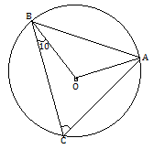

Determine the size of $∠CAB.$ (3 marks)

**Section II (50 Marks)**

**Answer ONLY FIVE questions in the section in the space provided:**

1. In the figure below and 

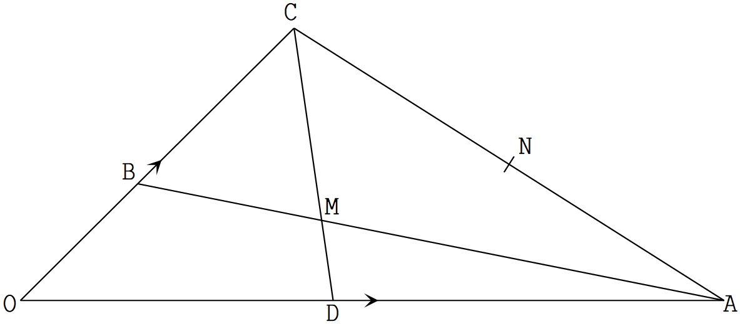

1. Given that  =  and and meet at M. Determine in terms

and .

1.  (1 mark)
2.  (1 mark)
3. Given that and . Determine the values of the scalars  and . (5 marks)
4. Show that O, M and N are collinear. (3 marks)
5. The table below shows the marks scored by form four students in a mathematics test in Amani secondary school.

|  |  |  |  |  |  |  |
| --- | --- | --- | --- | --- | --- | --- |
| Marks | Mid-point  X | Frequency $$f$$ | $$d=x-A$$ | $$fd$$ | $$d^{2}$$ | $${fd}^{2}$$ |
| 40-44 |  | 3 |  |  |  |  |
| 45-49 |  | 30 |  |  |  |  |
| 50-54 |  | 29 |  |  |  |  |
| 55-59 |  | 33 |  |  |  |  |
| 60-64 |  | 13 |  |  |  |  |
| 65-69 |  | 1 |  |  |  |  |
| 70-74 |  | 1 |  |  |  |  |
|  |  | $$\sum{f=}$$ |  | $$\sum{fd=}$$ |  | $$\sum{fd^{2}=}$$ |

Using an assumed mean of 57

1. Complete the table (4 marks)
2. Determine
3. the mean mark (2 marks)
4. The standard deviation (2 marks)
5. Find the mark scored by the 50th student. (3 marks
6. An arithmetic progression AP has the first term a and the common difference d.
7. Write down the third, ninth and twenty fifth terms of the AP in terms of a and d. (2marks)
8. The AP above is increasing and the third, ninth and twenty fifth terms form the first three consecutive terms of a geometric progression (G.P). The sum of the seventh and twice the sixth term of AP is 78. Calculate
9. The first term and common difference of the A.P (5marks)
10. The sum of the first 5 terms of the G.P (3marks)

1. (a) (i) Taking the radius of the earth, R=6370km and $π=\frac{22}{7}$, calculate the shortest distance between two cities P(600N, 290W) and Q(600N, 310E) along the parallel of latitude. (3marks)

(ii) If it is 1200hrs at **P**, what is the local time at **Q** (3marks)

(b) An aeroplane flew due south from a point A(600N, 450E) to a point B, the distance covered by the aeroplane was 8000km, determine the position of B. (4marks)

1. (a) Complete the table below to 2 decimal places. (2mks)

|  |  |  |  |  |  |  |  |  |  |  |  |  |  |
| --- | --- | --- | --- | --- | --- | --- | --- | --- | --- | --- | --- | --- | --- |
| X | 00 | 300 | 600 | 900 | 1200 | 1500 | 1800 | 2100 | 2400 | 2700 | 3000 | 3300 | 3600 |
| – Cos x | – 1 |  | – 0.5 |  | 0.5 | 0.87 |  | 0.87 |  |  | -0.5 | – 0.87 |  |
| Sin ( x – 300) |  | 0.0 | 0.5 |  |  | 0.87 | 0.5 |  | – 0.5 |  |  | – 0.87 | – 0.5 |

(b) Draw the graphs of $y=sin (x – {30}^{°})$ and y= – Cos x on the same axes, for 00< x < 3600. (5mks)

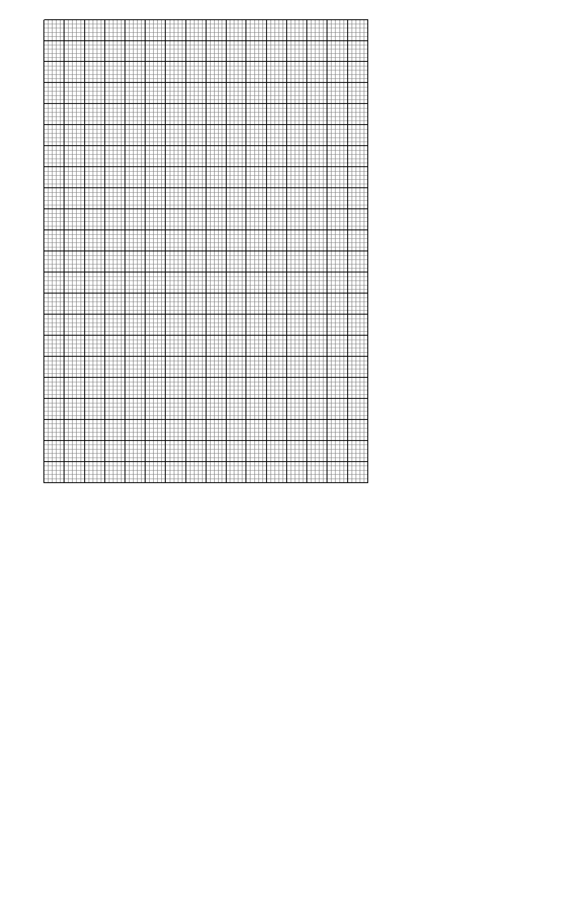

1. Use your graph to solve the equation s
2. $sin (x – {30}^{°}) + Cos x = 0.$ (2marks)
3. $-Cos x=0.5$ (1 marks)
4. Kamau, Njoroge and Kariuki are practicing archery. The probability for Kamau hitting the target is $\frac{2}{5}$, that of Njoroge hitting the target is $\frac{1}{4}$ and that of Kariuki hitting the target is $\frac{3}{7}$.

Find the probability that in one attempt;

1. Only one hits the target (2marks)

b) All three hit the target (2marks)

c) None of them hits the target (2marks)

d) Two hit the target (2marks)

e) At least one hits the target (2marks)

1. Figure below is a pyramid on a rectangular base. PQ=16cm, QR = 12cm and VP = 13cm.

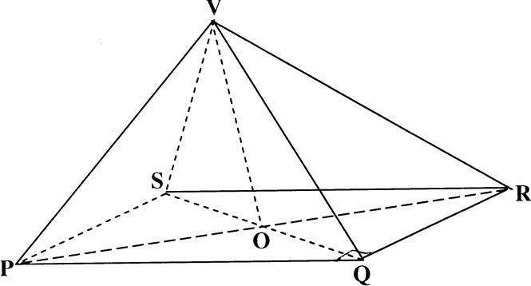

13cm

12cm

16cm

Find

(a) The length of **QS**. (2marks)

(b) The height of the pyramid to 1 decimal place. (2marks)

(c) The angle between **VQ** and the base. (2marks)

(d) The angle between plane **VQR** and the base. **(**2marks)

(e) The angle between planes **VQR** and **VPS (**2marks)

1. **ABCD is** a quadrilateral with vertices as follows: **A** (3, 1), **B** (2, 4) **C** (4, 3) and **D** (5, 1)
2. (i) On the grid provided draw the quadrilateral **ABCD** and the image **A'B'C'D'** under a transformation With matrix $\left[\begin{matrix}0 & -1 \\ 1 & 0\end{matrix}\right]$. Find the co-ordinates of **A'B'C'D'** (3marks)

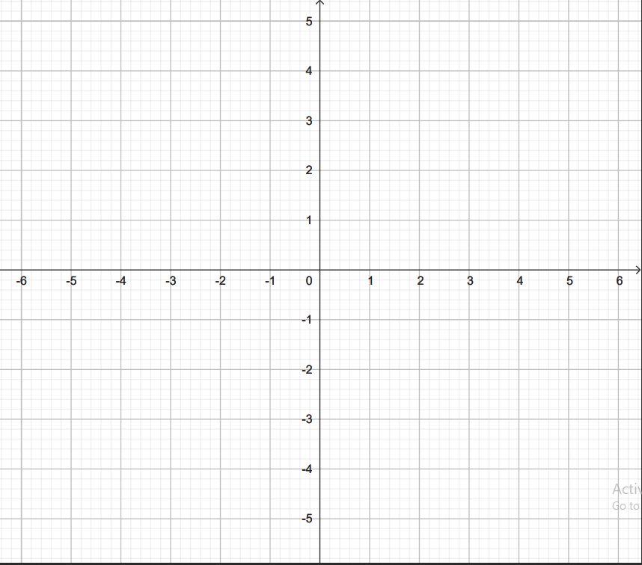

(ii) Describe the transformation that maps **ABCD** onto **A'B'C'D**' fully (1mark)

1. A transformation represented by the matrix $\left[\begin{matrix}1 & 0 \\ 0 & -1\end{matrix}\right]$ maps **A'B'C'D'** onto **A''B''C''D''** find the co-ordinates of **A''B''C''D''.** Plot **A''B''C''D''** on the same grid. (3marks)
2. Determine a single transformation that maps **A''B''C''D''** onto **ABCD**. Describe this transformation fully. (3marks)