AGRICULTURE.
1. a) State two climatic conditions that favour the growing of oil palm in
Nigeria. (2mks)
b) Give two problems experienced in the marketing of palm oil in
Nigeria. (2mks)
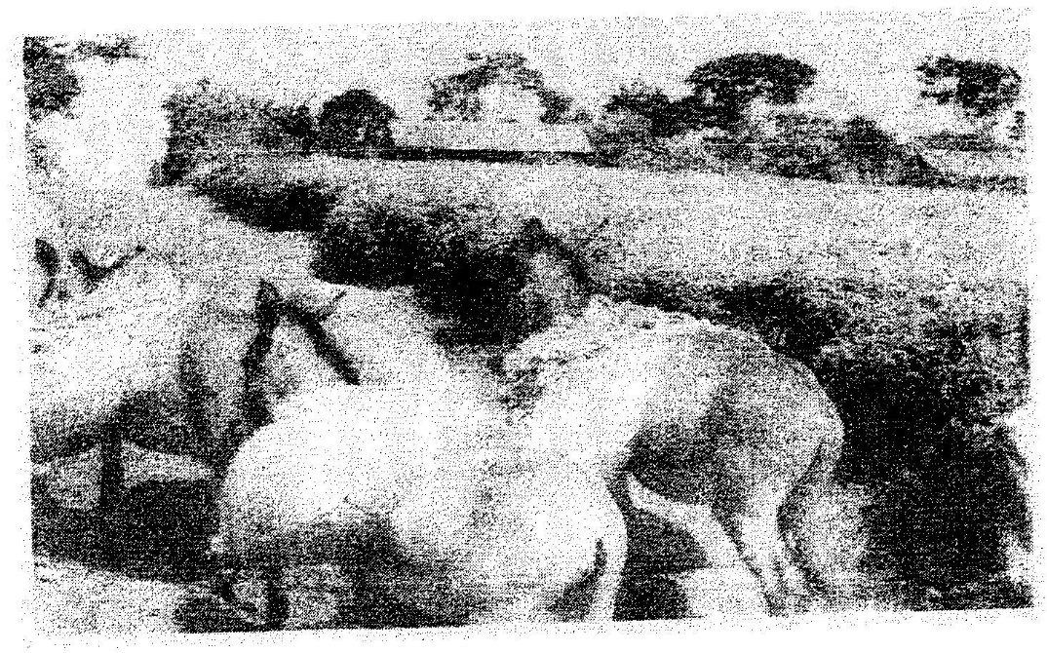
2. The photograph provided shows a tea growing area in Kenya. Use it to answer questions (a) and (b)

a) (i) What evidence in the photograph shows that this is a ground
genera-view type of photograph? (2mks)
(ii) Draw a rectangle measuring 15cm by 10cm to represent the area of the photograph. On it sketch and label the main features shown on the photograph. (5mks)
(iii) Identify two features from the photograph that show that this is a small scale tea farm. (2mks)
b) Describe the stages involved in the cultivation of tea from land preparation to the stage shown on the photograph.

c) (i) Name two districts in the Eastern province where tea is grown.
(2mks)
(ii) Explain four ways in which the Kenya Tea development agency
(KTDA) assists small scale tea farmers in Kenya (8mks)
3. (a) State three physical conditions that are necessary for the growing of cocoa
(3mks)
(b) Give three economic problems experienced in cocoa farming in Ghana
(3mks)
4. a) Give three physical factors that favour coffee growing in Kenya highlands.
b) State two problems facing coffee farming in Kenya
5. a) i) Name two provinces in Kenya where wheat is grown on large
scale (2mks)
ii) Explain four physical conditions that favour wheat growing in Kenya (8mks)
b) Compare wheat farming in Canada and / Kenya under the following
i) Storage (2mks)
ii) Transportation (2mks)
iii) Marking (2mks)
c) i) Explain three climate problems that affect wheat farming in
Canada (6mks)
ii) Give three uses of wheat (2mks)
d) Name two districts in Kenya where wheat is grown on commercial scale.
(2mks)
e) Name two wheat producing provinces in Canada (2mks)
f) Explain five factors which enable Canada to produce more wheat than
Kenya. (5mks)
6. a) State five physical conditions required for the growing of tea in Kenya
(5mks)
b) Explain four problems experienced in small scale tea farming in Kenya
(8mks)
7. The map below shows some major tea growing areas in Kenya.

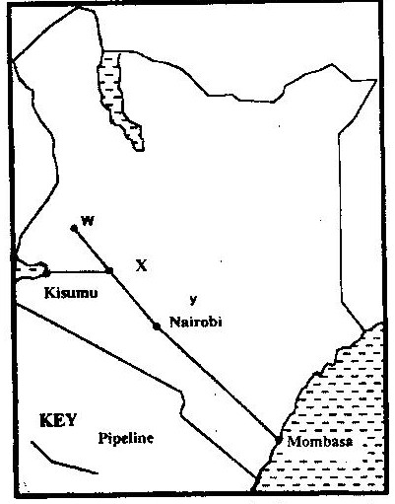

a) Name the areas marked W, X and Y. (3mks)
b) Give two reasons why there was an increase in tea production over the
given period. (2mks)
c) Describe the stages through which tea is processed from picking to the time it is ready for marketing. (5mks)
8. Name major cocoa growing areas in Ghana. (3mks)
9. List suitable conditions for cultivation of cocoa. (4mks)
10. Name types of commercially cultivated coffee. (3mks)
11. Explain ways in which Brazilian government responds to problems facing coffee industry. (6mks)
12. Name four uses of maize. (4mks)
13. List four problems facing maize farmers. (4mks)
14. Outline stages in industrial processing of cocoa. (5mks)

