POPULATION
1. (a) State four reasons why the northern parts of Kenya are sparsely populated.
4 mks
(b) Give two primary sources of population data 2 mks
(c) What information can be derived from a population pyramid? 4 mks
(d) Describe three ways in which the population of Kenya differ from those of Sweden. 6 mks
(e) Explain four causes of rural-urban migration in Kenya. 8 mks
2. Explain three problems which result from the high population growth rate in the East African countries. 6 mks
2005:
3. List three factors that have contributed to a decline in infant mortality in Kenya. 3 mks
4. Explain two reasons why Thika District has a higher population than Murang'a district. 4 mks
5. (a) State the reasons for carrying out population census. 5 mks
(b) How the following factors lead to population increase in Kenya.
(i) Early marriages
(ii) Improved medical facilities
(iii) Cultural beliefs. 6 mks
6. The pyramid below represents the population of country X. Use it to answer question (a).
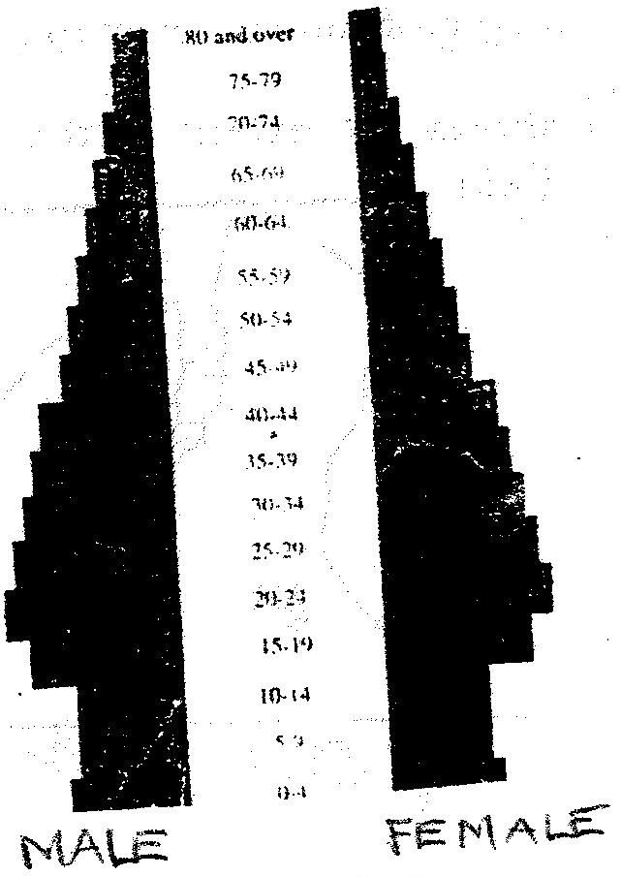

(a) Describe the characteristics of the population represented by the pyramid.
4 mks
(b) Explain three problems which may result from a high population growth rate. 6 mks
(c) Describe THREE measures that have been taken in Kenya to reduce infant mortality. 6 mks
(d) Explain four factors that have led to a high population density in Lake Victoria basin. 8 mks
7. a) Define the term population. 2 mks
(b) Explain factors influencing population distribution. 6 mks
8. (a) Explain factors influencing population growth. 8 mks
(b) Describe the main features of population structure of a developing country. 4 mks
9. Explain the factors leading to high fertility levels in a population. 6 mks
10. Compare and contrast population trends between Kenya and Sweden. 8 mks
11. The table below shows population distribution in Kenya by province in 1999. Use it to answer the questions below.
Province | Population | Area in Sq Kms
Nairobi | 2,143,254 | 696
Central | 3,724,159 | 13,220
Rift Valley | 6,987,036 | 182,539
Western | 3,358,776 | 8,264
Nyanza | 4,392,264 | 12,547
Coast | 2,487,264 | 82,816
Eastern | 4,634,779 | 153,473
N. Eastern | 962,143 | 128,124
Table 9.3 Population of Kenya by Provinces
(a) Calculate the population density of each province. 2 mks
(b) Give reasons why there is a high population density in Central Province of Kenya. 3 mks

