EXTERNAL LAND FORMING PROCESSES – WEATHERING.
1. (a) (i) What is the difference between weathering and mass wasting?
(ii) Apart from plants, give three other factors that influence the rate of
Weathering (3mks)
(iii) Explain two ways in which plants cause weathering (4mks)
(b) (i) List two types of mass wasting other than soil creep (2mks)
(ii) Explain three factors that cause soil creep. (6mks)
(c) Explain four effects of mass wasting on the environment. (8mks)
2. Give two processes involved in each of the following types of weathering
(a) Physical weathering (2mks)
(b) Chemical weathering (2mks)
3. (a) What is mechanical weathering? (2mks)
(b) How is an exfoliation dome formed? (5mks)
4. Describe five processes involved in chemical weathering? (3mks)
5. Name physical weathering processes that take place in the arid areas.
6. List factors that determine rate of weathering.
7. Define the term denudation
8.

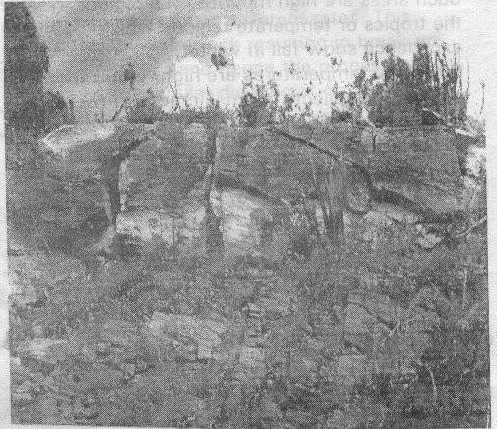

a) Name the above type of weathering.
b) Describe the process shown by the photograph

