

**CEKENA END OF TERM TWO EXAMINATION 2022**

*Kenya Certificate of Secondary Education (K.C.S.E)*

**FORM FOUR**

**232/1**

**PHYSICS**

**PAPER 1**

***MARKING SCHEME***

**SECTION A**

1. Mechanics ✓ 1mk

2.

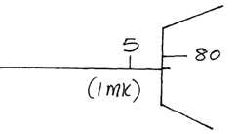

3.i) They are light and bright (either)

ii) No change (1mk)

4. sum of clockwise moment = sum of Anticlockwise moment



5.i) Toward B

ii) Surface tension has been reduced at A and higher surface tension at B pulls the math stick.

b) Due to adhesive force between ink and boatel being stronger than cohesive forces between ink/ chalk molecules.

6. Horizontal force applied in equal to the kinetic friction force. ✓1mk

7. A1V1=A2V2 ✓1



8.

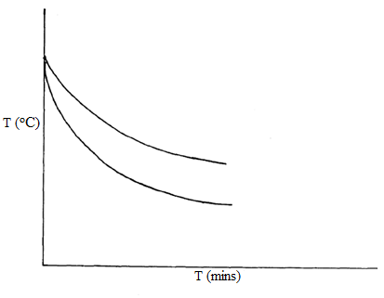

9. when it is heated it expands and volume increases hence does not pass through the ring. When left on the ring it heats the ring, the ring expands the diameter increases while the ball cools reducing its volume hence passes through.

10. Unstable

11. New line below the given line.

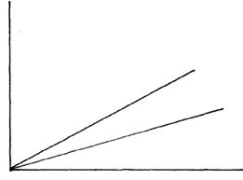

12. In the shoes one exerts his/ her weight on a very small area therefore producing very high pressure which causes pain when placed on the hand it has negligible weight on a very large area negligible pressure.

13.



**SECTION B**

14.a)i) Its product of mass and its velocity.

ii) To increase time of impact hence reducing the impact force which could harm the jumper.

b)i)



ii)

.

15.i) Liquid is lost in form of vapor.

ii) Ice absorbs latent heat of fusion✓ to melt to liquid at zero oC and again to warm from zero to room temperature while water absorbs heat on to warm from zero to room temperature.



16.a)i)



ii)



b)i) The body maintains its initial horizontal velocity throughout the motion.



17.a) Light bulb or LED

b)i)



ii)



c) Measure vertical height of one stair case count the number of stairs cases.

Vertical height = height of one stair case × No of stairs

Partner takes time taken to run up for all the stair cases.

Use the formula



18.a) Its temperature at which the molecules of a gas have their lowest possible kinetic energy.

b) Mass/size of the molecule are negligible

- Negligible intermolecular force

- Negligible time of collision

-Collision between particles and the walls of the container are elastic.

c)



19.a) It states that when a body is fully or partially immersed in a fluid it experiences on up thrust equal to the weight of the fluid displaced.

b)i)



ii)



c

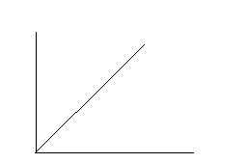

20.a) North pole and south pole.

b)

