

**CEKENA END OF TERM TWO EXAMINATION 2022**

*Kenya Certificate of Secondary Education (K.C.S.E)*

**FORM FOUR**

**232/3**

**PHYSICS**

**PAPER 3**

***MARKING SCHEME***

**Question One**

A i) h =14.8±1.0cm✓1

Range 1 dp

iii) d = 4.3±0.2cm✓1

iv) t = C.E of h-d✓1 -C.E/Exact

v) m =51.10±1.00g ✓1

Range 2 dp

vi) D=2.43±0.02cm 2d.p must

Range

2 dp

vii) R=C.E 

viii) C.S✓

C.E✓

4 s.f/ exact +unit✓

B) e) x=47o

f) yo=C.S✓

C.E✓ 4 s.f or exact

g) C.S (4 sf/ exact)

C) b) U1=20.0±2.0

c) U2=80.5±2.0cm

d) C.E of d (exact subtraction U1-U2)✓1

e) Evaluation of M 4 sf or exact.✓1

C.S of M✓1

Evaluation of Ø 4 s.f or exact ✓1

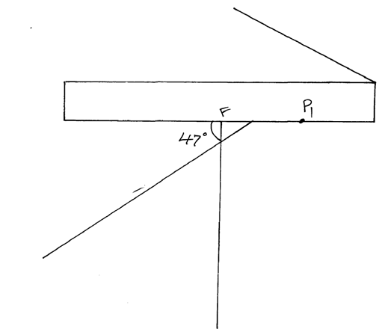

Question Two

i) M=3.0±0.1v

iii)

|  |  |  |  |  |  |  |  |  |
| --- | --- | --- | --- | --- | --- | --- | --- | --- |
| Length L(m) | 0.1 | 0.2 | 0.3 | 0.4 | 0.5 | 0.6 | 0.7 | 0.8 |
| Current I(A) | 0.50 | 0.41 | 0.36 | 0.32 | 0.27 | 0.25 | 0.23 | 0.20 |
| Voltage V (V) | 0.6 | 1.0 | 1.25 | 1.5 | 1.6 | 1.7 | 1.8 | 1.85 |
|  | C.E |  |  |  |  |  |  |  |
|  | C.E |  |  |  |  |  |  |  |

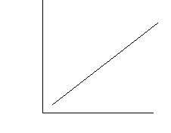iv) A-1

S-1

P-2

C-1

v) m=

x=C.S/C.E