NAME………………………………………………. ADM NO ……………………………………
SCHOOL…………………………………CLASS…………………SIGN.............................……………
DATE……………………………….
231/2
PHYSICS
PAPER 2
END OF TERM 2
AUG-SEPT 2022
TIME: 2 hours
CEKENA END OF TERM TWO EXAM- 2022
Kenya Certificate of Secondary Education (K.C.S.E)
FORM FOUR
232/2
PHYSICS
PAPER 2
TIME: 2½ Hours
Instruction to The Candidates
- Write your name and ADM number in the spaces provided above.
- Sign and write the date of examination in the spaces provided above.
- This paper consists of two Sections A and B.
- There are 14 printed pages, with 18 questions check to confirm that your paper is complete.
- Answer all the questions in sections A and B in the spaces provided.
- All working must be clearly shown in the spaces provided.
- Mathematical tables and electronic calculators may be used.
For Examiners Use Only

Section | Question | Total Score | Candidates Score
A | 1-13 | 25
B | 14 | 8
 | 15 | 9
 | 16 | 11
 | 17 | 14
 | 18 | 13
Total |  | 80

SECTION I (25 MARKS)
1. State the number of images formed when three objects are placed between two plane mirrors which parallel to each to each other. (1mk)
………………………………………………………………………………………………………
2. The figure shows a highly negatively charged electroscope. A pointed pin M which is earthed is brought closer to the metal cap N as shown.
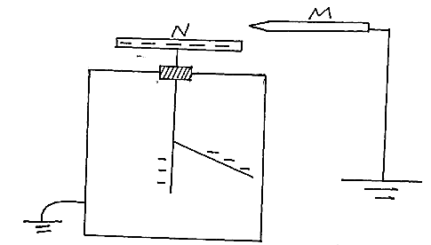
State and explain the observations that will be made. (3mks)
………………………………………………………………………………………………………………………………………………………………………………………………………………………………………………………………………………………………………………………
3. The figure below shows an electric circuit. S₁, S₂ and S₃ are switched and L₁,L₂ and L₃ are lamps. A constant potential difference is applied across X and Y.
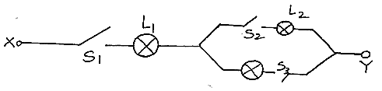
i) Other than L₁ state the lamp that will light when S₁ and S₂ are closed. (1mk)
………………………………………………………………………………………………………………………………………………………………………………………………………………
ii) How does the brightness in L₁in (i) above compared with its brightness when all the switches are closed. (1mk)

4. One method of magnetization is by single stroking. State the disadvantage of this method. (1mk)
………………………………………………………………………………………………………………………………………………………………………………………………………………
5) A pendulum bob takes 0.5seconds to move from its mean position to maximum displacement. Calculate its frequency. (2mks)

6. The figure below shows part of a rainbow.
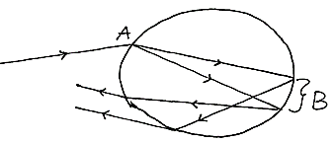
State what happens at part
A ……………………………………………… (1mk)
B ……………………………………………… (1mk)
7. State one factor that affects resistance of metal conductor other than temperature. (1mk)
………………………………………………………………………………………………………………………………………………………………………………………………………………
8. The figure shown a network of three capacitors
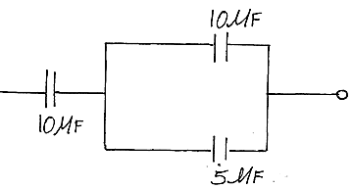
Determine the effective capacitance. (2mks)

9. The figure shows sound waves emitted by a drum stick.
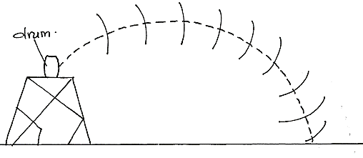
Explain way the wave fronts are directed to the ground (2mks)
………………………………………………………………………………………………………………………………………………………………………………………………………………………………………………………………………………………………………………………
10. Write a nuclear equation of a radioactive cobalt which undergoes a decay to form element W. (2mks)
………………………………………………………………………………………………………………………………………………………………………………………………………………………………………………………………………………………………………………………
11. The figure below show an object O placed in front of concave mirror.

On the same figure construct a ray diagram to locate the image of the object. (3mks)
12.a) State one property common to all electromagnetic waves. (1mk)
………………………………………………………………………………………………………………………………………………………………………………………………………………
b) On the axis provided, sketch a frequency wavelength graph for electromagnetic waves. (1mk)
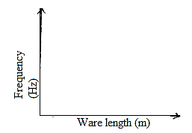

13.a) The figure below shows a p-n junction connected to a cell.
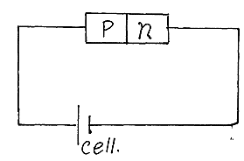
What type of biasing will occur if the terminals of the cell are interchanged (1mk)
………………………………………………………………………………………………………………………………………………………………………………………………………………
b) The graph below shows the output obtained with time during rectification process
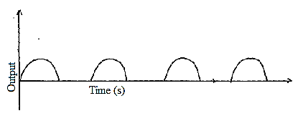
State the number of diode used in this process. (1mk)
………………………………………………………………………………………………………………………………………………………………………………………………………………
SCTION II (55 MARKS)
Answer all the question in the space provided
14.a) State Ohm’s law (1mk)
………………………………………………………………………………………………………………………………………………………………………………………………………………
b) Study the circuit diagram below and answer the question that follows.
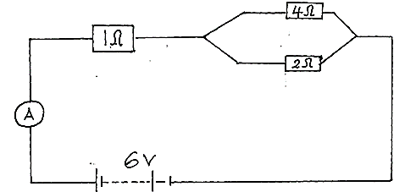

Calculate
i) The effective resistance (2mks)

ii) Current flowing through the ammeter (2mks)

iii) Current flowing through the 4resister. (3mks)

15.a) State one use of echoes (1mk)
………………………………………………………………………………………………………
b) Explain why there is gradual decrease in amplitude of a progressive wave (1mrk)
………………………………………………………………………………………………………………………………………………………………………………………………………………………
c)i) Distinguish between Refraction and reflection of waves (1mk)
………………………………………………………………………………………………………………………………………………………………………………………………………………………………………………………………………………………………………………………
ii) In the figure below complete the diagram to show how plane wave move in the shallow and deep region there after (2mks)
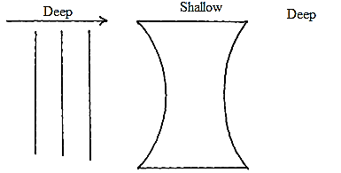

iii) The figure below shows how water wave interferes in a ripple tank. The amplitude and wavelength of each wave is 8cm and 5cm respectively.
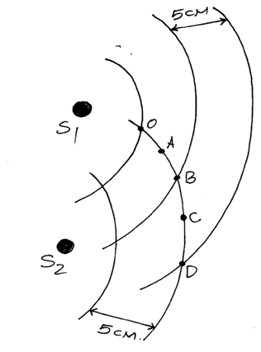
Determine the amplitude of the water wave at point
A (1mk)
B (1mk)
iv) If the Vibrator at S₁ and S₂ in part (iii) above produce coherent waves of frequency 40Hz, determine the speed of the water wave. (2mks)

16.a) Determine the term principal focus for a convex lens. (1mk)
………………………………………………………………………………………………………………………………………………………………………………………………………………
b) A certain student accommodates objects situated at a distance greater than 80.0cm from the eye.
i) Define the term accommodation in reference to eye vision. (1mk)
………………………………………………………………………………………………………………………………………………………………………………………………………………
ii) State with a reason this type of eye defect (2mks)
………………………………………………………………………………………………………………………………………………………………………………………………………………

iii) Identify the type of lens that would enable the student to see. (1mk)
………………………………………………………………………………………………………………………………………………………………………………………………………………
c) The graph below is a plot of image distance (v) against object distance (u) for a convex lens.
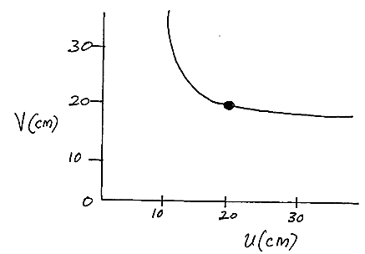
From the graph determine the focal length of the convex lens. (2mks)

d) An object of height 4cm is placed 2cm from a diverging lens of focal length 3cm calculate:
i) The image distance. (2mks)

ii) The height of the image (2mks)

17.a) The figure below shows a cathode ray oscilloscope (CRO)
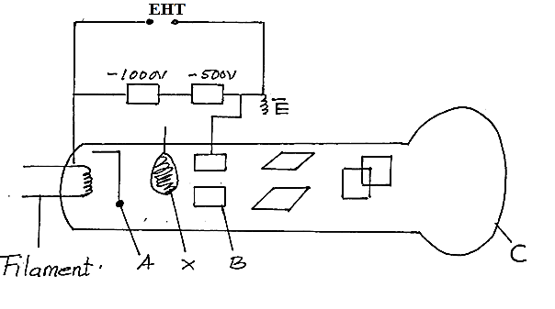
i) State the function of the component labeled: (3mks)
A ……………………………………………………………………………………………………
B ……………………………………………………………………………………………………
C …………………………………………………………………………………………………….
ii) What would be the effect on the CRO if the temperature of the filament of the electron gun was raised. (1mk)
………………………………………………………………………………………………………………………………………………………………………………………………………………
iii) Name and state the function of the part labeled X. (2mks)
………………………………………………………………………………………………………………………………………………………………………………………………………………………………………………………………………………………………………………………
b) Apart from thermionic emission name the other method of emitting electrons from a metal surface. (1mk)
……………………………………………………………………………………………………………………………………………………………………………………………………………….
c) State two factors that affect photoelectric effect on a metal surface. (2mks)
………………………………………………………………………………………………………………………………………………………………………………………………………………………………………………………………………………………………………………………

d) The graph below shows how kinetic energy varies with frequency f in an experiment using a photocell.
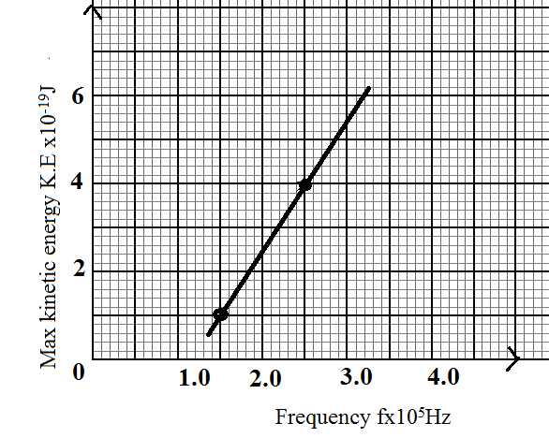
Given the k.e max=hf-Ø determine from the graph :
i) Plank constant h (3mks)

ii) The Constant Ø (2mks)

18.a) State the Lenz’s low of electromagnetic induction. (1mk)
………………………………………………………………………………………………………………………………………………………………………………………………………………
b) The figure below shows two coil connected using a soft iron core
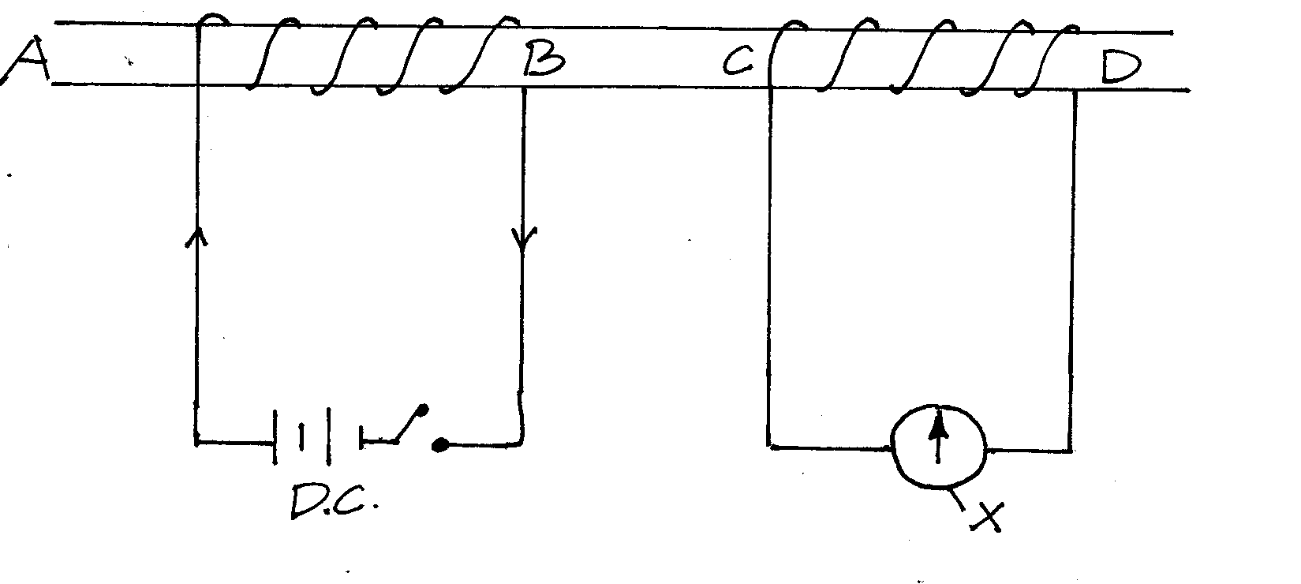

i) Name the part labeled X (1mk)
………………………………………………………………………………………………………
ii) State and explain what happens when the switch is closed (3mks)
………………………………………………………………………………………………………………………………………………………………………………………………………………………………………………………………………………………………………………………………………………………………………………………………………………………………
ii) State the observation made on X when the D.C supply is replaced with A.C (1mk)
………………………………………………………………………………………………………………………………………………………………………………………………………………
c) A generator produces 250kW is connected to a factory by a cable which has a total resistance of 10. Determine the voltage at which the generator produces power if the maximum current in the cable is 8.0A (2mks)

d)i) State two ways through which power loss is minimized in a transmission cables. (2mks)
………………………………………………………………………………………………………………………………………………………………………………………………………………………………………………………………………………………………………………………
ii) The figure below shows part of a wiring circuit for a house.
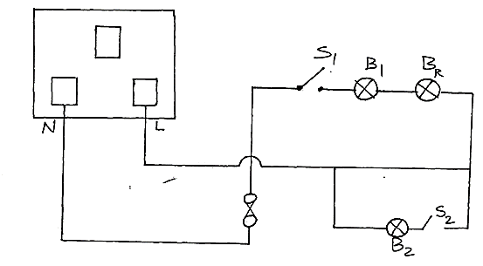

Identify three faults made in the wiring. (3mks)
………………………………………………………………………………………………………………………………………………………………………………………………………………………………………………………………………………………………………………………………………………………………………………………………………………………………………………………………………………………………………………………………………

THIS IS THE LAST PRINTED PAGE!

