

**CEKENA END OF TERM TWO EXAMINATION 2022**

*Kenya Certificate of Secondary Education (K.C.S.E)*

**FORM FOUR**

**232/2**

**PHYSICS**

**PAPER 2**

***MARKING SCHEME***

1. infinity✓

2. Divergence decreases/ leaf falls ✓The cap repels negative charges/ electrons on the pin to earth. High concentration of positive charges at sharp point ionize air molecules near the capü. Positive ions are attracted to the cap and neutralizes electros leading to discharge.

3. i) L3 ✓ 1mk

ii) Will be brighter ✓/ more brought

4. Produces magnets in which one pole is nearer the end than the other

5. 

6. A- Refraction and diffraction✓

B- Total internal refraction✓

7. Cross- sectional area/ thickness/ length any ✓mk

8. Parallel C = 10+5=15F



9. The wave is refracted towards the ground because wave front travel faster in the upper layers that the lower part.

10. 

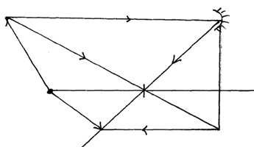11.

each ray @ 1mk✓

Total 2mks✓✓

Image ✓ 1mk

12.a) All are transverse/ travels with same speed in vacuum

Any other correct award 1mk

b)

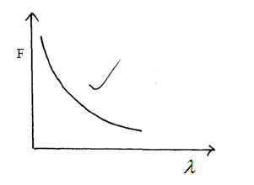

13.a) Reverse biasing✓

b) One diode✓

**SECTION II**

14.a) Current Flowing through a conductor is directly proportional to the p.d across it provided temperature and other physical conditions are kept constant.✓ 2

b)

✓2



✓3

15.a) - Determining the speed of sound

Pulse- echo technique to determine to depth of the sea.

b) Energy is spread over on increasingly large area as the wave moves.

c)i) Refraction is change of direction and speed of wave at they passes through different medium while refraction is bouncing back of waves. ✓

ii)

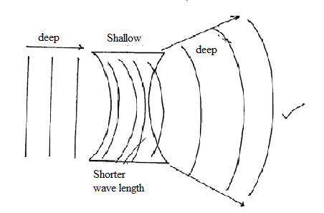

iii) A 0cm✓

B 16cm✓

iv)



16.a) It is the point on the principal axis at which all rays parallel and close to the principal axis converge after refraction.

b)i) It is the process by which the eye adjusts the focal length of its own lens in order to focus images of objects at different distances on the retina.

ii) Myopia/ Short sightedness

iii) Concave/ diverging lens.

c)



d)i)



ii)



17.a)i) A- produce electrons by thermionic emmission✓

B- Accelerates electrons to the screen✓

C- glows fluoresces on impact with electrons✓

ii) The spot will be brighter

iii) Grid✓

Controls the intensity of beam and hence the brightness on the screen✓

b) Photoelectric effect

c) Type of metal

Energy/ frequency/ wavelength of the radiation (any 2)

Intensity of the radiation

b)i)



ii)



18.a) The direction of induced current is such that if produces a magnetic field which opposes the change producing it.

b) i) Galvanometer

ii) The galvanometer cleflects to the right momentarily✓/ deflection to the right and the come back to zero.

When the switch is closed current increases from zero to maximum. In the primary coil producing a charge in the magnetic flux✓ linkage inducing an emf that produces current.

c)



d)i) Using thick cables/ low resistance cable✓

Stepping up the voltage

ii) The fuse is connected on the neutral wire instead of live.

Bulb B3 is short circuit

Switch S1 is connected on the neutral wire instead of live.

Tapping the lighting circuit from the socket