NAME………………………………………………. ADM NO ……………………………………
SCHOOL…………………………………………… SIGNATURE………………………………
DATE……………………………….
231/1
PHYSICS
PAPER 1
END OF TERM 2
AUGUST 2022
TIME: 2 hours
CEKENA END OF TERM TWO EXAMINATION 2022
Kenya Certificate of Secondary Education (K.C.S.E)
FORM FOUR
232/1
PHYSICS
PAPER 1
TIME: 2½ Hours
Instruction to The Candidates
- Write your name and ADM number in the spaces provided above.
- Sign and write the date of examination in the spaces provided above.
- This paper consists of two Sections A and B.
- There are 14 printed pages, with 18 questions check to confirm that your paper is complete.
- Answer all the questions in sections A and B in the spaces provided.
- All working must be clearly shown in the spaces provided.
- Mathematical tables and electronic calculators may be used.
For Examiners Use Only

Section | Question | Total Score | Candidates Score
A | 1-13 | 25
B | 14 | 08
 | 15 | 09
 | 16 | 08
 | 17 | 09
 | 18 | 06
 | 19 | 07
 | 20 | 08
Total |  | 80

SECTION A (25 MARKS)
Answer all Questions in the space provided
1. State the branch of physics applied by a soldier when firing a gun. (1mrk)
………………………………………………………………………………………………………
………………………………………………………………………………………………………
2. The figure bellow shows part of micrometer screw gauge with 100 divisions on the thimble scale. Complete the diagram to show a reading of 5.79mm (2mks)
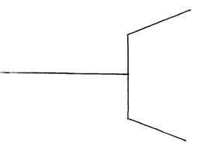
3. The diagram bellow shows apparatus used to observe the behavior of smoke particles in air.
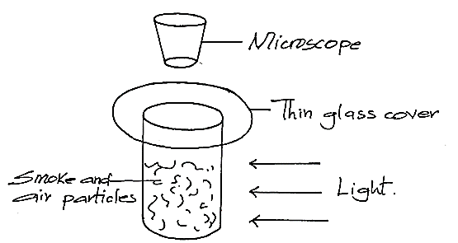
i) Why are smoke particles suitable for use in this experiment? (1mk)
………………………………………………………………………………………………………………………………………………………………………………………………………………
ii) What difference if any would be seen in the motion of the smoke particles if a source of light of weaker energy was used (1mk)
………………………………………………………………………………………………………
………………………………………………………………………………………………………
4. The diagram bellow shows a uniform meter rule pivoted at its center and balanced bay the forces shown. (3mks)
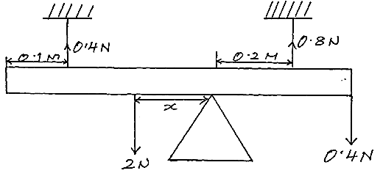
Determine the value of x.

5.a) The Figure below shows a matchstick soaped on one end and placed on the surface of water as shown below. If soap solution is poured at A
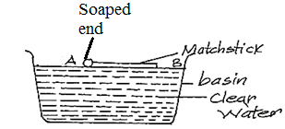

The matchstick is observed to move in a certain direction.
i) State the direction (A or B) (1mk)
………………………………………………………………………………………………………
ii) Explain your answer in (i) above. (1mk)
………………………………………………………………………………………………………
b) A physics teacher writing on a board uses a piece of chalk or white board marker. Explain why any ink or chalk particles sticks on the board. (1mk)
………………………………………………………………………………………………………………………………………………………………………………………………………………
6. A student pulls a block of wood along a horizontal surface by applying a constant force. State the reason why the block moves at a constant velocity. (1mk)
………………………………………………………………………………………………………
………………………………………………………………………………………………………

7. Water moves through a horizontal pipe of varying crossection area as shown below.

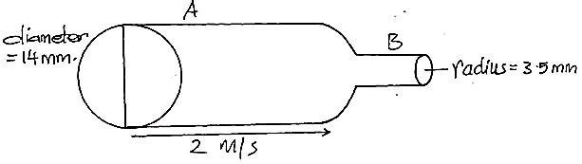
Determine the velocity of the water in pipe B given the velocity of A is 2m/s (3mks)

8. Equal amount of hot water at 100ºC is poured in to vessels P and Q as shown below and left to cool up to the room temperature. P is painted black and Q is polished.
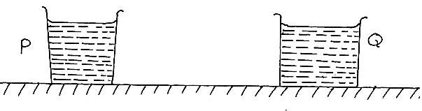
The readings of the thermometer are taken at interval of five minutes. On the axes below, sketch a graph of temperature against time for P and Q (2mks)
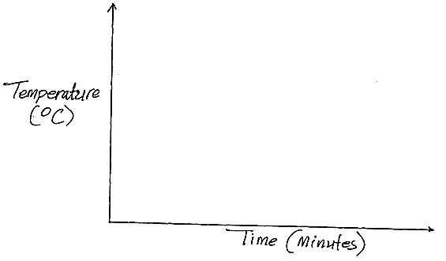
9. In a ball and ring experiment the ball goes through the ring at room temperature. When it is heated it does not go through the ring but when left on the ring for some time it goes through. Explain this observation. (2mks)
………………………………………………………………………………………………………
………………………………………………………………………………………………………
………………………………………………………………………………………………………

10) State the type of stability shown below (1mk)
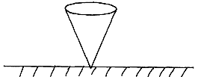
………………………………………………………………………………………………………
11) The graph below shows Force against extension of the spring. (1mk)
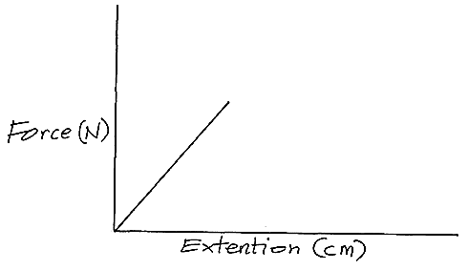

On the same axes sketch a graph of force against extension for a spring double the length same thickness and same material as the given spring.

12. A small stone in your shoes is painful when you step on it but does not hurt you when removed from the shoe and placed in on the hand.
Explain (2mks)
………………………………………………………………………………………………………
………………………………………………………………………………………………………
………………………………………………………………………………………………………
13. Consider the Figure below.

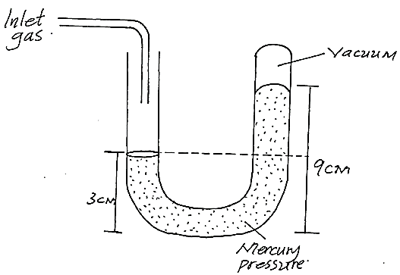

Mercury = (13.6gcm⁻³) and Pa=760mmHg
Calculate the pressure of the gas in cm Hg. (2mks)

EXPLAIN B (55 MARKS)
Answer all question in the space provided
14.i) Define the term momentum. (1mk)
………………………………………………………………………………………………………
………………………………………………………………………………………………………
ii) Explain why high jumpers flexes their knees when landing on the ground. (2mks)
………………………………………………………………………………………………………
………………………………………………………………………………………………………
b) A body of mass 150Kg travelling at a constant velocity of 72km/h collides with a stationary object of mass 90kg. If the impact takes 3s before the two moves together at a constant velocity for 20s. Find
i) Their common velocity (2mks)

ii) Impulsive Force. (3mks)

15.i) State one similarity between boiling and evaporation. (1mk)
………………………………………………………………………………………………………………………………………………………………………………………………………………

ii) Explain why pieces of ice at 0ºC added to a drink at room temperature are more effective in cooling the drink than equal mass of water at 0ºC. (2mks)
………………………………………………………………………………………………………
………………………………………………………………………………………………………
………………………………………………………………………………………………………
b)i) 200g of a liquid at a temperature of 10ºC is poured into a well lagged calorimeter. An electric heater rated 1500W is used to heat the liquid. The graph below shows a variation of temperature of the liquid with time.
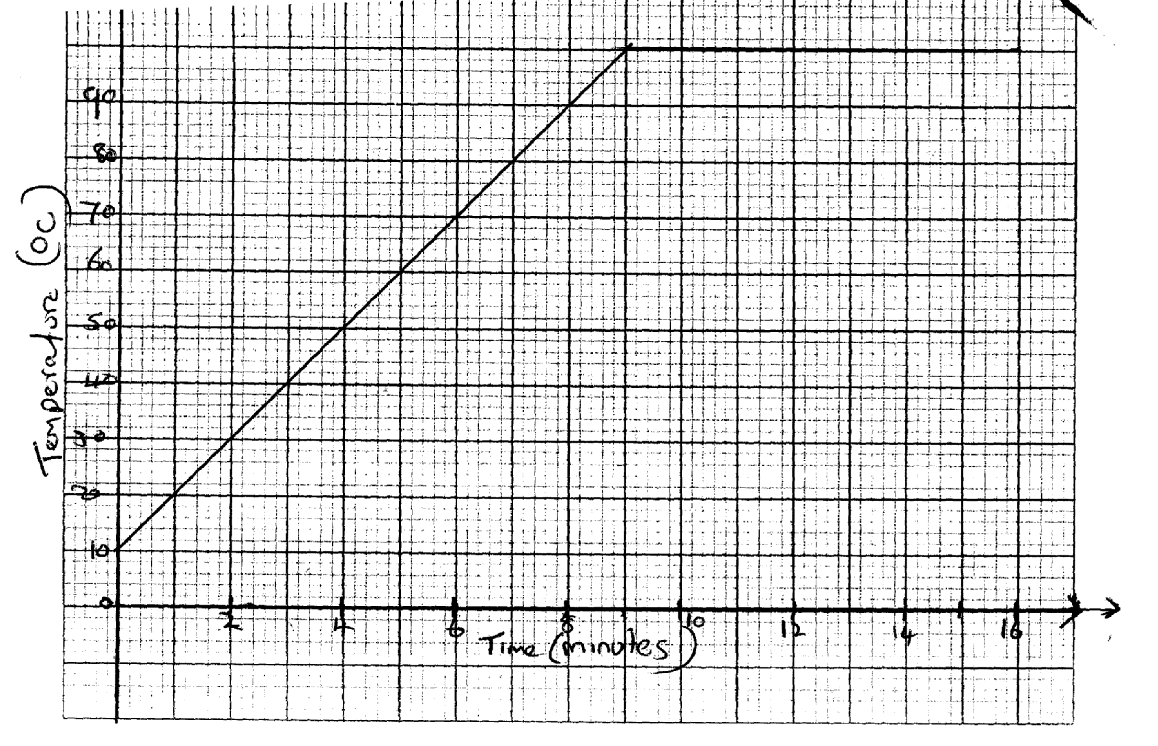
From the graph determine the specified latent heat of vaporization assuming that the liquid evaporates. (3mks)

c)i) A small electric heater rated 20W 240V is immersed in crushed ice in a funnel. Before the heat is switched on, the water drops from the funnel at a rate of 0.5g/min and when the heater is working the water drop at the rate of 4g/min.
Calculate the specified latent heat of fusion. (3mks)

16.a) A ball is thrown verticality upwards from hands at 125m/s and the thrower receives it back.
i) Calculate the time of flight. (2mks)

ii) Calculate how high the ball rises (2mks)

b)i) A bullet is fired horizontal at a target. Neglecting air resistance, give a reason why the horizontal acceleration of the bullet is zero. (1mk)
………………………………………………………………………………………………………
………………………………………………………………………………………………………
ii) A bullet is fired horizontally from a flat form 15m high. If initial speed is 300m/s determine maximum horizontal distance covered g=10m/s² (3mks)

17.a)i) Name the device that is used to convert electrical energy to light energy (1mk)
………………………………………………………………………………………………………
………………………………………………………………………………………………………
b) The figure below shows a load of 100N being raised by pulling it along a incline plane of length 3m.
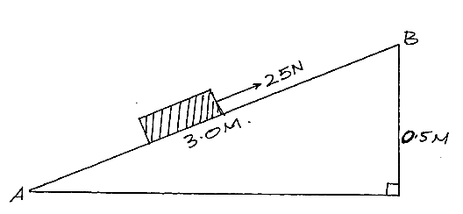
i) Calculate the efficiency of the system (3mks)

ii) Calculate the work done against the friction when moving the body from point A to B. (2mks)

c)i) Assuming that you know your weight, Explain how you can calculate your own power given the following:
Tape measure, stopwatch, A partner to record the time, Flight of stairs. (3mks)

18.a) Define the term “Absolute zero temperature” as applied in gas laws. (1mk)
………………………………………………………………………………………………………
………………………………………………………………………………………………………
b) State two assumptions used in gas laws. (2mks)
………………………………………………………………………………………………………
……………………………………………………………………………………………………….
c) An air pump is taking in air at 1.01×10⁵Pa and supplies it into a rigid container of volume 2 liters. The barrel of the pump has a volume of 0.2 liters. If the pressure in the receiver is initially at 101×10⁵Pa what is the pressure in the receiver after five strokes of the pump. Assuming temperature is constant. (3mks)

19.a) State the Archimedes principle (1mk)
………………………………………………………………………………………………………
………………………………………………………………………………………………………
b)i) The figure below shows a rectangular block of height 6cm floating. Vertically in a beaker containing two immiscible liquids A and B. The density of the liquid is 800kgm³ and 1200kgm³ respectively.
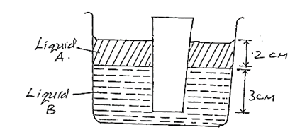
The cross-section area of the block is 2cm²

Determine:
i) The total weight of the liquid displaced by both liquids A and B. (3mks)

ii) Density of the block (2mks)

c) In the space provided sketch a graph of the weight of the water displaced against the lost in weight of the object when the object is lowered in the water until it is fully submerged. (1mk)

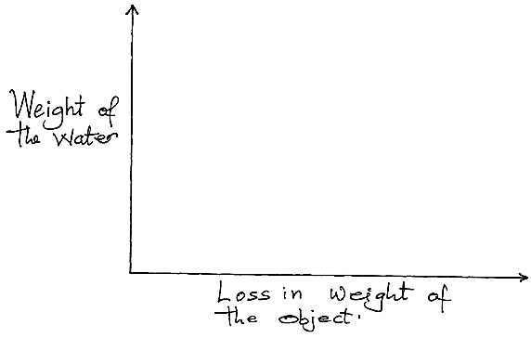

20.a) State two parts of the earth which have zero angular velocity of linear velocity as it completely one rotation. (1mk)
………………………………………………………………………………………………………………………………………………………………………………………………………………

b) A particle moving along a circular path of radius 5cm describes an arch length of 2cm every 2 seconds. Determine:
i) Its Angular velocity (2mks)

ii) Its periodic time (2mks)

c) A car of mass 1500kg negotiates a bend of radius 45m on horizontal road. If the friction force between the road and the tires is 7200N, calculate the maximum speed at which the car can be driven at the bend without skidding. (3mks)

THIS IS THE LAST PRINTED PAGE!

