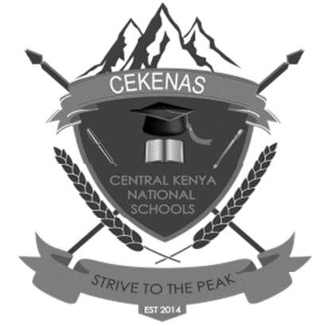
CEKENA END OF TERM TWO EXAMINATION 2022
Kenya Certificate of Secondary Education (K.C.S.E)
FORM FOUR
232/3
PHYSICS
PAPER 3
CONFIDENTIAL
Each student will require;
Question one
1. Boiling tube approx. 15.0cm tall and diameter 2.4±0.5cm
2. Some dry sand
3. Half meter rule
4. Vernier calipers (to be shared)
5. Weighing balance (At least one per room)
6. A piece of tissue paper.
7. A glass beaker (at least 600ml almost full of liquid L and labeled L)
(Liquid L is brine prepared with 1kg salt in 5 liters of water)
8. A plane mirror.
9. A rectangular glass block approximately 100mm×60mm×18mm.
10 A plain white paper.
11 Soft board.
12. Protractor (Student geometrical set)
13. A piece of plasticine.
14. Four optical pins
15. A lit candle
16. A biconvex lens of f =15cm
17. A lens holder
18. A meter rule
19. A white screen.
Question Two
1. Ammeter (0-1A)
2. Voltmeter (0-5V)
3. Two new size D cells.
4. A cell holder.
5. A resistance wire fixed on a millimeter scale (SWG 31)
6. A switch.
7. Six connecting wire with crocodile clips.

