A C K PHYSICS PAPER 3

INSTRUCTIONS TO CANDIDATES
1. Write your name, index number, class, date and signature in the spaces provided above.
2. This paper consists of two questions 1 and 2.
3. Answer all questions in the spaces provided.
4. Non-programmable calculators and mathematical tables may be used.
5. Show all your workings.

QUESTION 1 | c | g | h | i | j | k | l
Maximum score | 1 | 8 | 5 | 2 | 1 | 2 | 1
Candidates score

QUESTION 2 | b | c | d | e |  | GRAND TOTAL
Maximum score | 3 | 2 | 6 | 9
Candidates score

QUESTION ONE
You are provided with the following
2 new dry cell size D
A cell holder
A switch
A milliameter of range 0 – 1mA
A capacitor labelled C
8 connecting wires at least four with crocodile clips on one end
A stop watch
A carbon resistor labelled R
Proceed as follows
a) Connecting the circuit as shown in the figure 1 below, where P and Q are crocodile clips
R
mA
C
S
Figure 1

b) Close the switch S
c) Record the highest reading of the milliammeter I_{o} and then open the switch.

I_{o} =………………………………………… (1 mark)

d) Use I_{o} above to calculate ⁴/₅I_{o,} ³/₄I_{o}, ²/₃I_{o}, ¹/₂I_{o}, ²/₅I_{o}, ¹/₃I_{o} and ¹/₄I_{o.} Record in the table 1 below.
e) Close switch S for a second time and observe the deflection in the milliammeter (the pointer should rise back to the same initial value I_{o.)}

f) Open switch S and at the same time start the stop watch to measure the time taken for the current to decrease to four fifth the value of I_{o}. i.e. ⁴/₅I_{o}. Record your value in the table 1 below.

g) Repeat steps e and f for other values of current as shown on the table 1 below

Current I (mA) | I_{o} | ⁴/₅I_{o} | ³/₄I_{o} | ²/₃I_{o} | ¹/₂I_{o} | ²/₅I_{o} | ¹/₃I_{o} | ¹/₄I_{o}
Your calculated fraction of I_{o} (mA)
Time t (s)
(8marks) Table 1

h) Plot a graph of current I (y-axis) (mA) against time t (s) (5marks)

i) From your graph, find W the value of I when t = 7.00s in SI units. (2marks)

j) Given that A = 10W, determine the value of A. (1mark)

k) Determine the voltage across R at t = 7.00s given that R = 4.7 KΩ (2marks)

l) State the quantity represented by the area under the graph (1mark)

- QUESTION TWO
This question has two parts A and B. Answer both parts.

PART A
You are provided with the following:-
- A retort stand, clamp and boss.
- A spiral spring.
- A stop watch.
- Three 100g masses.

Proceed as follows:
    - Suspend a 100g mass at the end of the spring as shown in figure 1.
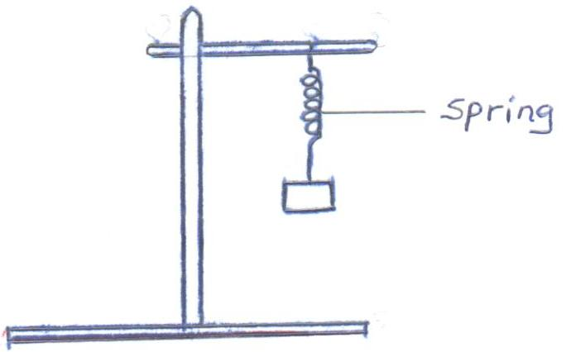

Fig. 1

Now give the mass a small vertical displacement and release so that it performs vertical oscillations. Time ten oscillations and determine the period T. Enter your results in table 1.

    - Repeat the experiment for the other values of mass and complete the table.
Table 1
Mass m (g) | 100 | 200 | 300
Time for 10 oscillations (s)
Periodic time T(s)
(3mks)
    - Given that T = π m , where k is the spring constant, find the average value k for the spring. K (2mks)

PART B
You are provided with the following:-
- A 250ml glass beaker
- A Bunsen burner
- A Thermometer
- A Stop watch
- A Tripod stand and a Wire gauze
- A measuring cylinder 100ml
- Water
Set the apparatus as shown in figure 2 below.
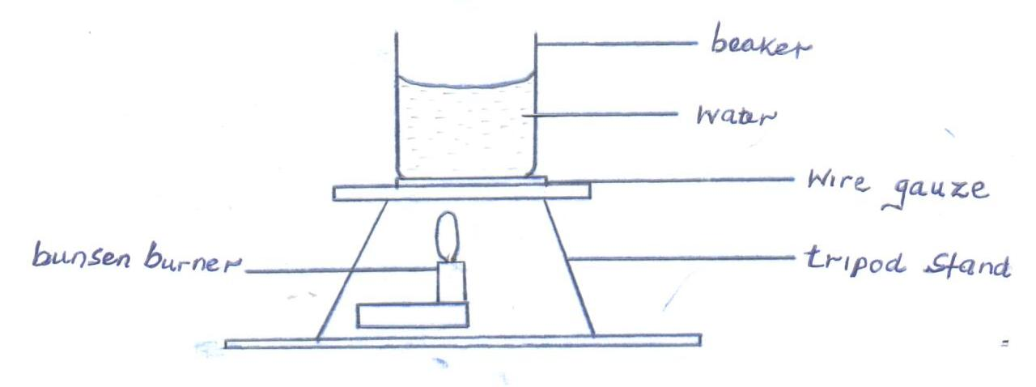
Fig. 2
    - Measure 100cm³ of water and pour it into the beaker. Take the initial temperature of the water.
T₀ = …………………………………………….⁰C (1mk)
Now heat the water to a temperature of 80⁰C. switch off the gas tap and place a thermometer into the beaker and start the stop watch when the temperature is 65⁰C. Take the temperature T⁰C of water ever two minutes. Record your results in the table 2 below.

Table 2
Time, t(min) | 2 | 4 | 6 | 8 | 10 | 12 | 14
Temperature (T) ⁰C
(T - T₀)
Log (T - T₀)
(5mks
    - Plot a graph of Log (T - T₀) against Time (t). (5mks)

- Find the value of P of log (T - T₀) when t = 0. (1mk)

- Determine N, where N is the antilog of P. (1mk)

- Calculate the temperature of the surrounding T_{R} using the expression N = 65–T_{R}
(2mks)

