**A C K PHYSICS MARKING SCHEME PAPER 3 2022**

**QUESTION ONE**

You are provided with the following

**2** new dry cell size **D**

A cell holder

A switch

A milliameter of range **0** – **1mA**

A capacitor labelled **C**

**8** connecting wires at least four with crocodile clips on one end

A stop watch

A carbon resistor labelled **R**

Proceed as follows

a) Connecting the circuit as shown in the **figure 1** below, where **P** and **Q** are crocodile clips

**R**

**C**

**S**

**Figure 1**

b) Close the switch **S**

c) Record the highest reading of the milliammeter **Io** and then open the switch.

**Io** = ***0.64 mA*** **± 0.05mA** (1mark)

d) Use **Io** above to calculate **4/5Io, 3/4Io**, **2/3Io**, **1/2Io**, **2/5Io**, **1/3Io** and **1/4Io.** Record in the **table 1** below.

e) Close switch **S** for a second time and observe the deflection in the milliammeter (*the pointer should rise back to the same initial value Io*.)

f) Open switch **S** and at the same time start the stop watch to measure the time taken for the current to decrease to four fifth the value of **Io**. i.e. **4/5Io**. Record your value in the **table 1** below.

g) Repeat steps **e** and **f** for other values of current as shown on the **table 1** below

|  |  |  |  |  |  |  |  |  |
| --- | --- | --- | --- | --- | --- | --- | --- | --- |
| Current **I** (**mA**) | **Io** | **4/5Io** | **3/4Io** | **2/3Io** | **1/2Io** | **2/5Io** | **1/3Io** | **1/4Io** |
| Your calculated fraction of **Io** (**mA**) | ***0.64*** | ***0.51*** | ***0.48*** | ***0.43*** | ***0.32*** | ***0.26*** | ***0.21*** | ***0.16*** | *Each 1/2  mk (use student value of Io)*  *(***Max 4mks)** |
| Time **t** (**s**) | ***0.00*** | ***2.57*** | ***3.34*** | ***4.72*** | ***7.87*** | ***10.09*** | ***12.55*** | ***15.88*** | *± 1.00 sec*  *Each 1/2  mk (2d.p must)* **(Max 4mks)** |

(8marks) **Table 1**

h) Plot a graph of current **I** (y-axis) (**mA**) against time **t** (**s**) (5marks)

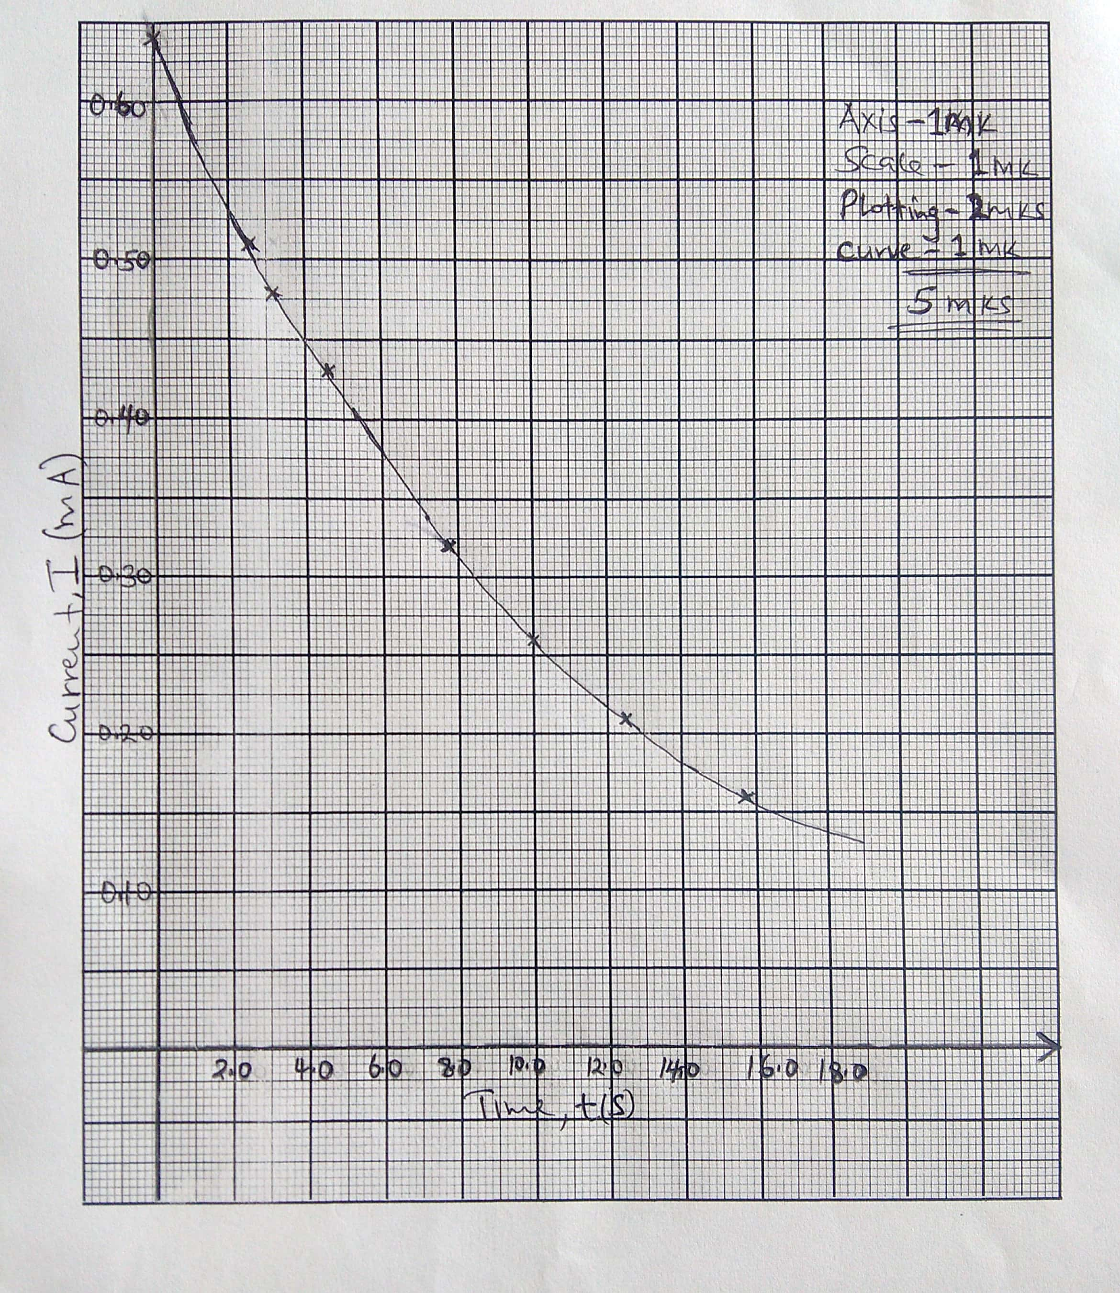

i) From your graph, find **W** the value of **I** when **t** = **7.00s** in **SI** units.(2marks)



j) Given that **A** = **10W**,determine the value of **A**. (1mark)



k) Determine the voltage across **R** at **t** = **7.00s** given that **R** = **4.7 KΩ** (2marks)



l) State the quantity represented by the area under the graph (1mark)

***Quantity of charge in the capacitor;***

