2022
NAME__________________________________INDEX NO.________________
DATE__________________________________SIGNATURE________
ADM NO.______________
232/2
PHYSICS PAPER 2
THEORY
YEAR 2022 SEPTEMBER
TIME: 2 HOURS
A.C.K DIOCESE OF MUMIAS JOINT EVALUATIONASSESMENT TEST
KENYA CERTIFICATE OF SECONDARY EDUCATION (K.C.S.E.)
INSTRUCTIONS TO THE CANDIDATES:
- Write your name and index number in the spaces provided above
- Sign and write the date of the examination in the spaces provided.
- This paper consists of two sections: A and B.
- Answer all questions in section A and B in the spaces provided.
- All working must be clearly shown in the spaces provided in this booklet.
- Scientific calculators and KNEC mathematical tables may be used except where stated otherwise.
For Examiner’s Use Only
SECTION | QUESTION | MAXIMUM SCORE | CANDIDATE’S SCORE
A | 1-12 | 25
B | 13 | 09
 | 14 | 08
 | 15 | 10
 | 16 | 11
 | 17 | 09
 | 18 | 08
 | TOTAL | 80

This paper consists of 12 printed pagesCandidates should check the question paper to ensure that all the pages are printed as indicated and no questions are missing.

Section A ( 25 marks)
Answer ALL the questions in this section.
1. State one use of magnets. (1mk)
……………………………………………………………………………………………………………………………………………………
2. Two mirrors are incline at 60⁰ to each other. Determine the number of images observed and state one application of this arrangement. (3mks)
………………………………………………………………………………………………………………………………………………………………………………………………………………………………………………………………………………………………………………………………………………………………………………………………………………………………………………………………………………………………………………………………………………………………………………………………
3. Explain the purpose of manganese (IV) oxide in a dry cell. (1mk)
…………………………………………………………………………………………………………………………………………………………………………………………………………
4. The period of a wave is T seconds. Its wavelength is λ metres. Show that V= fλ where v is the speed of the wave and f is the frequency. (2mks)
……………………………………………………………………………………………………………………………………………………………………………………………………………………………………………………………………………………………………………………………………………………………………………………………………………………

5. a) State one application of force on a current carrying conductor placed in magnetic field. ……………………………………………………………………………………………………………………………………………………………………………………………… (1mk)
b) Your house is supplied with 240 v from a power source which is fitted with a 13 A safe fuse. What is the maximum number of 60w bulbs that can be fitted in the house?

........................................................................................................................................................................................................................................................................................................................................................................................................................................................................................................................................................................................................ (2mks)

6. What causes electrical resistance in conductors? (1mk)
………………………………………………………………………………………………………………………………………………………………………………………………………………………………………………………………………………………………………..

7. Figure 3 shows how the displacement of a point varies with time as waves passes it.
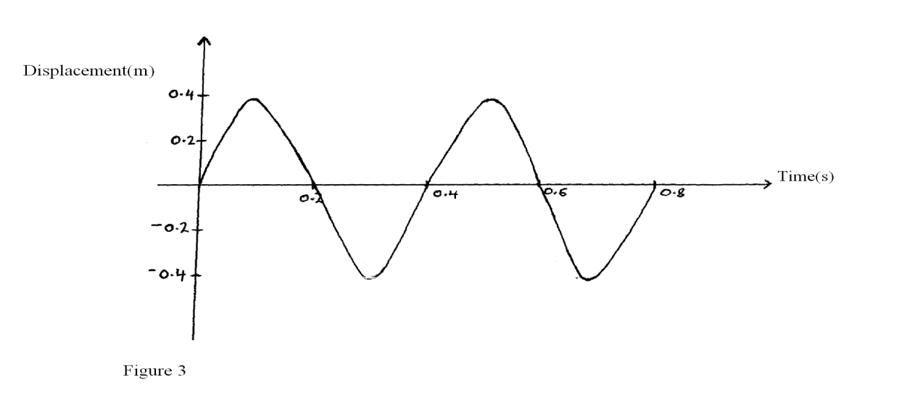
On the same diagram, draw a wave which passes the point with twice the frequency and half the amplitude of the one shown. (2 marks)

8. Figure 8 shows a ray of light incident on the face of a water prism.
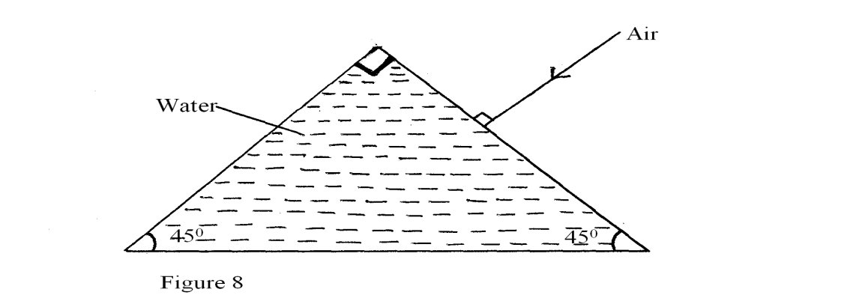
Sketch the path of the ray as it passes through the prism. Critical angle for the water is 49⁰. (2mks)
- A boy observes his face in a concave mirror of focal length 100cm. If the mirror is 80cm away, state one characteristics of the image observed (1mks) ...........................................................................................................................................................

- Describe how microwaves are used in determining distances of objects as in the radar.(3mks)
………………………………………………………………………………………………………………………………………………………………………………………………………………………………………………………………………………………………………………………………………………………………………………………………………………………………………………………………………………………………………………………………………………………………………………………………………………………………………………………………………………………………………………………………………………………………………………………………………………………………11. An alternating voltage of peak value 15v and frequency 25Hz is applied to the terminals of a Cathode ray oscilloscope. The Y-gain is set at 5 v/cm and the time base at 10 ms/cm. Draw the trace observed on the screen. (2mks)
1cm
1cm

- (a) Name all the radiations of the electromagnetic spectrum which have higher wavelengths
than the visible light.

................................................................................................................................................................................................................................................................................................................................................................................................................................................
(1 mark)

(b) State the radiation that is detected using a blackened bulb of a thermometer.
................................................................................................................................(1 mark)
13. The figure below shows two rays drawn from an object on to the mirror.

Mirror
Object

Complete the ray diagram to show the position of the image. (2 marks)

SECTION B (55 MKS)
14. (a) Figure 4 below shows an X – ray tube
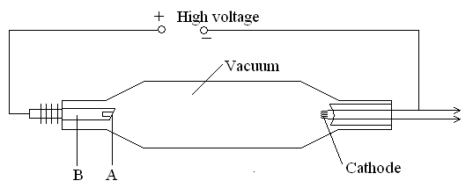
Figure 4
    - Label the parts A and B. (2mks)
A…………………………………………………………………………
B…………………………………………………………………………
    - Suggest with a reason the material used for A. (2mks)
…………………………………………………………………………………………… ……………………………………………………………………………………………
    - State the reason why the X –ray tube is evacuated. (1mk)
…………………………………………………………………………………………… ……………………………………………………………………………………………
    - For the X – ray tube how would the following be controlled;
- The intensity (1mk)
…………………………………………………………………………………………… ……………………………………………………………………………………………
- Quality of X- rays (1mk)
…………………………………………………………………………………………… ……………………………………………………………………………………………
- The exposure to patients (1mk)
…………………………………………………………………………………………… ……………………………………………………………………………………………

(b) (i) A potential difference of 50KV is applied across an X-ray tube. Given that the charge of
an electron e = 1.6 x 10⁻¹⁹coulombs and the mass of an electron Calculate the kinetic energy of the electrons. (3mks)
…………………………………………………………………………………………………………………………………………………………………………………………………………………………………………………………………………………………………………………………………………………………………………………………………………………………………………………………………………………………………………………………………………………………………………………………………………………………………………………………………………………………………………………………………………………………………………………………………………………………………………………………………………………………………………………………………………………………………………………………………………
- If 12% of the electron energy is converted into X-ray, determine the minimum wavelength of the emitted X –ray given planks constant h = 6.63 x 10⁻³⁴ (3mks)
………………………………………………………………………………………………………………………………………………………………………………………………………………………………………………………………………………………………………………………………………………………………………………………………………………………………………………………………………………………………………………………………………………………………………………………………………………………………………………………………………………………………………………………………………………………………………………………………………………………………………………………………
- (a) Figure 7 below shows the deflection from a radioactive isotope by an electric field.
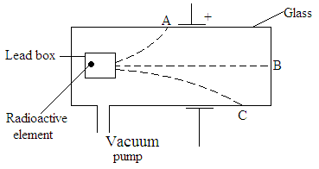
Figure 7

      - Define the term isotope. (1mk)
…………………………………………………………………………………………… ……………………………………………………………………………………………
      - Identify the radiations A,B, and C (3mks)
A ………………………………………………………………………………..
B ………………………………………………………………………………..
C ………………………………………………………………………………..
(b) Give one use of a radioactive isotope in medicine. (1mks)
…………………………………………………………………………………………… ……………………………………………………………………………………………
(c) Radium disintegrates into a new stable element lead how many alpha and Beta particles are emitted (3mks)
………………………………………………………………………………………………………………………………………………………………………………………………………………………………………………………………………………………………………………………………………………………………………………………………………………………………………………………………………………………………………………………………………………………………………………………………………………………………………………………………………………………………………………………………………………………………..
(d) A 32g sample of radioactive substance was reduced to 2g in 96 days. What is the half life
of the substance. (2mks)
………………………………………………………………………………………………………………………………………………………………………………………………………………………………………………………………………………………………………………………………………………………………………………………………………………………………………………………………………………………………………………………………………………………………………………………………………………………………………………………………………………………………………………………………………………………………………………………………………………………….
- (a) Distinguish between self-induction and mutual induction. (2mks)
…………………………………………………………………………………………… ……………………………………………………………………………………………
(b) In what form is energy lost in acable during transmission. (1mk)
………………………………………………………………………………………………………………………………………………………………………………………………………………………………………………………………………………………………………………………………………………………………………………………………………………………………………………………
(c) State the difference between a step-up transformer and an induction coil. (1mk)
……………………………………………………………………………………………

(d) Figure 5 below shows a diagram of a bicycle dynamo. The wheel A is connected by an
axle to a permanent cylindrical magnet and is rotated by the bicycle tyre.
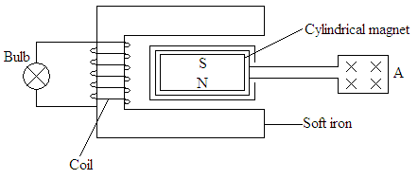
Figure 5
      - Explain why the bulb lights. (2mks)
……………………………………………………………………………………………………………………………………………………………………………………………………………………………………………………………………………………………………………………………………………………………………………………………………………………………………………………………………………………………………………………………………………………………………………………………………………………. ………………………………………………………………………………………………………………………………………
      - If you were riding the bicycle, what would you do to make the bulb light more brightly? (2mks)
…………………………………………………………………………………………………………………………………………………………………………………………………………………………………………………………………………………………………………………………………………………………………………………………………………………………………………………………………………………………………………………………………………………………………………………………………………………………………………………………………………………………………………………………………………………………………………………………………………………………………………………………………………………………………………………….
      - On the axes provided, sketch the graph of induced e.m.f with time(1mk)

Induced
e.m.f

Time t
17. I a) A 10 μf capacitor is charged to a potential difference of 300V and isolated. It is then connected in parallel to a 5 μF capacitor. Find the resultant potential difference. (3mks)
…………………………………………………………………………………………………………………………………………………………………………………………………………………………………………………………………………………………………………………………………………………………………………………………………………………………………………………………………………………………………………………………………………………………………………………………………………………………………………………………………………………………………………………………………………………………………………………………………………………………………………
b) The energy stored before connection. (3mks)
………………………………………………………………………………………………………………………………………………………………………………………………………………………………………………………………………………………………………………………………………………………………………………………………………………………………………………………………………………………………………………………………………………………………………………………………
c) The energy in the two capacitors after connection. (3mks)
………………………………………………………………………………………………………………………………………………………………………………………………………………………………………………………………………………………………………………………………………………………………………………………………………………………………………………………………………………………………………………………………………………………………………………………………………………………………………………………………………………………………

- a) State how distance of separation between the plates affect the capacitance of a parallel plate capacitor. (1mks)
................................................................................................................................................
................................................................................................................................................
................................................................................................................................................
................................................................................................................................................
b) Three capacitors of capacitance 100µƒ, 500aF and 400µƒ are connected together in a circuit.
Draw a circuit diagram to show the arrangement of the capacitors which gives an effective capacitance of 250µƒ (1mks)
................................................................................................................................................
................................................................................................................................................
................................................................................................................................................
................................................................................................................................................
................................................................................................................................................
18. (a) Differentiate between an Ohmic and non-ohmic conductor giving one example in each case.(2marks)

………………………………………………………………………………………………………………………………………………………………………………………………………………………………………………………………………………………………………………………………………………………………………………………………………………………………………………………………………………………………………………………………………………………………………………………………………………………………………………………………………………………………………………………………………………………………………………………………………………………………………………………………………………………………………………………………………………………………………………………………………………………………………………………………………………………………………………………………………

(b) Figure 7 shows a circuit with resistors and voltmeter connected to a battery.
6.0V
V
3Ω
2Ω
5Ω
S
Figure 7

- If each cell has an internal resistance of 0.7Ω, determine the total resistance in the circuit.(3mks)
…………………………………………………………………………………………………………………………………………………………………………………………………………………………………………………………………………………………………………………………………………………………………………………………………………………………………………………………………………………………………………………………………………………………………………………………………………………………………………………………………………………………………………………………………………………………………………………………………………………………………………………………………………………………………………………………………………………………………………………………………………………………………………………………………………………………………………………………………………………………………..
- What amount of current flows through the 3Ω resistor when the switch is closed? (3mks)
………………………………………………………………………………………………………………………………………………………………………………………………………………………………………………………………………………………………………………………………………………………………………………………………………………………………………………………………………………………………………………………………………………………………………………………………………………………………………………………………………………………………………………………………………………………………………………………………………………………………………………………………………………………………………………………………………………………………………………………………………………..

- What is the reading of the voltmeter when the switch S is
(I) Open (1mk)

……………………………………………………………………………………………………………………………………………………………………………………………………………………………………………………………………………………………………………………………………………………………………………………………………………………………………………………………………………………………

(II) Closed (1mk)
…………………………………………………………………………………………………………………………………………………………………………………………………………………………………………………………………………………………………………………………………………………………………………………………………………………………………………………………………………………………………………………………………………………………………………………………………………………………………………………………
- Account for the difference between the answers in (I) and (II) above. (1mk)
......................................................................................................................................................
............................................................................................................................................................................................................................................................................................................

