ACK SCHOOLS JOINT EVALUATION TEST

PHYSICS PAPER 2

SEPTEMBER 2022

MARKING SCHEME

**SECTION A**

**1. Magnets are used -** In hospitals to extract iron particles from eyes

- Making loudspeakers, dynamos e.t.c.

( any one correct) 🗸 1

**2.** (i) n = 360 - 1 🗸 1

60

= 6 – 1

= 5 images 🗸 1

1. Used by designers to obtain ideals 🗸 1
2. Manganese oxide converts the hydrogen gas produced to water.🗸 1
3. Distance = λ cm

Time = T (s)

Speed = distance = λ

Time

⇒ V = λ

T 🗸 1

But I = f

T

∴ v = fλ 🗸 1

1. a) Used in meters, moving coil loudspeakers. (any one )🗸 1

b) P=VI

60n = 240×13

n = 52bulbs

1. Electrical resistance is caused when a charge flowing through a conductor is slowed by collisions with atoms and impurities in the conductor.🗸 1
2. 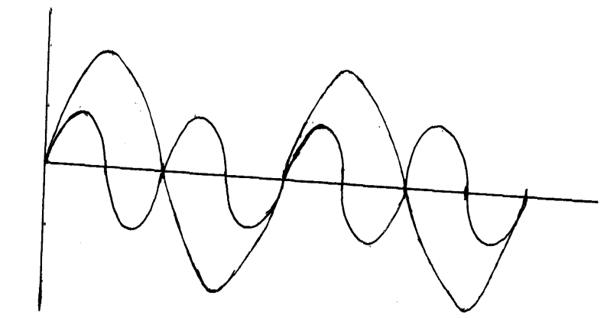

Amplitude ✓

1 Cycle

Frequency ✓

1. 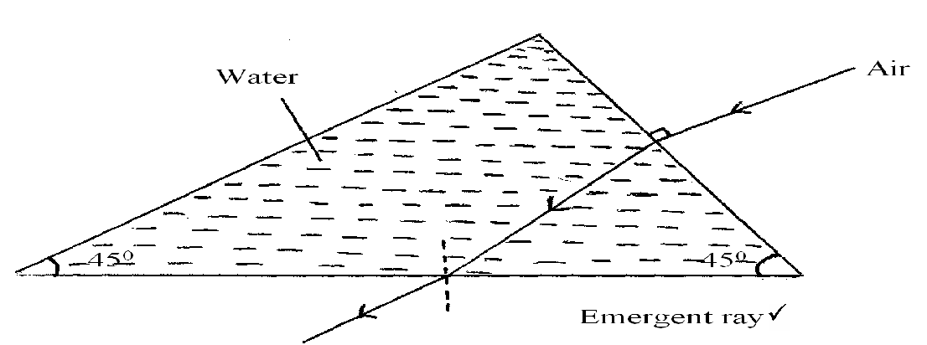
2. Imageis virtual/ erect/magnified
3. A narrow beam of microwaves is sent out in the short pulses from the radar. Distant objects in the path of the beam reflect part of the waves back. The reflected waves give the direction and the distance of the reflecting object.

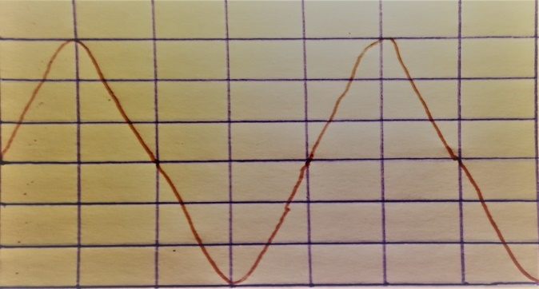

Peak voltage

Correct period

1. a) radio waves, microwaves and infra red

b) infra red

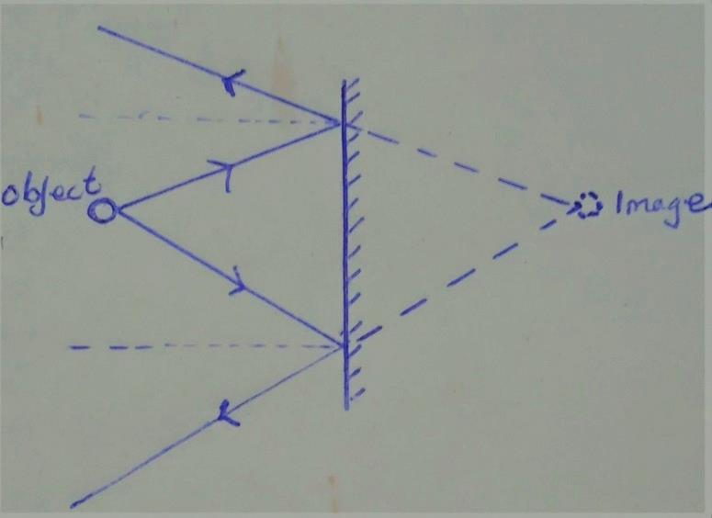

**SECTION B 55 MKS**

1. (a) (i) A – target;

B – Anode;

(ii) A Tungsten /molybdenum

High melting point;

(iii) To reduce energy the electrons would lose in ionizing the atoms of air molecules;

1. (I) Varying the heater current;

(II) Varying the accelerating potential;

(III) Using the lead shield

(b) (i) Kinetic energy = Electrical energy

= eV ;

= 1.6 x10-19 x5 x 104;

= 8 x 10-15 J ;

(ii) 

1. (a) Self induction is where a changing magnetic field round a conductor induces current/ e.m.f in the same conductor;

Mutual induction – where a changing magnetic field in one coil or circuit induces an e.m.f /current in another circuit or near it ;

(b) Heat energy;

(c) Step up transformer uses A.C only while induction coil uses D.C;

(d) (i) when magnet is rotated by the axle, there is change in magnetic flux. This change links

the flux to the coil and induces e.m.f; The induced,/ generated current flows in the circuit and makes the bulb to light;

(ii) Cycling faster; makes the rate of change of flux increase as the wheel rotates the axle and the magnet; This increases the magnitude of induced e.m.f and makes the bulb brighter

(iii) 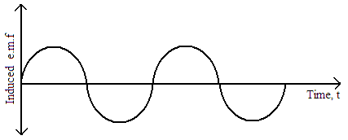(atleast one complete cycle)

1. (a) (i) Element having the same atomic number but different mass number;

(ii) A Beta particles;

B ;

C Alpha particles;

(b) Radio active iodine – 131 used in diagnosis and treatment of goitre (thyroid disorder)

Cobalt – 60 used in treatment of cancer

Sterilization of medical equipment with  (any one correct)

(c) 

4x=20

2x-y=6

Alpha particles = 5 beta particles =4

(d) 



1. I. a) Q = CV

Q = 10 x 10 -6 x 300

= 3.0 x 10-3 C

CT= 5 + 10 = 15 μ f.

V = Q

C

= 3.0 x 10-3 🗸 1

15 x 10-6

= 200volts 🗸 1

1. E = ½ CV2 🗸 1

= ½ x 10x 10-6 x 300 x 300 🗸 1

= 0.45J 🗸 1

1. E = ½ x 15 x 10-6 x 200 x 200 🗸 1

= 0.3J 🗸 1

II. a) Increasing the separation distance capacitance reduces while decreasing separation distance the capacitance increases.

b)

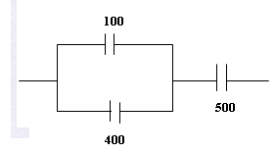

$$µF$$

$$µF$$

$$µF$$

1. (a) Ohmic conductor obeys Ohm’s law/ forms straight line through the origin on V-I graph e.g copper, aluminium while non-ohmic conductor doesn’t obey Ohm’s law and the graph of V-I is not a straight line through the origin e.g semi-conductor, thermistor, bulb.

(b) i) **Rseries = 3Ω +5Ω = 8Ω Rparallel = = = 1.6 Ω**

**total resistance = 1.6 + 0.7 x 2 = 3.0 Ω**

ii) **Total current It = = = 2A Vparallel = 1.6 x 2 = 3.2 V I3Ω = = 0.4 A**

iii) (I) **6.0 V**

(II) **6.0 – 3.2 = 2.8 V**

iv) Lost voltage- is the energy used to drive electrons through the cell itself.

-voltage required to overcome the internal resistance of the cell