232/1
PHYSICS
PAPER 1
(THEORY)
FORM FOUR
MUMIAS ACK SCHOOLS 2022 JOINT EXAMS

MARKING SCHEME
Section A (25 mks)
1. M.S.R = 8.5 mm Actual reading = 8.96 – 0.5 = 8.46mm
S.S.R = (0.01 × 46) = 0.46mm
= 8.96mm
2. Up thrust and frictional force

3. i) Convection takes place in air upwards direct due to1 density deference.
ii) Convection requires a 1 material medium but the space between the sun and the earth i.e. space of the atmosphere has no material medium
4. Cool the joint. The metal contract at a higher rate than glass hence the separation.
5. 30.6 – 20.6 = 10cm3
Volume of drop of water = 10/ 50 = 0.2cm2
Volume of sphere = 4/3 πr3
0.2 cm3 = 4/3 πr3
r= 0.3627cm
6. Bright specks are seen to be moving in random motion.The bright specks are smoke particles
which are bombarded by the invisible air molecules which are in continuous state of random motion.
7. (i) Ammonia gas particles diffuse faster than acid gas particles.
(ii) The smaller the size of particles and the smaller the mass, the faster the rate of diffusion.
(iii) It takes longer time because the kinetic energy of particles is reduced i.e particle move at a lower speed.
8. Impulse= change in momentum=Ft
= 3.5$×1000×0.02=70NS$
9. Gas passes the nozzle at a high speed creating a region of low pressure at A. Atmospheric pressure pushes air in through the hole.

10. Sum of clockwise moments = Sum of anticlockwise moments
0.3m x 1N = 0.1m x W + 0.3m x 0.5N
0.3Nm = 0.15Nm + 0.1W
0.15Nm = 0.1W
$W=1.5 N$
11. The density increases since the volume reduces due to the exit of air.
12. Thermodynamics.
13. A. In A the c.o.g is lower than the point of support unlike B which is higher.
SECTION B (55 MKS)
- a)
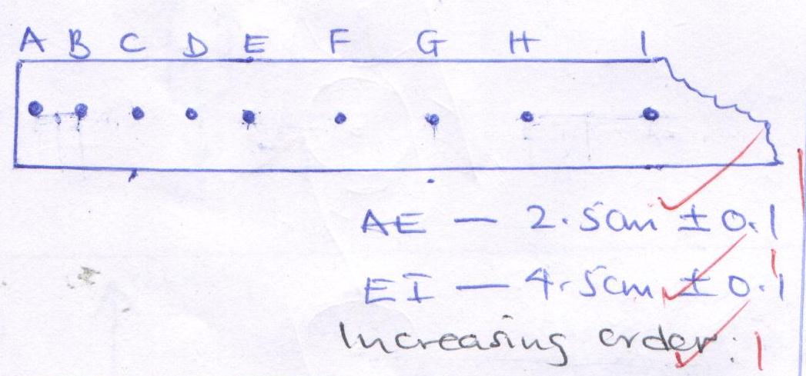
b) i) Velocity = $\frac{displacement}{time}$
=$\frac{2.5}{4×0.02}$1
= 31.25cms⁻¹1 OR 0.3125ms⁻¹
ii) E to I
Velocity = $\frac{4.5}{4 ×0.02}$1
= 56.25 cms⁻¹1

c) a = $\frac{u-u}{t}$
= $\frac{0.5625-0.3125}{0.02 ×8}$
= $\frac{0.25}{0.16}$ = 1.5625ms⁻²

d) End A1
e) i) Trolley runs on a straight path on the runway1
ii) Tape lies flat on the horizontal surface. 1

- a) Gravitational force of attraction between the Astronaut and earth provides centripetal force.
For the astronaut to move round orbit then gravitational force must be equal to centripetal force.
b) Angular velocity is the rate of change of angular displacement while linear velocity is the rate of displacement.
c) i) Angular velocity
ώ = Δϴ/ Δt
= (4cm/15cm)/ 10s = 0.2667/10
= 0.02667rad/s
ii) Linear velocity of the stone
v =r ώ
= 0.15 X 0.02667
= 0.004 m/s
OR Δv = ΔS/Δt = 4cm/10s = 0.04m/10s = 0.004m/s
iii) Periodic time
T = 2π/ ώ
= 2π/0.02667
= 235.59 s

- i) $w=mgh$
$=30×10×10=3000J$

ii) $\cos{75=\frac{10}{AB}}$
AB$=38.64m$

$w=Fd=100×38.64=3864J$

iii) Wastage$=3864-3000=864J$ $\frac{864}{3864}×100=22.36\%$

iv)Wastage=F_{r}$×distance$AB
$864=F_{r}×38.64$
$F_{r}=22.36J$

v) $MA=\frac{L}{E}=\frac{300}{100}=3$
vi) $VR=\frac{Effort distance}{Load distance}=\frac{38.64}{10}=3.864$
- a) I)
- Time of heating.
- P.d across the heating coil
- Mass of the copper wire
II)
- Determine the mass of the block
- Record the initial temperature
- Put on the switch for some time, t.
- Note the voltmeter and Ammeter reading
- Record the final temperature.
- $c=\frac{VIt}{mθT}$
III) To create thermal contact between the thermometer / heater and block

b) $Heat lost=Heat gained$
${mL}_{v}+mcΔT=Heat capacity×ΔT+McΔT$
$m×2.26×{10}^{6}+m×4200×50= 60×30+0.2×4200×30$
$m=0.01093kg or 10.93g$
17. a) A floating body displaces its own weight of the fluid in which it floats.
b) i) The total weight of hot air balloon
W= 1300 X 0.82 X 10 + 420 X 10
= 10660 + 4200
= 14860N
ii) The weight of air displaced by the balloon
W = pVg
= 1.35 X1300 X10
= 17550N
iii) Upthrust force on the balloon
Upthrust = weight of air displaced
= 17550N
iv) the tension in the rope holding the balloon in the ground.
T = U – W = 17550 – 14860 = 2690N
v) The acceleration with which the balloon begins to raise when released.
F = Ma
2690 = 1486 kg X a
a = 1.8102 m/s2

