**NAME……………………………………………………….…… INDEX NO.:………………………...**

**STREAM: .…..…………………………………………………… ADM NO: …………………………**

**DATE: …………………….………**

**PHYSICS**

Paper 232/2

(THEORY)

**Time: 2 Hours**

**MINCKS GROUP OF SCHOOLS**

***Kenya Certificate of Secondary Education(K.C.S.E)***

**FORM FOUR**

**INSTRUCTIONS TO CANDIDATES:-**

* *Write your* ***Name****,* ***Index******number, Admission number*** *and* ***school*** *in the spaces provided above.*
* *This paper consists of* ***two*** *sections;* ***A*** *and* ***B***
* *Answer* ***all*** *the questions in section* ***A*** *and* ***B*** *in the spaces provided*
* *All working* ***must*** *be clearly shown.*
* *Mathematical tables and electronic calculators may be used.*
* *This paper consist of 19 printed pages. You are advised to ascertain that all pages are printed as indicated.*
* *Take the earth’s gravitational field strength g = 10 m/s2.*

**For Examiner’s Use Only:**

|  |  |  |  |
| --- | --- | --- | --- |
| **SECTION** | **QUESTION** | **TOTAL SCORE** | **CANDIDATES SCORE** |
| **A** | **1 – 12** | **25** |  |
| **B** | **13** | **10** |  |
| **14** | **9** |  |
| **15** | **8** |  |
| **16** | **9** |  |
| **17** | **9** |  |
| **18** | **10** |  |
| **TOTAL** |  | **80** |  |

**SECTION A (25 MARKS)**

***Answer all questions in this section in the spaces provided.***

1. The diagram below shows two parallel mirrors M1 and M2 and a ray of light being incident on one of the mirrors as shown.



Trace the ray of light through the mirrors and indicate the angle of incidence on M1 (2 mks)

1. Two pins are hanging from a magnet as shown in the diagram below.

S

N

Explain why the pins spread as shown in the diagram. (2mks)

………………………………………………………………………………………………………………………………………………………………………………………………………………………………………………………………………………………………………………………………………………

1. An image I is formed infront of a concave mirror and on the principal axis as shown in the figure below.

C

F

1. The figure below shows a set up by a student.



  State and explain what happens to the sound from the buzzer as the bottle and its contents are cooled to 0°C. (2 mks)

………………………………………………………………………………………………………………………………………………………………………………………………………………………………………………………………………………………………………………………………………........…………

1. Arrange the following waves in order of decreasing wavelength. (1mk)

**Infrared, X-rays, Microwaves, Radio waves, Red light.**

……………………………………………………………………………………………………………………………………………………………………………………………………………………………………

1. Figure below shows an incomplete circuit of an electromagnet.

**Core**

**A**

**B**

Complete the circuit by drawing the windings on the two arms of the core such that A and B are both North poles when the switch is closed. (1mk)

1. Figure represents a step in charging a material **B** negatively by induction.

**-**

**-**

**-**

**-**

**-**

**-**

**A**

**X**

**Y**

(i) What is the charge on **Y**? (1mk)

…………………………………………………………………………………………………………………

(ii) Explain what happens at **A**. (1mk)

…………………………………………………………………………………………………………………

1. The graph below shows the variation of p.d. (V) across the terminals of a cell and current drawn from the cell.

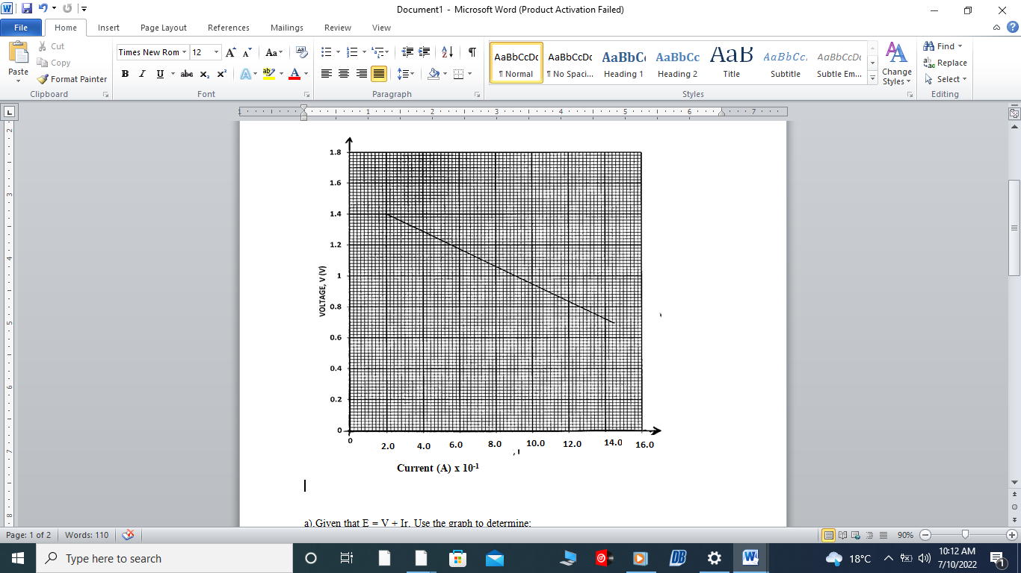

1. Use the graph to determine the electromotive force (emf) of the cell. (1mk)
2. Draw a circuit diagram that may be used to obtain the values plotted in the graph. (2mk)
3. A vibrator is sending out eight ripples per second across a water tank. The ripples are observed to be 4cm apart. Calculate the velocity of the ripples. (3mks)
4. The figure below shows part of electric cooker coil.

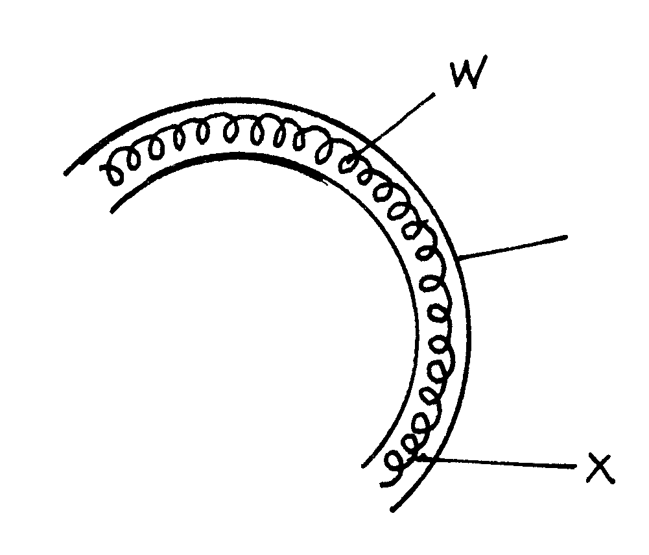

**y**

1. Why is the material labeled Y coiled? (1mk)

…………………………………………………………………………………………………………………

1. State the property of material Y that makes it suitable for its use. (1mk)

……………………………………………………………………………………………………………………………………………………………………………………………………………………………………

1. An immersion heater rated 1500W is used continuously for 30 minutes per hour per day. Calculate the cost of electricity per week if the rate is Ksh. 6.70 per unit. (2mks)
2. Fig below shows a conductor y placed in a magnetic field. The conductor carries a current flowing into the paper.

S

**N**



**S**

(i) Sketch the resultant magnetic field between the poles of the bar-magnet.

(1mk)

(ii) Show on the diagram the direction of the force, F acting on the conductor

(1mk)

**SECTION B (55 MARKS)**

***Answer all questions in this section in the spaces provided.***

1. Figure below shows the path of light through a transparent material placed in air.

1400

Air

Ray of light.

Transparent material

1. Give a reason why the above ray is not refracted at the interface of air and the transparent material as shown in the diagram. (1mk)

……………………………………………………………………………………………………………………………………………………………………………………………………………………………………

1. Calculate the refractive index of the transparent material. (3mks)
2. An image is formed 10cm in front of a concave lens of focal length 15cm. calculate the position of the object in respect to the lens. (3mks)
3. You are provided with the following apparatus to determine the focal length of a lens.

* A lit candle.
* A white screen.
* A metre rule.

With a aid of a labelled diagram, describe the procedure you would follow to determine the focal length of the lens. (3mks)

2. The figure below shows metal plates X and Y each fixed to an insulated stand. X is charged and Y is earthed. X is connected to an uncharged electroscope with a conductor.

d

X

Y

If plate Y is moved away from plate X,

1. State what happens to the amount of charge on the plates. (1mk)

……………………………………………………………………………………………………………………………………………………………………………………………………………………………………

1. State and explain the observation made. (3mks)

…………………………………………………………………………………………………………………………………………………………………………………………………………………………………………………………………………………………………………………………………………………………………………………………………………………………………………………………………………

1. The figure below shows an arrangement of capacitors connected to a 12V dc supply.

1μF

3μF

4μF

12V

Determine:

1. The total capacitance of the arrangement. (2mks)

……………………………………………………………………………………………………………………………………………………………………………………………………………………………………

1. The voltage across the 3μF capacitor. (3mks)
3. The figure below shows an attempt to supply each of the three lamps L1, L2 and L3 with a switch.

L1

L2

L3

S1

S2

S3

To the mains

1. Give a reason why this is a poor connection. (1mk)

……………………………………………………………………………………………………………………………………………………………………………………………………………………………………

1. Redraw the diagram to show the correct positioning of the switches. (1mk)
2. A wire placed between the pole of two permanent magnets is connected to a galvanometer as shown below.

N

S

N

S

Wire

1. State what is observed when the wire is moved up and down. (2mks)

………………………………………………………………………………………………………………………………………………………………………………………………………………………………………………………………………………………………………………………………………………………

1. Suggest two ways of increasing the magnitude of the effect you have stated in (i) above. (2mks)

…………………………………………………………………………………………………………………………………………………………………………………………………………………………………………………………………………………………………………………………………………………………………………………………………………………………………………………………………………

1. The figure below shows a simple transformer. Study it and answer the questions that follow.

**Soft iron core**

**Primary coil**

**Secondary coil**

State and explain which coils are thicker. (2mks)

………………………………………………………………………………………………………………………………………………………………………………………………………………………………………………………………………………………………………………………………………………………

1. The figure below shows Zinc plate placed on the cap of a negatively charged electroscope.

Zinc plate

Ultra violet radiation

Ultraviolet radiation is made to fall on the plate as shown on the diagram.

1. What happens to the leaf of the electroscope? (1mk)

………………………………………………………………………………………………………………………………………………………………………………………………………………………………………………………………………………………………………………………………………………………

1. What would happen if radiation was red light? (1mk)

…………………………………………………………………………………………………………………………………………………………………………………………………………………………………………………………………………………………………………………………………………………………………………………………………………………………………………………………………………

1. In an experiment to find the relationship between frequency of a radiation and kinetic energy of the photoelectrons in a photoelectric device, the following graph was obtained.

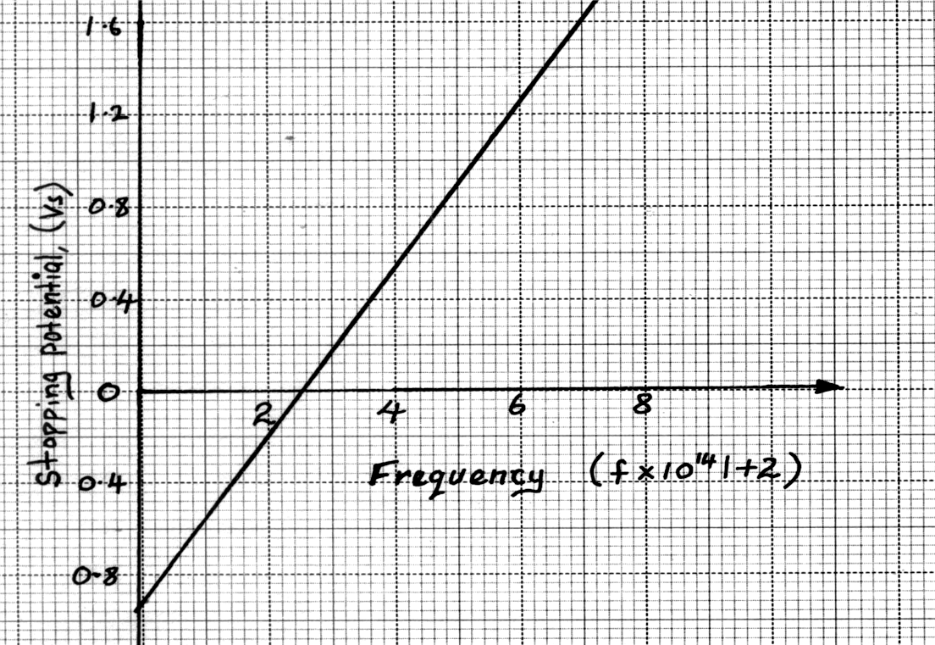

(Hz)

Use the graph to determine the Planck’s constant h. (3mks)

1. Figure below shows the features of an X-ray tube.

**G**

**B**

**C**

Copper fins

**P**

**D**

**A**

**Y**

**Oil in**

**Oil out**

**x-rays**

1. Explain the function of part labelled P. (1mk)

……………………………………………………………………………………………………………………………………………………………………………………………………………………………………

1. Explain why the part labelled C gets very hot during production of X-rays. (2mks)

…………………………………………………………………………………………………………………………………………………………………………………………………………………………………………………………………………………………………………………………………………………………………………………………………………………………………………………………………………

1. Explain what is done to produce X-rays of shorter wavelength using the above X-ray tube. (1mk)

…………………………………………………………………………………………………………………………………………………………………………………………………………………………………………………………………………………………………………………………………………………………………………………………………………………………………………………………………………

1. The figure below shows monochromatic source of light L behind a barrier with a single slit S placed behind another barrier with two identical slits S1 and S2. A screen PQ is placed in position as shown.

1. What is the significance of S1 and S2? (1 mk)

……………………………………………………………………………………………………………………………………………………………………………………………………………………………………

1. Explain what is observed on screen PQ. (2 mks)

…………………………………………………………………………………………………………………………………………………………………………………………………………………………………………………………………………………………………………………………………………………………………………………………………………………………………………………………………………

1. Waves pass from deep water to shallow water and refraction occurs.

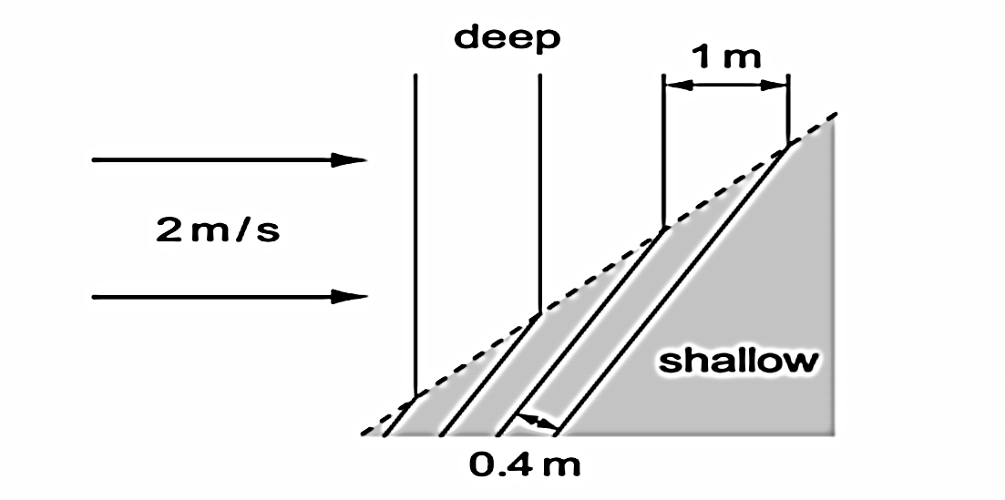

Calculate the speed of the waves in the shallow water. (2 mks)

1. The figure below shows an a.c. signal on the screen of a Cathode Ray Oscilloscope.

|  |  |  |  |  |  |  |  |  |  |  |  |
| --- | --- | --- | --- | --- | --- | --- | --- | --- | --- | --- | --- |
|  |  |  |  |  |  |  |  |  |  |  |  |
|  |  |  |  |  |  |  |  |  |  |  |  |
|  |  |  |  |  |  |  |  |  |  |  |  |
|  |  |  |  |  |  |  |  |  |  |  |  |
|  |  |  |  |  |  |  |  |  |  |  |  |
|  |  |  |  |  |  |  |  |  |  |  |  |
|  |  |  |  |  |  |  |  |  |  |  |  |
|  |  |  |  |  |  |  |  |  |  |  |  |

Determine the frequency of the signal given that the time base is set at 10ms/division. (2mks)

1. Diagram (a) below shows the position of the bright spot on the screen of a C.R.O. when there is no signal on both Y and X plates.

(a)

Indicate on the diagram (b) below what is observed on the display screen when the Y-plate is connected to a.c. signal and for (c) when X-plate is connected to a d.c. signal. (2mks)

(b)

(c)

2. The following reaction is part of a radioactive series.
$${}_{83}^{210}X→\underset{→}{r}→{}_{84}^{210}Y→\underset{→}{α}→{}_{b}^{c}Z$$

3. Identify the radiation r. (1mk)
4. Determine the value of c. (1mk)
5. At a certain instant the corrected count-rate registered on a detector placed close to an α-particle emitter is 200 per second and this falls to 50 per second in 12 minutes. Determine the half life of the source. (3mks)
6. Study the rectification circuit below and use it to answer questions that follow.

**a.c**

X

Y

Q

R

D2

1. Briefly explain how the circuit works to rectify the alternating current. (3mks)

……………………………………………………………………………………………………………………………………………………………………………………………………………………………………………………………………………………………………………………………………………………………………………………………………………………………………………………………………………………………………………………………………………………………………………………………

1. Show on the diagram how a capacitor should be connected to smooth the output voltage. (1mk)
2. In the grid provided, sketch a curve of smoothed output voltage against time. (1mk)

Voltage (V)

Time (s)