NAME……………………………………………………….…… INDEX NO.:………………………...
STREAM: .…..…………………………………………………… ADM NO: …………………………
DATE: …………………….………

PHYSICS
Paper 232/1
(THEORY)
Time: 2 Hours
MINCKS GROUP OF SCHOOLS

Kenya Certificate of Secondary Education(K.C.S.E)
FORM FOUR
INSTRUCTIONS TO CANDIDATES:-
- Write your Name, Index number, Admission number and school in the spaces provided above.
- This paper consists of two sections; A and B
- Answer all the questions in section A and B in the spaces provided
- All working must be clearly shown.
- Mathematical tables and electronic calculators may be used
- Take the earth’s gravitational field strength g = 10 m/s².
For Examiner’s Use Only:
SECTION | QUESTION | TOTAL SCORE | CANDIDATES SCORE
A | 1 – 11 | 25
B | 12 | 11
 | 13 | 12
 | 14 | 12
 | 15 | 10
 | 16 | 10
TOTAL |  | 80

SECTION A (25 MARKS)
Answer all questions in this section in the spaces provided.
- The figure below shows part of scales of a vernier caliper with a negative error of 0.04cm. It was used to measure the length of a wooden block whose actual length is 7.57cm.
7cm
8cm

Insert the vernier scale to show how the reading was. (3mks)

- The figure below shows two pins of the same mass and both pressed into a soft board by equal amount of force.
B
A
Soft board

State and explain which pin penetrates the least into the soft board. (2mks)
………………………………………………………………………………………………………………
………………………………………………………………………………………………………………
………………………………………………………………………………………………………………
- The figure below shows a uniform manometer that is closed at one end.
58cm
20cm
Water
Mercury
Trapped air

Determine the pressure of the trapped air. (Take atmospheric pressure as 75cmHg, density of mercury = 13600kg/m³ and density of water = 1000 kg/m³) (3mks)

- The displacement S of a body at time t moving with acceleration a is given by $S=ut+\frac{1}{2}at^{2}$. State the condition for this equation to apply. (2mks)
………………………………………………………………………………………………………………
………………………………………………………………………………………………………………
………………………………………………………………………………………………………………
- The figure below shows a sketch of a velocity-time graph for a body falling through a liquid.
C
D
Velocity
Time

Explain the motion between C and D. (2mks)
………………………………………………………………………………………………………………
………………………………………………………………………………………………………………
………………………………………………………………………………………………………………
- Using the kinetic theory of gases, explain how an increase in temperature causes increase in pressure of an enclosed gas. (2mks)
………………………………………………………………………………………………………………
………………………………………………………………………………………………………………
………………………………………………………………………………………………………………
………………………………………………………………………………………………………………

- A dripless candle is lit and placed on a level bench as shown.

State and explain the changes in stability of the candle as it continues to burn. (2mks)
………………………………………………………………………………………………………………
………………………………………………………………………………………………………………
………………………………………………………………………………………………………………
- Give a reason why diffusion is an evidence that matter is made up of tiny particles. (1mk)
………………………………………………………………………………………………………………
………………………………………………………………………………………………………………
- Explain the cause of surface tension on the surface of a liquid. (2mks)
………………………………………………………………………………………………………………
………………………………………………………………………………………………………………
………………………………………………………………………………………………………………
- A metal block is weighed in air and then in paraffin and water as shown in the Figure below.
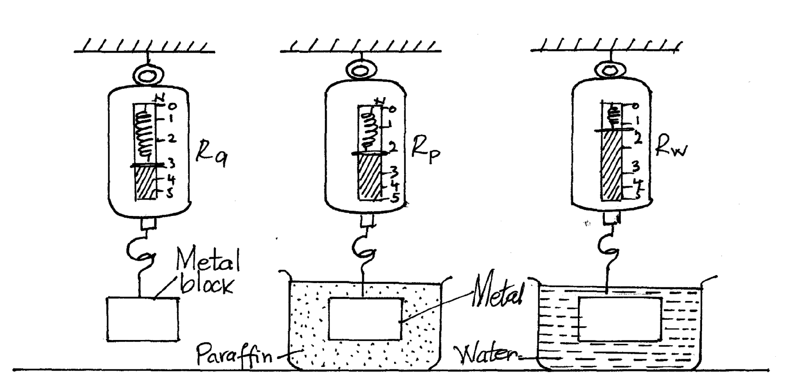

Calculate the density of paraffin given that the density of water is 1000kg/m³.
(Take g = 10 m/s² ) (3mks)

- The figure below shows two sheets of paper tolled into tubes. one has holes on it.
A
B

A stream of air is blown into each tube as shown. State with reason the tube that collapses. (2mks)
………………………………………………………………………………………………………………
………………………………………………………………………………………………………………
………………………………………………………………………………………………………………
- Differentiate between conduction and convection modes of heat transfer in terms of molecules.
(1mk)
………………………………………………………………………………………………………………
………………………………………………………………………………………………………………
SECTION B (55 MARKS)
Answer all questions in this section in the spaces provided.

- A form Two student wanted to carry out an experiment to verify Hooke’s law. the student assembled the apparatus as shown.
Spring

Mass
Metre rule

If the student had access to several other masses;
- State what was missing in the set up. (1mk)
………………………………………………………………………………………………………………
- Outline how the extension of the above spring is determined. (3mks)
………………………………………………………………………………………………………………
………………………………………………………………………………………………………………
………………………………………………………………………………………………………………
………………………………………………………………………………………………………………
- Other than extension of the spring, state one other measurement that should be determined. (1mk)
………………………………………………………………………………………………………………
- Considering the measurements above, describe how the above set up can be used to verify Hooke’s law. (3mks)

- Three identical springs are joined together as shown below to support a mass of 150g.
150g

Assuming that the springs have negligible weight and if the total weight of the above set up is 3cm, Determine the spring constant of one spring used in the set up. (3mks)

- The diagram below shows a wheelbarrow used to raise a 90kg sack of potatoes. The wheelbarrow has a mass of 20kg.
F
60cm
20cm

- Using the principle of moments, determine the effort that need to be applied at F in order to lift the load. (3mks)

- What is the velocity ratio of the wheelbarrow? (3mks)

- Determine the mechanical advantage of this machine. (2mks)

- Determine the efficiency of the machine. (3mks)

- Why is the efficiency of this particular machine less than 100%? (1mk)

- The diagram below shows a set up that is used in determining the upper fixed point of a thermometer.
Steam
Heat
Boiling water
Steam exit
Upper fixed point

- Identify the mistake in the set up. (1mk)
………………………………………………………………………………………………………………
- Explain how the mistake would affect the value obtained as the upper fixed point. (2mks)
………………………………………………………………………………………………………………
………………………………………………………………………………………………………………
………………………………………………………………………………………………………………
- What is the purpose of the steam exit. (1mk)
………………………………………………………………………………………………………………
………………………………………………………………………………………………………………
- When marking the fixed points of a thermometer, it is observed that at 0⁰C, the mercury thread is of length 3cm and 11cm at 100⁰C. What would be the length of the thread if the bulb of the thermometer is dipped in oil whose temperature is 80⁰C? (2mks)

- The graphs below show the cooling curves obtained when water at 800C was poured into two identical cans A and B painted silverly and black on their outside respectively.
Tx
80⁰C
Temperature ⁰C
Time (min)

- On the graph, name the curve T_{B} for the can B. (1mk)
………………………………………………………………………………………………………………
- Identify the temperature Tx. (1mk)
………………………………………………………………………………………………………………
- Name the mode of heart of heat Transfer tested above. (1mk)
………………………………………………………………………………………………………………
- Apart from length of the material and its cross section area, name two other factors on which conduction depends. (2mks)
………………………………………………………………………………………………………………
………………………………………………………………………………………………………………………………………………………………………………………………………………………………
- Why are gases generally poor conductors of heat? (1mk)
………………………………………………………………………………………………………………
………………………………………………………………………………………………………………

- Define specific latent heat of fusion of ice. (1mk)
………………………………………………………………………………………………………………
………………………………………………………………………………………………………………
………………………………………………………………………………………………………………

- Ice cube of mass m at 0⁰ float in water of mass 100 𝑔 at 0⁰ contained in a copper calorimeter of mass 50𝑔. Steam of mass 60𝑔 at 100⁰ is passed through the mixture until a temperature 40⁰ is attained. (Specific latent heat of vaporization of water is 2.26 × 10⁶ 𝐽/𝑘𝑔, specific latent heat of fusion of ice is 3.34 × 10⁵ 𝐽/𝑘𝑔, specific heat capacity of water is 4.2 × 10³ 𝐽/𝑘𝑔/K and specific heat capacity of copper is 400 𝐽/𝑘𝑔/K).
Determine the;
- Quantity of heat lost by steam to condense to water and cool to 40⁰. (3 mks)

- Quantity of heat absorbed by ice, water and calorimeter to raise its temperature to 40⁰. (3 mks)

- Mass m of ice that melted at 0⁰. (3 mks)

- The moon goes round the earth at constant speed. Explain why it is true to say that the moon is accelerating. (1mk)

………………………………………………………………………………………………………………
………………………………………………………………………………………………………………

- A string of negligible mass has a bucket tied at the end. The string is 60m long and the bucket has a mass of 45g. The bucket is swung horizontally making 6 revolutions per second. Calculate the centripetal acceleration of the bucket. (3mks)

- The figure below shows a body of mass m = 200g attached to the centre of a rotating table with a string. The radius of the string was varied and different values of angular velocity recorded. the mass of the body remained constant throughout the experiment.
String
Direction of rotation
r

The results obtained for angular velocity and radius were used to plot the following graph.
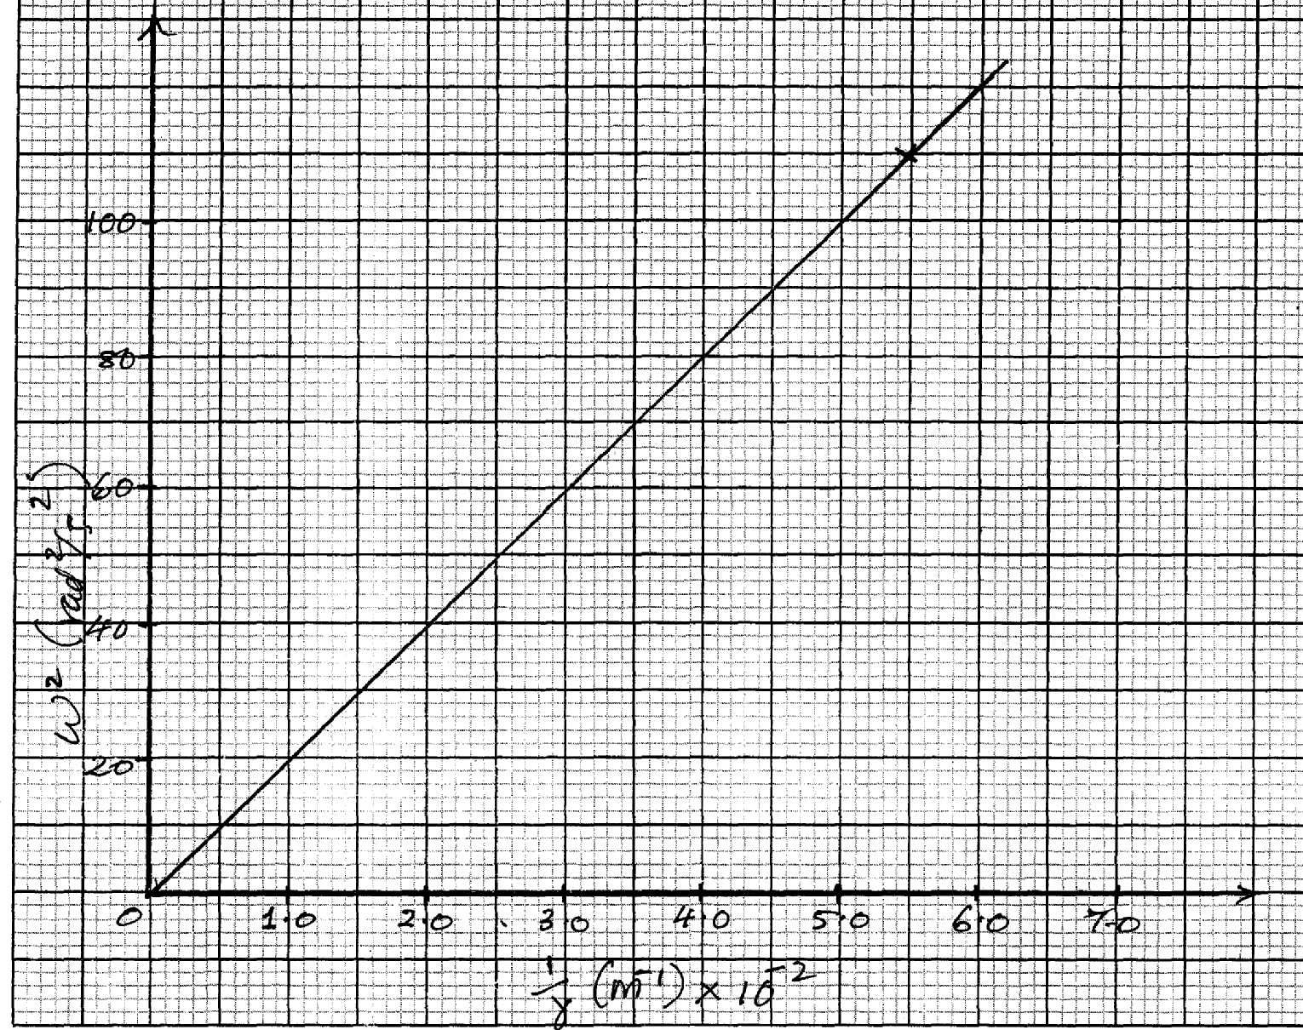
From the above graph.
- Calculate the value of the slope. (2mks)

- If $ω^{2}and\frac{1}{r}$are related by the equation $ω^{2}=\frac{P}{r}×\frac{1}{m}$, find the value of P. (3mks)

- State the significance of P. (1mk)

