END OF TERM 1 EXAM-TERM 1-2023

Name………………………………………………………................ Adm No…………………CLASS.....................Date ………………………….…
Student’s Signature…………………………………….
FORM 2
449/1
DRAWING AND DESIGN
Paper 1
2 ½ hours
Kenya Certificate of Secondary Education (K.C.S.E)

FOR EXAMINERS USE ONLY
1 | 2 | 3 | 4 | 5 | 6 | 7 | 8 | 9 | 10 | 11 | 12 | 13 | 14 | TOTAL

INSTRUCTIONS TO CANDIDATES.
You should have the following for this examination:
- Drawing instruments
- 3 sheet of drawing paper size A3
- Scale rule
Answer ALL the questions
Questions 1-12 should be answered in the spaces provided
Questions 13 & 14 should be answered in A3 papers provided
All dimensions are in millimetres unless otherwise stated.
Candidates may be penalized for not following the instructions given in this paper.

- Define the term scale. (2 marks)
________________________________________________________________________________________________________________________________________________________________________________________________________________________________________________________________________
- Differentiate between plain and diagonal scale. (4 marks)
________________________________________________________________________________________________________________________________________________________________________________________________________________________________________________________________________________________________________________________________________________________________________________________________________________________________________________________________________________________________________________________________________________
- (a) Define an ellipse as a locus. (2 marks)
______________________________________________________________________________________________________________________________________________________________________________________________________________________________________________________________________________
- (b) Construct an ellipse whose major and minor axes are 70mm and 50mm respective and indicate the two foci points. (7 marks)

- Illustrate the following terms as used in dimensioning. (4 marks)
- Projection line
- Dimension line
- Leader line
- Dimension

- Draw a line 100mm long and sub-divide proportionally into nine equal portions. (5 marks)

- The mechanism shown below is a plan of a folding door . “K” and “L” are hinges while “M” slides vertically along KN. Plot the locus of the handle “H” as the door moves from fully opened to fully closed position.
(8 marks)
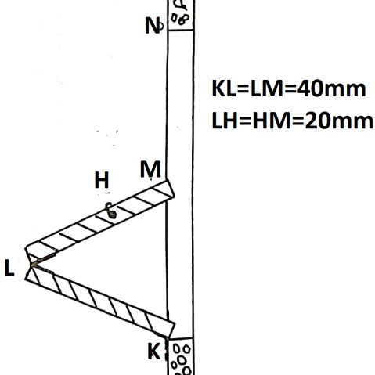
- Construct a diagonal scale to read up to 1/100th of a metre and long enough to measure up to 6 metres. (6 marks)

- Front elevation of pentagonal prism is shown in the figure below. Its slanting height and length of one side are given as 60mm and 20mm respectively. (6 marks)
Draw the following
- Given front elevation
- Surface development.
- The plan

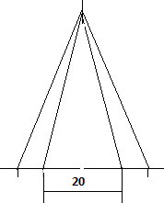

- Sketch the three views in figure 3 below in two-point perspective. (5 marks)
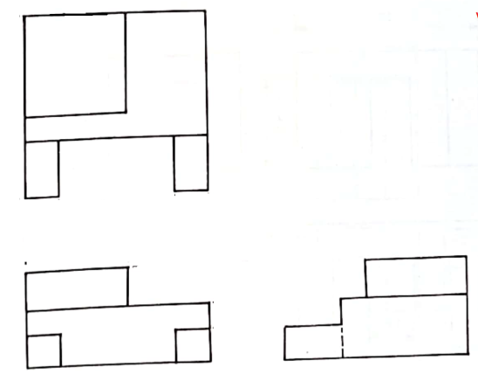

- State four factors to be considered when choosing a material to used in design. (2 marks)
______________________________________________________________________________________________________________________________________________________________________________________________________________________________________________________________________________
______________________________________________________________________________________________________________________________________________________________________________________________________________________________________________________________________________

- Sketch the three views in figure 3 below in oblique taking A-A as the lowest point. (4 marks)
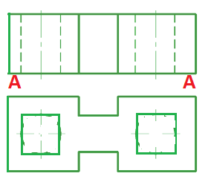

- The isometric view of a machine part is shown below. Draw full size the following views in third angle projection. (15 marks)
- Front elevation
- The plan
- End elevation
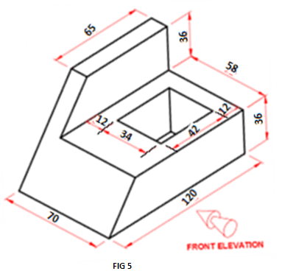
- In the mechanism shown in figure 6, the crank EF rotates about Centre E while GH oscillates about G.
Plot the locus of the point for one complete revolution of EF. (15 marks)
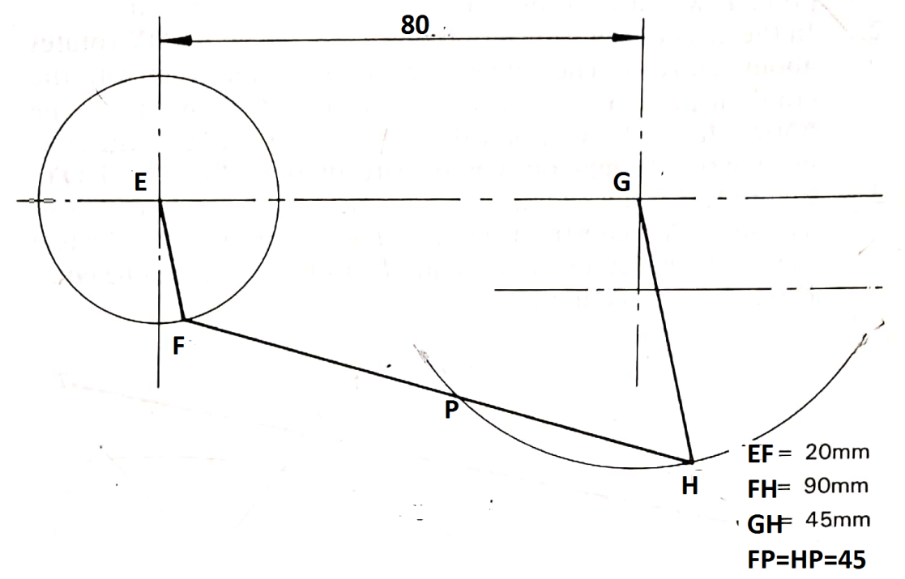

- Three views of a machine component are shown below.
Draw an isometric block taking X as the lowest point. (15 marks)
