CHEMISTRY PAPER 1 MARKING SCHEME
DECEMBER EXAM 2021
FORM FOUR

1.a)
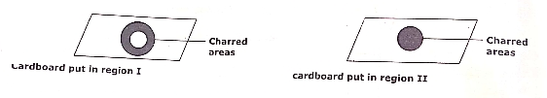
1 mks 1mk
- I- the uncharred area was placed in region of unburnt gas// no burning ½ mk
II – charred areas was in contact with region of burnt gas// complete burning ½ mk
2. Add dilute hydrochloric// sulphuric(VI) acid(1) rej.use of nitric(V) acid and conc.H₂SO₄
Filter (1) to obtain copper as residue(1)
3. (i) sample 3 1mk
(ii) Boiling precipitates calcium or magnesium ions hence removing hardness 1mk
4. Add cold water (1/2)to dissolve A. Filter to obtain filtrate of A and residue of B and C.
Evaporate to obtain A(1/2)
To the residue add hot water(1/2) to dissolve solid C. Filter to obtain filtrate of solid C and residue B(1)
Evaporate filtrate C to obtain C(1/2)
5. PH 4-6(1) sugar is neutral and thus will not have an effect on the PH of the lemon juice which is a weak acid.(1)
6.
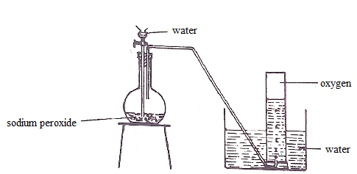
Accept if collected using syringe
- Apparatus 1mk
- Labelling 1mk
- Workability 1mk

7a) i. hydrogen
ii. water
b) reducing
c) 3Fe_{(s)} + 4H₂O_{(g)} Fe₃O_{4(s)} + 4H_{2(g)}
8. Add excess lead(II)oxide to dilute nitric(V) acid(1/2mk)
Filter (1/2)
Add solid potassium carbonate to water to obtain solution(1/2)
Add the potassium carbonate solution to the filtrate(1/2)
Filter(1/2mk)
Wash residue with distilled water
Dry between filter papers(1/2)
9. H + 64.26= -637.56 – 286.78 (1)
H = -637.56-286.78 – 64.26(1)
= -988.6kJ/mol (1)
10. a) A(1)
Has a bigger atomic radius hence a weaker metallic bond (1)//atoms are not closely packed hence easily looses an electron
b)They have similar electrical conductivity(1/2) because of equal number of delocalized electrons(1/2)
11. mass of 1cm³ of acid = 1.42g
Actual mass of acid= 68/100 x1.42 = 0.9656g ½ mk
RFM of HNO₃= 1+ 14+ 48 = 63(1/2)
Moles of acid = 0.9656/63 = 0.01533 ½ mk
Molarity = 1000 x 0.01533 1mk
1
= 15.33M ½ mk
12. a) deliquescence
b) efflorescence
c) hygroscopy
13. molarity of NaOH = 8/40 = 0.2M(1/2)
Moles of NaOH = 0.2 x 25=0.005(1/2)
1000
MR 2:1//equation(1/2)
Molesofacid =1/2 x 0.005 = 0.0025(1/2)
RFM = 0.245/0.0025(1/2) = 98 (1/2)

14.a) any isomer of pentene, C₅H₁₀
Structure 1mk name 1mk
b) yellow brominewater is decolourised(1) because M is unsaturated// contains a double bond(1)
15. X(s) + 2HCI(aq) XCI2(aq) + H2(g)// MR 1:1(1/2)
Moles of H2 = 240/24000 = 0.01(1/2)
Moles of X = 0.01moles(1/2)
RAM OF X = 0.12/0.01(1)
= 12(1/2)
16. a) State where the rate of forward reaction is equal to the rate of backward reaction
b) Brown colour intensifies (1mk) . equilibrium shift to the left to absorb heat//lower temperature(1mk)// backward reaction is favoured because it is endothermic
17. a) Br₂
(b) E.M.F=E^{Ѳ}(reduction)-E^{Ѳ}(oxidation)
=1.09-0.54
=0.45V
- moles of NO = 200/22400 =0.0089mols(1mk)
Moles of O2 = 5/4 x 0.0089 = 0.01116moles(1/2)
Volume of O2 = 0.01116 x 22400 = 250cm³(1/2)
Volume of air = 100/20 x 250= 1250cm³(1)

19.a) CH = CH₂
C₆H₅
b)RFM of monomer = 12x8+ 8x1 = 104(1)
n=20800/104= 200(1)
20. a) W and Y
b) Diagram, atomic structure of Z
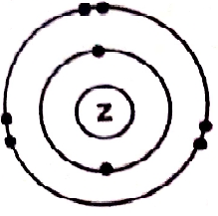
21. a(i) X₂O₃// J₂O//TO
(ii) WO₂
(iii)ZO_{2//} Y₂O₅
iv) WCl₄
b) Sodium chloride conducts in molten//aqueous states while graphite conducts in solid//
Sodium chloride conducts using mobile ions whereas graphite by use of delocalized electrons

22. a) heat
b) green yellow gas//fumes
c) Na+(l) +e Na(s)
23a) Na₂CO₃.NaHCO₃.2H₂O
b) Centrifuge// centrifugation chamber
c) Removal of impurities and small rocks

24) the two gas jars were filled with brown coloured fumes 1mk
The particles in bromine water vapourised and diffused in the air inside the gas jars 1mk
25(i) absorb carbon(IV) oxide(1)
(ii) argon// noble gas (1) is unreactive(1)

26 a) The solution turned from yellow to pale green // Red brown to pale green/ brown to pale green(1)

b) 2FeCl₃ (aq) + H₂S (g) 2FeCl₂ (aq)+S(s) +2HCl(aq)

27 a) To dry chlorine
$${ii) MnO}_{2(s)}+{4HCl}_{(aq)} {MnCl}_{2\left(aq\right)}+{Cl}_{2(g)}+ {2H}_{2}O_{(l)}$$
- Oxidizes HCl to chlorine

28. a) froth flotation
b) 2PbS_{(s)} + 3O_{2( g) 2} PbO_{(s)} +2 SO_{2(g)}
c) in lead acid accumulators
making of water pipes

29 . $R.M = O.M \left(\frac{1}{2}\right)\frac{100}{25}$
$5 = O.A ×{\left(\frac{1}{2}\right)}^{4}$

Initial mass = 5 $×16$
= 80g

