

**CEKENAS END OF TERM TWO EXAM-2022**

**FORM FOUR EXAM**

*Kenya Certificate of Secondary Education. (K.C.S.E)*

**CHEMISTRY 233/1**

**MARKING SCHEME**

1. a) C 🗸1

b) Smallest atomic radius.**½**It has a greater nuclear pull**½** of electrons hence attracts electrons more.1

c) A**½** it has largest atomic radius

1. a) i) Q 

ii) S 

iii) P

1. a) 1

Or



b) – Formation of calcium/magnesium octadecanoate which dirties white linen. 1

Or – wastage of soap (1mk)

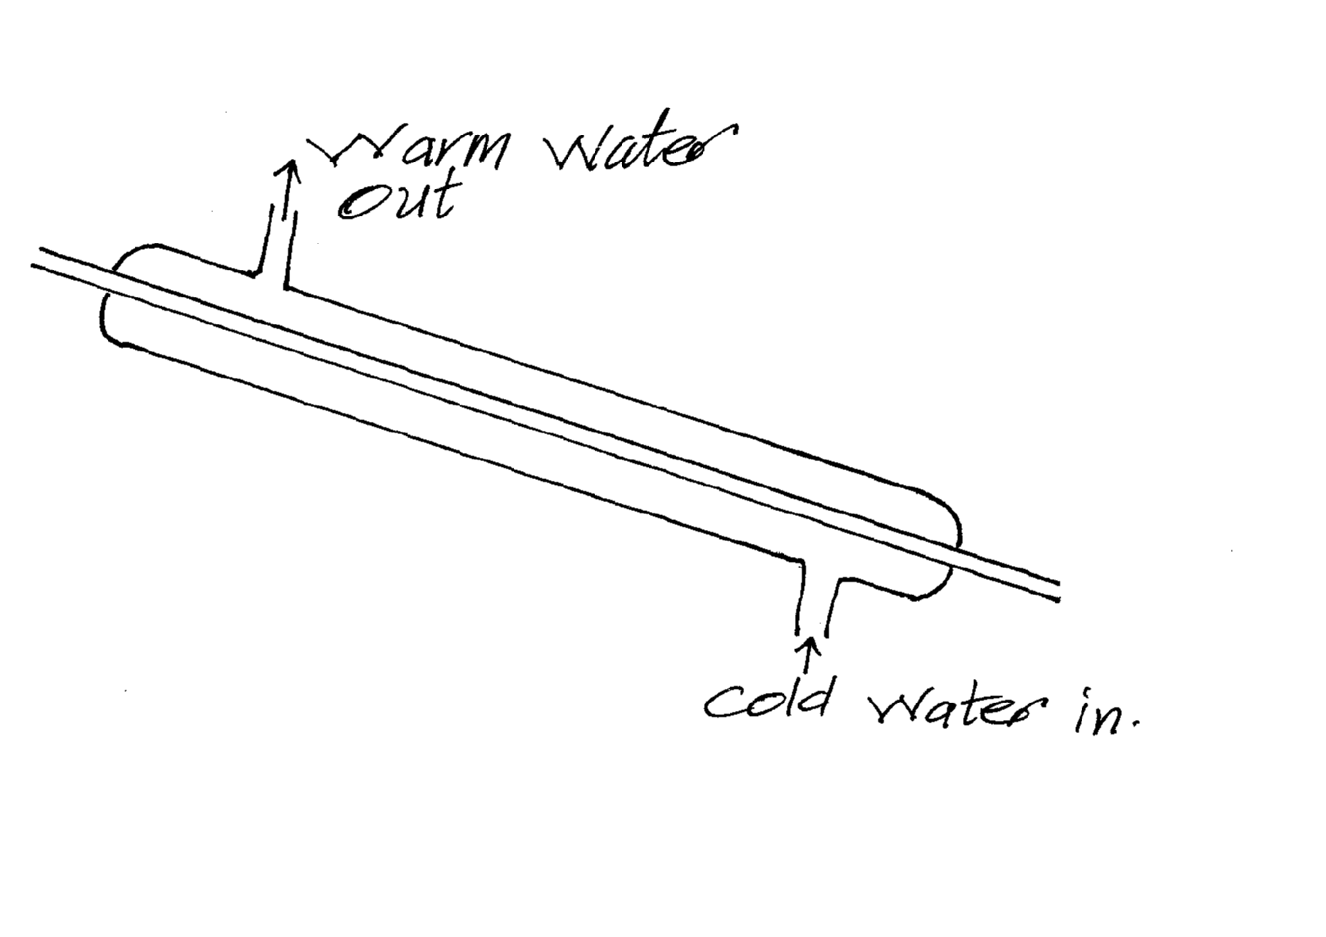

1. i)

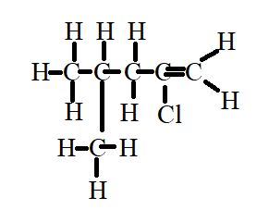1

ii)

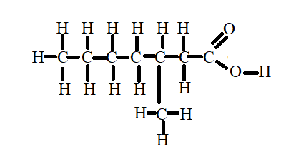 1

1. a) 

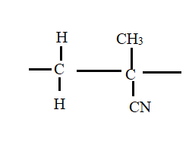n

b) R.A.M of monomer =  = 671

No of monomers = ** ½**

= 60 units **½**

1. i) By distilling it over concentrated sulphuric (VI) acid1 or phosphorous (V) oxide.

ii) Dissolved nitrogen (IV) oxide 1 formed due to decomposition of HNO3.

Removed by bubbling air 1through the acid.

1. a) i) Nuclear fusion **½**

ii) Nuclear fission** ½**

b)

|  |  |
| --- | --- |
| Nuclear reactions | Chemical Reactions |
| Involves protons and neutrons  Involves large amounts of energy.  Not affected by environmental factors | Involves valence electrons  Little amount of energy is released    Affected by environmental factors |

Accept any two correct (2mks)

1. Number of electrons 471

Number of neutrons 611

1.  1

**½**

**½**

**½**

= 166.28 sec**½**

1. The rate of the reaction would be low. Decrease in temperature below optimum reduces the kinetic energy1 of reacting particles (molecules) hence reducing1 the number of effective collisions. (less effective collisions per unit time)
2. a) 1

b) Sodium metal would be deposited.1

Mercury electrode is not**½**inert: sodium ions would be preferentially discharged.**½**

1. of H2O

of H2O

1

= 37.5g/100g of water.1

1. Magnesium oxide has a giant ionic structure with strong ionic bonds**½** that require a lot of energy to break.

Phosphorous (V) oxide has simple molecular structure with weak**½** vanderwaal forces that require less energy**½**. (2mks)

1. Crush the ore**½**

Add nitric (V) acid**½** to dissolve.

Filter**½** to obtain the filtrate.

To the filtrate add potassium**½** iodide solution

A yellow ppt1 formed confirms presence.

**Or**

To the filtrate add sodium chloride**½** solution

A white precipitate**½** is formed.

Warm the mixture**½**

Dissolves to form a colourless solution confirms

(3mks)

1. Across a period proton increases sodium has less**½** protons that have a weaker**½** metallic bond compared to aluminum that has more number of delocalized electrons hence stronger **½**metallic bonds.
2. a) ** 1**

b) Lowers the pH**1**of water hence killing the microorganism. (1mk)

1. 

**1**

** 1**

**1**

(3mks)

1. FeSO4 : H2O

Mass 2.84 2.36** ½**

R.F.M 152 18

No of moles  ** ½**

0.01868 0.1311** ½**

Mole ratio  

1 : 7

N = 7**½**

(3mks)

1. a) The enthalpy change that occurs when one mole of a substance is formed from its constituent elements under standard conditions.**1**

b)

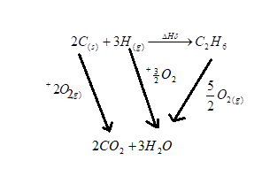

1. The reaction is highly exothermic, the heat evolved melts potassium to a silvery ball. **1**
2. i) Froth flotation**1**

ii) ** 1**

iii) Zinc blende **1**

(3mks)

1. i) ** 1**

ii) Mole of acid = ** ½**

Moles of XOH

**½**

R.F.M of XOH = **½**

= 40**½**

**½**

**½**

(3mks)

1. (i) Amphoteric **1**

(ii) Zinc**1**

Lead **1**

1. a) Crystalline forms of an element that occurs in the same physical state.**1**

b) Graphite uses 3 valence electrons out of the four in covalent bonding one electron remains delocalized.**1**

In diamond all the four valence electrons takes part in covalent bonding.**1**

1. i) Chemical process.**1**

ii) Blue litmus paper turns**½**to red and the red litmus remains red.**½**

AlCl3 is hydrolyzed by water to form an acidic solution.**½**

(2mks)

1. i) Anode – Zinc/Zn **½**

Cathode – Lead/Pb **½**

ii) **1**

iii) Filter paper soaked in concentrated solution of KNO3/NaNO3**1**

Or U-tube filled with KNO3/NaNO3 solution. **1**

(1mk)

1. a)

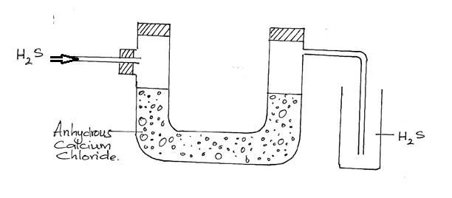

* drying agent**1**
* method of collection**1**
* workability **1**

b) **1**

1. a) i)

**1**

ii)

**1**

b) Oxidised; manganese has lost an electron**1** to be oxidized to manganese of positive +8. (3mks)