CEKENAS END OF TERM I EXAM-2022
FORM FOUR EXAM
Kenya Certificate of Secondary Education.(K.C.S.E)
MARKING SCHEME
BIOLOGY PAPER 3 (231/3)

- You are provided with irish potato tuber,dilute Hydrogen peroxide solution, washing up solution, solutions labelled K, PH 4, solution labelled L of PH 7, and solution labelled M of PH 9. You are also provided with 10ml measuring cylinder, white tile , glass rod, scapel , stop watch , test tubes in a test tube rack.

Peel the potato tuber and cut a piece measuring 1cm3. Crush it on a white tile using the glass rod to obtain a paste.divide the paste into 3 portions and use them as follows.

- Put 2cm3 of solution K into a 10ml measuring cylinder. Add one portion of the potato paste into the cylinder containing solution K. read and record the volume of the mixture in the table below.

Add one drop of the washing up solution. Add 1cm3 of hydrogen peroxide solution into the mixture and immediately start a stop watch. At the end of 2minutes read the mark to which the foam rises and record in the table below

ii) Put 2cm3 of solution L into a 10ml measuring cylinder. Add one portion of the potato paste into the cylinder containing solution L . Read and record the volume of the mixture in the table below.

Add one drop of the washing up solution. Add 1cm3 of hydrogen peroxide solution into the mixture and immediately start a stop watch. At the end of 2minutes read the mark to which the foam rises and record in the table below

iii) Put 2cm3 of solution M into a 10ml measuring cylinder. Add one portion of the potato paste into the cylinder containing solution M. read and record the volume of the mixture in the table below.

Add one drop of the washing up solution. Add 1cm3 of hydrogen peroxide solution into the mixture and immediately start a stop watch. At the end of 2minutes read the mark to which the foam rises and record in the table below

- Complete the table below by calculating the volume of the foam produced in each of the solutions using the data obtained in (i), (ii) and (iii) (3mks)

 | SOLUTION K | SOLUTION L | SOLUTION M
Volume of the solution +potato portion | 2.1 – 2.4 | 2.1 – 2.4 | 2.1 – 2.4
Volume of the solution +potato portion+foam | 3.1- 4.7 | 3.4 – 7.7 | 3.6 – 9.7
Volume of the foam | 0.1 – 1.7 | 0.4 - 4.7 | 1.6 – 7.7

- Explain the observation made when hydrogen peroxide was added to the mixture (2mks)
- There is foaming/ bubbling; Enzyme catalase present in the potato break down hydrogen peroxide into water and oxygen

- Acc word / chemical equation for explanation

- Rej wrong spelling for catalase.

- Account for the difference in the volume of the foam that was produced in solution K and solution M (2mks)
- More foam is produced in M ; it is the optimum PH for enzyme catalase. owtte

- Cut a piece of potato measuring 1cm3 from the remaining potato .Use the reagent provided to test for the food substance . (3mks)

Test | Procedure | Observation | conclusion
starch | Put pieces of potato in a test tube. Add (two) drops of iodine solution | Iodine solution Changes to blue black | Starch present

- Rej blue/black

- You are provided with photographs of specimen Q and N together with actual specimens H, K and P. specimen H is a complete plant while K is a portion of a different plant. Observe the specimens and the photographs and use them to answer the questions that follows.
- State two observable differences between the leaves of H and K. (2mks)

H | K
Broad leaves /broad leaf lamina  Network veins  Acc short | Narrow leaves/lamina  Parallel veins  Acc long

- Explain how the stem of specimen H adapts the plants to photosynthesis (2mks)

- Firm /upright to expose the leaves to light for photosynthesis
- Green to trap sunlight for photosynthesis

- State the ecological importance of specimen H (1mk)
- Producer / food for herbivores
- Habitat for small animals
- Reduce CO2 in the atmosphere
- Ground cover

- Describe how specimen K is adapted to its habitat (2mks)

- Woody for support
- Has thorns on the stem for protection against herbivores

Rej predators

- Explain the consequences of spilling common salt to the soil in which specimen H is growing. (2mks)
- The common salt will make the surrounding soil solution hypertonic to cell sap; The plant lose water to the soil by osmosis hence become dehydrated /wilt / dry/ die .

- With reason identify the subdivision from which specimen H and K belong (2mks)
- Angiospermaphyta ; - Veined leaves
Seed bearing / flower bearing

Rej parallel veined, net veined

- Cut a longitudinal section of specimen P . using the observable features

Identify the type of placentation (1mk)
- Basal

With a reason classify the type of fruit to which it belongs. (2mks)

- Drupe ; - one seeded

- Use the photographs of Q and N to complete the table below

PHOTOGRAPH Q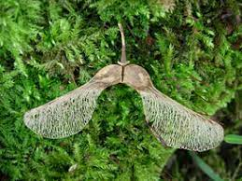
PHOTOGRAPH N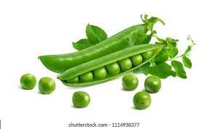

SPECIMEN | MODE OF DISPERSAL | ADAPTIVE FEATURE
Q | wind | Wing –like membrane/ winged pericarp
N | Self dispersal/self explosive  Mechanism  Rej self explosion | Sutures / lines of weakness  Rej satures

(4mks)

- Below is a photograph of a dissected rat with the abdominal organs spread out. Examine it

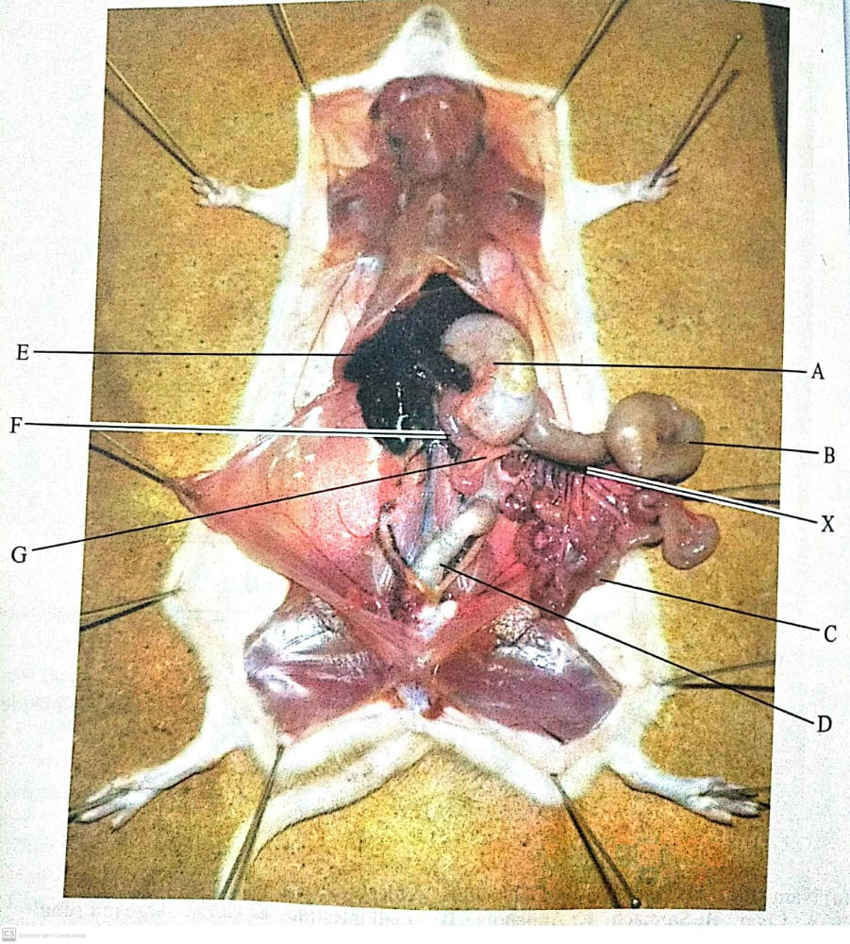

- State two characteristics that distinguish the dissected animal into its taxonomic class (2mks)
- Posess hair on their body / body covered with hair
- Presence of muscular diaphragm
- Presence of external ears / pinna

- Name the parts labeled (3mks)
- B - caecum

- C - small intestines

- F - duodenum

- State
i) Two functions of part labeled A (2mks)
- temporary storage of food during digestion
- churning
- digestion

- The function of D
- Harbours bacteria that digest cellulose owtte

- Other than homeostasis and excretion state two functions of structure E (2mks)
- Red blood cell formation
- Synthesis of plasma proteins
- Production of bile

- Given the magnification of the specimen in the photo as X 0.67 , calculate the length of the rat from X to Y (2mks)
- Actual length = $\frac{length XY}{magniication}$ = (use students values)

THIS IS THE LAST PRINTED PAGE

