443/2

AGRICULTURE PAPER 2

THEORY

DECEMBER EXAM 2021

2 HOURS

NAME-------------------------------------------------------------------------------------INDEX NO. ---------------- SCHOOL--------------------------------------------DATE------------------------------- SIGN-----------------------
INSTRUCTIONS TO CANDIDATES

a)This paper consists of Three sections A,B and C. b) Answer all questions in section A and B.
c) Answer any Two questions in section C.

d) The questions should be answered in English.

FOR EXAMINERS USE ONLY

SECTION | QUESTION | MAX.SCORE | CNDIDATES SCORE
A | 1-17 | 30
B | 18-21 | 20
C | 22-24 | 20
 |  | 20
 |  | 90

SECTION A. [ 30MKS ].
(Answer all questions in this section in the spaces provided.)

1. Explain TWO maintenance practices that should be done on a wheelbarrow. (1mk.)

……………………………………………………………………………………………………

……………………………………………………………………………………………………

2 a) Name a breed of goat kept mainly for mohair (wool) production.( 1/2mk)

……………………………………………………………………………………….

b) Mention TWO distinguishing characteristics of the bacterian camel breed. (1mk)

…………………………………………………………………………………….

………………………………………………………………………………………
3 ) Name THREE rabbit breeds reared in Kenya. (1 ½ mks)

……………………………………………………………………………………………………

……………………………………………………………………………………………………

………………………………………………………………………………………………….…
4.a) State FOUR methods of maintaining good health in livestock production. (2 mks)

……………………………………………………………………………………….

…………………………………………………………………………………….

…………………………………………………………………………………….

……………………………………………………………………………………..

b) What is vaccination? (1mk)

………………………………………………………………………………………

………………………………………………………………………………………

5. State FOUR symptoms of internal parasite infestation in animals. (2mks

……………………………………………………………………………………..

………………………………………………………………………………………

…….………………………………………………………………………………..

………………………………………………………………………………………

6. State TWO commonly used methods of computation of livestock feeds. (1mk)

……………………………………………………………………………

……………………………………………………………………………
7. State FOUR disadvantages of natural mating as a method of breeding in dairy cattle Production. (2mks).

………………………………………………………………………………..

………………………………………………………………………………

8. Give the differences of the following livestock practices as used in livestock production.

a) Ringing and Raddling . (1mk)

………………………………………………………………………………………………………………………………………………………………………………………………………………………………………………………………………………………………………………………
b) Tupping and Serving. (1mk).

………………………………………………………………………………………………………………………………………………………………………………………………………………………………………………………………………………………………………………………
9. a) Name TWO methods of harvesting fish. (1mk).

…………………………………………………………………………………….

……………………………………………………………………………………….
c) State TWO roles of the queen bee in the bee colony. (1mk).

……………………………………………………………………………………………
…………………………………………………………………………………………………….
10. Name FOUR maintenance practices to be done on a wire fence. (2mks)
……………………………………………………………………………………….
………………………………………………………………………………………
……….………………………………………………………………………………
……………………………………………………………………………………….
11 a) Name TWO notifiable diseases in cattle. (1mk).

………………………………………………………………………………………

……………………………………………………………………………………..

b) . List FOUR routes through which pathogens can enter the body of an animal. (2mks).
………………………………………………………………………………………
………………………………………………………………………………………
…………………………………………………………………………………….
…………………………………………………………………………………….
12. Name TWO methods of killing birds for marketing. (1mk).

…………………………………………………………………………………………….

……………………………………………………………………………………………
13.State TWO advantages of single housing in calf rearing. (1mk).
……………………………………………………………………………………….

………………………………………………………………………………………

……………………………………………………………………………………..
14 .Give FOUR rules (principles) to be observed when milking. (2mks).

………………………………………………………………………………………

……………………………………………………………………………………….

………………………………………………………………………………………

………………………………………………………………………………………
15. Differentiate between Homogenization and pasteurization of milk as used in manufacturing of dairy products. (1mk).

……………………………………………………………………………………

……………………………………………………………………………………….

………………………………………………………………………………………
16. State FOUR disadvantages of using animal power over human power. (2mks).
………………………………………………………………………………………
………………………………………………………………………………………
……………………………………………………………………………………….
………………………………………………………………………………………
……………………………………………………………………………………….

17.List FOUR long term tractor service. (2mks).
……………………………………………………………………………………
……………………………………………………………………………………
……………………………………………………………………………………….
SECTION B: (20MKS).

Answer all questions from this section in the spaces provided.

18 , Bellow are illustrations of tools used in agriculture.

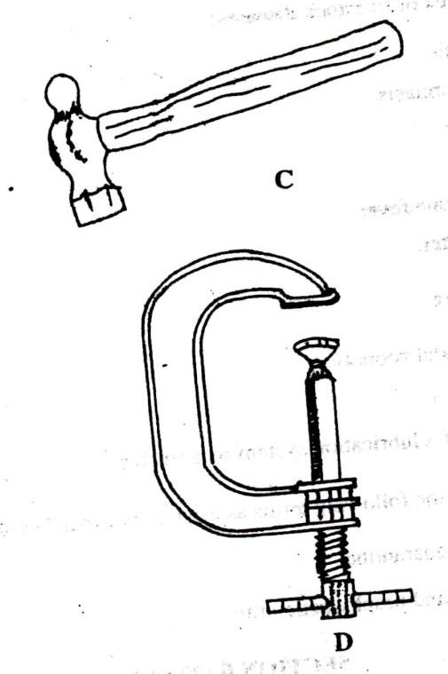

a) . Identify tool C and D. (2mks).

C-………………………………………………………………………….

D-…………………………………………………………………………

b) State one appropriate use of tool labeled C. (1mk).

……………………………………………………………………………….

c). Explain TWO maintenance practices for tool labeled D.( 2mks).

………………………………………………………………………………………

………………………………………………………………………………………

……………………………………………………………………………………….

19. The diagram bellow shows a livestock parasite. Use it to answer questions that follow
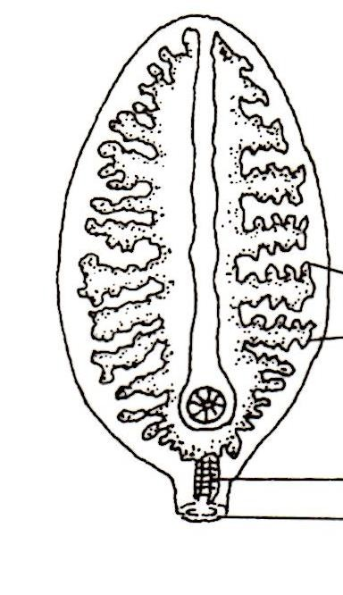

a) . Identify the parasite shown above. (1mk).

………………………………………………………………………………………

……………………………………………………………………………………….
b). Name the disease caused by the parasite shown above. (1mk).

………………………………………………………………………………………

……………………………………………………………………………………..

c) . State THREE control measures for the parasite. (3mks).

……………………………………………………………………………………….

………………………………………………………………………………………

………………………………………………………………………………………

20. The illustration bellow shows a livestock suffering from a malnutrition condition.

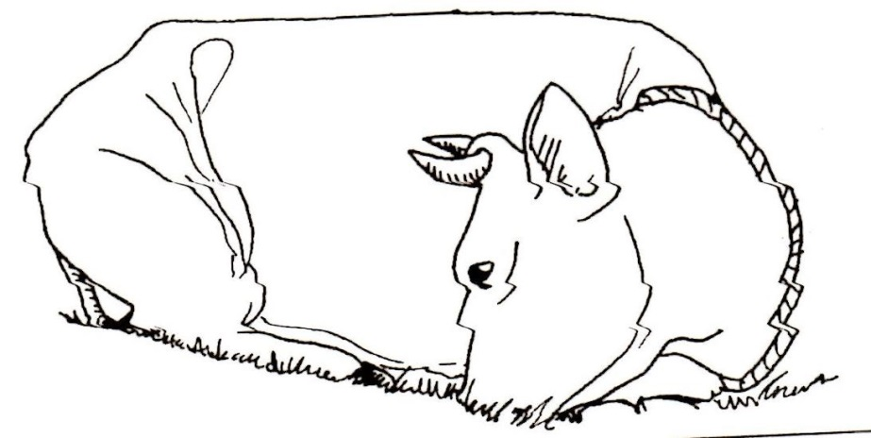

a) . Identify the deficiency disease the animal is suffering from. (1mk).

……………………………………………………………………………………….
……………………………………………………………………………………….

b) Which food element is the animal lacking? (1mk).

……………………………………………………………………………………………………

……………………………………………………………………………………………..……..

c) . Apart from the symptom shown above, name THREE other symptoms shown by the animal suffering from above condition. (3mks)

………………………………………………………………………………………………..……

…………………………………………………………………………………………………….

…………………………………………………………………………………………………….

21. The diagram bellow is an illustration of an egg . Study it carefully and answer the questions that follow.
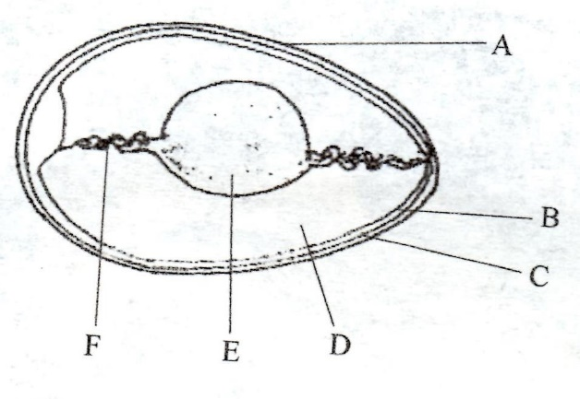
a). Name the parts labeled B,C ,D and F.

B……………………………………………………………………………(1/2mk).

C……………………………………………………………………………(1/2mk)

D…………………………………………………………………………..(1/2mk)

F……………………………………………………………………………(1/2mk)

b). State TWO qualities of the part labeled A that should be considered when selecting eggs for incubation. (2mks).

………………………………………………………………………………….

……………………………………………………………………………………

c) .What is the function of the part labeled E in a fertilized egg? (1mk).
………………………………………………………………………………
SECTION C: (40MKS).
Answer any TWO Questions from this section in the spaces provided.

22. a) Give importance of keeping livestock in Kenya. (5mks)
.
b). State FIVE indicators that can be observed on the sheep to confirm sickness. (5mks).

c). State FIVE reasons for feeding livestock. (5mks).

d). Explain FIVE factors to be considered when siting a farm store. (5mks).

23 a). Describe how a newly constructed pond is prepared and stocked with fingerlings. (9mks).
b).Give SIX signs of heat in cattle. (6mks) .
c) .Describe the management of growers in poultry rearing. (5mks) .

24. a) Explain SEVEN factors that affect milk composition in dairy farming. (7mks).
b). Describe Brucellosis disease in cattle under the following sub headings.

(i). Causal organism. (1mk). (ii) Signs of attack. (3mks) . (iii) Control measures. (4mks).
c). Name various sources of power on the farm.(5mks).

END

