NAME_____________________________________ DATE ________________
INDEX NUMBER___________________________________________________

AGRICULTURE FORM FOUR PAPER ONE
443/1

DECEMBER EXAM 2021

AGRICULTURE EXAMINATION – 443/1
FORM FOUR – 2021
EXAMINATION

INSTRUCTIONS
- Answer all questions in sections A and B.
- Attempt ANY TWO questions in section C.
- Be precise and clear in the presentation of your answers.
- Stealing examination is an offence.

SCORE SUMMARY
SECTION | MAXIMUM SCORE | CANDIDATE SCORE
A | 30 marks
B | 20 marks
C | 40 marks
TOTAL | 90 marks

SECTION A (30 MARKS)
Attempt all questions in this section
1. Give four roles of mulches in soil and water conservation? 2 mks
- ___________________________________________________________________________
- ___________________________________________________________________________
- ___________________________________________________________________________
- ___________________________________________________________________________
2. State two differences between field crops and horticultural crops 2mks
____________________________________________________________________________
____________________________________________________________________________
____________________________________________________________________________
____________________________________________________________________________
3. Give the reason why Nitrogen, phosphorous and Potassium nutrients are referred to as fertiliser elements
1mk
____________________________________________________________________________
____________________________________________________________________________
____________________________________________________________________________
4. Mention four advantages associated with the use of seeds as planting materials 2mks
- ___________________________________________________________________________
- ___________________________________________________________________________
- ___________________________________________________________________________
- ___________________________________________________________________________

5. State four advantages of landlordism and tenancy systems of land ownership 2mks
- ___________________________________________________________________________
- ___________________________________________________________________________
- ___________________________________________________________________________
- ___________________________________________________________________________

6. a). What is solifluction 1mk
_____________________________________________________________________________
______________________________________________________________________________
b). Give any two conditions that may increase the speed and intensity of solifluction process 2mks
- __________________________________________________________________________
- __________________________________________________________________________
7. Give four adaptions that enable weeds to have extremely successful means of propagation 2mks
- ___________________________________________________________________________
- ___________________________________________________________________________
- ___________________________________________________________________________
- ___________________________________________________________________________

8. State four importance for carrying out crop rotation on the farm. 2 mks
- ___________________________________________________________________________
- ___________________________________________________________________________
- ___________________________________________________________________________
- ___________________________________________________________________________
9. a) Give two conditions that may necessitate roguing on the farm 1mk
- __________________________________________________________________________
- __________________________________________________________________________
10. State four reasons why strong wind is a threat in agricultural production 2 mks
- __________________________________________________________________________
- __________________________________________________________________________
- __________________________________________________________________________
- __________________________________________________________________________
11. Mention two conditions that may necessitate irrigation of crops on the farm 2 mks
- _________________________________________________________________________
- _________________________________________________________________________

12. a) What is opportunity cost? 1 mk
____________________________________________________________________________
____________________________________________________________________________
____________________________________________________________________________
b) State four reasons why farmers are encouraged to keep livestock health records 2 mks
_______________________________________________________________________________
_______________________________________________________________________________
_______________________________________________________________________________
_______________________________________________________________________________

13. a) Give two major causes of blossom end rot disease in tomatoes. 1 mk
- ________________________________________________________________________
- ________________________________________________________________________
b) Why are tomato seedlings watered thoroughly before transplanting 1mk
____________________________________________________________________________
_____________________________________________________________________________
_____________________________________________________________________________
14. State two reasons why soil testing should be carried out. 2mks
- ________________________________________________________________________
- ________________________________________________________________________
15. Give four disadvantages of row planting in crop production 2 mks
- ________________________________________________________________________
- ________________________________________________________________________
- ________________________________________________________________________
- ________________________________________________________________________

SECTION B (20 MARKS)
Attempt all questions in this section
16. Study the illustration below and answer the questions that follows

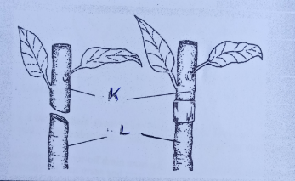

a) Identify the method of propagation shown in the illustration above 1 mk
__________________________________________________________________________________
b) Give three desirable features that the mother plant from which the part labelled K should have 3mks
________________________________________________________________________________
________________________________________________________________________________
________________________________________________________________________________

c) Give one factor considered when choosing part L during the practice shown above 1mk
________________________________________________________________________________
________________________________________________________________________________

17. The information 20:10:5 was observed on a bag of fertiliser;
a) What does ‘20’ on the bag of fertiliser mean? 1mk
______________________________________________________________________________
_______________________________________________________________________________
_______________________________________________________________________________
b) What factor determines the rate and amount of fertiliser applied on the farm? 1 mk
____________________________________________________________________________
____________________________________________________________________________
____________________________________________________________________________
c) A farmer was advised to apply 200kg of the above fertiliser on his one hactare of land under
maize production, calculate the amount of nutrients that were applied on the farm. 3 mks

18. Study the illustration below and answer the questions that follow
RECEIPTS |  |  | ISSUES
Date | Commodity/item | Quantity | Date | Issued to | Quantity | Bal. in stock
01/2/21 | DAP Fertiliser | 150 bags | 15/2/21 | F/Manager | 30 bags DAP | 120 bags DAP

a) Identify the farm document above. 1mk
_______________________________________________________________________________
b) State four specific importance of the above document being kept on the farm 4mks
________________________________________________________________________________
________________________________________________________________________________
________________________________________________________________________________
________________________________________________________________________________
19. The figure represents a structural measure used in soil and water conservation, study it and answer the questions that follows.
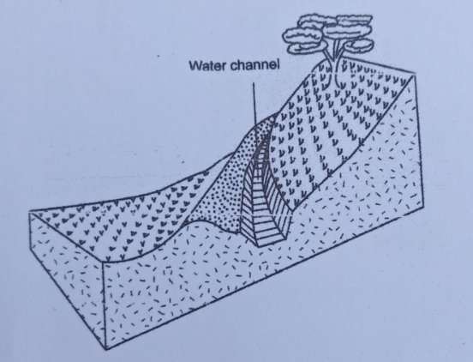
a). Identify the structural measure represented above. 1 mk
_______________________________________________________________________________
b). under what circumstances is the measure above used? 1mk
______________________________________________________________________________
______________________________________________________________________________
c). Give three special features and precautions taken when the measure above is put into use 3mks
______________________________________________________________________________
______________________________________________________________________________
______________________________________________________________________________
______________________________________________________________________________
_______________________________________________________________________________
______________________________________________________________________________

SECTION C (40 MARKS)
This section comprises of three questions, attempt any TWO questions in this section.

20. a) Describe ten factors that influence soil erosion 10 mks
b) Describe five nursery management practices carried out on the farm 10 mks
21. a) Explain eight reasons why weeds are controlled on the farm 8 mks
b) Describe six basis of field pests classification on the farm 12 mks
22. a) Why are farmers encouraged to consolidate their farms in agricultural production 12 mks
b). What eight advantages will the farmer who keep proper farm records have over the
one who does not keep farm records at all? 8 mks
____________________________________________________________________________________________________________________________________________________________________________________________________________________________________________________________________________________________________________________________________________________________________________________________________________________________________________________________________________________________________________________________________________________________________________________________________________________________________________________________________________________________________________________________________________________________________________________________________________________________________________________________________________________________________________________________________________________________________________________________________________________________________________________________________________________________________________________________________________________________________________________________________________________________________________________________________________________________________________________________________________________________________________________________________________________________________________________________________________________________________________________________________________________________________________________________________________________________________________________________________________________________________________________________________________________________________________________________________________________________________________________________________________
LAST PRINTED PAGE.

