WOODWORK (444/1)
MARKING SCHEME
BUNAMFAN 2022
SECTION A
1. (a) Sources of business capital.
-Loans from ﬁnancial institutions.
-Personal savings.
-Family shares.
-Donations from friends.
-Pulling resources together.
(b) Factors to consider when starting a business.
-Market.
-Infrastructure.
-Availability of raw materials.
-Cultural values.
-Security of the locality.
2. (a) Dangers of inhaling toxic adhesives
-Blurred vision.
-Difﬁculty in breathing.
- Brain damage.
-Headache.
-Memory loss.
-Death.
(b) Characteristics of softwood trees.
-Seeds are enclosed in cones.
- Needle like leaves.
- Evergreen.
-Mature faster.
-Seeds have wings.
3. (a) Reasons that make a mortice gauge produce inaccurate marks.
-Loose spurs.
-Loose thumbscrew.
-If the stem is worn out.
-If the stock hole is not tightly ﬁtting the stem.
-If accurate readings were not taken before locking the thumb screw.
4. Timber defects
(a) A - upset
B - waney edge
(b) Causes of upsets
-Fracturing of the Wood ﬁbres across the grain.
-Caused by sudden shock at the time of felling.
-Tree becoming over stressed during growth.
-Tree being bent by strong winds.
Causes of Waney edge
- Uneven growth and size of the tree. This refers to the edge of a piece of timber which has retained part of the bark after conversion.
-Too economical conversion.
5. (a) Practices that demonstrate the correct use of a cross-cut hand saw.
-Pull the saw towards your body to start the cut.
-Take short, light strokes, gradually increasing the strokes to full length of the saw.
-Use the saw at an angle of approximately 45” with the face of the board.
-Keep the saw in line with the forearm.
-Keep the saw plumb with the face of the board.
-Do not force or jerk the saw while in use.
-Hold the saw in one hand and extend the ﬁrst ﬁnger along the handle.
-Keep your eye on the line rather than on the saw while working.
(b) Parts of a circular saw.
A - Riving knife.
- Saw blade.
- Saw guard.
- Fence.
6.-Functions of the knob in a bench plane.
-The knob allows the user to control and direct the plane with both hands.
-It allows the user to hold and leverage the plane during use.
7. Precautions to be observed when using a lathe machine.
-Select the correct speed for the work to be turned.
-Ensure the work is secured to the face plate or between centres.
-Spin work by hand to ensure that it clears the lathe bed and tool rest.
- Always return tools to the tray - do not place them on the bed of the lathe.
- Wear protective clothing.
8.Characteristics of polyvinyl actate (PVA) glue.
-Easily applied.
-Sets at room temperature.
- Does not stain.
-Sets clearly and does not damage the edge of tools.
-Water resistant.
9. Disadvantages of oil based paint.
-Flammable.
-Produces an odour when newly applied.
-Requires a thinner therefore more expensive.
10. Exploded pictorial view of a mitred bridle joint.
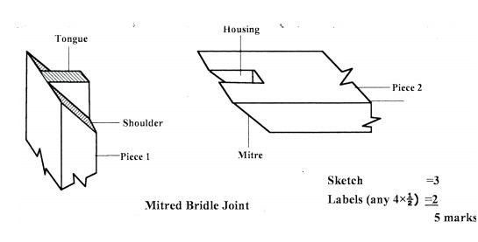
11.
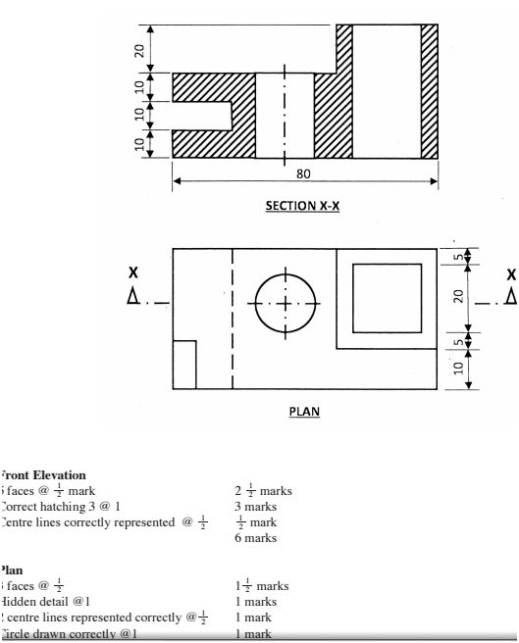
12. (a) Procedure of making a groove.
-Mark the work piece.
- Clamp the work piece.
-Set blade to depth.
-Set the fence.
-Identify direction of grain.
- Make ﬁrst cut gently.
-Make deep cut.
7 marks
(b) Procedure of carving.
-Prepare the template.
-Transfer the outline onto the work piece.
-Hold the work piece on the vice.
-Carve the hollow part of the dish.
-Carve the shape of the neck.
-Shape the base.
-Finish the surfaces of the dish to the required texture.
8 marks 13. (a) Difference between auger bit and twist drill bit.
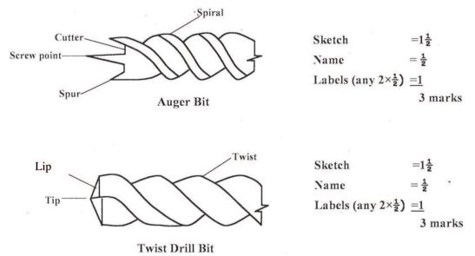
(b) Oven dry method of moisture content determination.
-A small sample of wood is cut from the batch of timber to be dried.
-The sample is weighed to determine the initial or wet weight.
-It is then placed in a special drying oven and left until no further Weight loss can be recorded.
-The ﬁnal or dry weight is noted.
-The percentage moisture content is calculated using the formula.
_ initial (wet) weight - final (dry) weight
(c) Film forming ﬁnishes form a thin layer over the surface to Which they are applied eg. paints, varnishes, Wax.
Penetrating ﬁnishes are absorbed into the wood, saturating the ﬁbres and partially or completely ﬁlling the surface pores. eg. Water repellants, stains, spirits.
Total 4 marks
14. (a) Procedure of marking out
-Ensure one face or edge is true.
-Set the gauge to the required size using a rule.
-Tighten the thumb screw.
-Hold the Wood at an angle and press the gauge stock against the side.
-Tilt the gauge to let the spur trail.
-Move the gauge along the length of the wood.
-The spur point will cut a line as it goes alone. 7 marks
(b) Cost of coffee stool
Block board
Assume full board is used
3600 =900
Lipping top + base = _ >< 500 + >< 200
: 1571+ 628 : 2199 Q 2200 mm
i.e. lengths Q 8
Cost of lipping 30 x 8 = 240 ©
Stand length = 450 ie. 2 lengths
Cost of stand 2 x 40 = 80 Cg
Glue 1/2kg 60/= =60
Wood varnish f kg @ 180 ﬁg
1,460
Add 30% for labour and overheads 438
Cost of materials Ksh 1323 Cg
l5. (a) Pocket screw method of ﬁxing table top.
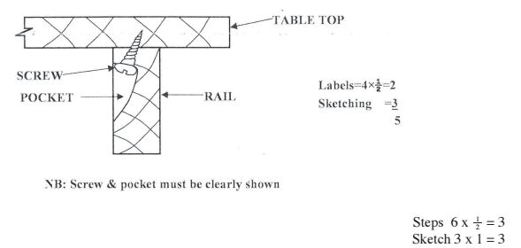
(b) Parts of brush and function
Part Function
P - handle - to hold brush.
Q - ferrule - connects handle to bristles.
- plug - holds and spreads the bristles.
- bristles - spread the paint
(c) Favourable conditions for fungal growth.
(i) Moisture in wood - must be above 20%
(ii) Temperature - between 30 - 37°C. Lower temperatures may reduce growth higher temperatures will kill fungi.
(iii) Air - essential requirement for growth and respiration.

