BUNAMFAN CLUSTER EXAMINATION – 2022
Kenya Certificate of Secondary Education
444/1 – WOOD WORK – Paper 1
June 2022 - 2 ½ hours
Name…………………………………Adm No……
Class…………… Date……………………………

INSTRUCTIONS TO CANDIDATES
You should have the following for this examination.
Answer booklet.
- Drawing Instruments.
- Drawing Paper size A3

SECTION A: Answer all the questions.
SECTION B: Answer question 11 and any other 3 questions.

This paper consists of 12 printed pages.
Candidates should check the question paper to ensure that all pages are printed as indicated and no questions are missing.

SECTION A (40 MARKS)
Answer all the questions in this section in the space provided
- a) List four functional requirements of woodwork workshop. (2 marks)
….……………………………………………………………………………………
….……………………………………………………………………………………
….……………………………………………………………………………………
….……………………………………………………………………………………
b) State three causes of accidents relating to the use of hand tools in a woodwork workshop. (3 marks)
….……………………………………………………………………………………
….……………………………………………………………………………………
….……………………………………………………………………………………
….……………………………………………………………………………………
- Explain the cause of each of the following classes of fire.
- Class A fire (2 marks)
….……………………………………………………………………………………
….……………………………………………………………………………………
….……………………………………………………………………………………
….……………………………………………………………………………………

- Class B fire (2 marks)
….……………………………………………………………………………………
….…………………………………………………………………………………..
….……………………………………………………………………………………
….……………………………………………………………………………………
- Figure 1 shows a vernier caliper reading

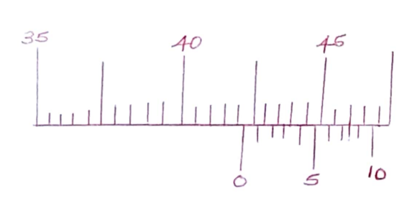
Determine the value of the reading (2 marks)
….……………………………………………………………………………………
….……………………………………………………………………………………
….……………………………………………………………………………………
….……………………………………………………………………………………
- State four practices that demonstrate the proper use of a cross-cut saw when cutting timber. (4 marks)
….……………………………………………………………………………………
….……………………………………………………………………………………
….……………………………………………………………………………………
….………………………………………………………………………………….
5 a) State two functions of the knob on a bench plane (2 marks)

….……………………………………………………………………………………
….……………………………………………………………………………………
….……………………………………………………………………………………
….……………………………………………………………………………………
b) Sketch the plan of the head to show the shape of the slots on the following types of screw.
- Philips recess (2 marks)
….……………………………………………………………………………………
….……………………………………………………………………………………
….……………………………………………………………………………………
….……………………………………………………………………………………
- Coach recess (2 marks)
….……………………………………………………………………………………
….……………………………………………………………………………………
….……………………………………………………………………………………
….……………………………………………………………………………………
6 a) Sketch and label a try square (2 marks)

b) State two uses of a try square (2 marks)
….……………………………………………………………………………………
….……………………………………………………………………………………
….……………………………………………………………………………………
- Figure 2 shows the cutting edge of a chisel

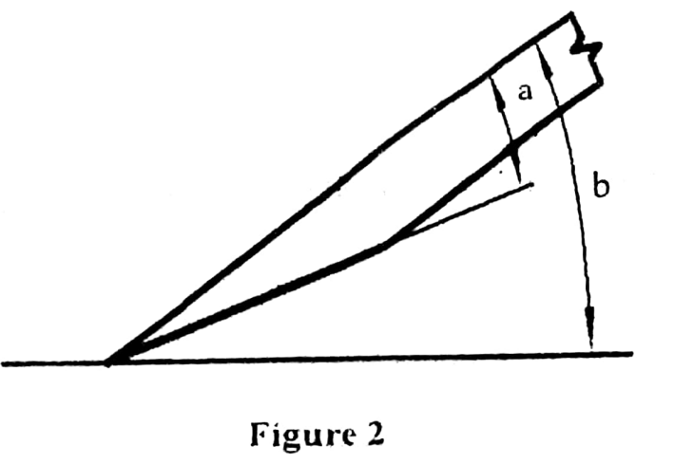

- Name the angles labelled a and b (1 mark)
….……………………………………………………………………………………
….……………………………………………………………………………………
- Give the recommended value for each of angles in 7(a) (2 marks)
….……………………………………………………………………………………
….……………………………………………………………………………………
….……………………………………………………………………………………
….……………………………………………………………………………………
- Sketch each of the following types of treatment given to the edges of tables
(3 marks)
- Chamfer
….…………………………………………………………………………………
….……………………………………………………………………………………
….……………………………………………………………………………………
….……………………………………………………………………………………
- Bevel
….……………………………………………………………………………………
….……………………………………………………………………………………
….……………………………………………………………………………………
….……………………………………………………………………………………
- State four characteristics of varnish applied on a dry wooden surface (4 marks)
….……………………………………………………………………………………
….……………………………………………………………………………………
….……………………………………………………………………………………
….……………………………………………………………………………………
- Print the phrase ‘God is Good’ using the vertical capital letters of uniform 7mm height and word spacing of 5mm. (5 marks)

SECTION B (60 marks)
Answer question 11 on A 3 size paper provided and any other three questions from this section in the spaces provided . Candidates are advised Not to spend more than 25 minutes on question 11.
11.Figure 3 shows a block in orthorgraphic view, Draw the block in an isometric projection full scale with P the lowest point. (15 marks)

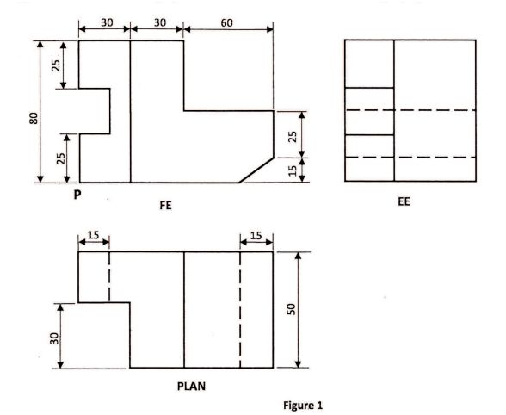

12 (a) Outline the procedure of making a groove in a workpiece using a plough plane. (7 marks)
……………………………………………………………………………………………………………………………………………………………………………………………………………………………………………………………………………………………………………………………………………………………………………………………………………………………………………………………………………………………………………………………………………………………………………………………………………………………………………………………………………………………………………………………………………………..
b) Using labelled sketches, show the difference between an auger bit and a twist drill bit. (6 marks)

(c) State two precautions to be observed when using a steel tape measure.
(2 marks)
………………………………………………………………………………………………………………………………………………………………………………………………………………………………………………………………………

13. (a) State four precautions to be observed when using a steel tape measure.
(4 marks)
……………………………………………………………………………………………………………………………………………………………………………………………………………………………………………………………………………………………………………………………………………………………………………………………………………………………………………………………………………………………………………………………………

(b) State four purposes of a primer coat as used in painting. (4 marks)
……………………………………………………………………………………………………………………………………………………………………………………………………………………………………………………………………………………………………………………………………………………………………………………………………………………………………………………………………………………………………………………………………
c) Outline the procedure of marking out a piece of wood to size using a marking gauge. (7 marks)
………………………………………………………………………………………………………………………………………………………………………………………………………………………………………………………………………………………………………………………………………………………………………………………………………………………………………………………………………………………………………………………………………………………………………………………………………………………………………………………………………………………………………………………………………………………………………………………………………………………………………………………………………………………………………………………………………………………………………………………………………

14.(a) With the aid of a labelled sketch, show the pocket screw method of ﬁxing table top to rails. (5 marks)

(b) State six beneﬁts of starting a small scale business in rural areas. (6 marks)
……………………………………………………………………………………………………………………………………………………………………………………………………………………………………………………………………………………………………………………………………………………………………………………………………………………………………………………………………………………………………………………………………………
(c) Other than food, state and explain two favorable conditions for fungal growth in timber. (4 marks) ……………………………………………………………………………………………………………………………………………………………………………………………………………………………………………………………………………………………………………………………………………………………………………………………………………………………………………………………………………………………………………………………………………..

15(a) Figure 4 shows pictorial views of wall mounted shelf. All members are 22 mm thick softwood.

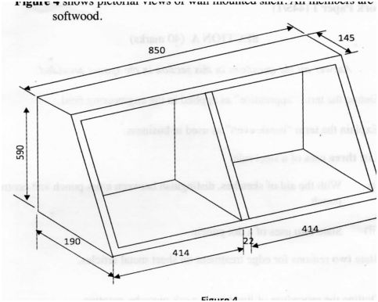

Prepare a cutting list for purchasing the timber required for the shelf. (9 marks)

(b) Figure 5 shows a paint brush.

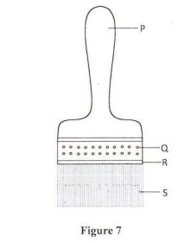
- Name the parts marked P, Q, R and S.
……………………………………..
…………………………………......
……………………………………..
…………………………………….
(ii) State the function of each part. (6 marks)
P”……………………………………………………………………………………Q”……………………………………………………………………………………R”……………………………………………………………………………………S”……………………………………………………………………………………

THIS IS THE LAST PRINTED PAGE

