VISUAL ARTS - GRADE 7 EXAMS TERM 1 2023
QUESTIONS
- List tany 3 principle of Art (3mrks)
- Pupils at Tumaini Academy were told to come with any materials that can be used in crayon etching. Write the possible tools, John, a pupil in that class came with. (3mks)
- 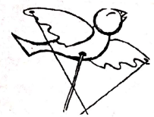
The picture shown above represents a ______________________________ puppet. (1mk)
- John a grade pupils rolled clay when making a pot and used beads to decorate. John made the pot using ____________________ technique and decorated it using ________________________(2mks)
- Name 2 characteristics of seasonal cards. (2mks)
- Differentiate between slab technique and pinch technique. (3mks)
- A wristband was made and a needle was used to insert holes to decorate it. The method used to decorate it is called _________________________________ (1mk)
- Fill in the following
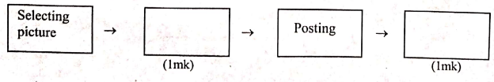
- The picture making technique that involves creating a pictorial composition using a collection of pictures is called _________________________
- List 3 techniques used in basketry. (3mks)
- Amina intended to make a yellow colour. She mixed, _______________________ and ______________________ Which was the final type of colour? _____________________________ (3mks)
- Explain 3 importance of a book jacket. (3mks)
- Write down any 2 uses of a puppet. (2mks)
- Draw a gradation strip and arrange it from dark to light. (3mks)
- Write a 3 letter word using block lettering. (2mks)
- A place where we perform puppets is called _________________________
- Write 3 materials or tools used in thonging technique. (3mks)
- Still life drawing is ___________________________
- Practical (8mks)
On the space given draw any form showing overlapping and show value using stippling technique. (1mk)

MARKING SCHEME;

  - Balance of form Proportion of form
  - Rhythm and movement
  - Overlapping

  - Sharp tool Crayon
  - Black Indian Ink
  - Paper
- rod
- John made the pot using coil technique and decorated it using embedding method.

  - Have a message(title)
  - Are attractive
- Slab technique is used to make various shapes white pinch technique is used to make a pot.
- perforation

  - cutting and trimming
  - mounting
- Montage

  - Rolling
  - Colling
  - Stitching
- Amina intended to make a yellow colour, she mixed a red and yellow colour. The final colour is which type of colour secondary.

  - Aesthetic reason
  - Protection of book
  - Durability of beok.

  - Pass information
  - Earn income
  - Education purpose
  - Source of employment
  - Entertainment

- Any 3 letter using block letters
- Open window theatre

  - Thong chisel
  - A thong
  - Leather revolving punch
  - scissors
- A still life drawing is drawing of non moving things object.
- Leamer should draw more than one object, the smaller object being in front of the bigger o then shade using dots to show light or dark.

