Social Studies/R.E - Grade 4 Term 1 Exams 2023

QUESTIONS
JUMBO AREA
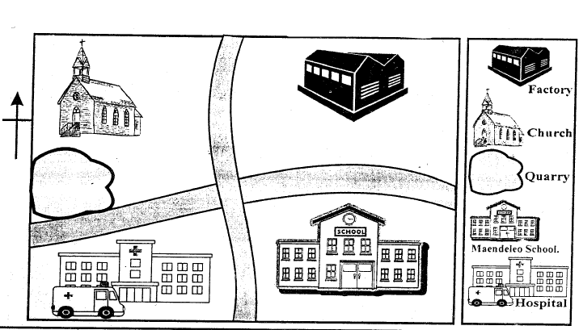
Study the map and answer the questions
- What is the direction of the school from the church?.........................................
- The students learn in a school called? .........................................
- The people in Jumbo area worship in a .........................................
- Name two economic activities carried out in Jumbo area
  - .........................................
  - .........................................
- What is a compass direction? .........................................
- Draw a compass and name it (4mks)
- Name the physical features
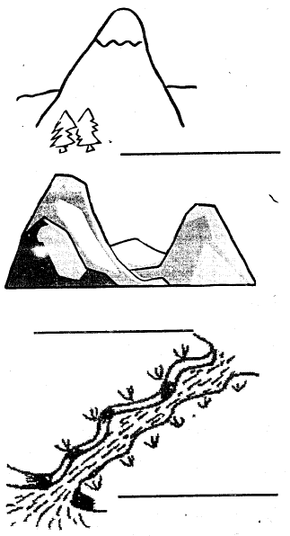
- We plant crops during ......................................... season
- Name three animals kept at home
  - .........................................
  - .........................................
  - .........................................
- Our country has : ......................................... counties
C.R. E
- Name two activities that you like doing
  - .........................................
  - .........................................
- .........................................created everything in six days.
- "You created every part of me.
You put me together in my mother's womb." This verse. is from the book of .........................................
- Write three bad thought and feelings.
  - .........................................
  - .........................................
  - .........................................
- Draw God's creation
- Write three good choices
  - .........................................
  - .........................................
  - .........................................
- Jesus had .........................................disciples.
- The wife of Abraham was called? .........................................
- Name two members of nuclear family
  - .........................................
  - .........................................

MARKING SCHEME
SOCIAL STUDIES

  - church
  - Sunday
  - Baraka Primary
  - SW
  - farming, fishing
- North
- President
- Governor

  - Fibres
  - mud

  - hill
  - valley
  - river
- East, West
- calm

  - cow (any)
  - dog
- sun
C.R.E

  - love
  - responsibility
  - generous
- Easter
- Eden

  - Nuclear
  - Extended
- 12
- Goliath
- 2
- God

  - washing utensils
  - looking after young children

  - fighting
  - stealing
  - killing

- Moses
- Jesus

