Social Studies and Religious Activities - Grade 5 Term 1 Exam 2023
ENVIRONMENT
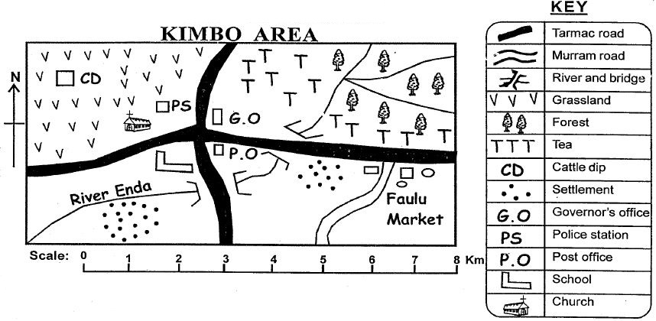
Use the map of Kimbo area to answer Question 1 - 4
- What is the climate of the North Eastern region of Kimbo Area?
__________________________________________________
- Who is the head of Kimbo area?
__________________________________________________
- What is the religion of the people in Kimbo Area?
__________________________________________________
- River Enda flows towards which direction?
__________________________________________________
- List any 2 elements for a map
__________________________________________________
__________________________________________________
- A compass has how many cardinal points?
__________________________________________________
Use the map of Kenya below to answer questions 7 -10
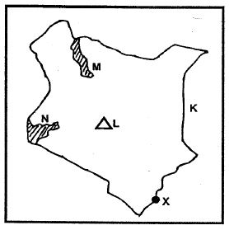
- The country that boarders Kenya marked K is
__________________________________________________
- The lake marked M is called
__________________________________________________
- The mountain marked L is known as
__________________________________________________
- The lake marked N is known as
__________________________________________________
- What is weather?
__________________________________________________
- What is climate?
__________________________________________________
- List any 4 historic built environments in Kenya
__________________________________________________
__________________________________________________
__________________________________________________
__________________________________________________
- List any 3 methods of instruction used in traditional education in promotinf values
__________________________________________________
__________________________________________________
__________________________________________________
- List any 2 adminitstrative leaders in a school
__________________________________________________
__________________________________________________
- Outline any 4 duties of administrative leaders in school
__________________________________________________
__________________________________________________
__________________________________________________
__________________________________________________
- List 4 language groups in Kenya
__________________________________________________
__________________________________________________
__________________________________________________
__________________________________________________
CRE
- Outline 3 lessons that we can learn from the parable of the talents
__________________________________________________
__________________________________________________
__________________________________________________
- Identify any 3 responsibilities given to human beings by God
__________________________________________________
__________________________________________________
__________________________________________________
- Give 4 causes of child labour
__________________________________________________
__________________________________________________
__________________________________________________
__________________________________________________
- Give 4 lessons learnt from the fall of human beings in the garden of eden
__________________________________________________
__________________________________________________
__________________________________________________
__________________________________________________
- List the 3 members of nuclear family
__________________________________________________
- State 2 uses of the Bible
__________________________________________________
__________________________________________________
- List down the first 5 books of the New Testament of the Bible
__________________________________________________
__________________________________________________
__________________________________________________
__________________________________________________
__________________________________________________
- Give two good qualities learnt from the story of Peter and John at the temple
__________________________________________________
__________________________________________________
- Name the three sons of Noah
__________________________________________________
- Prophet Elijah held a contest with false prophets of Baal at Mount ___________

MARKING SCHEME
- Tropical climate
- Governor
- Christianity
- NE to SW
- Scale, Key
- 4
- Somalia
- L. Turkana
- Mt. Kenya
- L.Victoria
- The state of the atmosphere during a short period of time.
- The pattern of changes in the atmosphere over a long period of time.
- Gedi Ruins, Malindi.
Shimoni Slave Caves, Kwale.
Fort Jesus, Mombasa.
Mombasa Old Town, Mombasa.
Hell's Gate National park, Naivasha.
Paradise Lost, Limuru.
Lamu Old Town, Lamu.
Koobi Fora, Turkana.
- Reciting
Singing
Memorization
- Head teacher
Senior teacher
deputy headteacher
- Ensure the school is running well
Ensuring there is discpline
Planning the timetable
Settling disputes within the school
Coordinating diffrent school departments
- Bantu
Nilotes
Cushites
CRE
- We should use out talents well
We should not hide out talents
We will be accountable to God
When we use what we are given well, God will increase to what we have
- Cultivate the garden
Fill the world
Take care of all of God's creation
- Poverty
Disobedience to the law
No acccess to education
Natural distasters
Social norms that allow them to happen
- Sin brings death
Sin brings punishment( consequences)
God still loves us
We should learn to say no to temptation
We should learn to obey God
- Mother
Father
siblings(brother, sister)
- To teach God's word
To guide christians on how to live
- Matthew, Mark, Luke, John, Acts
- Kindness- they helped the lame man despite saying they had nothing
Compassion - they stopped going into the temple to help/ listn to the cripple
- Shem , ham , japheth
- Mt. Carmel

