Social Studies and CRE - Grade 4 Term 1 Exam 2023 SET 1
KATI AREA
Study the map of kati area and use it to answer questions 1-4
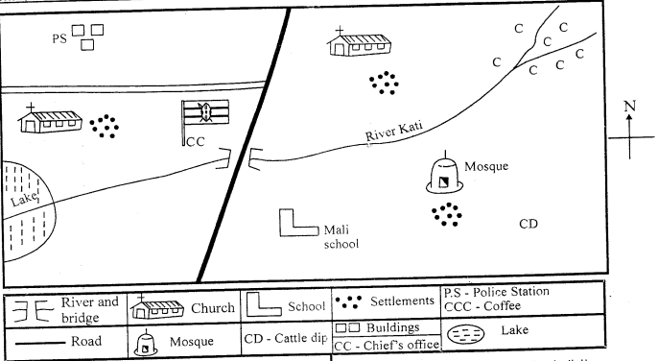
- People in kati area get water from a _________________
- The main cash crop in the area is ___________________
- The name of the school in kati area is ___________________
- Kati area is likely to be ___________________ (sub-location, location, county)
- River kati starts from what direction ____________________
- Children you learn with in the same class and share items are your _____________________
- Elijah is facing the sun in the morning. He is walking towards ________________________
- An instrument used to tell the direction of one place from another is called __________________
- The sun sets to the __________________
- The other name for the four main points of a compass is ___________________
- Mountains, rivers, lakes are all called __________________features.
- The direction of a compass marked below is called ________________
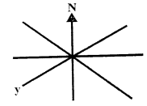
- A person who uses compass direction to land at an airport is called _________________________
- There are ______________ counties in Kenya.
- The smallest county in Kenya is _________________________.
- The head of a county is called _____________________
- Which one is the following is the odd one out.
(bus, aeroplane, ship and cart)
- An area with many trees is called a _______________________
- Rainfall, sunshine, temperature, wind are all called _____________________
- Drops of water that fall from the sky are called ____________________
(clouds, rain, sunshine)
- The head of a location is called _______________________
- A river which flows throughout the year is called _______________________
- Crops that are grown for sale are called ____________________
- My father's father is my __________________________
- Name one physical feature in your county.
- Kamau is sitting facing the sun in the morning. His right hand is facing _________________
- Planting different types of crops at different times is called ___________________
(soil erosion, crop rotation, shift cultivation)
- What is the name of your county? ________________________
- People come together in our county to ___________________
(chase one another, help one another, quarrel one another)
- Dairy animals are mainly kept for _____________________ (meat, milk, blood, mutton)
- The people who keep law and order in our country are the ____________________
- A flat area is called a __________________ (valley, coast, plain)
- A person who mends our clothes is called a ___________________
- The largest county in Kenya is _______________________
- Mountains, valleys, hills and rivers all are called __________________ features.
- A weather instrument used to measure the amount of rainfall is called ___________________
CHRISTIAN RELIGIOUS EDUCATION
- Human beings are special. They are created in ______________ image.
- Complete Psalms 139:13 "You created every part of me, you put me together in my _____________
womb.
- Write one good thought ___________________________________________
- The commandment that has a promise added is _______________________________________
- _______________________ was punished by abusing his sister sexually. (David, Amnon)
- Our bodies are the ____________________ of the Holy Spirit.
- God does not make mistakes, we say He is ________________________ (loving, Holy)
- When I am sad, I can control my emotions by ___________________ (crying, sleeping, praying)
- The members of a nuclear family are __________________, _______________ and _______________
- When your friend wrong you, you should ________________________ (fight, abuse, forgive)

MARKING SCHEME
- lake
- Coffee
- Mali School
- Locatio
- North East
- Friends
- East
- Compass
- West
- Cardinal points
- Physical
- South West
- Pilot
- 47
- Mombasa
- Governor
- cart
- forest
- weather elements
- rain
- Chief
- Permanent
- Cash crops
- grandfather

- South
- crop rotation

- Help one anothrer
- Milk
- Police
- Plain
- Tailor
- Marsabit
- Physical
- Rain gauge
C.R.E
- God's
- Mother's

- obey your father and mother
- Amnon
- Temple
- Holy
- Praying
- father, mother and children
- forgive

