Social Studies - Grade 5 Term 1 Exam 2023
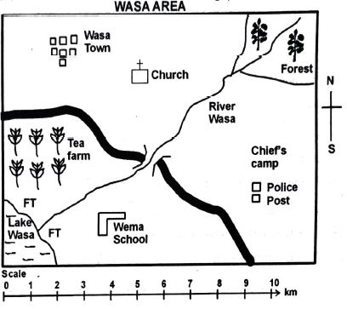
- What is the direction of:
  - Lake Wasa from church
__________________
  - Tea farm from chief's camp
__________________
- The main cash crop grown in Wasa area is ______________
- People in Wasa area belong to which religion?
__________________
- The main means of transport in Wasa area is
__________________
- Who maintains law and order in Wasa area
__________________
- Which economic activity takes place in Lake Wasa
__________________
- State 3 elements of a map
__________________
__________________
__________________
- Fill in the table below with the correct natural and built environment
Natural environment | Built environment
__________________  __________________  __________________ | __________________  __________________  __________________
- Which country borders Kenya to North West__________________
- What is weather___________________
- State three elements of weather
____________________
____________________
____________________
- The main language groups found in Kenya are:
____________________
____________________
____________________
____________________
____________________
- What is the longitude of Kenya _______E and _________E
- Name 4 lakes found in Kenya
____________________
____________________
____________________
____________________
- Name three roles of the school administration
____________________
____________________
____________________
- The way of life of a particular community is known as
____________________
- Name five rivers that drain into Lake Victoria
____________________
____________________
____________________
____________________
____________________
- Who were the traditional teachers?
____________________
- Traditional society youths were taught through the following ways except
  - Proverbs
  - Songs and dances
  - Riddles
  - Writing
- The largest lake in Kenya is ____________________
- The most Northerly point of Kenya is at ____________________
- The largest valley in Kenya is ____________________
- Our country is called ____________________
- Kenya has ____________________ counties.
MARKING SCHEME

  - South West
  - West
- tea
- christian
- road
- police
- farming
- key, scale, compass

Natural environment | Built environment
Rivers  Mountains  Forests | Roads  cities/towns  buildings
- state of the atmosphere for a short period of time
- temperature, wind, air pressure, rain
- reciting, singing, riddles, proverbs
- bantus, nilotes( plain nilotes, highland nilotes, rive-lake nilotes), cushites
- 34° and 42°E.
- L. turkana, L. victoria, L. nakuru, L. bogoria. L. magadi
- maintain discpline, create school program, manage school activities
- tradition
- River Mara, Kagera, Yala, Nyando, Bukora and Katonga.
- elders in society
- writing
- L. victoria
- ilemi triangle/ naitatitok
- rift valley
- Kenya
- 47

